Effect of nintedanib in patients with progressive pulmonary fibrosis associated with rheumatoid arthritis: data from the INBUILD trial (Matteson EL et al)

SUPPLEMENTARY INFORMATION

Online Resource 1 Immunomodulatory medications taken at baseline in patients with RA-ILD in the INBUILD trial.
≥1 immunomodulatory medication | 79 (88.8)
Biologic DMARDs | 19 (21.3)
Abatacept | 6 (6.7)
Etanercept | 4 (4.5)
Adalimumab | 3 (3.4)
Tocilizumab | 3 (3.4)
Infliximab | 2 (2.2)
Rituximab | 1 (1.1)
Non-biologic DMARDs | 48 (53.9)
Hydroxychloroquine/hydroxychloroquine sulphate | 18 (20.2)
Leflunomide | 15 (16.9)
Methotrexate/methotrexate sodium | 13 (14.6)
Sulfasalazine | 10 (11.2)
Bucillamine | 1 (1.1)
Chloroquine phosphate | 1 (1.1)
Iguratimod | 1 (1.1)
Glucocorticoidsª | 65 (73.0)
Prednisone | 33 (37.1)
Prednisolone | 23 (25.8)
Methylprednisolone | 4 (4.5)
Meprednisone | 2 (2.2)
Cortisone acetate | 1 (1.1)
Deflazacort | 1 (1.1)
Triamcinolone acetonide | 1 (1.1)
Data are n (%) of patients with RA-ILD (n=89) based on customised drug groupings (bold) and preferred names (non-bold). ªBased on customised drug grouping “corticosteroids”; restricted to oral, intravenous, intravenous bolus, intravenous drip, or intramuscular administration. DMARDs disease-modifying anti-rheumatic drugs, RA-ILD rheumatoid arthritis-associated interstitial lung disease.
Online Resource 2 Comorbidities at baseline in patients with RA-ILD in the INBUILD trial.
Hypertension | 48 (53.9)
Gastro-oesophageal reflux disease | 22 (24.7)
Menopause | 18 (20.2)
Hyperlipidaemia | 16 (18.0)
Diabetes mellitus | 12 (13.5)
Dyslipidaemia | 11 (12.4)
Benign prostatic hyperplasia | 10 (11.2)
Osteoporosis | 10 (11.2)
Sleep apnoea syndrome | 10 (11.2)
Post-menopause | 9 (10.1)
Asthma | 9 (10.1)
Cataract | 9 (10.1)
Rhinitis allergic | 9 (10.1)
Data are n (%) of patients with RA-ILD (n=89) based on preferred terms in MedDRA version 22.0. Comorbidities reported in ≥10% of patients are shown. MedDRA, Medical Dictionary for Regulatory Activities, RA-ILD, rheumatoid arthritis-associated interstitial lung disease.
Online Resource 3 Restricted or prohibited immunomodulatory or antifibrotic therapies taken at baseline, during treatment with trial drug, or following discontinuation of trial drug in patients with RA-ILD in the INBUILD trial.
 | Nintedanib (n=42) | Placebo  (n=47)
≥1 restricted or prohibited therapy | 14 (33.3) | 21 (44.7)
Glucocorticoids | 12 (28.6) | 20 (42.6)
Mycophenolate mofetil | 0 | 3 (6.4)
Rituximab | 2 (4.8) | 1 (2.1)
Cyclophosphamide | 0 | 2 (4.3)
Tacrolimus | 0 | 1 (2.1)
Nintedanib | 0 | 1 (2.1)
Azathioprine | 1 (2.4) | 0
Pirfenidone | 1 (2.4) | 0
Data are n (%) of patients who took ≥1 such therapy at baseline, during treatment with trial drug, and/or following discontinuation of trial drug for any duration. Glucocorticoids were based on the customised drug grouping “corticosteroids”; for other therapies, preferred names are shown. Glucocorticoids were counted as restricted therapies if used at dose of >20 mg/day prednisone or equivalent via oral, intravenous, intravenous bolus, intravenous drip, or intramuscular administration. RA-ILD rheumatoid arthritis-associated interstitial lung disease.
Online Resource 4 Kaplan-Meier estimates of time to (A) acute exacerbation of ILD or death, (B) hospitalisation or death, (C) respiratory hospitalisation or death, (D) progression of ILD (absolute decline in FVC % predicted ≥10%) or death and (E) death in patients with RA-ILD in the INBUILD trial. FVC forced vital capacity, ILD, interstitial lung disease, RA-ILD rheumatoid arthritis-associated interstitial lung disease
A
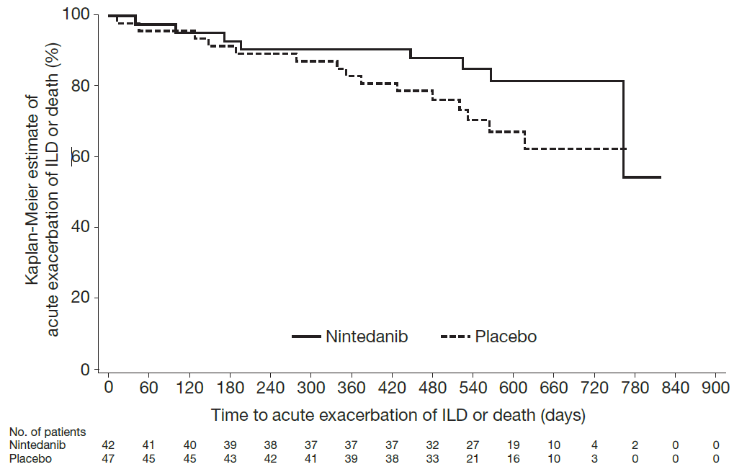
B
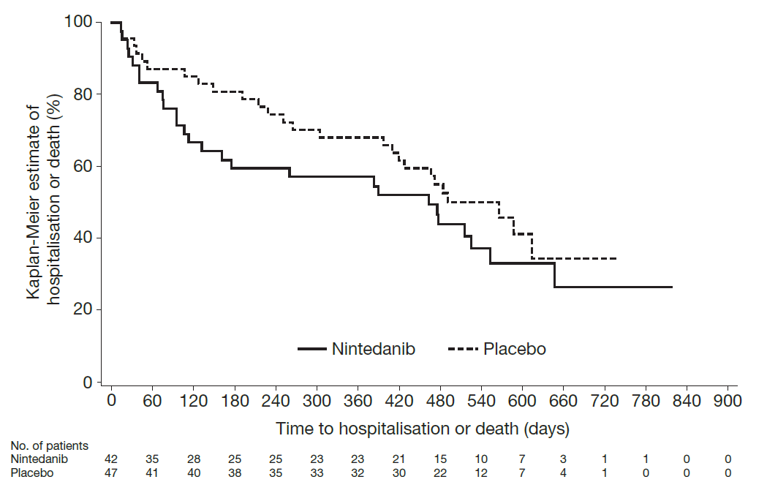

C
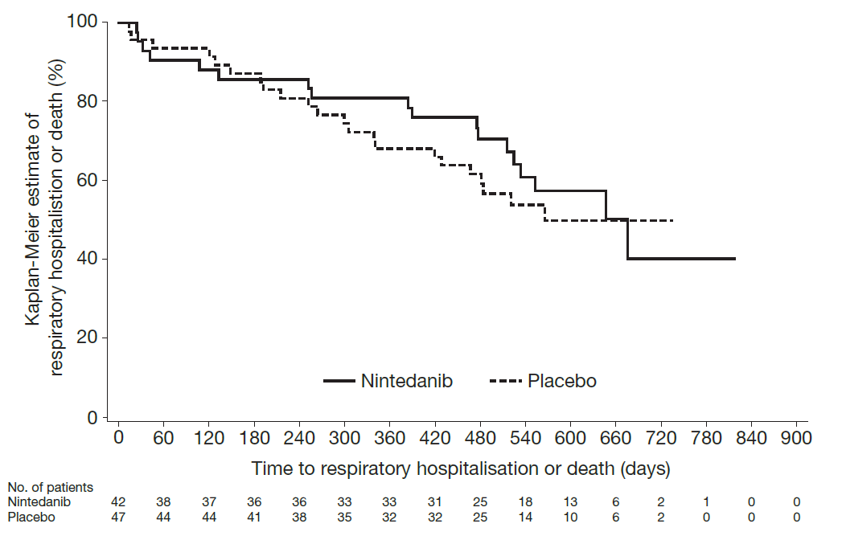

D
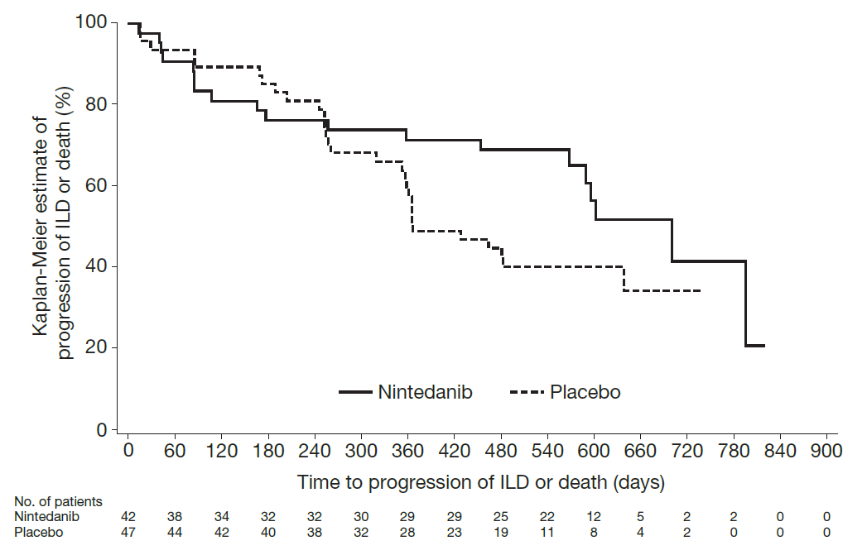

E
