SUPPLEMENTAL DATA

Supplemental Fig. 1 LS mean change (95% CI) from baseline over time in a) LEI and b) DSS in patients with enthesitis or dactylitis by treatment group at weeks 24, 52, and 100. CI, confidence interval, DSS, Dactylitis Severity Score; GUS, guselkumab; LEI, Leeds Enthesitis Index; LS, least squares; PBO, placebo; Q4W, every 4 weeks; Q8W, every 8 weeks
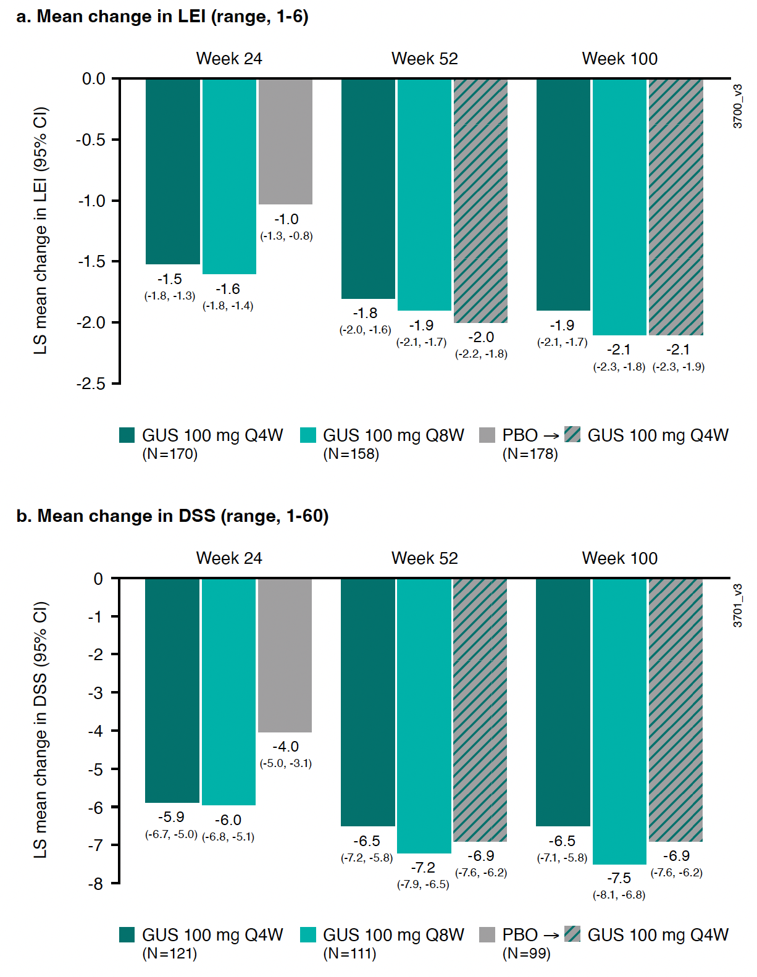
Supplemental Fig. 2 Proportion of patients achieving a) ER and b) DR over time. DR, dactylitis resolution; DSS, Dactylitis Severity Score; ER, enthesitis resolution; GUS, guselkumab; LEI, Leeds Enthesitis Index; PBO, placebo; Q4W, every 4 weeks; Q8W, every 8 weeks

