Supplementary material
Subgroups | Severity | N | Cut-off value NRS score* | Prevalence (%) | Baseline scores* (mean ± SD) | Actual observed effect size# | Adjusted between-subgroup MD**[95 %CI]
Morning stiffness | 1. More | 97 | ≥ 8 | 30.9 | 8.4 ± 0.6 | 0.578 | -0.130 [-1.01 to 0.75]]
 | 2. Less | 217 | < 8 | 69.1 | 5.2 ± 1.9 | 0.578 | -0.708 [-1.29 to -0.13]
Sensation of swelling | 3. More | 103 | ≥ 6 | 30 | 7.0 ± 1.1 | 0.104 | -0.493 [-1.34 to 0.36]
 | 4. Less | 211 | < 6 | 70 | 2.2 ± 1.9 | 0.104 | -0.597 [-1.19 to -0.002]
Pain | 5. More | 84 | ≥ 8 | 26.8 | 8.4 ± 0.6 | -0.502 | -0.931 [-1.9 to 0.01]
 | 6. Less | 230 | < 8 | 73.2 | 6.2 ± 0.8 | -0.502 | -0.428 [-0.99 to 0.13]

Supplementary table 1. Subgroup definitions and baseline scores per subgroup
N = number of patients (randomized) per group; NRS = Numeric Rating Scale; SD = standard deviation; MD = adjusted mean difference; CI = confidence interval
*NRS scores (stiffness, swelling, and pain) at baseline on a 0-10 scale range.
#For the primary outcome pain severity at day 5
**Adjusted for treatment center and baseline score of the outcome. Between-subgroup mean treatment difference is the mean difference between the subgroup with less and more severe complaints for the treatment of 2400 mg versus 1200 mg ibuprofen treatment.

 | Subgroup with less severe complaints |  | Subgroup with more severe complaints
 | Treatment effect MD* | 95% CI | Treatment effect MD* | 95% CI
Morning stiffness
Pain severity day 5 | 0.708 | 0.129 to 1.288 | 0.130 | -0.749 to 1.009
WOMAC pain day 5 | -0.534 | -1.054 to 0.014 | -0.222 | -1.010 to 0.565
Pain severity day 3 | -0.402 | -0.912 to 0.108 | -0.088 | -0.859 to 0.684
Swelling
Pain severity day 5 | 0.597 | 0.002 to 1.193 | 0.493 | -0.356 to 1.343
WOMAC pain day 5 | -0.310 | -0.221 to 0.840 | -0.729 | -1.486 to 0.28
Pain severity day 3 | -0.376 | -0.898 to 0.147 | -0.254 | -1.003 to 0.495
Pain
Pain severity day 5 | 0.428 | -0.130 to 0.987 | 0.931 | -0.006 to 1.868
WOMAC pain day 5 | -0.364 | -0.865 to 0.137 | -0.682 | -1.522 to 0.158
Pain severity day 3 | -0.236 | -0.729 to 0. 257 | -0.602 | -1.427 to -0.223
Supplementary table 2. Subgroup analyses. Subgroup analyses (interaction intervention x subgroup and adjusted* mean differences) for pain severity at day 5 (primary outcome), WOMAC pain at day 5 (secondary outcome) and pain severity at day 3 (secondary outcome) for N =308. *Adjusted for treatment center and baseline score of the outcome. Treatment effect is the difference between 2400 mg and 1200mg within each subgroup (adjusted mean within-subgroup treatment difference). CI = confidence interval; MD = adjusted mean difference.
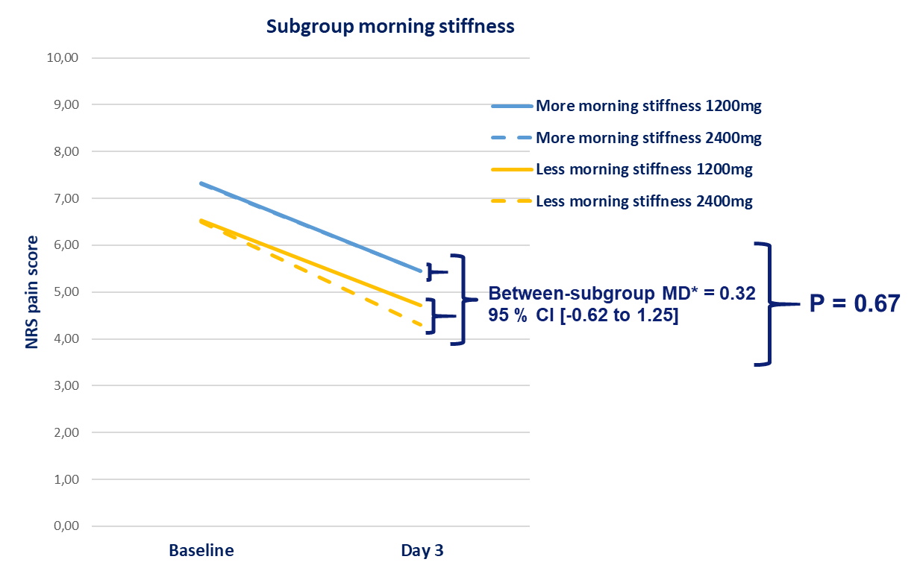
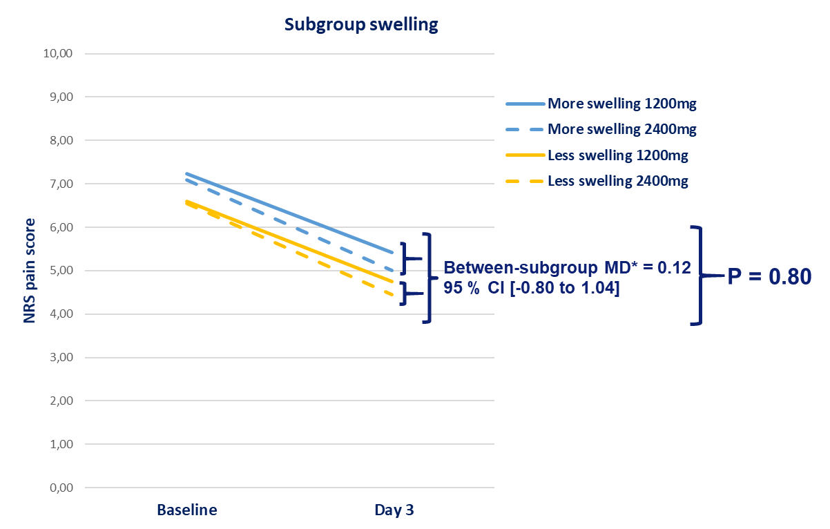
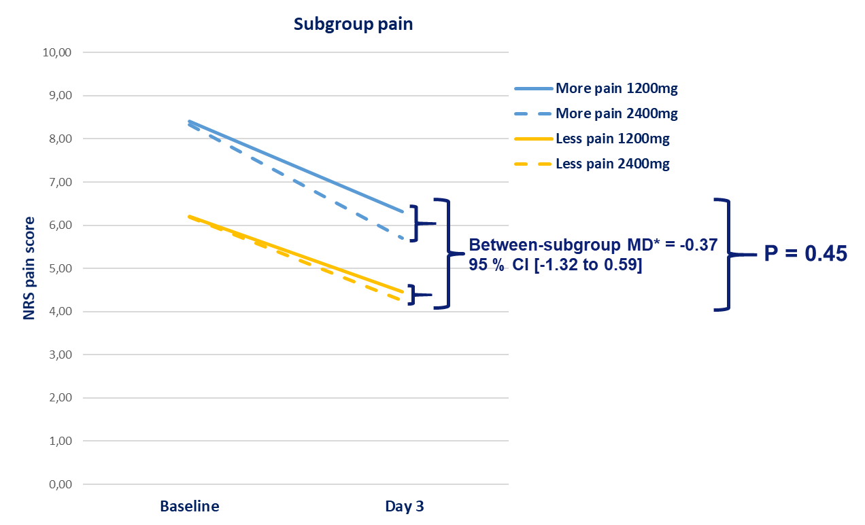
Supplementary figure 3. Adjusted mean between-subgroup treatment differences and corresponding significance level of the treatment effect for each subgroup on the secondary outcome measures.
NRS pain severity score (0-10 range) at day 3 of treatment. * MD = adjusted mean difference; NRS = Numeric Rating Scale; P = p-value

