Supplementary (S) Figures and Tables
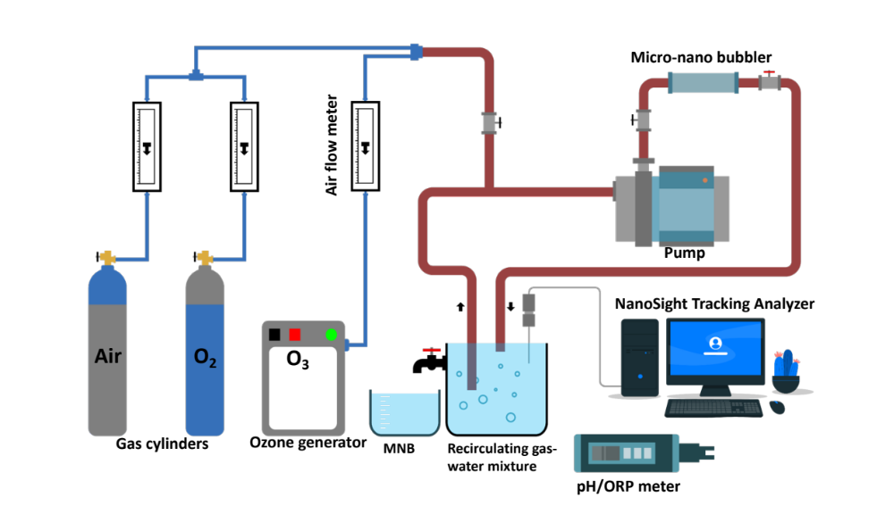
S-Figure 1. The conceptual model and schematic diagram for micro-nano bubble water generator system with different feed gases, and characterization of MNB physicochemical properties.

S-Table 1. Physico-chemical characteristics of treatments

Treatments |  | pH |  | ORP (mV) |  | Temperature (°C)
Distilled water |  | 6.45 ± 0.45 ^{c} |  | 286 ± 31.00 ^{c} |  | 18.1 ± 1.90 ^{c}
NaOCl |  | 10.74 ± 0.00 ª |  | 478 ± 1.00 ^{b} |  | 21.6 ± 0.00 ^{ab}
Air-MNB |  | 9.50 ± 0.50 ^{b} |  | 188 ± 18.00 ^{d} |  | 19.3 ± 0.70 ^{bc}
O₂-MNB |  | 9.32 ± 0.68 ^{b} |  | 232 ± 12.00 ^{c} |  | 19.7 ± 0.30 ^{bc}
O₃-MNB |  | 2.71 ± 0.01^{d} |  | 919 ± 12.28 ª |  | 21.3 ± 0.40 ^{ab}
Mean values (n = 5) ± standard deviation, and similar lower-case letters along the columns are not significantly different at p ≤ 0.05.

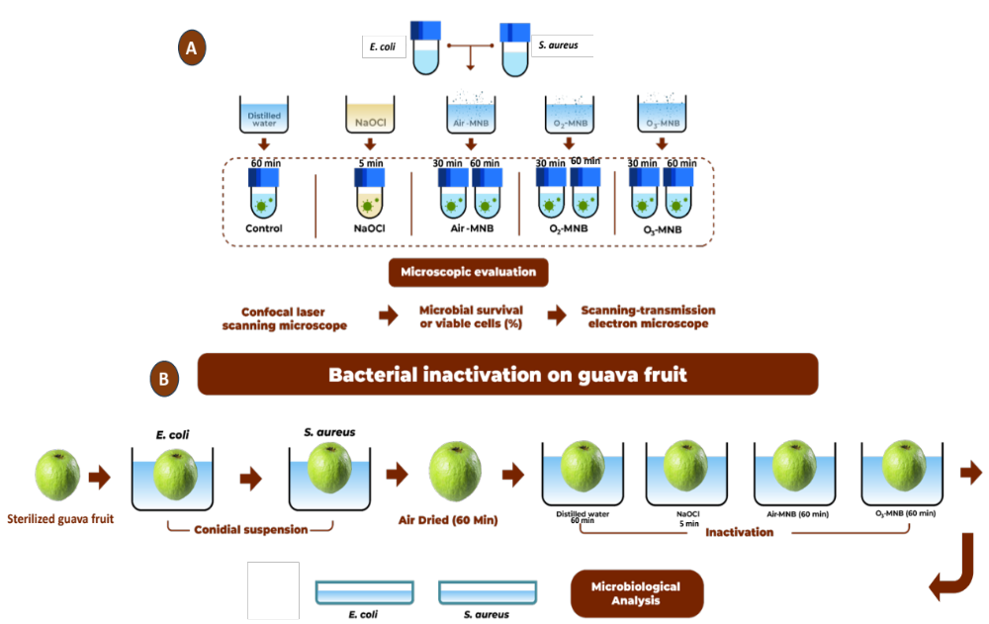

S-Figure 2. Experimental layout for bacterial inactivation (A) in cell suspension and (B) on guava fruit surface stored at 13 °C for 12 days.

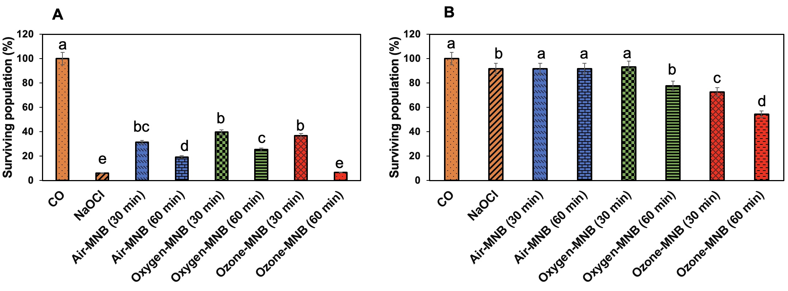
S-Figure 4. Survival or viable cells (%) of (A) E. coli and (B) S. aureus after treatment with distilled water (CO), NaOCl (200 mg/L), air-MNB (30 min and 60 min), O₂-MNB (30 and 60 min) and O₃-MNB (30 and 60 min). The error bars indicate the standard deviation. Mean values denoted by similar letters are not significantly different at p ≤ 0.05.

