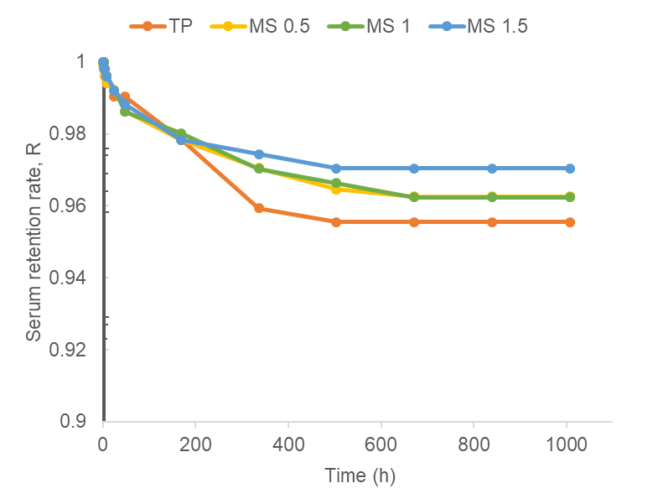
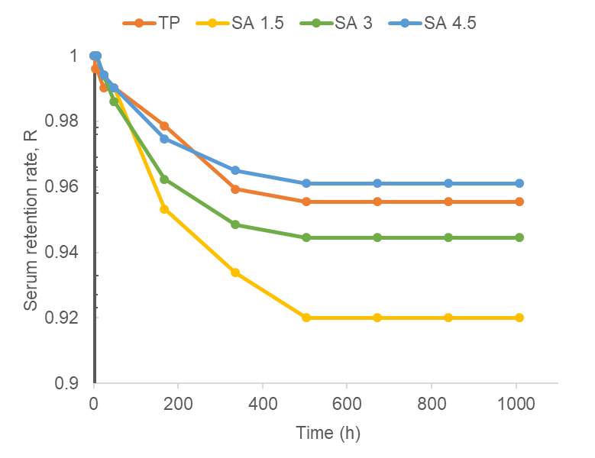
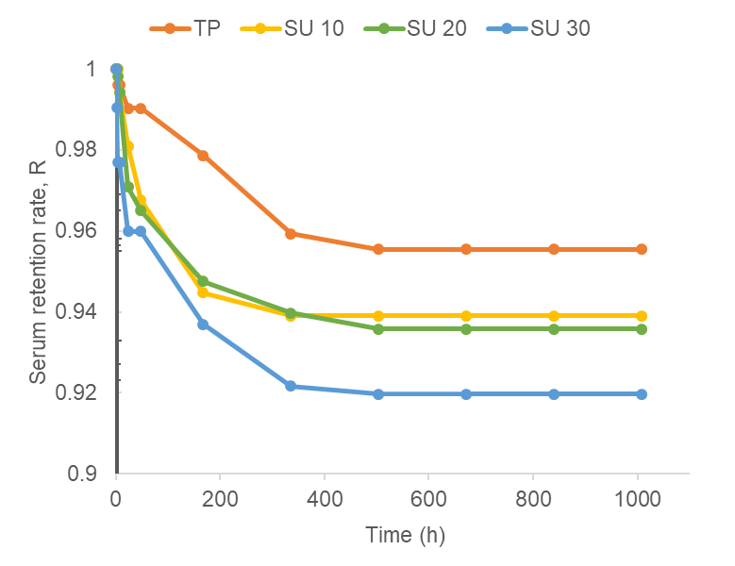
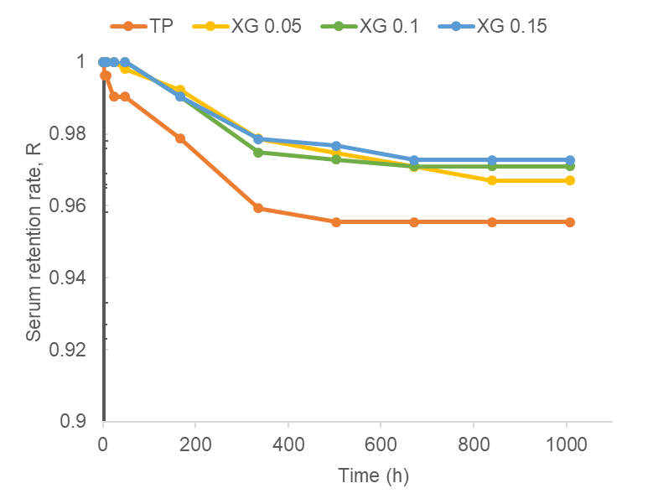

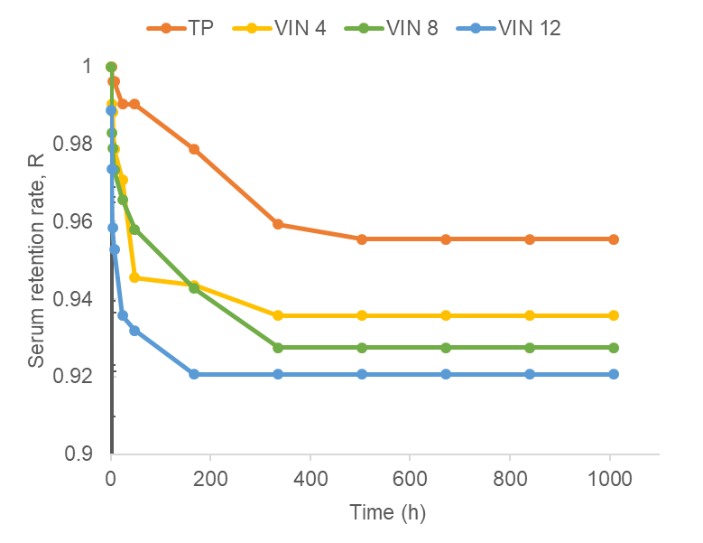

Fig. S1. The serum retention rate (R) during storage of model tomato ketchup with different supplemented ingredients. The numbers following sample abbreviations indicate the concentration (wt%) of supplemented ingredients to the tomato paste. TP = tomato paste; MS = TP + modified starch; XG = TP + xanthan gum; SU = TP + sugar; SA = TP + salt; VIN =TP + vinegar.

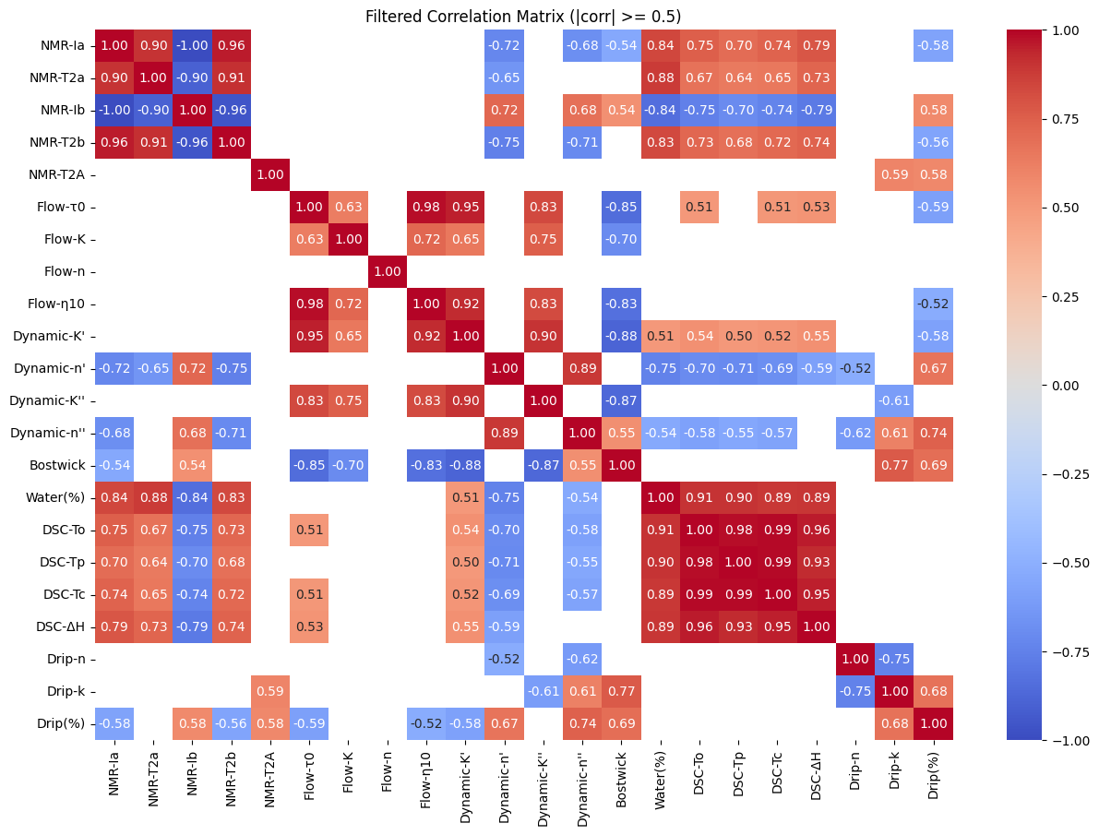

Fig. S2. Correlation matrix for measured physicochemical properties of model tomato ketchup samples. Absolute values of correlation coefficient greater than 0.5 are presented.

