Name | Description | Reference
Strains
D452-2 | MATα, leu2, his3, ura3, and canI | (Hosaka et al., 1992)
+P1/K2 | D452-2 HIS3::P_{PGK}-EPX1_{SP}-ovalbumin-T_{CYC1} LEU2::P_{tHXT7}-PDI1-T_{CYC1} URA3::P_{tHXT7}-KAR2-T_{CYC1} | (Jin et al., 2024)
+INO2 | +P1/K2 CS6::P_{tHXT7}-INO2-T_{CYC1} | In this study
+COG5 | +P1/K2 CS6::P_{tHXT7}-COG5-T_{CYC1} | In this study
+ERV29 | +P1/K2 CS6::P_{tHXT7}-ERV29-T_{CYC1} | In this study
ΔDER1 | +P1/K2 with DER1 disruption | In this study
ΔOPI1 | +P1/K2 with OPI1 disruption | In this study
ΔTDA3 | +P1/K2 with TDA3 disruption | In this study
ΔGOS1 | +P1/K2 with GOS1 disruption | In this study
ΔHDA2 | +P1/K2 with HDA2 disruption | In this study
ΔVPS5 | +P1/K2 with VPS5 disruption | In this study
ΔCCW12 | +P1/K2 with CCW12 disruption | In this study
ΔFYV5 | +P1/K2 with FYV5 disruption | In this study
Supporting Information
Table S1. Saccharomyces cerevisiae strains and plasmids used in this study.

Name | Description | Reference
Strains
ΔOCH1 | +P1/K2 with OCH1 disruption | In this study
ΔPAH1 | +P1/K2 with PAH1 disruption | In this study
ΔYPK1 | +P1/K2 with YPK1 disruption | In this study
Plasmids
pKCK21 | G418^{R}, P_{tHXT7}-GSH2-T_{CYC1}, an integrative plasmid, Amp^{R} | (Jeon et al., 2023)
pEYK05 | G418^{R}, P_{tHXT7}-ERV29-T_{CYC1}, Amp^{R}, an integrative plasmid | In this study
pEYK06 | G418^{R}, P_{tHXT7}-COG5-T_{CYC1}, Amp^{R}, an integrative plasmid | In this study
pEYK07 | G418^{R}, P_{tHXT7}-INO2-T_{CYC1}, Amp^{R}, an integrative plasmid | In this study
pEYK08 | G418^{R}, P_{PGK}-EPX1_{SP}-ovalbumin-T_{CYC1}, Amp^{R}, an integrative plasmid | In this study
pCas9_AUR | Aur^{R}, P_{TEF1}-Cas9-T_{CYC1}, modified Cas9 expression plasmid, Amp^{R} | (Lee et al., 2017)
pgRNA-TRP1-HYB | Hyg^{R}, 2 μ origin, P_{SNR52}-gTRP1-T_{SUP4}, Amp^{R} | (Zhang et al., 2014)
pgRNA-OCH1-HYB | Hyg^{R}, 2 μ origin, P_{SNR52}-gOCH1-T_{SUP4}, Amp^{R} | In this study
pgRNA-FYV5-HYB | Hyg^{R}, 2 μ origin, P_{SNR52}-gFYV5-T_{SUP4}, Amp^{R} | In this study
pgRNA-DER1-HYB | Hyg^{R}, 2 μ origin, P_{SNR52}-gDER1-T_{SUP4}, Amp^{R} | In this study
pgRNA-YPK1-HYB | Hyg^{R}, 2 μ origin, P_{SNR52}-gYPK1-T_{SUP4}, Amp^{R} | In this study

Name | Description | Reference
Plasmids
pgRNA-PAH1-HYB | Hyg^{R}, 2 μ origin, P_{SNR52}-gPAH1-T_{SUP4}, Amp^{R} | In this study
pgRNA-OPI1-HYB | Hyg^{R}, 2 μ origin, P_{SNR52}-gOPI1-T_{SUP4}, Amp^{R} | In this study
pgRNA-CCW12-HYB | Hyg^{R}, 2 μ origin, P_{SNR52}-gCCW12-T_{SUP4}, Amp^{R} | In this study
pgRNA-HDA2-HYB | Hyg^{R}, 2 μ origin, P_{SNR52}-gHDA2-T_{SUP4}, Amp^{R} | In this study
pgRNA-VPS5-HYB | Hyg^{R}, 2 μ origin, P_{SNR52}-gVPS5-T_{SUP4}, Amp^{R} | In this study
pgRNA-GOS1-HYB | Hyg^{R}, 2 μ origin, P_{SNR52}-gGOS1-T_{SUP4}, Amp^{R} | In this study
pgRNA-TDA3-HYB | Hyg^{R}, 2 μ origin, P_{SNR52}-gTDA3-T_{SUP4}, Amp^{R} | In this study

Table S2. List of primers used in this study.
Name | Sequence (5′→3′) | Amplified gene | Description
EY12[F] | GATCCATTTCACTTGTCAAACAAAGTTTTAGAGCTAGAAATAGCAAGTTAAAATAAG | pgRNA-ΔOCH1-HYB | To introduce ΔOCH1
EY13[R] | TGTTTGACAAGTGAAATGGATCATTTATCTTTCACTGCGGA | pgRNA-ΔOCH1-HYB | To introduce ΔOCH1
EY11[F] | AATAGCAATTTGGAAAAAGAAAGCAAGTAAAAGAAAGAAGAGATCAATTACAGTTAACAA | ΔOCH1 repair DNA | To introduce ΔOCH1
EY10[R] | TCACGTAAATTATGCAATTGATTTTTTTTCTTGTTAACTGTAATTGATCTCTTCTTTCTT | ΔOCH1 repair DNA | To introduce ΔOCH1
EY29[F] | GCAGTGAAAGATAAATGATCGTAAATATATACATATAGAGGTTTTAGAGCTAGAAATAGCAAGTTAAAATAAG | pgRNA-ΔFYV5-HYB | To introduce ΔFYV5
EY28[R] | ACGATCATTTATCTTTCACTGCGGA | pgRNA-ΔFYV5-HYB | To introduce ΔFYV5
EY26[F] | AGCGACGATGCTTTATATATATTCAAAAAAAAAAATAATAAAAATCTATAAGGAAAAGCC | ΔFYV5 repair DNA | To introduce ΔFYV5
EY27[R] | AGCATGCTGAAGCAGATCGAAATGATATCCGGCTTTTCCTTATAGATTTTTATTATTTTT | ΔFYV5 repair DNA | To introduce ΔFYV5
EY34[F] | AGCCAAGAATCTACCACTTGTTTTAGAGCTAGAAATAGCAAGTTAAAATAAG | pgRNA-ΔCCW12-HYB | To introduce ΔCCW12
EY35[R] | AAGTGGTAGATTCTTGGCTGGATCATTTATCTTTCACTGCGGA | pgRNA-ΔCCW12-HYB | To introduce ΔCCW12
EY32[F] | CCAAGAAATTAATCTTCTGTCATTCGCTTAAACACTATATCAATAATACACCACCTGGTG | ΔCCW12 repair DNA | To introduce ΔCCW12
EY33[R] | CCGTTCTTTGGGGCTTCAGTGGTCAATGGGCACCAGGTGGTGTATTATTGATATAGTGTT | ΔCCW12 repair DNA | To introduce ΔCCW12
EY40[F] | AACGCTAACCCAATTTCAAAGTTTTAGAGCTAGAAATAGCAAGTTAAAATAAG | pgRNA-ΔHDA2-HYB | To introduce ΔHDA2
EY41[R] | TTTGAAATTGGGTTAGCGTTGATCATTTATCTTTCACTGCGGA | pgRNA-ΔHDA2-HYB | To introduce ΔHDA2
EY38[F] | CATTAGTGTGTGAAAAATAAAGAAAATAGATACAATACTATCGACGCTATCACAAAGGCA | ΔHDA2 repair DNA | To introduce ΔHDA2
EY39[R] | CTTATGTTTGAATCAAAGATATAGGTTAATTGCCTTTGTGATAGCGTCGATAGTATTGTA | ΔHDA2 repair DNA | To introduce ΔHDA2
Name | Sequence (5′→3′) | Amplified gene | Description
EY46[F] | TTGGGACGAACTAAATCATGGTTTTAGAGCTAGAAATAGCAAGTTAAAATAAG | pgRNA-ΔVPS5-HYB | To introduce ΔVPS5
EY47[R] | CATGATTTAGTTCGTCCCAAGATCATTTATCTTTCACTGCGGA | pgRNA-ΔVPS5-HYB | To introduce ΔVPS5
EY44[F] | CAGCAGGGATTTTATAAACTTTCATACATCCTGCAATAACAAGCCAGACCCTGGTTTGTC | ΔVPS5 repair DNA | To introduce ΔVPS5
EY45[R] | TGCTCCTCTAGTTGCGGATTACCAGCCACCGACAAACCAGGGTCTGGCTTGTTATTGCAG | ΔVPS5 repair DNA | To introduce ΔVPS5
EY52[F] | ATCACAACTAGTTCAGAACAAACGTTTTAGAGCTAGAAATAGCAAGTTAAAATAAG | pgRNA-ΔGOS1-HYB | To introduce ΔGOS1
EY53[R] | GTTTGTTCTGAACTAGTTGTGATCATTTATCTTTCACTGCGGA | pgRNA-ΔGOS1-HYB | To introduce ΔGOS1
EY50[F] | CTAGACACAGGGAAAAGCCCAATTCCAGACAAGCAACCACACCACCTGCGATTCTAACCC | ΔGOS1 repair DNA | To introduce ΔGOS1
EY51[R] | AGTTGGGAAAGCTTTGAGGCGGAGATTGCCGGGTTAGAATCGCAGGTGGTGTGGTTGCTT | ΔGOS1 repair DNA | To introduce ΔGOS1
EY58[F] | TGATCATATTACCATCATTGAATCGGTTTTAGAGCTAGAAATAGCAAGTTAAAATAAG | pgRNA-ΔTDA3-HYB | To introduce ΔTDA3
EY59[R] | CGATTCAATGATGGTAATATGATCATTTATCTTTCACTGCGGA | pgRNA-ΔTDA3-HYB | To introduce ΔTDA3
EY56[F] | ATCAATAGCATTTTAACCAAGCAACAGAAGGAATAGTGTTTATAATAAAGCAGGTGGCTT | ΔTDA3 repair DNA | To introduce ΔTDA3
EY57[R] | ATTTGGTGAGGGAAAGCCCAAGATGCAAGCAAGCCACCTGCTTTATTATAAACACTATTC | ΔTDA3 repair DNA | To introduce ΔTDA3
EY64[F] | ATCAGAGGAAGAGGTAGAAGGTTTTAGAGCTAGAAATAGCAAGTTAAAATAAG | pgRNA-ΔOPI1-HYB | To introduce ΔOPI1
EY65[R] | CTTCTACCTCTTCCTCTGATGATCATTTATCTTTCACTGCGGA | pgRNA-ΔOPI1-HYB | To introduce ΔOPI1
EY62[F] | GCGTGTGTATCAGGACAGTGTTTTTAACGAAGATACTAGTCATTGAGTGACATTCTACGA | ΔOPI1 repair DNA | To introduce ΔOPI1
EY63[R] | TTCAGTGGCCTCTTGTTGGTGTTTATTTCATCGTAGAATGTCACTCAATGACTAGTATCT | ΔOPI1 repair DNA | To introduce ΔOPI1

Name | Sequence (5′→3′) | Amplified gene | Description
EY70[F] | TAGTGGAGCATCCAGACGGAGTTTTAGAGCTAGAAATAGCAAGTTAAAATAAG | pgRNA-ΔPAH1-HYB | To introduce ΔPAH1
EY71[R] | GTCTGGATGCTCCACTAGATCATTTATCTTTCACTGCGGA | pgRNA-ΔPAH1-HYB | To introduce ΔPAH1
EY68[F] | AACATACAGGGAAGAAATTACTGAAGATAGACACATCGGTCGATTGAAACTGAGTAATAT | ΔPAH1 repair DNA | To introduce ΔPAH1
EY69[R] | GCTTCTCCAGAATCACTCAGTTTCATTGGCATATTACTCAGTTTCAATCGACCGATGTGT | ΔPAH1 repair DNA | To introduce ΔPAH1
EY76[F] | CATTGGCTGTCTTGTACTATCGTTTTAGAGCTAGAAATAGCAAGTTAAAATAAG | pgRNA-ΔDER1-HYB | To introduce ΔDER1
EY77[R] | GATAGTACAAGACAGCCAATGATCATTTATCTTTCACTGCGGA | pgRNA-ΔDER1-HYB | To introduce ΔDER1
EY74[F] | CAGAGATTTCGTCACCAACAGAAGAAAAGCTAAAGCCCAAGCAATTTGGATATCCATGAT | ΔDER1 repair DNA | To introduce ΔDER1
EY75[R] | GATAAGTGATTAGCGCTGACAAAGATGTTTATCATGGATATCCAAATTGCTTGGGCTTTA | ΔDER1 repair DNA | To introduce ΔDER1
EY109[F] | CGAAAAAGAAGCCAAACATAGGTTTTAGAGCTAGAAATAGCAAGTTAAAATAAG | pgRNA-ΔYPK1-HYB | To introduce ΔYPK1
EY110[R] | CTATGTTTGGCTTCTTTTTCGATCATTTATCTTTCACTGCGGAGAAGTTTCGAA | pgRNA-ΔYPK1-HYB | To introduce ΔYPK1
EY99[F] | TCAAAGTTCCTCTCATATCAACAAACATTAATACAGTTCCTGAAAGGTTCGTGTTTCATA | ΔYPK1 repair DNA | To introduce ΔYPK1
EY100[R] | GTACAGTAGAGGTCGATGAGGATGCATCGTTATGAAACACGAACCTTTCAGGAACTGTAT | ΔYPK1 repair DNA | To introduce ΔYPK1
EY80[F] | TCAAAAAATGTCTTACAGAGGACCTATTGG | ERV29 from Saccharomyces cerevisiae D452-2 genome | To construct pEYK05
EY81[R] | CGTGACATAACTAATTACATGACTAGTAAATCTTCTTCTTTTCATCAACGG | ERV29 from Saccharomyces cerevisiae D452-2 genome | To construct pEYK05
EY82[F] | AGTCATGTAATTAGTTATGTCACGCTTAC | pKCK21 (Jeon et al., 2023) | To construct pEYK05
EY83[R] | GTCCTCTGTAAGACATTTTTTGATTAAAATTAAAAAAACTTTTTGTTTTTGTG | pKCK21 (Jeon et al., 2023) | To construct pEYK05

Name | Sequence (5′→3′) | Amplified gene | Description
EY88[F] | TTAATCAAAAAATGACAATAGCGCCAAT | COG5 from S. cerevisiae D452-2 genome | To construct pEYK06
EY89[R] | ACTAATTACATGATCACTTATTTAGAGAAATAGATACTGAGTTTAGCATTACATCCAA | COG5 from S. cerevisiae D452-2 genome | To construct pEYK06
EY90[F] | TCTCTAAATAAGTGATCATGTAATTAGTTATGT | pKCK21 (Jeon et al., 2023) | To construct pEYK06
EY91[R] | GCGCTATTGTCATTTTTTGATTAAAATTAAAAAAACTTTTTGTTTTTGTGTTTATTCTTT | pKCK21 (Jeon et al., 2023) | To construct pEYK06
EY92[F] | TTTTAATCAAAAAATGCAACAAGCAACTGGG | INO2 from S. cerevisiae D452-2 genome | To construct pEYK07
EY93[R] | TAACTAATTACATGATCAGGAATCATCCAGTATGTGCTGTAGTGC | INO2 from S. cerevisiae D452-2 genome | To construct pEYK07
EY94[F] | ATGATTCCTGATCATGTAATTAGTTATGTCACGCTTAC | pKCK21 (Jeon et al., 2023) | To construct pEYK07
EY95[R] | GCTTGTTGCATTTTTTGATTAAAATTAAAAAAACTTTTTGTTTTTGTGTTTATTCTTTG | pKCK21 (Jeon et al., 2023) | To construct pEYK07
EY121[F] | AGACGCGAATTTTTCG | An ovalbumin expression cassette from pP_{PGK}E1 (Jin et al., 2024) | To construct pEYK08
EY122[R] | GGCCGCAAATTAAAGC |  | To construct pEYK08
EY123[F] | TTTAATTTGCGGCCGGTACCCAATTCGCC | pKCK21 (Jeon et al., 2023) | To construct pEYK08
EY124[R] | GAAAAATTCGCGTCTATGCATTTACTTATAATACAGTTT | pKCK21 (Jeon et al., 2023) | To construct pEYK08

Table S3. List of genetic targets selected in this study.
Gene | Modification | Expected function | Reference
HDA2 | Disruption | Transcriptional derepression and upregulation of secretion- and folding-related genes | (Huang et al., 2018)
INO2 | Overexpression | Activation of phospholipid biosynthesis and endoplasmic reticulum (ER) membrane biogenesis | (Moon et al., 2023)
OPI1 | Disruption | Disruption of a transcriptional repressor of phospholipid metabolism for enhanced membrane expansion and ER surface area | (Moon et al., 2023)
PAH1 | Disruption | Disruption of a phosphatidate phosphatase for enhanced membrane expansion and ER surface area | (Besada-Lombana and Da Silva, 2019)
DER1 | Disruption | Minimization of proteolytic degradation of recombinant proteins | (Besada-Lombana and Da Silva, 2019)
ERV29 | Overexpression | Enhanced transport of ovalbumin (OVA) to the Golgi | (Besada-Lombana and Da Silva, 2019)
COG5 | Overexpression | Upregulation of a protein involved in intra-Golgi vesicle tethering for enhanced glycoprotein processing | (Miller et al., 2013)
OCH1 | Disruption | Simplification of glycosylation patterns to reduce protein misfolding | (Tang et al., 2016)
GOS1 | Disruption | Reduction of retrograde trafficking and ER retention | (Huang et al., 2018)
TDA3 | Disruption | Improvement of OVA maturation efficiency | (Huang et al., 2018)
VPS5 | Disruption | Reduction of retrograde trafficking and Golgi retention | (Huang et al., 2018)
CCW12 | Disruption | Compromised cell wall integrity and increased permeability facilitating OVA secretion | (Wentz and Shusta, 2007)
FYV5 | Disruption | Cell wall remodeling and partial weakening of integrity increasing permeability and extracellular release of recombinant proteins for enhanced OVA secretion | (Chen et al., 2023)
YPK1 | Disruption | Alteration of membrane dynamics in favor of OVA secretion | (Chen et al., 2023)

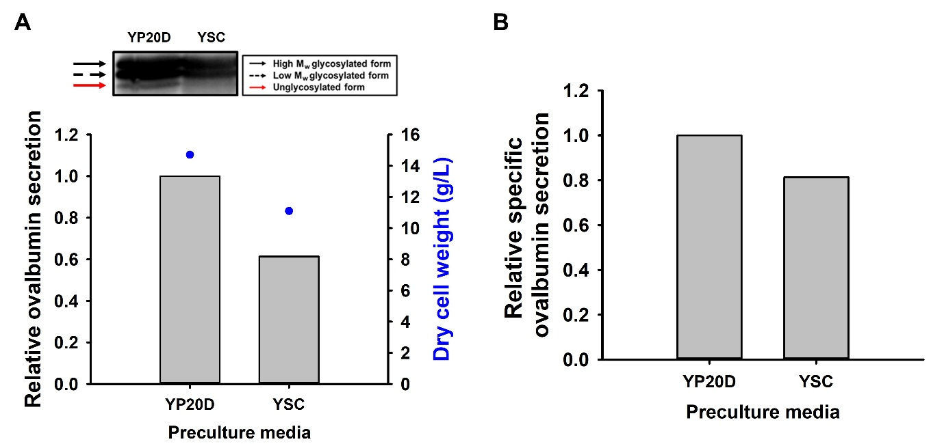
Figure S1. Comparison of ovalbumin secretion by the +P1/K2 strain under different preculture media. (A) Relative ovalbumin secretion and dry cell weight. (B) Relative specific ovalbumin secretion. For the western blot analyses, culture supernatants were harvested after 48 h of cultivation in YP50D medium. The relative fold change in extracellular ovalbumin levels was calculated for the +P1/K2 strain precultured in either YP20D or YSC medium, using the amount secreted by cells precultured in YP20D as the reference. +P1/K2, the Saccharomyces cerevisiae D452-2 containing P_{PGK}-EPX1_{SP}-ovalbumin, tHXT7p-PDI1, and tHXT7p-KAR2.

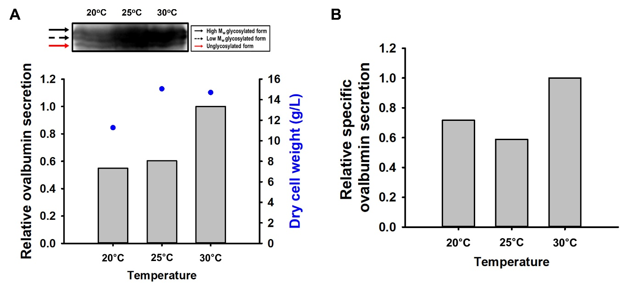
Figure S2. Comparison of ovalbumin secretion by the +P1/K2 strain at different cultivation temperatures. (A) Relative ovalbumin secretion and dry cell weight. (B) Relative specific ovalbumin secretion. For the western blot analyses, culture supernatants were harvested after 48 h of cultivation in YP50D medium at 20, 25, or 30°C. The relative fold change in extracellular ovalbumin levels was calculated for the +P1/K2 strain cultured at each temperature, using the amount secreted at 30°C as the reference. +P1/K2, the Saccharomyces cerevisiae D452-2 containing P_{PGK}-EPX1_{SP}-ovalbumin, tHXT7p-PDI1, and tHXT7p-KAR2.

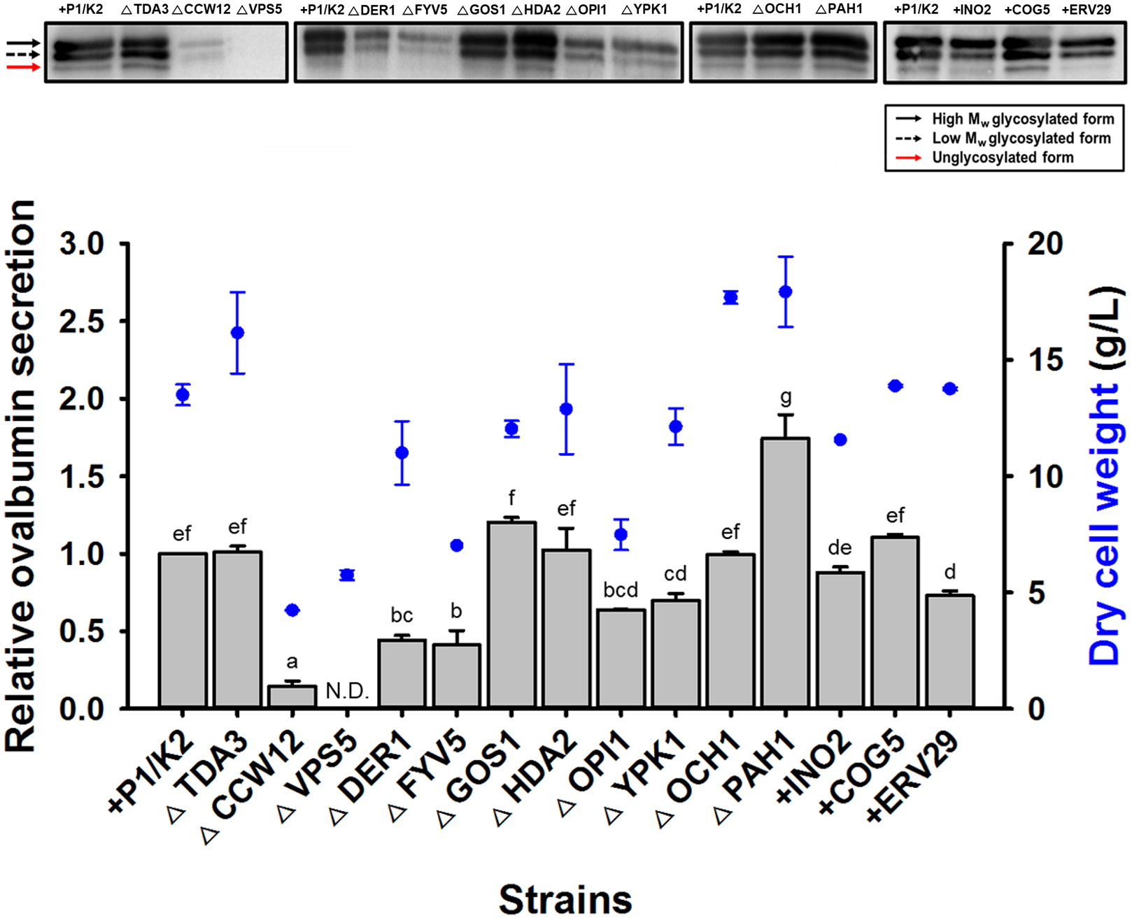
Figure S3. Effects of various genetic modifications on ovalbumin secretion. For the western blot analyses, culture supernatants were harvested after 48 h of cultivation in YP50D medium. The relative fold change in the amount of extracellular ovomucoid produced was calculated for each sample strain using the amount produced by the +P1/K2 strain as the reference. Results are the means of two experiments, and error bars indicate standard deviation. Different letters represent significantly different means (Tukey’s HSD tests, p < 0.05). +P1/K2, the Saccharomyces cerevisiae D452-2 containing P_{PGK}-EPX1_{SP}-ovalbumin, tHXT7p-PDI1, and tHXT7p-KAR2; ΔTDA3, +P1/K2 with TDA3 knockout; ΔCCW12, +P1/K2 with CCW12 knockout; ΔVPS5, +P1/K2 with VPS5 knockout; ΔDER1, +P1/K2 with DER1 knockout; ΔFYV5, +P1/K2 with FYV5 knockout; ΔGOS1, +P1/K2 with GOS1 knockout; ΔHDA2, +P1/K2 with HDA2 knockout; ΔOPI1, +P1/K2 with OPI1 knockout; ΔYPK1, +P1/K2 with YPK1 knockout; ΔOCH1, +P1/K2 with OCH1 knockout; ΔPAH1, +P1/K2 with PAH1 knockout; +INO2, +P1/K2 containing tHXT7p-INO2; +COG5, +P1/K2 containing tHXT7p-COG5; +ERV29, +P1/K2 containing tHXT7p-ERV29; N.D., not detected.

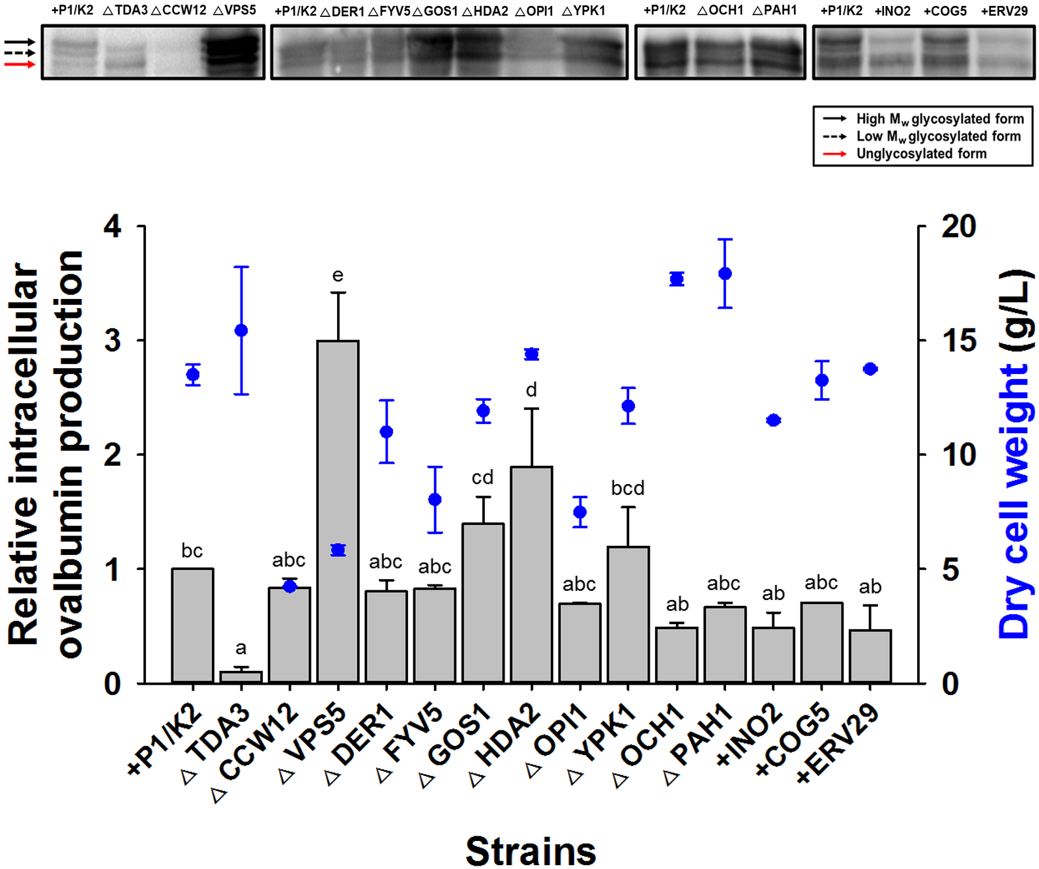
Figure S4. Effects of various genetic modifications on intracellular ovalbumin production. Cell lysates of various engineered Saccharomyces cerevisiae strains expressing ovalbumin were prepared after 48 h of cultivation in YP50D medium and analyzed using an anti-ovalbumin antibody. The relative fold change in the amount of intracellular ovomucoid produced was calculated for each sample strain using the amount produced by the +P1/K2 strain as the reference. Results are the means of two experiments, and error bars indicate standard deviation. Different letters represent significantly different means (Tukey’s HSD tests, p < 0.05). +P1/K2, the S. cerevisiae D452-2 containing P_{PGK}-EPX1_{SP}-ovalbumin, tHXT7p-PDI1, and tHXT7p-KAR2; ΔTDA3, +P1/K2 with TDA3 knockout; ΔCCW12, +P1/K2 with CCW12 knockout; ΔVPS5, +P1/K2 with VPS5 knockout; ΔDER1, +P1/K2 with DER1 knockout; ΔFYV5, +P1/K2 with FYV5 knockout; ΔGOS1, +P1/K2 with GOS1 knockout; ΔHDA2, +P1/K2 with HDA2 knockout; ΔOPI1, +P1/K2 with OPI1 knockout; ΔYPK1, +P1/K2 with YPK1 knockout; ΔOCH1, +P1/K2 with OCH1 knockout; ΔPAH1, +P1/K2 with PAH1 knockout; +INO2, +P1/K2 containing tHXT7p-INO2; +COG5, +P1/K2 containing tHXT7p-COG5; +ERV29, +P1/K2 containing tHXT7p-ERV29; N.D., not detected.

Figure S5. Effects of an additional copy of the ovalbumin expression cassette on ovalbumin secretion. For the western blot analyses, culture supernatants were harvested after 48 h of cultivation in YP50D medium. The relative fold change in the amount of extracellular ovomucoid produced was calculated for each sample strain using the amount produced by the +P1/K2 strain as the reference. Results are the means of two experiments, and error bars indicate standard deviation. Different letters represent significantly different means (Tukey’s HSD tests, p < 0.05). WT, Saccharomyces cerevisiae D452-2; +P1/K2, the S. cerevisiae D452-2 containing P_{PGK}-EPX1_{SP}-ovalbumin, tHXT7p-PDI1, and tHXT7p-KAR2; +P1/K2+OVA, +P1/K2 containing an additional copy of P_{PGK}-EPX1_{SP}-ovalbumin; N.D., not detected.

Supplementary References
Besada-Lombana PB, Da Silva NA. Engineering the early secretory pathway for increased protein secretion in Saccharomyces cerevisiae. Metabolic Engineering. 55: 142-151 (2019)
Chen N, Yang S, You D, Shen J, Ruan B, Wu M, Zhang J, Luo X, Tang H. Systematic genetic modifications of cell wall biosynthesis enhanced the secretion and surface-display of polysaccharide degrading enzymes in Saccharomyces cerevisiae. Metabolic Engineering. 77: 273-282 (2023)
Hosaka K, Nikawa J, Kodaki T, Yamashita S. A dominant mutation that alters the regulation of INO1 expression in Saccharomyces cerevisiae. The Journal of Biochemistry. 111: 352-358 (1992)
Huang M, Wang G, Qin J, Petranovic D, Nielsen J. Engineering the protein secretory pathway of Saccharomyces cerevisiae enables improved protein production. Proceedings of the National Academy of Sciences. 115: E11025-E11032 (2018)
Jeon GB, Lee HJ, Park JP, Park K, Choi CH, Kim SK. Efficient production of glutathione in Saccharomyces cerevisiae via a synthetic isozyme system. Biotechnology Journal. 18: 2200398 (2023)
Jin KC, Seo SO, Kim SK. Animal-free production of hen egg ovalbumin in engineered Saccharomyces cerevisiae via precision fermentation. International Journal of Biological Macromolecules. 271: 132479 (2024)
Lee YG, Jin YS, Cha YL, Seo JH. Bioethanol production from cellulosic hydrolysates by engineered industrial Saccharomyces cerevisiae. Bioresource Technology. 228: 355-361 (2017)
Miller VJ, Sharma P, Kudlyk TA, Frost L, Rofe AP, Watson IJ, Duden R, Lowe M, Lupashin VV, Ungar D. Molecular insights into vesicle tethering at the Golgi by the conserved oligomeric Golgi (COG) complex and the golgin TATA element modulatory factor (TMF). Journal of Biological Chemistry. 288: 4229-4240 (2013)
Moon SY, Son SH, Oh SS, Lee JY. Harnessing cellular organelles to bring new functionalities into yeast. Biotechnology and Bioprocess Engineering. 28: 936-948 (2023)
Tang H, Wang S, Wang J, Song M, Xu M, Zhang M, Shen Y, Hou J, Bao X. N-hypermannose glycosylation disruption enhances recombinant protein production by regulating secretory pathway and cell wall integrity in Saccharomyces cerevisiae. Scientific Reports. 6: 25654 (2016)
Wentz AE, Shusta EV. A novel high-throughput screen reveals yeast genes that increase secretion of heterologous proteins. Applied and Environmental Microbiology. 73: 1189-1198 (2007)
Zhang GC, Kong II, Kim H, Liu JJ, Cate JH, Jin YS. Construction of a quadruple auxotrophic mutant of an industrial polyploid Saccharomyces cerevisiae strain by using RNA-guided Cas9 nuclease. Applied and Environmental Microbiology. 80: 7694-7701 (2014)

