Supplementary Material

Plasmolyzed Yeast Cell System for the Encapsulation of Pulicaria odora Polyphenols: RSM-Based Process Optimization and Functional Characterization
Djamel Eddine Laib¹, Imen Laib^{1,2,} Hamdi Bendif³*, Sulaiman A. Alsalamah³, Tarek H. Taha³, Fehmi Boufahja³, Walid Elfalleh³, Stefania Garzoli⁴*

¹ Department of Agronomic Sciences, Faculty of Sciences, August 20, 1955 University, Skikda, Algeria. d.laib@univ-skikda.dz; mina.laib@gmail.com;
²Laboratory of the Optimization of Agricultural Production in Subhumid Areas, Faculty of Sciences, University 20 August 1955, Skikda-21000, Algeria
³Department of Biology, College of Science, Imam Mohammad Ibn Saud Islamic University (IMSIU), Riyadh 11623, Saudi Arabia; faboufahja@imamu.edu.sa; saalsalamah@imamu.edu.sa; wbelfallah@imamu.edu.sa; hlbendif@imamu.edu.sa; thali@imamu.edu.sa
⁴Department of Chemistry and Technologies of Drug, Sapienza University, P. le Aldo Moro, 5,00185 Rome, Italy. stefania.garzoli@uniroma1.it;

*Correspondence: stefania.garzoli@uniroma1.it; hlbendif@imamu.edu.sa

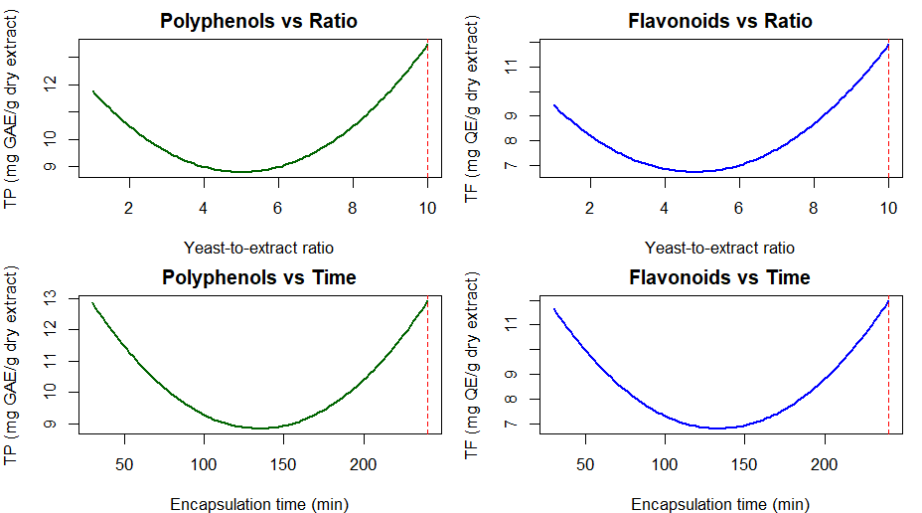

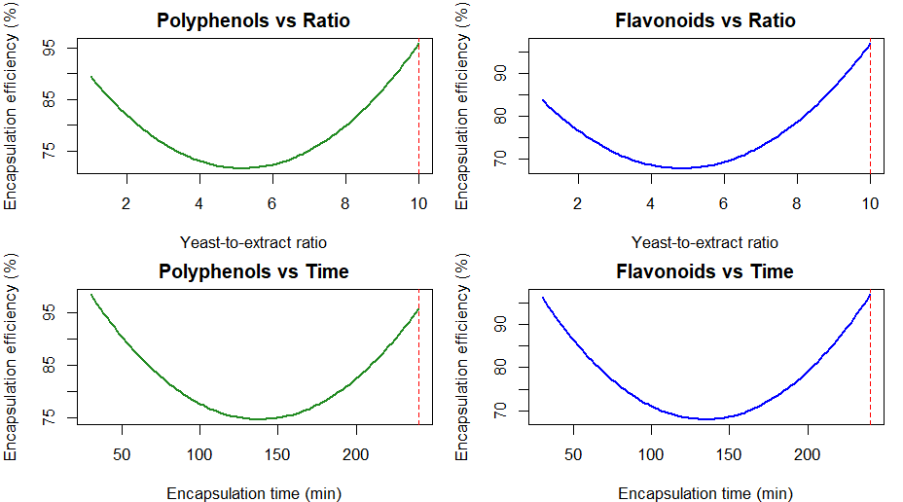
*

Figure S1. Model-Based Prediction of Optimal Parameters for Encapsulation Efficiency

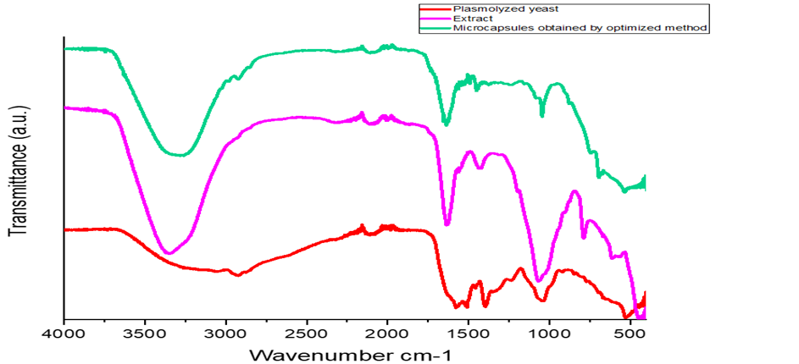

Figure S2. FTIR spectra of plasmolyzed yeast cells, Pulicaria odora extract, and the resulting microcapsules obtained through the optimized encapsulation method.

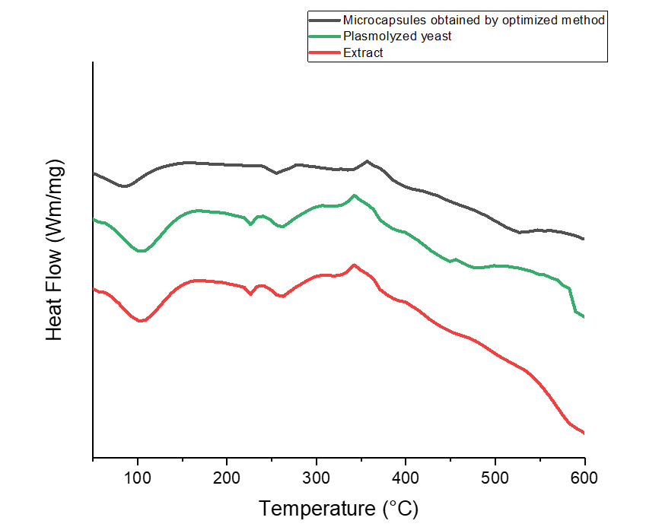

Figure S3. DSC Thermograms of Plasmolyzed Yeast, Pulicaria odora Extract, and Microcapsules Obtained by the Optimized Method

