Supplementary materials
Sight or smell: which senses do scavenging raptors use to find food?
Simon Potier^{a,b*}, Olivier Duriezª, Aurélie Célérierª, Jean-Louis Liegeois^{c} and Francesco Bonadonnaª
ª CEFE UMR 5175, CNRS - Université de Montpellier - Université Paul-Valéry Montpellier - EPHE – 1919 route de Mende, 34293 Montpellier cedex 5, France
^{b} Department of Biology, Lund University, Sölvegatan 35, Lund S-22362, Sweden
^{c} Académie de Fauconnerie du Grand Parc du Puy du Fou, CS 70 025, 85590 Les Epesses
* Corresponding author: sim.potier@gmail.com / +336 11 31 67 16 / ORCID : 0000-0003-3156-7846

Table S1 Information on birds used in the experiments
Species | ID | Birth year | Sex | Site | Month and year of experiment 1 | Month and year of experiment 2 | Colour of the ball associated with the smelling food in the training phase (experiment 2) | Weight in aviary (g) | Weight in experiment (g) | Weight variation (%)
Turkey vulture | TV1 | 2001 | Unknow | 1 | April 2014 | September 2015 | Blue | 1840 | 1450 | -26.90
 | TV2 | 2003 | Unknow | 1 | April 2014 | September 2015 | Blue | 1620 | 1350 | -20.00
 | TV3 | 2003 | Unknow | 1 | October 2014 | September 2015 | Green | 1680 | 1450 | -15.86
 | TV4 | 2010 | Unknow | 1 | October 2014 | September 2015 | Green | 1740 | 1350 | -28.89
 | TV5 | 2010 | Unknow | 1 | April 2014 | - | - | 1900 | 1450 | -31.03
 | TV6 | 2012 | Female | 2 | - | March 2016 | Green | 1490 | 1640 | +9.15
 | TV7 | 2012 | Female | 2 | - | March 2016 | Green | 1480 | 1610 | +8.07
 | TV8 | 2010 | Male | 2 | - | March 2016 | Blue | 1660 | 1760 | +5.68
 | TV9 | 2011 | Male | 2 | - | March 2016 | Blue | 1490 | 1640 | +9.15
Southern caracara | SC1 | 1990 | Male | 1 | October 2014 | September 2015 | Green | 1000 | 800 | -25.00
 | SC2 | 2005 | Female | 1 | October 2014 | September 2015 | Blue | 1240 | 1000 | -24.00
 | SC3 | 2011 | Male | 1 | October 2014 | September 2015 | Green | 940 | 850 | -10.59
 | SC4 | 2012 | Female | 1 | October 2014 | September 2015 | Blue | 1100 | 950 | -15.79
 | SC5 | 2012 | Male | 1 | October 2014 | - | - | 940 | 850 | -10.59
 | SC6 | 2013 | Male | 2 | - | March 2016 | Blue | 850 | 930 | +8.60
 | SC7 | 2009 | Male | 2 | - | March 2016 | Blue | 1000 | 970 | -3.09
 | SC8 | 2007 | Male | 2 | - | March 2016 | Green | 1090 | 1080 | -0.93
 | SC9 | 2007 | Male | 2 | - | March 2016 | Green | 1070 | 1030 | -3.88

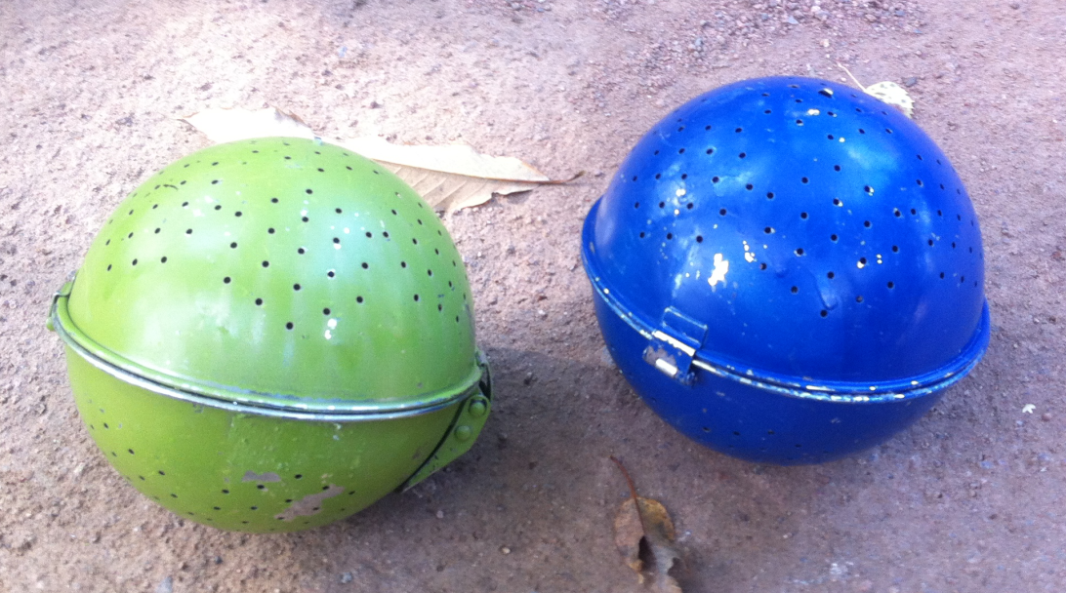

Figure S1 Colored balls used in Experiment 2

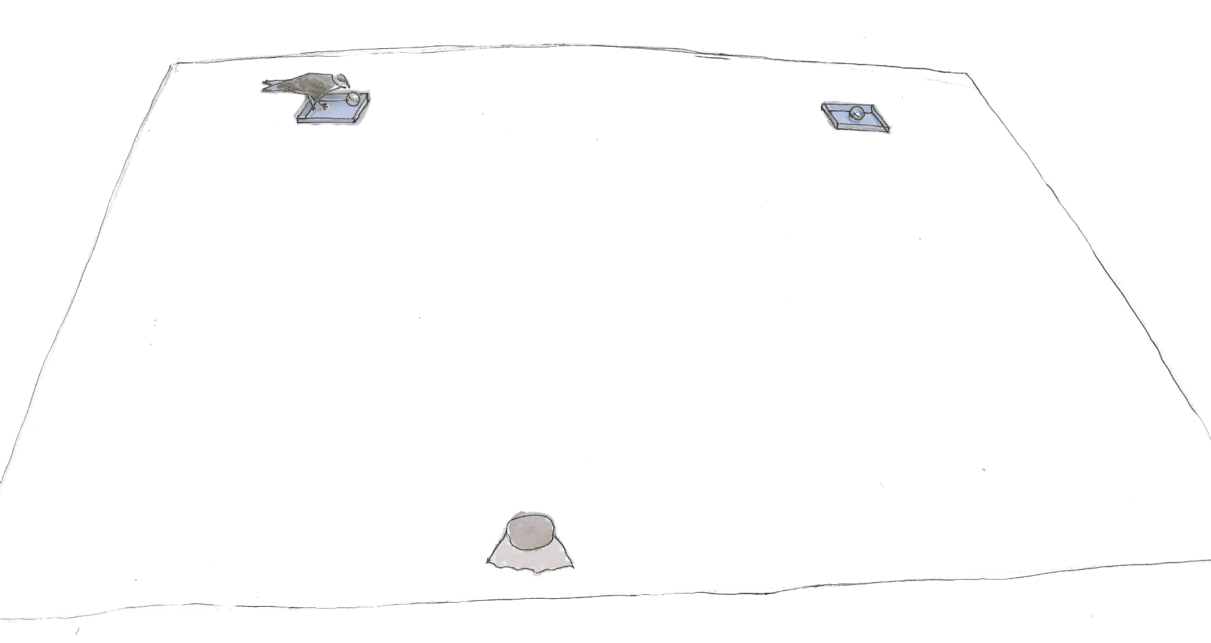Figure S2 Experimental setup used in experiment 1 and 2. From a starting perch (A), each bird (here a southern caracara) has to choose between two rice cooking balls (B, C) presented at 4m from the starting perch and distant from 6m. Both rice cooking balls were placed in a plastic recipient.
A
B
C

Table S2 Model selection based on AICc criterion. Models presentation were expressed by specifying a confidence set of models (delta AICc less than 5)

Time spent in contact
Model | K | logLik | AICc | delta | weight
Stimulus * species + side + (1 | species:individual) | 7 | -591.71 | 1198.47 | 0.000 | 0.306
Stimulus * species + (1 | species:individual) | 6 | -593.33 | 1199.44 | 0.976 | 0.188
trial + side + Stimulus * species + (1 | species:individual) | 8 | -591.69 | 1200.76 | 2.293 | 0.097
Stimulus + side + species + (1 | species:individual) | 6 | -594.00 | 1200.78 | 2.309 | 0.096
Stimulus + side + (1 | species:individual) | 5 | -595.41 | 1201.37 | 2.904 | 0.072
Stimulus + species + (1 | species:individual) | 5 | -595.56 | 1201.67 | 3.198 | 0.062
Stimulus * species + trial + (1 | species:individual) | 7 | -593.32 | 1201.70 | 3.230 | 0.061
Stimulus * trial + side + Stimulus * species + (1 | species:individual) | 9 | -591.28 | 1202.29 | 3.820 | 0.045
Stimulus + (1 | species:individual) | 4 | -597.05 | 1202.47 | 3.999 | 0.041
Stimulus + side + species + trial + (1 | species:individual) | 7 | -593.99 | 1203.03 | 4.561 | 0.031
Number of contacts
Model | K | logLik | AICc | delta | weight
Stimulus * trial + side + Stimulus * species + (1 | species:individual) | 8 | -1163.29 | 2343.95 | 0.00 | 0.87
Stimulus * trial + side + (1 | species:individual) | 6 | -1167.49 | 2347.76 | 3.81 | 0.13
First choice
Model | K | logLik | AICc | delta | weight
side + species + (1 | species:individual) | 4 | -28.29 | 65.34 | 0.000 | 0.481
side + (1 | species:individual) | 3 | -30.00 | 66.45 | 1.109 | 0.276
trial + side + species + (1 | species:individual) | 5 | -28.23 | 67.62 | 2.280 | 0.154
trial + side + (1 | species:individual) | 4 | -29.99 | 68.73 | 3.396 | 0.088
Latency
Model | K | logLik | AICc | delta | weight
1 + (1 | species:individual) | 3 | -276.27 | 559.01 | 0.000 | 0.235
trial + (1 | species:individual) | 4 | -275.82 | 560.42 | 1.412 | 0.116
species + (1 | species:individual) | 4 | -275.84 | 560.47 | 1.458 | 0.114
side + (1 | species:individual) | 4 | -275.97 | 560.73 | 1.720 | 0.100
Stimulus + (1 | species:individual) | 4 | -276.01 | 560.81 | 1.805 | 0.096
trial + species + (1 | species:individual) | 5 | -274.93 | 561.05 | 2.043 | 0.085
Stimulus + species + (1 | species:individual) | 5 | -275.40 | 562.00 | 2.990 | 0.053
side + species + (1 | species:individual) | 5 | -275.47 | 562.15 | 3.139 | 0.049
Stimulus + trial + (1 | species:individual) | 5 | -275.62 | 562.43 | 3.422 | 0.043
trial + side + (1 | species:individual) | 5 | -275.62 | 562.44 | 3.431 | 0.042
Stimulus + species + trial + (1 | species:individual) | 6 | -274.51 | 562.73 | 3.716 | 0.037
Stimulus + side + (1 | species:individual) | 5 | -275.92 | 563.04 | 4.030 | 0.031

