Electronic supplementary material for:
Experimental evidence for heterospecific alarm signal recognition via associative learning in wild capuchin monkeys

Brandon C. Wheeler^{1,2,*}, Martin Fahy³, and Barbara Tiddi^{2,4}
¹School of Anthropology and Conservation, University of Kent, Canterbury CT2 7NR, United Kingdom
²Cognitive Ethology Laboratory, German Primate Center, 37077 Göttingen, Germany
³Proyecto Caí, Iguazú National Park, Misiones, Argentina
⁴Department of Behavioral Ecology, Johann-Friedrich-Blumenbach Institute for Zoology and Anthropology, Georg-August University, 37077 Göttingen, Germany
*Corresponding author (bcwheeler43@gmail.com)

Details on decoy ocelot models
During the training period, capuchins were exposed to a novel sound together with a simulated predator, including either a decoy ocelot (Leopardus pardalis) model or a playback of a recording of a vocalising puma (Puma concolor). The decoy ocelot was constructed by mounting a faux-ocelot fur coat on a taxidermist’s bobcat (Lynx rufus) manikin (See Fig. S1).
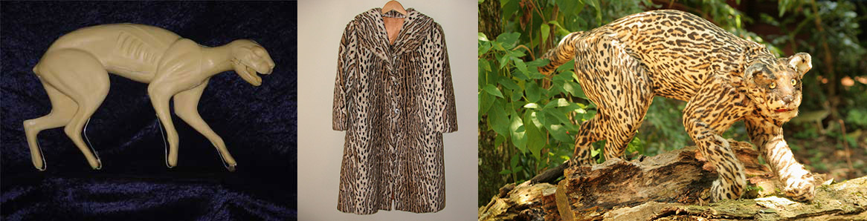
Figure S1. The bobcat manikin (left) and faux fur coat (center) used to construct the model, and the model used in the current study (right).

date of playback | focal ID | focal age | focal sex | focal group | playback stimulus | type | height (m) | vigilance? | alarm? | escape? |  | total strength of reaction | years since training phase | months since training phase
08/07/2012 | AST | juvenile | male | Macuco | bell tone | control | 4.0 | no | no |  | no | 0
17/07/2013 | AST | juvenile | male | Macuco | laugh | test | 2.0 | yes | yes |  | yes | 3 | 1 | 10.9
21/05/2013 | DAL | adult | male | Macuco | bell tone | control | 1.5 | no | no |  | no | 0
06/07/2013 | DAL | adult | male | Macuco | laugh | test | 2.5 | yes | no |  | yes | 2 | 1 | 10.5
20/06/2014 | EDU | adult | male | Macuco | laugh | test | 4.0 | yes | yes |  | yes | 3 | 2 | 22.0
20/07/2014 | EDU | adult | male | Macuco | rooster | control | 8.0 | yes | no |  | no | 1
16/07/2013 | ERN | adult | male | Macuco | laugh | test | 3.0 | yes | yes |  | no | 2 | 1 | 10.8
24/08/2011 | ERN | adult | male | Macuco | rooster | control | 7.0 | no | no |  | no | 0
01/08/2014 | MAW | adult | female | Macuco | laugh | test | 16.0 | yes | no |  | no | 1 | 2 | 23.4
05/08/2014 | MAW | adult | female | Macuco | rooster | control | 3.0 | yes | no |  | no | 1
21/07/2014 | MOR | juvenile | female | Macuco | laugh | test | 8.0 | yes | yes |  | no | 2 | 2 | 23.0
29/07/2014 | MOR | juvenile | female | Macuco | rooster | control | 1.5 | yes | no |  | no | 1
26/07/2014 | RIC | adult | male | Macuco | bell tone | control | 10.0 | no | no |  | no | 0
04/08/2014 | RIC | adult | male | Macuco | laugh | test | 5.0 | yes | yes |  | no | 2 | 2 | 23.5
15/06/2014 | HOR | adult | male | Rita | laugh | control | 4.5 | no | no |  | no | 0
19/07/2012 | HOR | adult | male | Rita | rooster | test | 6.0 | yes | yes |  | no | 2 | 1 | 11.0
08/08/2014 | ILA | juvenile | female | Rita | bell tone | control | 4.0 | yes | no |  | no | 1
20/06/2014 | ILA | juvenile | female | Rita | rooster | test | 3.0 | yes | yes |  | no | 2 | 3 | 34.0
24/08/2011 | JAC | juvenile | male | Rita | rooster | test | 8.0 | yes | no |  | yes | 2 | 0 | 0.1
09/08/2011 | MAR | adult | male | Rita | laugh | control | 4.0 | yes | no |  | no | 1
18/07/2013 | MAR | adult | male | Rita | rooster | test | 6.0 | yes | yes |  | no | 2 | 2 | 23.0
25/07/2012 | SEA | juvenile | male | Rita | rooster | test | 15.0 | yes | yes |  | yes | 3 | 1 | 11.2
06/07/2013 | CAM | juvenile | male | Spot | bell tone | test | 5.0 | yes | yes |  | no | 2 | 1 | 10.6
17/07/2013 | CAM | juvenile | male | Spot | laugh | control | 6.0 | yes | no |  | no | 1
18/07/2014 | FRA | adult | female | Spot | bell tone | test | 15.0 | yes | no |  | no | 1 | 2 | 23.0
27/06/2013 | FRA | adult | female | Spot | laugh | control | 2.5 | yes | no |  | no | 1
25/07/2014 | RIN | adult | male | Spot | bell tone | test | 15.0 | yes | no |  | no | 1 | 2 | 23.2
21/07/2014 | RIN | adult | male | Spot | laugh | control | 4.0 | yes | no |  | yes | 2
22/05/2013 | ROB | juvenile | male | Spot | bell tone | test | 2.0 | no | no |  | no | 1 | 1 | 9.1
15/07/2013 | ROB | juvenile | male | Spot | laugh | control | 2.5 | yes | no |  | no | 1
15/08/2014 | SPA | juvenile | male | Spot | bell tone | test | 7.0 | no | no |  | no | 0 | 2 | 23.9
01/08/2014 | SPA | juvenile | male | Spot | rooster | control | 16.0 | no | no |  | no | 0
31/07/2014 | TRU | adult | male | Spot | bell tone | test | 10.0 | no | no |  | no | 0 | 2 | 23.4
14/08/2014 | TRU | adult | male | Spot | rooster | control | 10.0 | yes | no |  | no | 1

