No Evidence of Spatial Representation of Age, but “Own-Age Bias” like Face Processing Found in Chimpanzees

Yuri Kawaguchi, Ikuma Adachi, Masaki Tomonaga
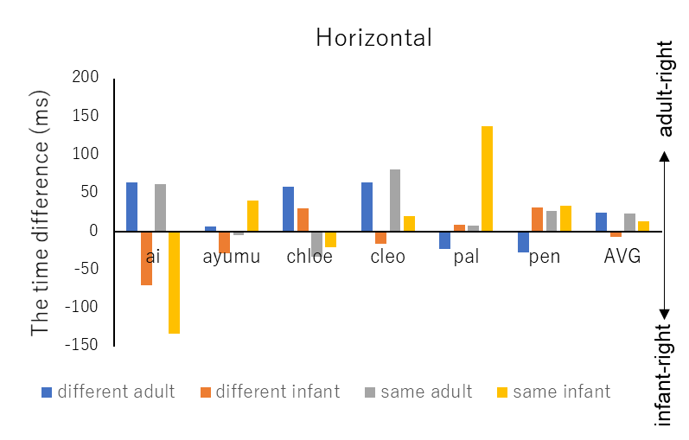
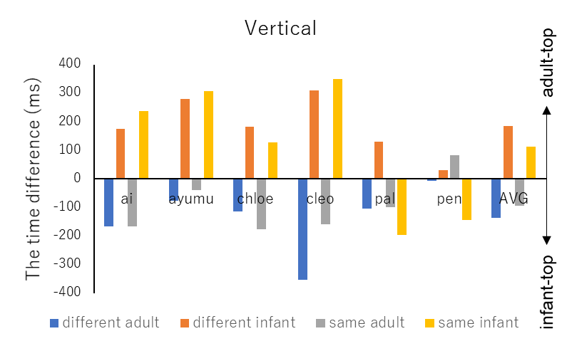

Figure A1. The individual and average (AVG) data of the response time difference between top and bottom in vertical (Experiment 1) and left and right in horizontal (Experiment 2) for each condition.

