Survey Items
Table 1 Items retained following the focus groups and used in the online survey. Items were presented in blocks in the survey. Block order was randomised across participants. Items were presented with a Likert scale from 1-5 (Never or almost never, Rarely, Sometimes, Often, Always or almost always), with a “not applicable” option where appropriate.
Block 1 - Statements about how your dog controls behaviours towards himself, you, and others.
My dog does not control his/her behaviour (e.g. jumps up on counter or people, when he/she should not).
My dog chokes/gags from eating too quickly.
My dog does not think before he/she acts (e.g. would steal food without first looking to see if someone is watching).
My dog can be very persistent.
My dog takes treats out of my hand gently (i.e. without hurting me).
My dog becomes frustrated when failing a task.
My dog shows warning signs (e.g. showing teeth, growling) before he/she snaps or lunges at another dog.
My dog shows warning signs (e.g. showing teeth, growling) before he/she snaps or lunges at people.
Block 2 - Statements about how changes in the environment or in your routine affect your dog.
My dog is creative in finding solutions when confronted with problems (e.g. a food puzzle).
My dog gets upset about changes in the environment (e.g. a new piece of furniture).
When a usual strategy does not work, my dog finds it difficult to change strategy (e.g. the usual path is blocked by a closed door, and the dog has to take a different path).
My dog adapts well to new situations and environments.
My dog gets upset if plans are changed last-minute (e.g. leash put on for walking, but then something comes up).
My dog comes when called at home.
My dog comes when called in the park.
My dog comes when called while playing with another dog.
Block 3 - Statements about how different things excite your dog.
When my dog gets excited it can lead to fixed repetitive behaviours (e.g. tail chasing/spinning in circles).
My dog can remain calm in exciting situations (e.g. visitors arriving).
My dog sometimes pees when he/she is excited.
My dog gets excited around other dogs.
My dog gets over-excited about things and can be a bit "over the top" at these times.
Overall, my dog is excitable.
My dog will release a toy when told to do so (e.g. when playing tug of war).
My dog will release food from its mouth when told to do so (e.g. when finding food on the ground).
Block 4 - Statements about how waiting for something or having to stop a behaviour impacts your dog.
My dog finds it difficult to tolerate waiting for a reward.
My dog finds it difficult to tolerate waiting for a walk.
My dog finds it difficult to tolerate waiting for dinner.
My dog gets frustrated when he/she is not immediately rewarded for a behaviour.
My dog finds it difficult to stop doing something (e.g. chasing another dogs ball) when being told off by another dog.
My dog finds it difficult to stop doing something when I tell him/her to stop.
Once my dog has started an activity, he/she finds it difficult to stop.
When I present a new toy to my dog, my dog engages with it for a long time.
Block 5 - Statements about how different things distract your dog.
Noises and/or smells can easily distract my dog.
When playing, my dog easily gets distracted by other things.
When on the leash, my dog lunges towards other dogs.
When on the leash, my dog lunges towards people.
When on the leash, my dog lunges towards other animals (e.g. cats, birds).
My dog walks on a loose lead.
It is difficult for my dog to concentrate on a single activity (e.g. chewing, playing).
Block 6 - Statements about how different situations affect your dog's focus, memory and calmness.
My dog often forgets what he/she was doing after getting distracted (e.g. forgets about a toy or treat if a loud noise distracted him/her for a moment).
My dog forgets about something he/she wanted once it is out of sight (e.g. toy, food).
My dog has trouble staying focused during training sessions if not reminded every few seconds.
My dog needs constant reminding to control behaviours which are inappropriate (e.g. jumping up on visitors).
My dog cannot stop barking once started.
My dog takes a long time to settle down enough to concentrate during training.
My dog remains calm at the vet or groomer.
My dog can relax in public places (e.g. a café).
My dog can relax in unfamiliar environments (e.g. a friend’s house, a holiday home).
Block 7 - Statements about how your dog follows instructions in different scenarios.
My dog easily follows simple instructions (e.g. ‘sit’).
My dog has difficulties following complicated instructions, such as ‘go to your place’, even if my dog has practiced them often.
My dog can follow an instruction for a minute (e.g. ‘sit’ or ’stay’).
My dog can follow an instruction (e.g. ‘stay’) in a quiet place (e.g. at home).
My dog can follow an instruction (e.g. ‘stay’) in a busy environment (e.g. the park).
My dog reacts to subtle cues (e.g. short, delicate hand-signals).
My dog reacts to obvious cues (e.g. loud voice cues, clear and visible hand signals).
My dog will follow instructions (e.g. 'sit' or 'stay') when the cue is slightly different than normal (e.g. change in tone or pitch).
My dog will follow instructions (e.g. 'sit' or 'stay') given by a stranger.
Block 8 - Statements about how your dog pays attention to his/her surroundings.
I can easily get my dog's attention.
I can hold my dog’s attention for minutes at a time.
My dog gazes at me or turns toward me when I speak to him/her.
My dog is easily bored during activities with me (e.g. pays attention to things other than me).
Squeaky toys or moving objects can easily capture my dog's attention.
Objects laying on the floor can easily capture my dog's attention.
My dog finds it hard to pay attention to his/her surroundings (e.g. walks into objects or people).
My dog is easily bored when playing (e.g. never plays with the same toy for more than a few minutes).

Exploratory Factor Analysis – Principal axis factoring in SPSS

Table 2 Exploratory factor analysis - principal axis factoring with direct oblimin rotation and pairwise deletion of missing cases in SPSS. N = 358
Label | Factor 1 | Factor 2 | Factor 3 | Factor 4 | Factor 5 | Factor 6
BF3 | -.808 | .096 | .047 | .029 | -.011 | .030
BF4 | -.747 | -.117 | .029 | .049 | .034 | -.050
BF2 | -.664 | -.212 | .018 | -.011 | .033 | -.020
BF1 | -.451 | .026 | -.027 | -.039 | .049 | .099
Mot_Reg3 | .038 | -.882 | -.046 | -.058 | .050 | -.019
Mot_Reg2 | -.103 | -.725 | .069 | -.030 | .043 | .031
Mot_Reg1 | -.009 | -.545 | .058 | -.014 | -.069 | -.013
Mot_Reg4 | -.070 | -.433 | -.058 | .196 | .102 | .232
Att_Own1 | -.074 | -.029 | .803 | .010 | -.053 | -.013
Att_Own3 | .076 | -.037 | .669 | .119 | .066 | -.046
Att_Own2 | -.086 | -.010 | .597 | .015 | .052 | .196
Instruct2 | .065 | -.018 | .025 | .757 | -.029 | .057
Instruct1 | .113 | .005 | .084 | .657 | .135 | .165
Instruct3 | -.121 | -.081 | .129 | .509 | .007 | .119
Instruct4 | -.215 | .068 | .079 | .415 | -.007 | -.077
Del_Inh1 | -.031 | -.010 | -.007 | .078 | .668 | .040
Del_Inh3 | .017 | .028 | -.010 | .024 | .654 | .003
Del_Inh4 | -.069 | .068 | .102 | -.225 | .630 | .084
Del_Inh2 | -.036 | -.159 | -.026 | .143 | .459 | -.137
WM3 | -.050 | -.057 | -.092 | .080 | .073 | .647
WM2 | -.039 | -.047 | .164 | -.141 | -.027 | .579
WM1 | .022 | -.010 | .162 | .037 | .047 | .507
WM4 | -.046 | .024 | -.047 | .107 | -.026 | .436
Eigenvalues | 1.50 | 2.11 | 5.64 | 1.69 | 1.65 | 1.36
Proportion of variance | 6.50 | 9.15 | 24.52 | 7.37 | 7.16 | 5.92
Cumulatve variance | 6.50 | 15.65 | 40.18 | 47.54 | 54.70 | 60.62

Confirmatory factor analysis – Path diagram
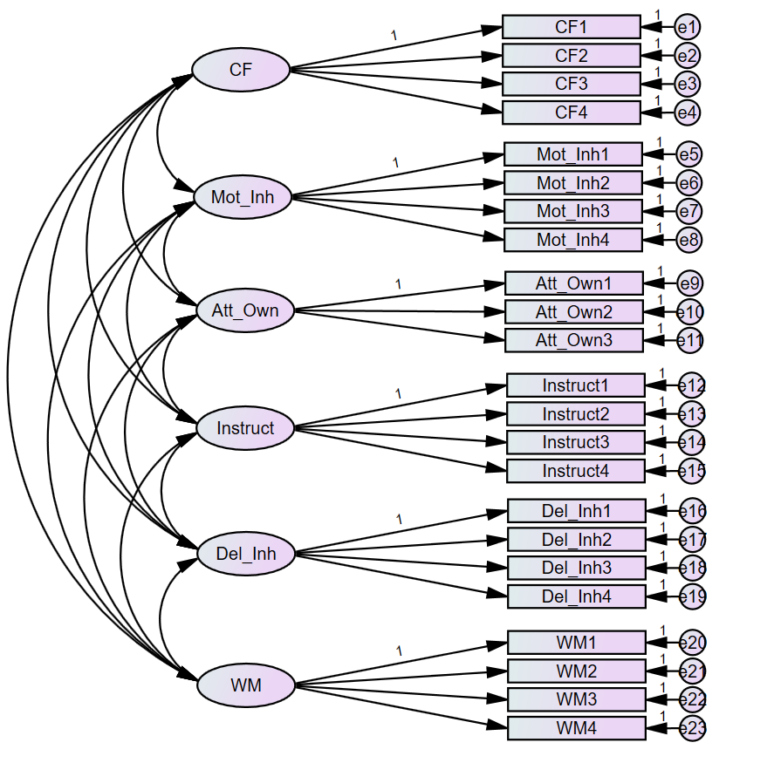
Figure 1 Path diagram of the 6-factor model with covariances among latent variables.

Demographics

Owner gender, working dog status & dog source

Table 3 Differences in subscale scores for categorical variables with two groups (Owner gender, working dog status, dog source)
Owner gender
 | Female (n=626) |  | Male (n=74) |  | Welch two sample t-test
 | mean | SD | mean | SD | t | df | P adjusted | Cohen’s d
BF | 3.84 | 0.865 | 3.95 | 0.915 | -1.0679 | 89.127 | 1.000 | -
Mot Reg | 2.83 | 0.883 | 2.75 | 0.782 | 0.79051 | 96.424 | 1.000 | -
Att Own | 4.26 | 0.640 | 4.23 | 0.797 | 0.23326 | 84.476 | 1.000 | -
Instruct | 3.88 | 0.745 | 3.80 | 0.827 | 0.79221 | 87.555 | 1.000 | -
Del Inh | 3.60 | 0.835 | 3.52 | 0.878 | 0.74706 | 89.299 | 1.000 | -
WM | 3.54 | 0.662 | 3.70 | 0.780 | -1.7486 | 85.904 | 0.490 | -
Working dog status
 | No (n=645) |  | Yes (n=56) |  | Welch two sample t-test
 | mean | SD | mean | SD | t | df | p adjusted | Cohen’s d
BF | 3.80 | 1.22 | 4.31 | 0.782 | -4.6307 | 67.45 | < .001*** | 0.62
Mot_Reg | 2.78 | 0.884 | 3.20 | 0.738 | -3.998 | 69.481 | <.001** | 0.52
Att Own | 4.22 | 0.661 | 4.62 | 0.506 | -5.5531 | 72.355 | < .001*** | 0.68
Instruct | 3.84 | 0.770 | 4.24 | 0.509 | -5.3521 | 78.735 | < .001*** | 0.61
Del Inh | 3.56 | 0.844 | 3.95 | 0.762 | -3.5886 | 67.264 | .004** | 0.49
WM | 3.52 | 0.678 | 3.90 | 0.522 | -5.1577 | 72.166 | < .001*** | 0.63
Dog source
 | Breeder (n=339) |  | Rescue shelter (n=205) |  | Welch two sample t-test
 | mean | SD | mean | SD | t | df | p adjusted | Cohen’s d
BF | 3.94 | 0.859 | 3.67 | 0.890 | 3.5441 | 418.32 | .003** | 0.31
Mot_Reg | 2.87 | 0.898 | 2.67 | 0.873 | 2.5969 | 439.92 | ..058 | 0.23
Att Own | 4.30 | 0.664 | 4.14 | 0.639 | 2.6874 | 442.93 | .045* | 0.25
Instruct | 3.93 | 0.725 | 3.82 | 0.714 | 1.7626 | 433.25 | .472 | -
Del Inh | 3.63 | 0.857 | 3.50 | 0.784 | 1.8825 | 460.06 | .362 | -
WM | 3.61 | 0.639 | 3.48 | 0.691 | 2.1522 | 404.64 | .192 | -

Dog sex and reproductive status

 | Female/intact (n=52) |  | Female/desexed (n=276) |  | Male/desexed (n=296) |  | Male/intact (n=90) |  |  | Two-way ANOVA (unbalanced design)
 |  |  |  |  |  |  |  |  |  | Sex |  | Reproductive status |  | Interaction
 | mean | SD | mean | SD | mean | SD | mean | SD |  | F | p-adjusted | F | p-adjusted | F | p-adjusted
BF | 4.10 | 0.93 | 3.86 | 0.87 | 3.73 | 0.86 | 4.06 | 0.84 |  | 3.1495 | 0.458 | 3.4859 | 0.374 | 0.2678 | 1.000
Mot Reg | 3.12 | 0.87 | 2.90 | 0.88 | 2.66 | 0.86 | 2.96 | 0.89 |  | 11.0888 | 0.005** | 2.7738 | 0.577 | 0.2660 | 1.000
Att Own | 4.41 | 0.65 | 4.27 | 0.64 | 4.20 | 0.68 | 4.25 | 0.65 |  | 1.4216 | 1.000 | 1.9773 | 0.961 | 0.5776 | 1.000
Instruct | 3.87 | 0.74 | 3.90 | 0.74 | 3.87 | 0.73 | 3.78 | 0.91 |  | 0.1231 | 1.000 | 0.0671 | 1.000 | 0.1882 | 1.000
Del Inh | 3.47 | 1.11 | 3.66 | 0.84 | 3.53 | 0.77 | 3.66 | 0.90 |  | 3.4030 | 0.393 | 2.3218 | 0.768 | 3.9756 | 0.280
WM | 3.67 | 0.63 | 3.58 | 0.67 | 3.45 | 0.68 | 3.72 | 0.64 |  | 5.5887 | 0.110 | 0.8156 | 1.000 | 2.0120 | 0.939

