Online Resource 2

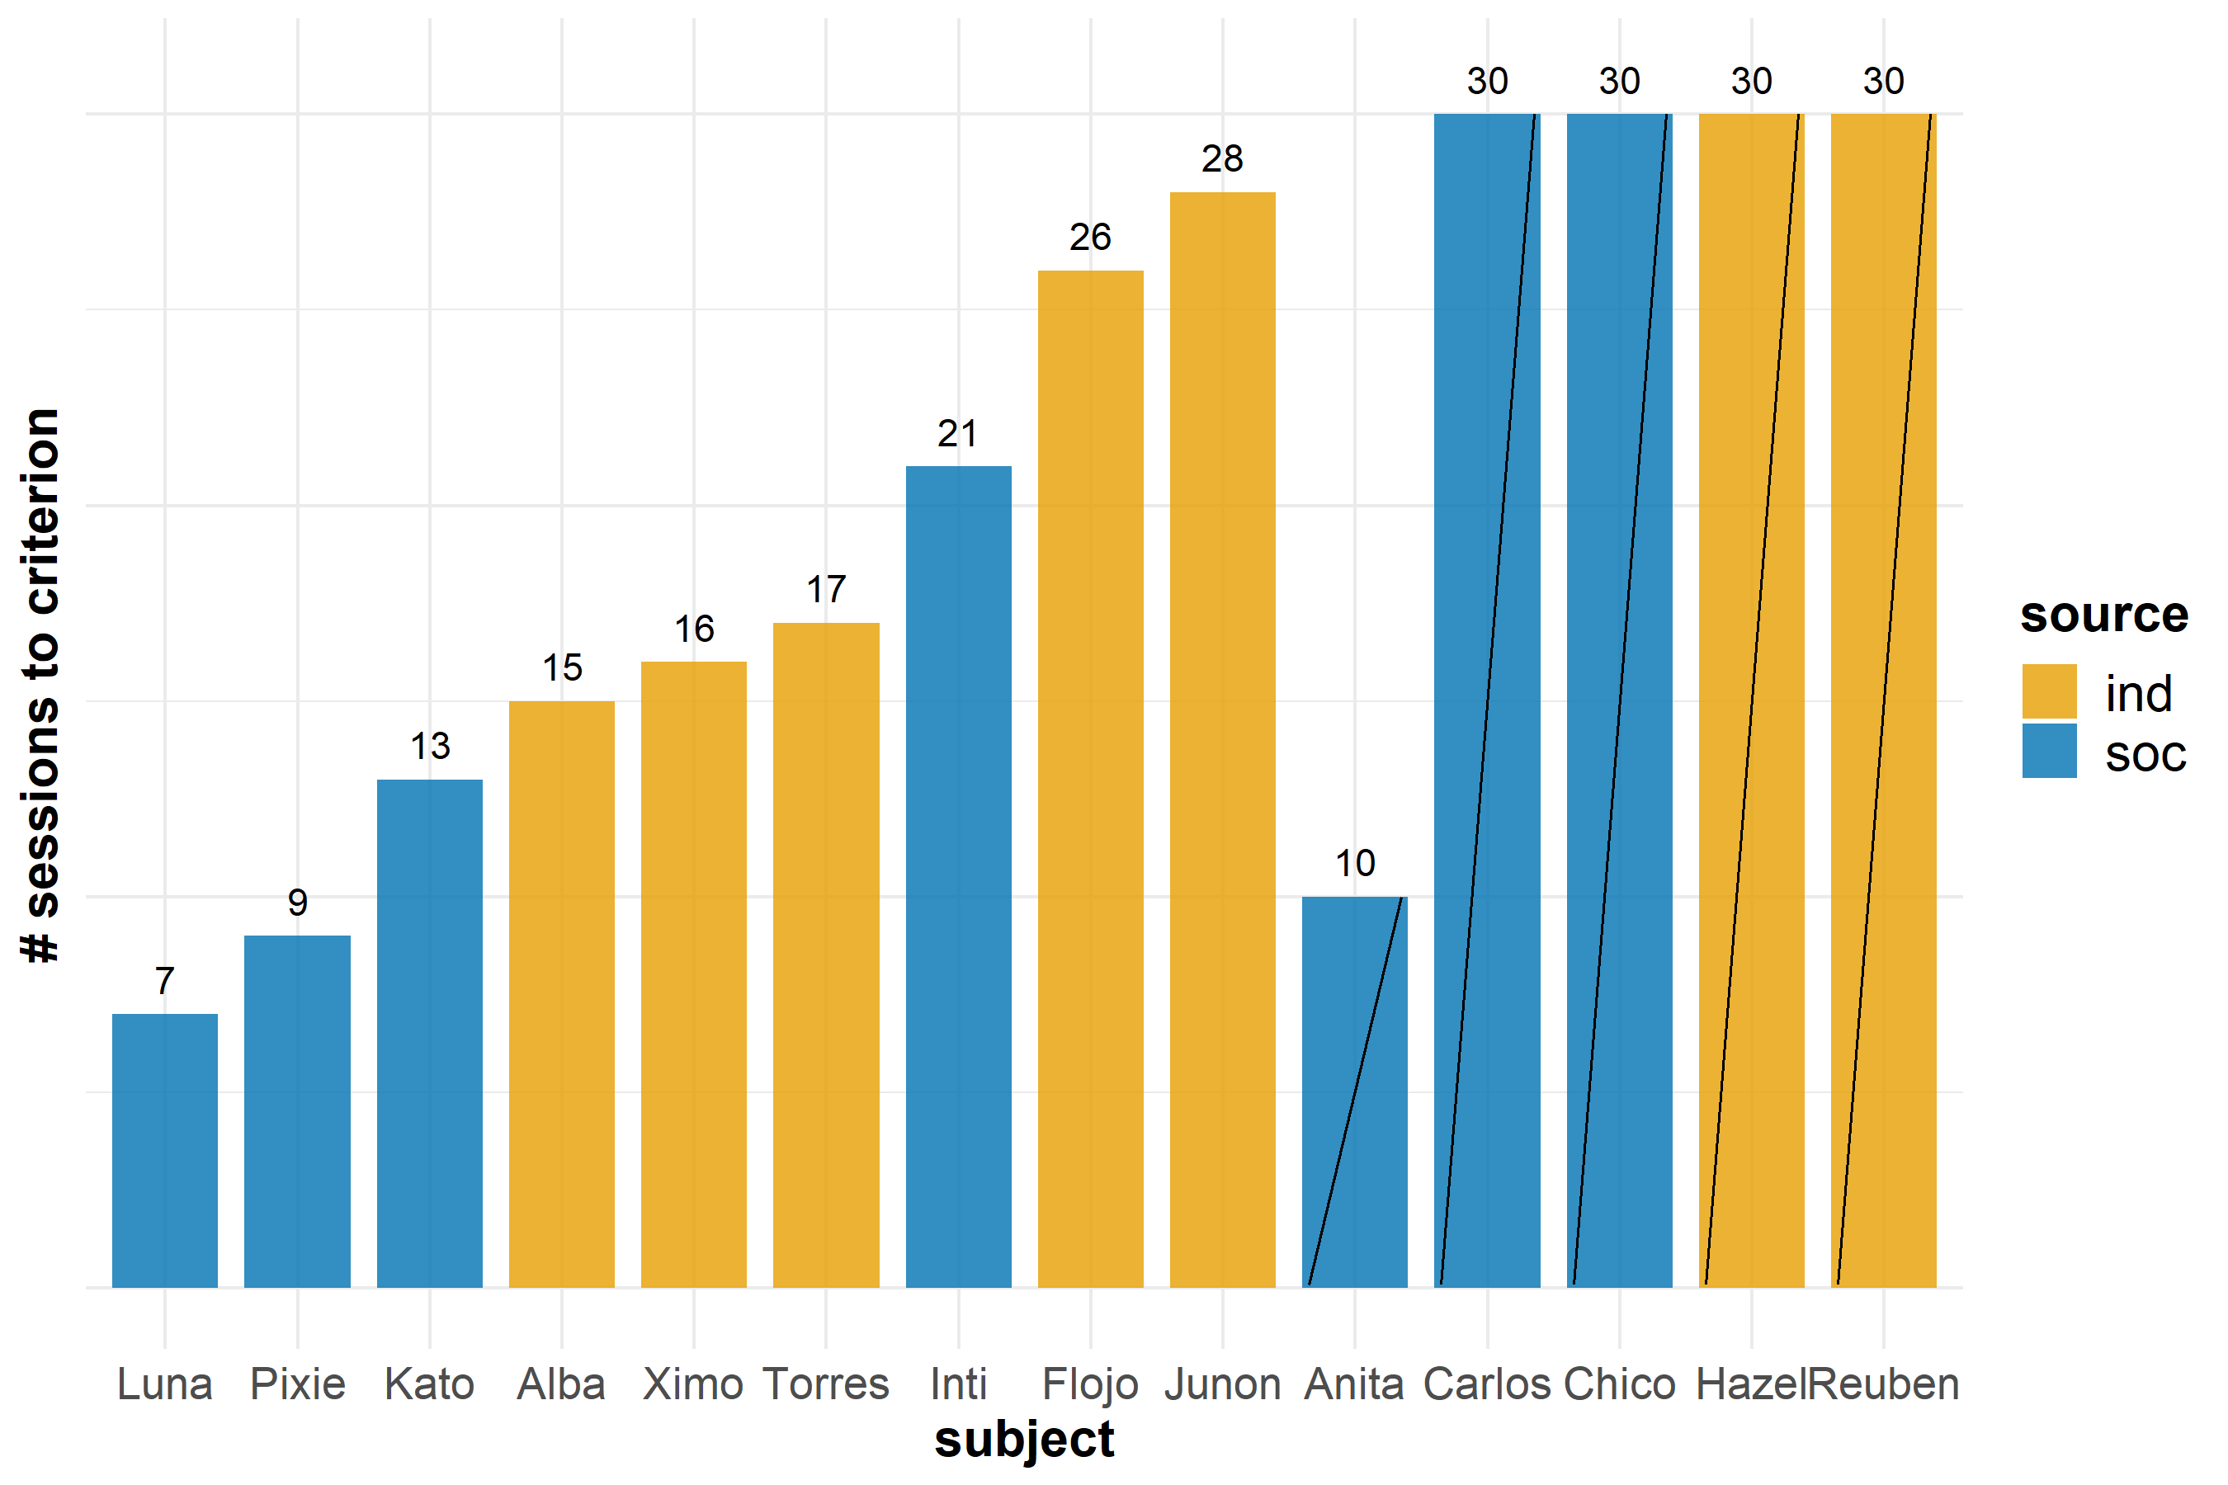
Fig. S1 Number of sessions to reach criterion and condition of information source received. Diagonal line through indicates subjects who did not meet criterion.

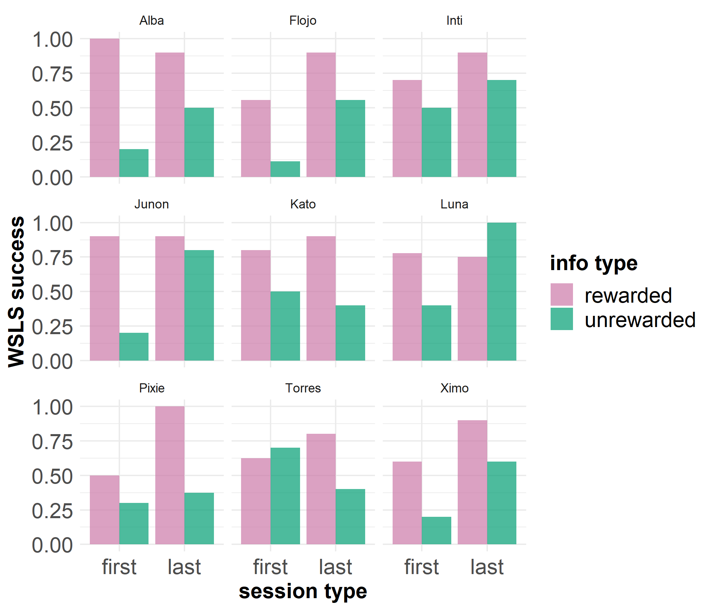
Fig. S2 Use of WSLS strategy by subjects that met criterion separated by information type. The first and last five sessions only are included as a broad overview to each subject’s progress on Stage A. This includes the three sessions where criterion was met.

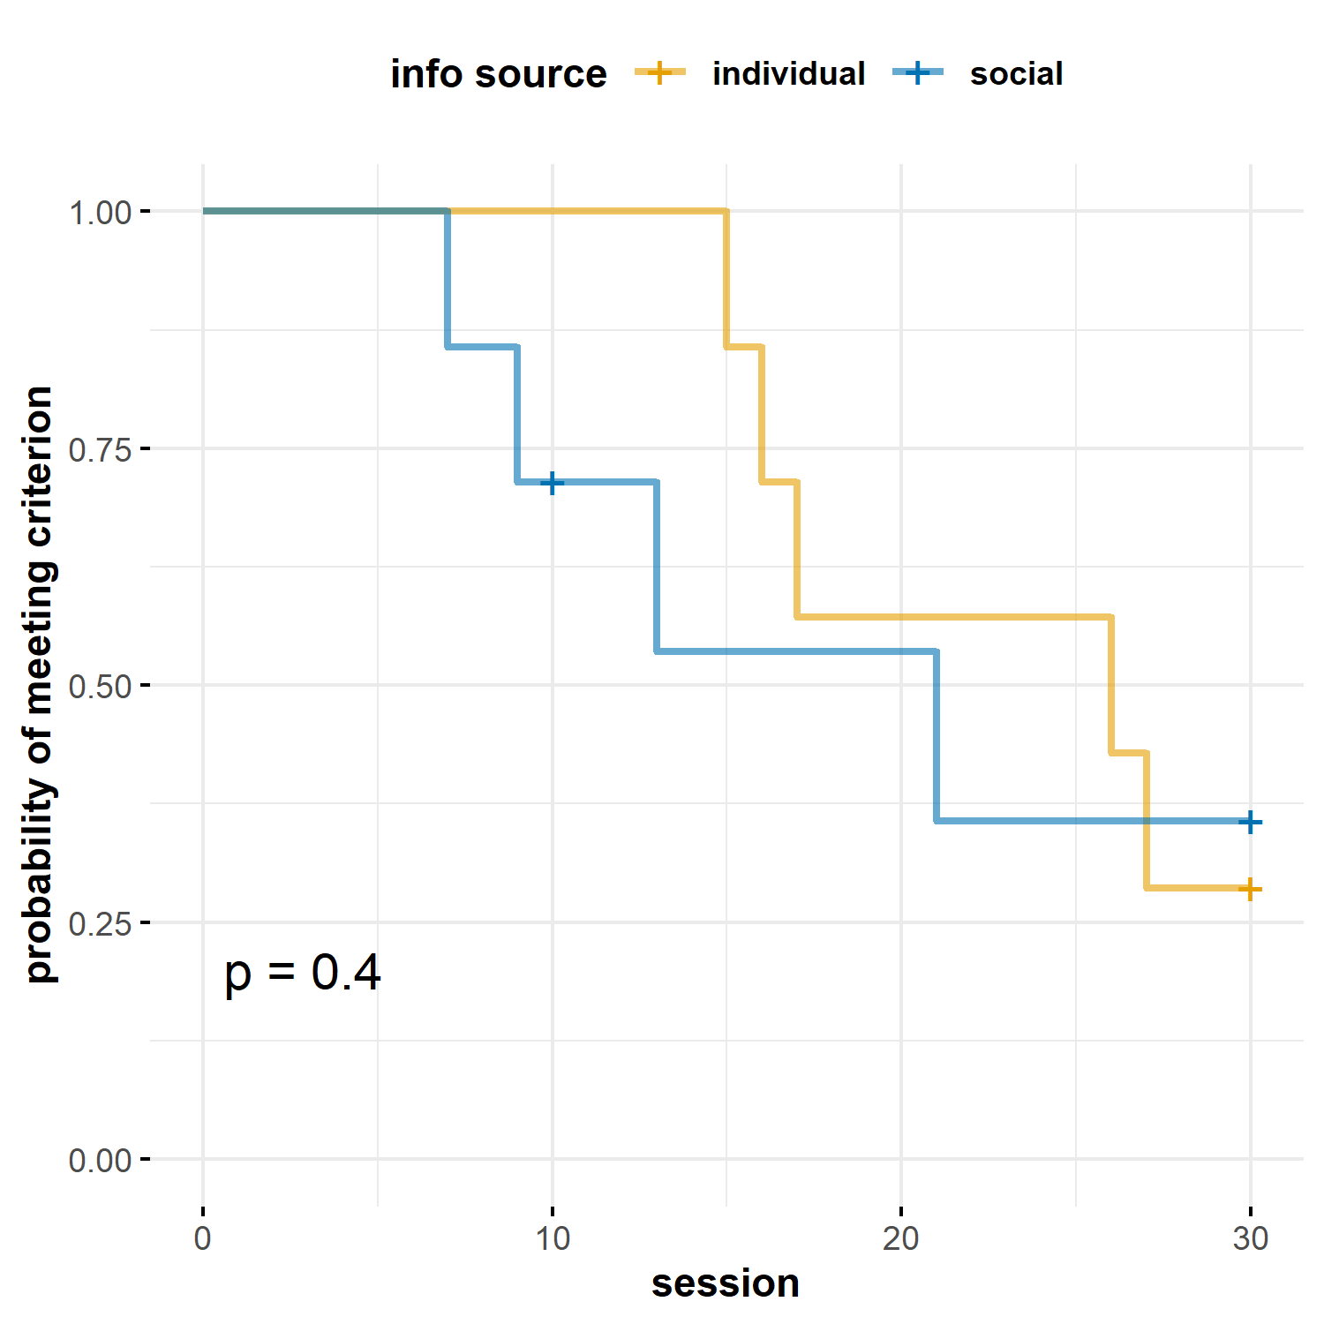
Fig. S3 Kaplan-Meier curves displaying the probability of meeting criterion over sessions for each information source.

