Supplementary materials
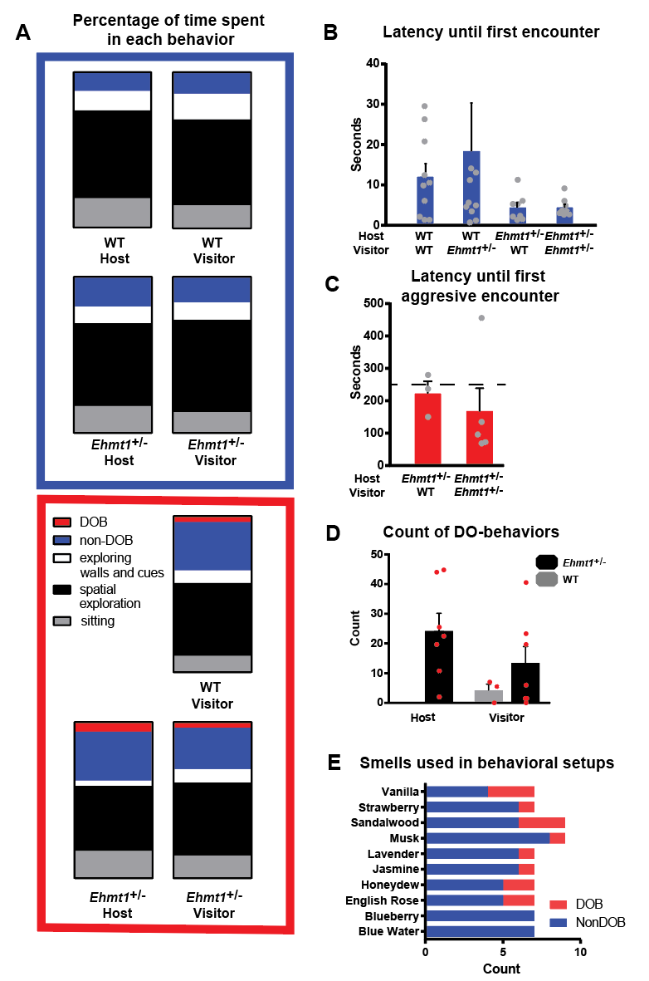
Supplementary figure 1. Main results shown by animal instead of by trial. A. Percentage of time spent in different behaviors during the 10-min interaction, divided in non-DOB trials (blue square) and in DOB trials (red square). There were no WT hosts in trials with DO-behaviors, hence there is a column missing. B. Average latency until first encounter in trials with no DOB interactions Trials with Ehmt1^{+/-} hosts seemed to have a shorter latency to approach the visitor, but this trend was non-significant. A value of 124 seconds is out of bounds, for WT- Ehmt1^{+/-} interactions. C. Average latency until first aggressive encounter Dashed line marks the 4-minute mark, which is the length of a trial in the original task. 75% of the animals experienced offense before four minutes. D. Average count of DO-behaviors in Ehmt1^{+/-} - WT and Ehmt1^{+/-} - Ehmt1^{+/-} pairings. E. Smells used in the behavioral setup. There was no difference in the incidence of aggression due to a particular smell (Chi-Square₉=5.054, p=0.7445). Circles correspond to the average of each individual, and error bars correspond to SEM.
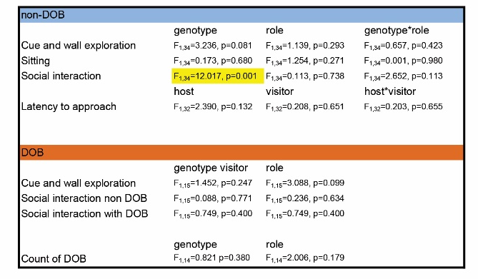
Supplementary Table 1. Statistical analysis of repeated measures. In yellow are marked statistically significant results. In this case the key result is that Ehmt1^{+/-} animals spend longer in social interaction than WT mice.

