Supplementary material
article title: “The song remains the same”: not really! Vocal creativity in contribution flexibility in the indris
journal name: Animal Cognition
author names: Anna Zanoli^{1*°}, Teresa Raimondi^{1*°}, Chiara De Gregorio¹, Daria Valente^{1,2}, Filippo Carugati¹, Valeria Torti¹, Olivier Friard¹, Longondraza Miaretsoa^{1,3}, Cristina Giacoma^{1§}, Marco Gamba^{1§}
affiliation and e-mail address of the corresponding author:
Anna Zanoli
anna.zanoli@unito.it
Department of Life Sciences and System Biology, University of Turin, Via Accademia Albertina 13, Torino, Italy
Teresa Raimondi
Teresa.raimondi@unito.it
Department of Life Sciences and System Biology, University of Turin, Via Accademia Albertina 13, Torino, Italy

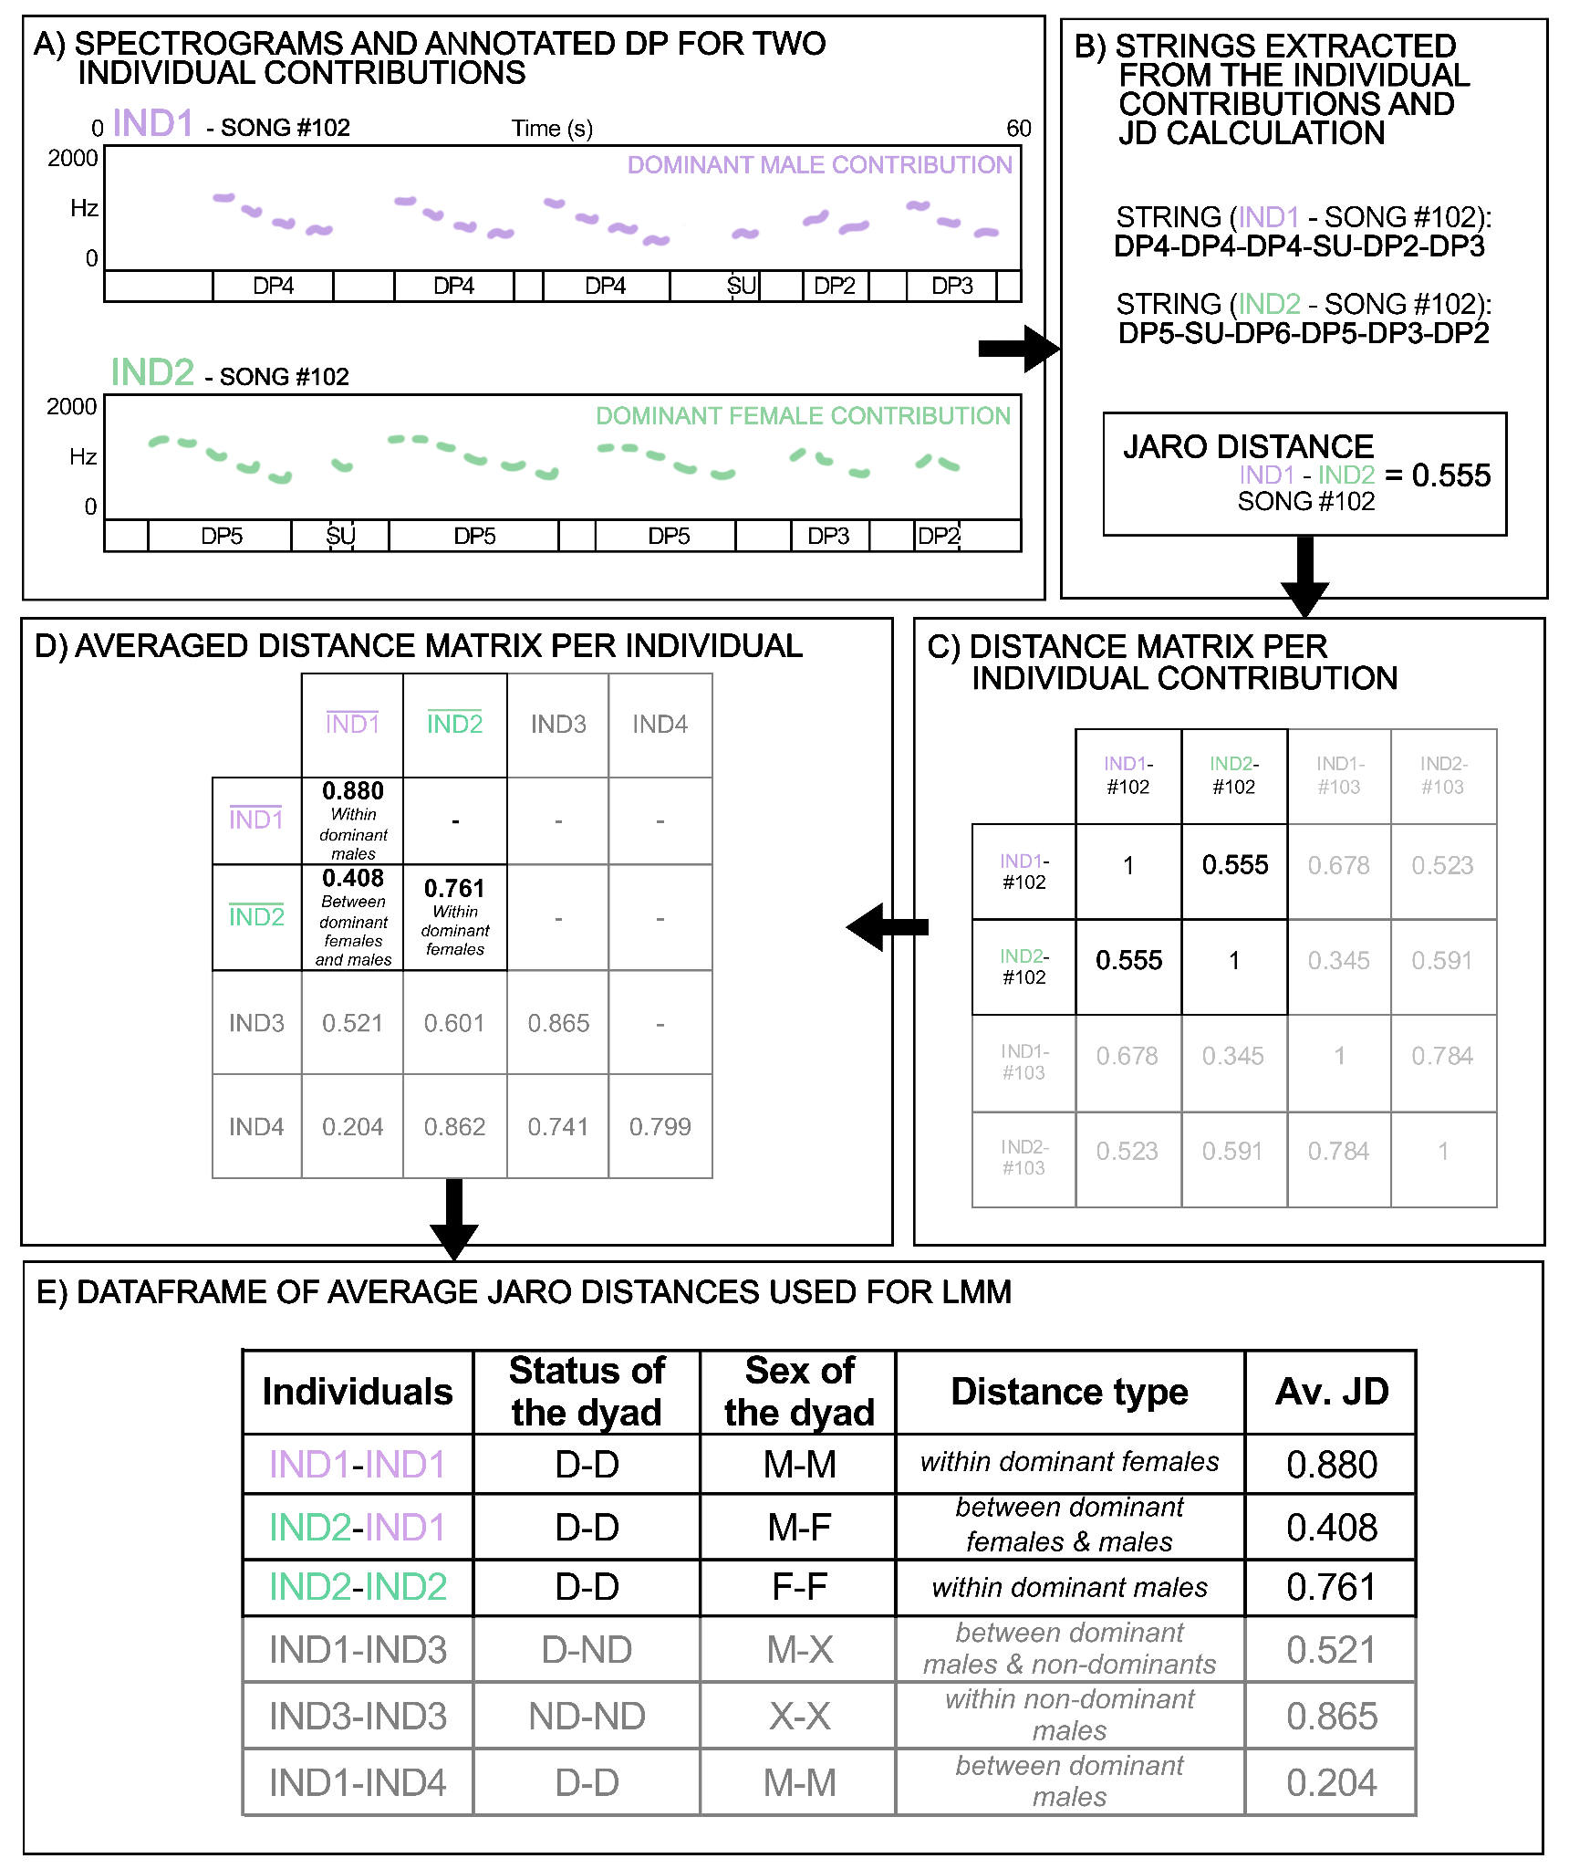
Figure SM1 - A) Spectrograms and annotated Descending Phrases (DP) for two individual contributions. The two spectrograms show the fundamental frequency of the modulated units, composing descending phrases, of two individuals: one dominant male (IND1 in purple) and one dominant female (IND2 in green) of a specific song (song code #102). Every DP is labeled with its phrase type, indicating the number of units composing it. B) Strings extracted from the individual contributions and Jaro Distance (JD) calculation. The string represents the concatenation of phrases extracted from every individual contribution, and the Jaro Distance is calculated between two strings (e.g. between the string of song #102 of IND1 and IND2). Below, the detailed calculation of the JD of the displayed exemple:
- DP4 | DP4 | DP4 | SU | DP2 | DP3 s1=6 (the length of string 1)
- DP5 | SU | DP6 | DP5 | DP3 | DP2 s2=6 (the length of string 2)

COMMON UNITS IN ORDER:

- SU | DP2 | DP3
- SU | DP3 | DP2

COUNT OF MATCHINGS (m) : 3 (SU, DP2, DP3)

COUNT OF NON-MATCHING AT THE SAME POSITION: 2 (DP2, DP3)

NUMBER OF TRANSPOSITION (t) : 1 (if in the first string we invert the position between DP2 and DP3 we obtain 2 identical strings)

$$JD= \frac{1}{3}\left(\frac{m}{s1}+ \frac{m}{s2}+\frac{m-t}{m}\right)$$

$$JD= \frac{1}{3}\left(\frac{3}{6}+ \frac{3}{6}+\frac{3-1}{3}\right)=0.555$$

C) Distance matrix per individual contribution. A distance matrix is extracted, showing all possible contrasts between all extracted strings in the sample. The specific example (IND1 and IND2 song #102) is highlighted in colors and bold black. D) Averaged distance matrix per individual. An averaged matrix is extracted, reporting the average JD per dyad of individuals (e.g. the average JD of all contrasts of all strings between IND1 and IND2). E) Dataframe of average JD used for LMM. From the averaged matrix, a data frame is extracted: it reports the individuals of the dyad, their status, sex, distance type and average JD. This dataframe is then used to build the LMM (with Average JD being the response variable).

contrast | estimate | SE | z-ratio | p-value
Between dominant females - Between dominant females & males (BDF - BDFDM) | -0.023 | 0.008 | -2.835 | 0.105
Between dominant females - Between dominant males (BDF - BDM) | 0.039 | 0.009 | 4.150 | 0.001
Between dominant females - Between dominant females & non-dominants (BDF - BDFND) | -0.045 | 0.007 | -6.207 | <0.001
Between dominant females - Between dominant males & non-dominants (BDF - BDMND) | -0.002 | 0.007 | -0.332 | 1.000
Between dominant females - Between non-dominants (BDF - BND) | -0.032 | 0.007 | -4.457 | <0.001
Between dominant females - Within dominant females (BDF - WDF) | 0.025 | 0.015 | 1.641 | 0.782
Between dominant females & males - Between dominant males (BDFDM - BDM) | 0.062 | 0.008 | 7.719 | <0.001
Between dominant females & males - Between dominant females & non-dominants (BDFDM - BDFND) | -0.022 | 0.005 | -4.225 | 0.001
Between dominant females & males - Between dominant males & non-dominants (BDFDM - BDMND) | 0.020 | 0.005 | 3.815 | 0.004
Between dominant females & males - Between non-dominants (BDFDM - BND) | -0.010 | 0.005 | -1.815 | 0.672
Between dominant males - Between dominant females & non-dominants (BDM - BDFND) | -0.084 | 0.007 | -11.584 | <0.001
Between dominant males - Between dominant males & non-dominants (BDM - BDMND) | -0.042 | 0.007 | -5.709 | <0.001
Between dominant males - Between non-dominants (BDM - BND) | -0.071 | 0.007 | -9.862 | <0.001
Between dominant males - Within dominant males (BDM - WDM) | 0.042 | 0.015 | 2.837 | 0.105
Between dominant females & non-dominants - Between dominant males & non-dominants (BDFND- BDMND) | 0.043 | 0.004 | 10.347 | <0.001
Between dominant females & non-dominants - Between non-dominants (BDFND - BND) | 0.013 | 0.004 | 3.176 | 0.040
Between dominant males & non-dominants - Between non-dominants (BDMND - BND) | -0.030 | 0.004 | -7.343 | <0.001
Between non-dominants - Within non-dominants (BND - WND) | 0.048 | 0.010 | 4.957 | <0.001
Table SM1 Tukey-Kramer test between distances of dominant male and female and non-dominant indris, resulting from the LMM testing whether intrinsic individual features could affect JDs between individuals. P-values for multiple comparisons were corrected applying the Bonferroni correction (R-package “emmeans”; Russel 2021).

 | estimate | SE | df | t-value | p-value
(Intercept) | -1.028 | 0.060 | a | -17.195 | a
Sex*Status | - | - | 2 | - | 0.009
Sex*Status (Dominant male)^{b,c} | 0.156 | 0.084 | - | 1.863 | 0.072
Sex*Status (Non-dominant)^{b,c} | 0.252 | 0.075 | - | 3.341 | 0.002
Table SM2 Summary of the GLMM testing the effect of sex (for dominant individuals) and status (dominant vs. non-dominant) on individual contributions diversity. Full vs. null model: χ²=9.837, df=2, p-value=0.007. ªNot shown as not having a meaningful interpretation. ^{b}Estimate ± SE refers to the difference in response between the reported level of this categorical predictor and the reference category of the same predictor. ^{c}These predictors were dummy coded, with ‘Dominant female’ being the reference category.

COMPARISON | NORM DIVERSITY |  | N
COMPARISON | Rho | p-value | N
1MZ bevolo - jery | 0.491 | <0.001 | 108
2MZ soa - max | 0.450 | <0.001 | 102
3MZ mena - ratsy | 0.526 | 0.014 | 22
3MZa mena - mahagaga | 0.116 | 0.466 | 43
4MZ eva - koto | 0.326 | 0.028 | 46
5MZ fern - graham | 0.684 | 0.011 | 13
5MZa takona - graham | 0.425 | 0.002 | 52
6MZ befotsy - zokibe | 0.386 | 0.007 | 51
8MZ bemasoandro - jonah | 0.251 | 0.103 | 42
9MZ sissie - emilio | 0.291 | 0.069 | 40
Table SM3 Results of the Spearman’s correlation tests performed between the normalized diversity values of each dominant female with the respective dominant male to test a possible covariation of duetting partners’ normalized diversity.

 | ID | GROUP | ENTROPY RATE
DOMINANT  MALES | JERY | 1MZ | 1.666
DOMINANT  MALES | MAX | 2MZ | 1.592
DOMINANT  MALES | MAHAGAGA | 3MZa | 0.000
DOMINANT  MALES | RATSY | 3MZb | 1.972
DOMINANT  MALES | KOTO | 4MZ | 1.791
DOMINANT  MALES | GRAHAM | 5MZ | 1.484
DOMINANT  MALES | ZOKIBE | 6MZ | 1.417
DOMINANT  MALES | JONAH | 8MZ | 1.598
DOMINANT  MALES | EMILIO | 9MZ | 1.946
DOMINANT  FEMALES | BEVOLO | 1MZ | 1.841
DOMINANT  FEMALES | SOA | 2MZ | 1.774
DOMINANT  FEMALES | MENA | 3MZ | 1.858
DOMINANT  FEMALES | EVA | 4MZ | 1.834
DOMINANT  FEMALES | FERN | 5MZa | 1.529
DOMINANT  FEMALES | TAKONA | 5MZb | 1.594
DOMINANT  FEMALES | BEFOTSY | 6MZ | 1.796
DOMINANT  FEMALES | BEMASOANDRO | 8MZ | 1.613
DOMINANT  FEMALES | SISSIE | 9MZ | 1.836
NON  -  DOMINANTS | BERTHE | 1MZ | 0.949
NON  -  DOMINANTS | CAMY | 1MZ | 1.426
NON  -  DOMINANTS | FOTSY | 1MZ | 1.577
NON  -  DOMINANTS | AFO | 2MZ | 0.000
NON  -  DOMINANTS | FANIHY | 2MZ | 0.000
NON  -  DOMINANTS | TOVO | 2MZ | 1.582
NON  -  DOMINANTS | ANA | 3MZ | 1.116
NON  -  DOMINANTS | FALY | 3MZ | 1.731
NON  -  DOMINANTS | TONGA | 3MZ | 1.532
NON  -  DOMINANTS | GIBET | 4MZ | 1.788
NON  -  DOMINANTS | HENDRY | 4MZ | 1.847
NON  -  DOMINANTS | MEVA | 4MZ | 1.325
NON  -  DOMINANTS | VOARY | 5MZ | 1.886
NON  -  DOMINANTS | CESARE | 8MZ | 1.695
NON  -  DOMINANTS | EME | 8MZ | 1.320
NON  -  DOMINANTS | MIKA | 8MZ | 1.438
NON  -  DOMINANTS | ZAFY | 8MZ | 1.696
NON  -  DOMINANTS | BENY | 9MZ | 0.000
NON  -  DOMINANTS | DOSY | 9MZ | 1.584
NON  -  DOMINANTS | OVY | 9MZ | 1.766
Table SM4 Entropy rate values for each individual, organized by dominant male, dominant female and non-dominants.

