Supplementary materials
Within wolves, we observed that three individuals with Eurasian ancestry (Maikan, Tekoa, and Taima) seemingly took more time than the rest of the group to approach the object in the exposure phase, and only one of them (Tekoa) touched it once. During the test sessions, none of them approached nor touched any of the items. Due to this behavior, we determined they did not complete the requisites to participate in the test (i.e., being habituated to the familiar object) and thus, we excluded them from the analyses.
(A)
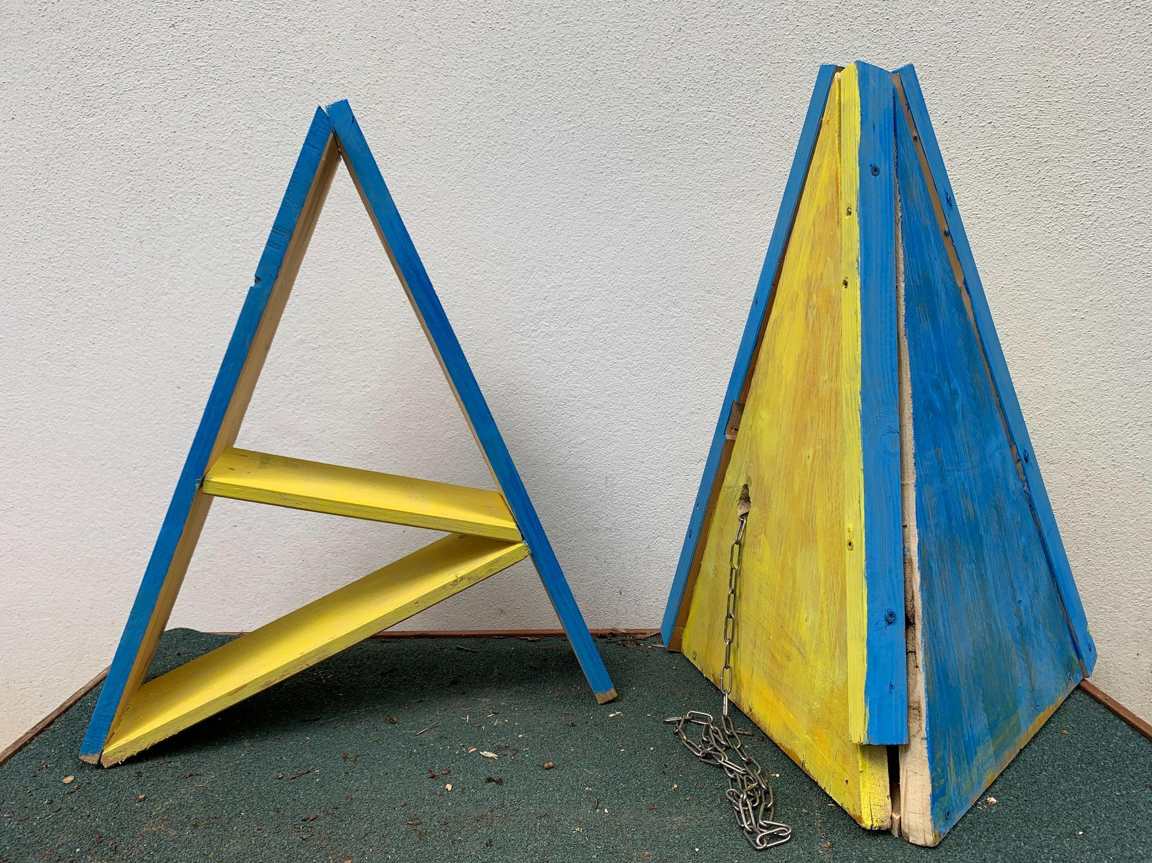
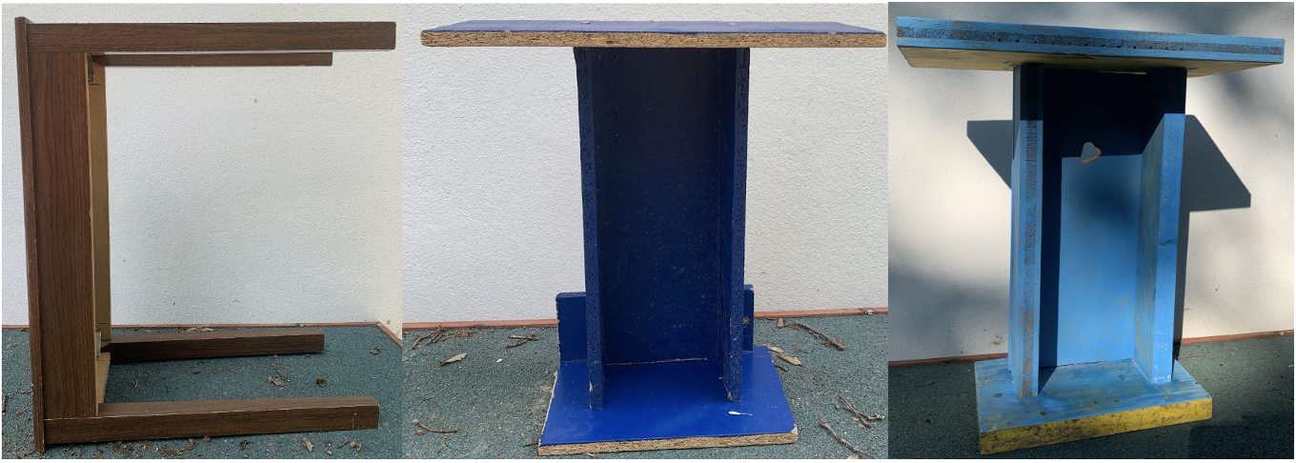
(B) (C)

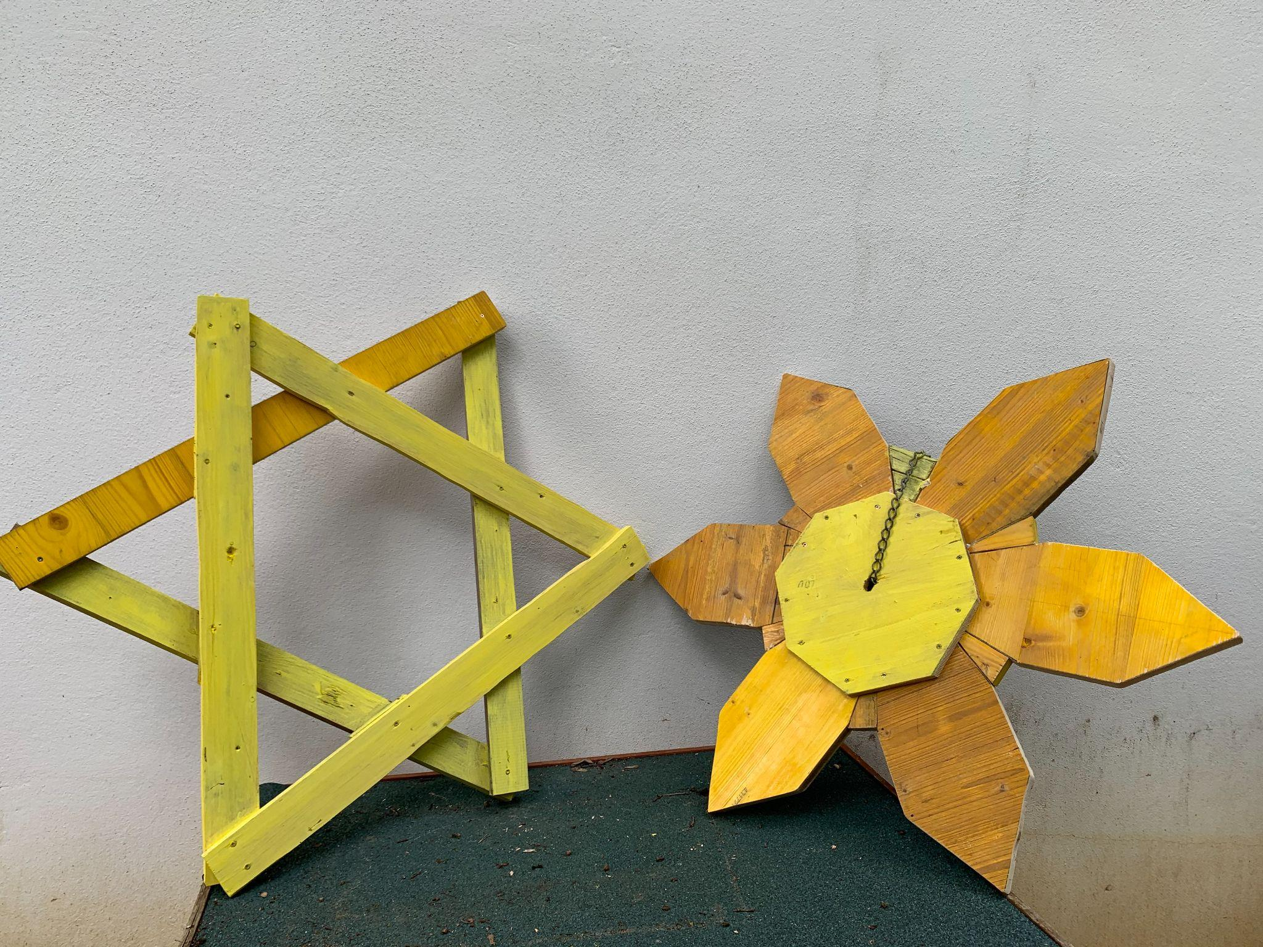

(D)
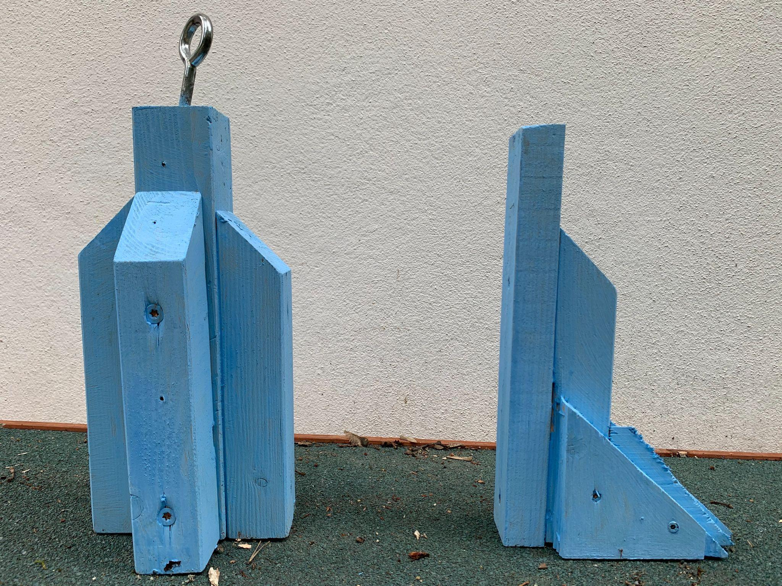

Figure S1. The different object pairs. The pair (A) was composed of a brown table and a dark blue T-shape and was approximately 50 cm high. A similar T-shape was built during the experiment because the first one was damaged by the wolves during a habituation phase (after which this pair was re-named as “E”). The pair (B) was composed of a star and a flower both painted in yellow and was 1 m high. The pair (C) was composed of a pyramid and a capital A both painted in yellow and blue and was 65 cm high. Finally, the pair (D) was composed of a rocket and a pistol both painted in light blue and was 30 cm high.

Table S1. Enclosures used during the experiment, with information on their size, the group (or groups) tested in them, and the relative distance to the trees in which each of the objects (new and familiar) were placed from the entrance used to release the animals into the enclosure (as well as which of the two objects was closer to said entrance), In the case of 9c, the distances were different for wolves and pet dogs because each of the species went into the enclosure through a different entrance.
Enclosure | Group tested | Size (m²) | Closer object from entrance | Distance from entrance new object (m) | Distance from entrance familiar object (m)
6 | Wolves | 1923 | New | 13.1 | 20.8
9b | Wolves | 10364 | Familiar | 54.1 | 51.7
9c | Wolves & Pet dogs | 1258 | Wolves: New  Pet dogs: Familiar | Wolves: 7.3  Pet dogs: 13.7 | Wolves: 9.3  Pet dogs: 10.1
10a back | Pack dogs | 2018 | Familiar | 17.9 | 4.5
10b front | Pack dogs | 2014 | New | 14.4 | 11.0
10b back | Pack dogs | 2012 | Familiar | 18.2 | 9.2
21 | Wolves | 4043 | New | 12.6 | 22.6
22 | Wolves | 4005 | Familiar | 25.4 | 15.4
23 | Wolves | 2039 | Familiar | 13.1 | 8.4
24 | Wolves | 2086 | Familiar | 26.5 | 14.5
OTE | Pet dogs | 400 | New | 10.6 | 12.6

Table S2. Summary table of the individuals tested, including their pack, age at the beginning of the experiment, origin, species, owners, relatives, and sex. Subjects greyed out were not considered for data analyses.
Subject | Pack / Group | Species / Group | Subspecies / Breed | Owner | Origin | Relatives | Age (months) | Sex
Taima | TT | Wolf | Timber + Eurasian wolf | WSC | Moscow | Tekoa, Maikan | 62 | Female
Tekoa | TT | Wolf | Timber + Eurasian wolf | WSC | Moscow | Taima, Maikan | 62 | Male
Nanuk | NU | Wolf | Timber wolf | WSC | Triple D Game Farm, Montana, USA |  | 147 | Male
Una | NU | Wolf | Timber wolf | WSC | Minnesota Wildlife Connection, USA | Chitto | 111 | Male
Geronimo | GYW | Wolf | Timber wolf | WSC | Triple D Game Farm, Montana, USA | Yukon | 146 | Female
Yukon | GYW | Wolf | Timber wolf | WSC | Triple D Game Farm, Montana, USA | Geronimo | 146 | Male
Wamblee | GYW | Wolf | Timber wolf | WSC | Haliburton Forest & Wildlife Reserve, Ontario, Canada | Etu | 111 | Female
Tala | TC | Wolf | Timber wolf | WSC | Minnesota Wildlife Connection, USA | Amarok | 111 | Male
Chitto | TC | Wolf | Timber wolf | WSC | Minnesota Wildlife Connection, USA | Una | 111 | Female
Maikan | ME | Wolf | Timber + Eurasian wolf | WSC | Moscow | Tekoa, Taima | 62 | Male
Etu | ME | Wolf | Timber wolf | WSC | Haliburton Forest & Wildlife Reserve, Ontario, Canada | Wamblee | 62 | Male
Amarok | AK | Wolf | Timber wolf | WSC | Minnesota Wildlife Connection, USA | Tala | 111 | Male
Kenai | AK | Wolf | Hudson Bay wolf | WSC | Parc Safari Hemmingford, Quebec, Canada |  | 136 | Male
Hiari | IH | Pack dog | Mongrel | WSC | Wildpark Ernstbrunn, Austria | Imara | 88 | Male
Imara | IH | Pack dog | Mongrel | WSC | Wildpark Ernstbrunn, Austria | Hiari | 88 | Female
Enzi | ZE | Pack dog | Mongrel | WSC | Wildpark Ernstbrunn, Austria | Layla, Panya, Zazu, Pepeo | 87 | Male
Zuri | ZE | Pack dog | Mongrel | WSC | Shelter Paks, Hungary |  | 121 | Female‡
Layla | LP | Pack dog | Mongrel | WSC | Next to highway Györ, Hungary | Enzi, Panya, Zazu, Pepeo | 119 | Female
Panya | LP | Pack dog | Mongrel | WSC | Wildpark Ernstbrunn, Austria | Layla, Enzi, Zazu, Pepeo | 87 | Female†
Asali | Group A | Pet dog | Mongrel | Owner 1 | Tierheim Szeged, Hungary |  | 130 | Male
Kilio | Group A | Pet dog | Mongrel | Owner 1 | Shelter Paks, Hungary |  | 139 | Male*
Zazu | Group A | Pet dog | Mongrel | Owner 2 | Wildpark Ernstbrunn, Austria | Layla, Enzi, Panya, Pepeo | 87 | Male*
Hakima | Group B | Pet dog | Mongrel | Owner 4 | Shelter Paks, Hungary |  | 130 | Male*
Pepeo | Group B | Pet dog | Mongrel | Owner 3 | Wildpark Ernstbrunn, Austria | Layla, Enzi, Panya, Zazu | 87 | Male
Freya | Group B | Pet dog | Irish Terrier | Owner 3 | Galahad’s Guardian Irish Terrier, Kirchberg, Switzerland |  | 74 | Female
* Castrated.
† Went through false pregnancy on 11/10/2021.
‡ Spayed during the experiment (on 26/10/2021).
Table S3. Summary table of the usage of objects to the different animals, with their dates. Subjects greyed out were not considered for data analyses.
Subject | Week item 1 | Pair 1 | Familiar Item 1 | New Item 1 | Week Item 2 | Pair 2 | Familiar item 2 | New Item 2 | Week Item 3 | Pair 3 | Familiar Item 3 | New Item 3
Tekoa | 02/08/2021 | A | T shape | Table | 27/09/2021 | B | Flower | Star | 22/11/2021 | C | Pyramid | Capital A
Taima | 02/08/2021 | A | T shape | Table | 27/09/2021 | B | Flower | Star | 22/11/2021 | C | Pyramid | Capital A
Nanuk | 02/08/2021 | C | Capital A | Pyramid | 13/09/2021 | D | Rocket | Pistol | 11/10/2021 | B | Star | Flower
Una | 02/08/2021 | C | Capital A | Pyramid | 13/09/2021 | D | Rocket | Pistol | 11/10/2021 | B | Star | Flower
Geronimo | 16/08/2021 | C | Capital A | Pyramid | 11/10/2021 | E | New T shape | Table | 08/11/2021 | B | Flower | Star
Yukon | 16/08/2021 | C | Capital A | Pyramid | 11/10/2021 | E | New T shape | Table | 08/11/2021 | B | Flower | Star
Wamblee | 16/08/2021 | C | Capital A | Pyramid | 11/10/2021 | E | New T shape | Table | 08/11/2021 | B | Flower | Star
Tala | 30/08/2021 | A | T shape | Table | 27/09/2021 | D | Pistol | Rocket | 08/11/2021 | C | Pyramid | Capital A
Chitto | 30/08/2021 | A | T shape | Table | 27/09/2021 | D | Pistol | Rocket | 08/11/2021 | C | Pyramid | Capital A
Maikan | 30/08/2021 | B | Flower | Star | 25/10/2021 | C | Capital A | Pyramid | 22/11/2021 | F | Table | New T shape
Etu | 30/08/2021 | B | Flower | Star | 25/10/2021 | C | Capital A | Pyramid | 22/11/2021 | E | Table | New T shape
Amarok | 13/09/2021 | B | Flower | Star | 25/10/2021 | E | New T shape | Table | 06/12/2021 | D | Pistol | Rocket
Kenai | 13/09/2021 | B | Flower | Star | 25/10/2021 | E | New T shape | Table | 06/12/2021 | D | Pistol | Rocket
Hiari | 02/08/2021 | B | Star | Flower | 13/09/2021 | C | Pyramid | Capital A | 22/11/2021 | D | Pistol | Rocket
Imara | 02/08/2021 | B | Star | Flower | 13/09/2021 | C | Pyramid | Capital A | 22/11/2021 | D | Pistol | Rocket
Enzi | 16/08/2021 | D | Rocket | Pistol | 27/09/2021 | E | Table | New T shape | 25/10/2021 | B | Star | Flower
Zuri | 16/08/2021 | D | Rocket | Pistol | 27/09/2021 | F | Table | New T shape | 25/10/2021 | B | Star | Flower
Layla | 30/08/2021 | D | Rocket | Pistol | 11/10/2021 | C | Pyramid | Capital A | 08/11/2021 | E | Table | New T shape
Panya | 30/08/2021 | D | Rocket | Pistol | 11/10/2021 | C | Pyramid | Capital A | 08/11/2021 | E | Table | New T shape
Asali | 16/08/2021 | A | Table | T shape | 11/10/2021 | D | Rocket | Pistol | 06/12/2021 | C | Capital A | Pyramid
Kilio | 16/08/2021 | A | Table | T shape | 11/10/2021 | D | Rocket | Pistol | 06/12/2021 | C | Capital A | Pyramid
Zazu | 16/08/2021 | A | Table | T shape | 11/10/2021 | D | Rocket | Pistol | 06/12/2021 | C | Capital A | Pyramid
Hakima | 16/08/2021 | A | Table | T shape | 01/11/2021 | D | Pistol | Rocket | 05/02/2022 | B | Star | Flower
Pepeo | 12/09/2021 | C | Capital A | Pyramid | 01/11/2021 | D | Pistol | Rocket | 05/02/2022 | B | Star | Flower
Freya | 12/09/2021 | C | Capital A | Pyramid | 01/11/2021 | D | Pistol | Rocket | 05/02/2022 | B | Star | Flower

Table S4. Summary table of the exposure time pet dogs had per session.
Exposure session | Subject group | Day 1 | Day 2 | Day 3 | Day 4 | Day 5 | Enclosure
1 | Zazu, Kilio, Asali, Hakima | 1h40 | 2h30 | 2h15 | 1h15 | 1h45 | 24
1 | Pepeo, Freya | 2h50 | 1h50 | 2h10 | 1h15 | 1h45 | 9c
2 | Zazu, Kilio, Asali | 1h10 | 2h15 | 2h30 | 2h15 | 2h00 | 10b_back
2 | Pepeo, Freya, Hakima | 1h15 | 1h50 | 1h50 | 1h15 | 1h15 | 9c, then 6
3 | Zazu, Kilio, Asali | 45min | 1h00 | 45min | 45min | 40min | OTE
3 | Pepeo, Freya, Hakima | 50min | 45min | 45min | 45min | 50min | OTE

Table S5. Code used to analyze the videos taken by camera-traps during the Exposure phase.
Code | Behavior
2_body_length | the animal enters the 2 body length circle
1_body_length | the animal enters the 1 body length circle
nothing | nothing related to the experiment is on the video
touch | the animal sniffs, licks, grabs, pulls, uses his paw to touch the object

Table S6. Amount of hours of videos we have recorded per pack and per session after we removed the time the videos were not available.
Pack | Session | Amount of hours of videos
TT | 1 | 168
TT | 2 | 168
TT | 3 | 89
NU | 1 | 168
NU | 2 | 96
NU | 3 | 144
GYW | 1 | 72
GYW | 2 | 168
GYW | 3 | 138
ME | 1 | 168
ME | 2 | 72
ME | 3 | 156
AK | 1 | 168
AK | 2 | 168
AK | 3 | 66
LP | 1 | 168
LP | 2 | 168
LP | 3 | 168
IH | 1 | 168
IH | 2 | 168
IH | 3 | 144
ZE | 1 | 168
ZE | 2 | 168
ZE | 3 | 168

Table S7. The different models run during the statistical analysis of the study.
Exposure models
Function | Model structure
lmer | log.hours_to_habituate ~ group + z.session + (1+z.session||subject) + (1+z.session+ group.Wolf||familiar_item), REML=F
lmer | log.duration_interaction ~ group * z.session + (1+z.session||subject) + (1+z.session+ group.Wolf||familiar_item) + offset(log(hours_camera_trap_active)) , REML=F
Test models
Function | Model structure
glmer | first_object_approached ~ group + z.session + closer_item + (1+z.session||subject), family = "binomial"
glmer | first_object_touched ~ group + z.session + closer_item + (1+z.session||subject), family = "binomial"
lmer | log.latency_new ~ group + z.session + log.distance_new + (1+z.session||subject), REML=F
lmer | log1p.duration_interaction ~ item * group + z.session + (1||subject) + (1||object_type), REML=F

Table S8. Average amount of time (in hours) for every animal to approach within two body lengths to the familiar object.
Subject | Mean latency to approach within two body lengths (hours) | Group | Mean per group
Amarok | 0.01±0.01 | Wolf | 0.16±0.05
Chitto | 0.00±0.00 | Wolf | 0.16±0.05
Etu | 0.00±0.00 | Wolf | 0.16±0.05
Geronimo | 0.00±0.00 | Wolf | 0.16±0.05
Kenai | 0.00±0.00 | Wolf | 0.16±0.05
Nanuk | 0.00±0.00 | Wolf | 0.16±0.05
Tala | 0.02±0.02 | Wolf | 0.16±0.05
Una | 0.34±0.15 | Wolf | 0.16±0.05
Wamblee | 1.24±0.93 | Wolf | 0.16±0.05
Yukon | 0.00±0.00 | Wolf | 0.16±0.05
Enzi | 0.34±0.18 | Pack Dog | 0.12±0.05
Hiari | 0.00±0.00 | Pack Dog | 0.12±0.05
Imara | 0.02±0.02 | Pack Dog | 0.12±0.05
Layla | 0.00±0.00 | Pack Dog | 0.12±0.05
Panya  Zuri | 0.00±0.00  0.34±0.18 | Pack Dog | 0.12±0.05

Table S9. Mean duration of interaction (in seconds) with the object during the exposure phase per subject and per group.
Subject | Mean duration of interaction | Group | Mean per group
Amarok | 7.62±1.85 | Wolf | 10.40±0.69
Chitto | 12.50±3.26 | Wolf | 10.40±0.69
Etu | 17.60±2.57 | Wolf | 10.40±0.69
Geronimo | 7.64±1.52 | Wolf | 10.40±0.69
Kenai | 7.90±1.21 | Wolf | 10.40±0.69
Nanuk | 10.70±1.18 | Wolf | 10.40±0.69
Tala | 17.00±3.47 | Wolf | 10.40±0.69
Una | 5.76±1.14 | Wolf | 10.40±0.69
Wamblee | 8.67±2.38 | Wolf | 10.40±0.69
Yukon | 10.7±1.91 | Wolf | 10.40±0.69
Enzi | 5.59±1.26 | Pack Dog | 5.76±0.56
Hiari | 5.35±1.07 | Pack Dog | 5.76±0.56
Imara | 6.10±1.10 | Pack Dog | 5.76±0.56
Layla | 4.30±1.08 | Pack Dog | 5.76±0.56
Panya  Zuri | 6.89±1.61  5.33±2.19 | Pack Dog | 5.76±0.56

Table S10. Summary of the interaction durations of the different groups with the two objects in seconds.
Group | Session | Mean duration interaction familiar object | Mean duration interaction familiar object per group | Mean duration interaction new object | Mean duration interaction new object per group
Pet Dogs | 1 | 2.50±1.24 | 1.79±0.82 | 5.39±1.07 | 3.74±1.08
Pet Dogs | 2 | 0.38±0.38 | 1.79±0.82 | 0.00±0.00 | 3.74±1.08
Pet Dogs | 3 | 2.50±2.20 | 1.79±0.82 | 5.83±2.57 | 3.74±1.08
Pack Dogs | 1 | 6.59±1.88 | 4.66±1.28 | 9.31±2.09 | 10.70±1.81
Pack Dogs | 2 | 4.04±3.23 | 4.66±1.28 | 14.50±4.17 | 10.70±1.81
Pack Dogs | 3 | 3.33±1.28 | 4.66±1.28 | 8.29±2.64 | 10.70±1.81
Wolves | 1 | 3.03±1.01 | 3.31±0.97 | 13.80±5.73 | 12.00±2.80
Wolves | 2 | 1.61±0.72 | 3.31±0.97 | 10.50±3.16 | 12.00±2.80
Wolves | 3 | 5.27±2.54 | 3.31±0.97 | 11.70±5.70 | 12.00±2.80

Hakima's first session was done with the first group due to the owner availability.
GYW pack had to be temporarily separated due intra-pack conflict; the enclosure where the pet dogs were habituated in had to be requisitioned for the wolves, thus we changed the enclosure for the pet dogs’ session.

