Supplemental Materials

Supplementary Video 1 Caption.
Representative video of automated tracking software example from an owner-versus-dog trial, including real-time measures of stimulus location in each zone.

Supplemental Figures

Supplemental Figure 1. Stimulus Toy and Tracking Validation
(a) Familiar toy stimulus used in the assay (Tuffy Jr. 3-Way Tug Dog Toy; approximate dimensions shown). (b) Representative video frame from a dog–toy trial, with a magnified inset illustrating the toy stimulus used for behavioral quantification.

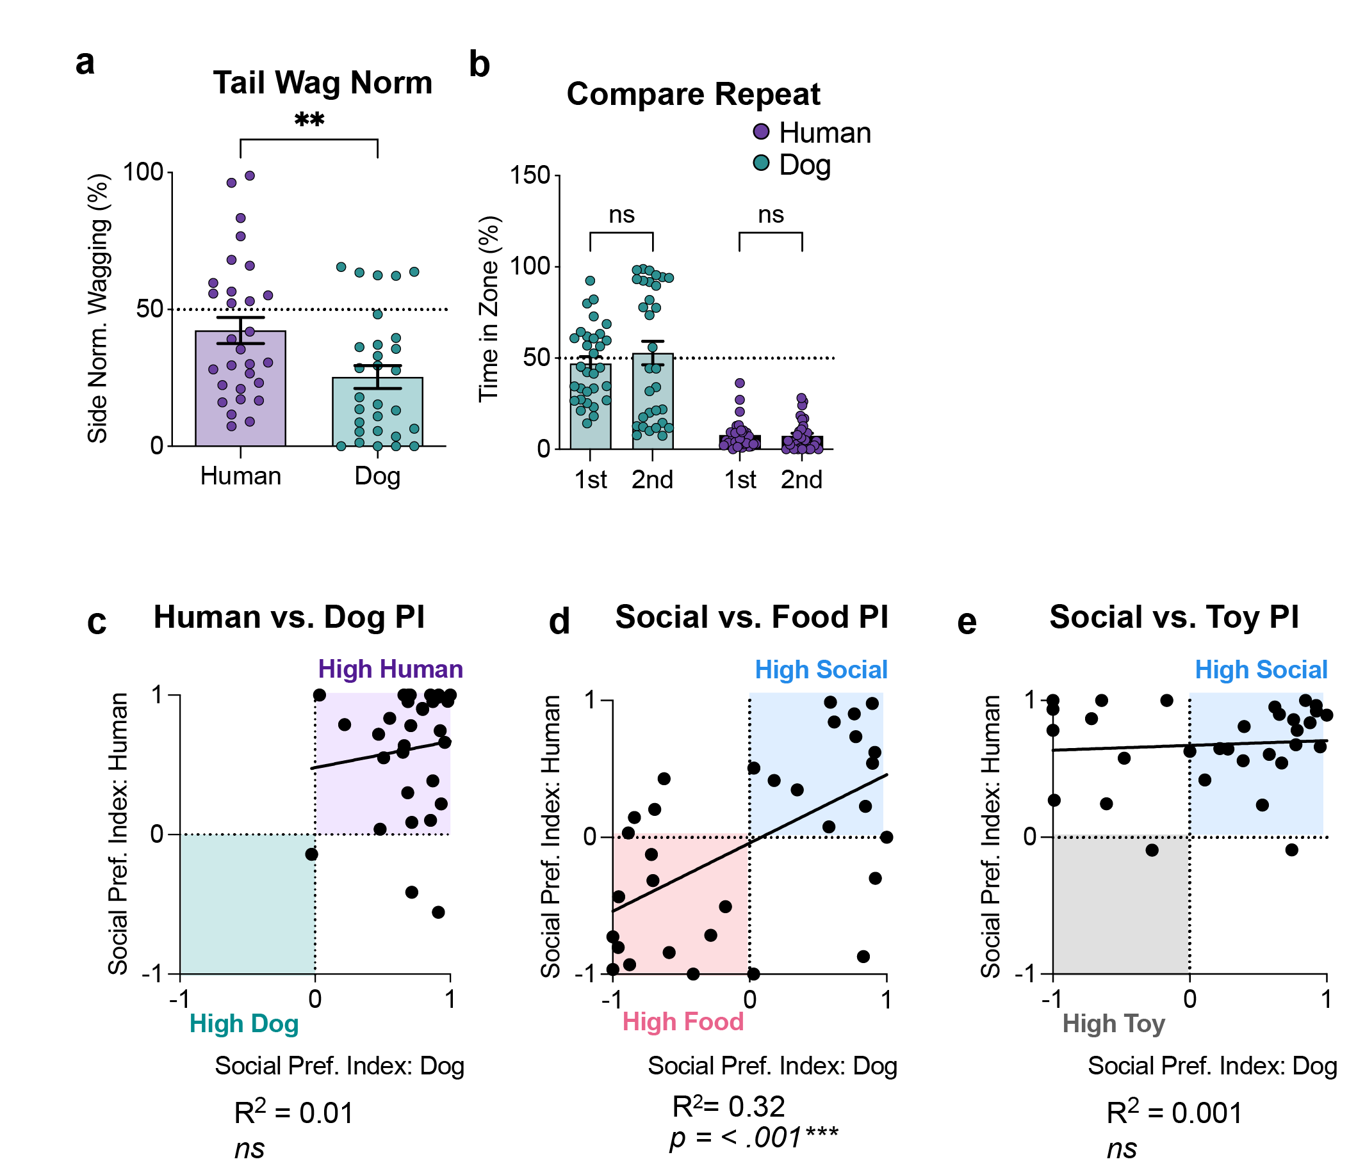
Supplementary Figure 2. Tail Wagging and Spatial Preferences.
(a) Time spent tail wagging (%) normalized by the amount of time spent (s) on the human side or the dog side (b) Compares zone occupancy time (s) for each stimulus on the first and repeated human–dog trials (ns). (c) Social preference indices for each dog across the first and repeat owner-dog trial. (x axis: first trial; y-axis repeat trial). (d) Social preference indices for each dog’s social preference (x axis: dog over food; y axis: human over dog) over food. (e) Social preference indices for each dog’s social preference over a toy on separate trials (x axis: dog over toy; y-human over toy). Bars indicate mean ± SEM. Asterisks denote significance (** p <.01, **** p < .0001; ns, not significant).

Supplemental Figure 3. Effect of Testing Order Across Trials.
(a) Zone time (%) in the First Human vs. Dog trial. (b) Zone time (%) in the repeated Human vs. Dog trial. (c) Zone time (%) in the Human vs. Food trial. (d) Zone time (%) in the Dog vs. Food trial. (e) Zone time in the (%) Human vs. Toy trial. (f) Zone time (%) in the Dog vs. Toy trial. Bars show mean ± SEM of time spent in (s) in each zone. No significant differences were observed between dogs tested first as subjects and those tested after serving as stimulus animals. Points represent individual subjects. Colors indicate grouping by testing order as shown in legend key; ns = not significant.

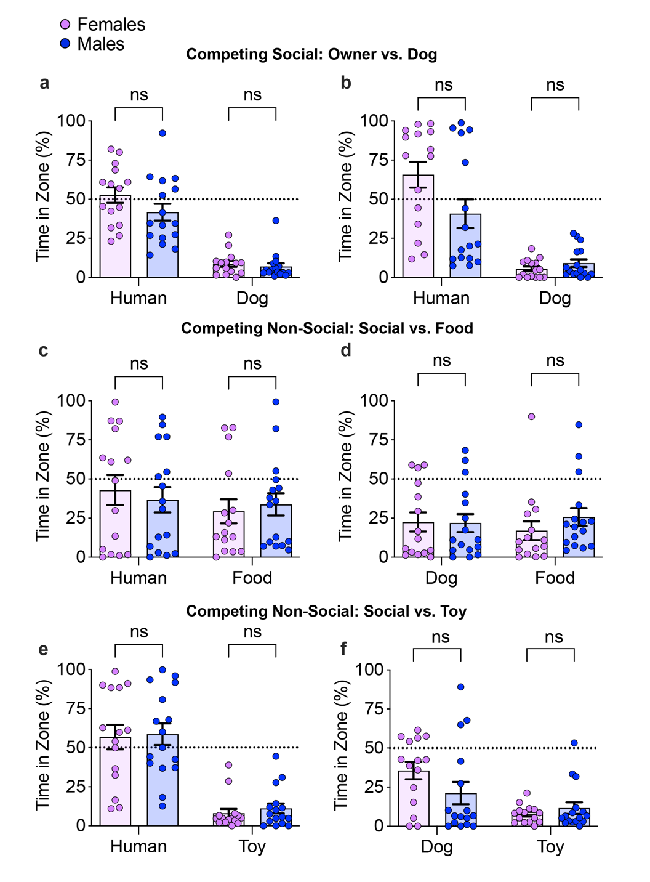

Supplemental Figure 4. Sex Comparison Across Trials
(a) Zone time (%) in the First Human vs. Dog trial. (b) Zone time (%) in the repeated Human vs. Dog trial. (c) Zone time (%) in the Human vs. Food trial. (d) Zone time (%) in the Dog vs. Food trial. (e) Zone time in the (%) Human vs. Toy trial. (f) Zone time (%) in the Dog vs. Toy trial. Bars show mean ± SEM of time spent in (s) in each zone. No significant differences were observed between dogs tested first as subjects and those tested after serving as stimulus animals. Points represent individual subjects. Colors indicate grouping by sex condition as shown the legend key. Asterisks denote significance (** p < .01, **** p < .0001; ns, not significant).

Supplemental Figure 5. Time-binned Analysis Across Trials.
(a) Zone time (s) in the First Human vs. Dog trial. (b) Zone time (s) in the repeated Human vs. Dog trial. (c) Zone time (%) in the Human vs. Food trial. (d) Zone time (s) in the Dog vs. Food trial. (e) Zone time in the (s) Human vs. Toy trial. (f) Zone time (s) in the Dog vs. Toy trial. Bars show mean ± SEM of time spent in (s) in each zone. Colors indicate grouping by stimulus condition as shown the legend key. Bars represent mean ± SEM across three 60-s bins (1st–3rd). Asterisks denote significance (** p < .01, *** p < .001; ns, not significant).

Supplementary Table 1. Subject Demographics Summary
Supplementary Table 1. Subject demographics summary.
Characteristic |  | n | % | Mean (SD) | Range
Total dogs tested |  | 31
Sex
Male |  | 16 | 51.6
Female |  | 15 | 48.4
Age (years) |  |  |  | 5.24 (3.62) | 1–15
Owner sex
Female |  | 31 | 100

Supplementary Table 2. Individual Subject Demographics
Breed | Sex | Age | Testing Order
Norwegian Elkhound | M | 9 | 1
Norwegian Elkhound | F | 4 | 2
Dachshund | F | 2 | 1
Dachshund | F | 2 | 2
Collie | F | 1.5 | 1
Collie | M | 9 | 2
Labrador Retriever | M | 2 | 1
Shepard Mix | F | 4 | 1
Bassett Hound | F | 4 | 1
Poodle | M | 4 | 2
Havanese | F | 7 | 1
Miniature Poodle | M | 15 | 2
Pitbull German Shepard – Husky | M | 2 | 1
Great Pyrenees –Shepard – Rottweiler | F | 5 | 2
Dalmatian | M | 4 | 1
Labradoodle | M | 12 | 1
Labradoodle | M | 12 | 2
Labrador Retriever | F | 5 | 1
Australian Shepard – Mudi | M | 2 | 2
English Setter | F | 3 | 1
Japanese Chin | F | 8 | 1
Pitbull | F | 8 | 1
German Shepard–Lab | M | 8 | 2
Golden Retriever | F | 9 | 1
Dachshund | F | 3 | 1
Labrador Retriever | M | 7 | 1
Great Pyrenees / Maremma | F | 2 | 1
Beagle – Coonhound | M | 2 | 1
Beagle – Coonhound | M | 2 | 1
Pitbull | M | 1 | 2
German Shepard – Great Pyrenees | M | 4 | 1
Testing order denotes whether dogs were tested as subjects before (1) or after (2) serving as stimulus dogs; dogs that never served as stimulus animals were classified as 1.

Supplementary Table 3. Test Order Comparisons Across Trials
Trial | Main Effect of Order | Main Effect of Stimulus | Stimulus × Order Interaction | Figure
Owner vs. Dog (First) | F(1, 29) = 1.12, p = .30 | F(1, 29) = 71.04, p < .0001 | F(1, 29) = 0.52, p = .48 | S3a
Owner vs. Dog (Repeat) | F(1, 29) = 0.02, p = .84 | F(1, 29) = 35.11, p < .0001 | F(1, 29) = 0.44, p = .51 | S3b
Owner vs. Food | F(1, 29) = 1.33, p = .26 | F(1, 29) = 0.93, p = .34 | F(1, 29) = 0.44, p = .51 | S3c
Dog vs. Food | F(1, 29) = 0.22, p = .64 | F(1, 29) = 0.09, p = .76 | F(1, 29) = 0.34, p = .56 | S3d
Owner vs. Toy | F(1, 29) = 0.11, p = .74 | F(1, 29) = 55.05, p < .0001 | F(1, 29) = 0.14, p = .71 | S3e
Dog vs. Toy | F(1, 29) = 0.036, p = .85 | F(1, 29) = 8.72, p = .006 | F(1, 29) = 0.15, p = .70 | S3f
Table note: Test order comparisons were conducted using two-way mixed model ANOVAs with stimulus as a within-subject factor and test order as a between-subject factor. No statistically significant main effects of sex or stimulus × sex interactions were observed across comparisons (all p > .05). Group conditions consisted of those that served as stimulus dogs first or second.

Supplementary Table 4. Sex Comparisons Across Trials
Trial | Main Effect of Sex | Main Effect of Stimulus | Stimulus × Sex Interaction | Figure
Owner vs. Dog (First) | F(1, 29) = 2.97, p = .10 | F(1, 29) = 88.86, p < .0001 | F(1, 29) = 1.21, p = .28 | S4a
Owner vs. Dog (Repeat) | F(1, 29) = 3.59, p = .07 | F(1, 29) = 42.43, p < .0001 | F(1, 29) = 4.11, p = .05 | S4b
Owner vs. Food | F(1, 29) = 0.03, p = .86 | F(1, 29) = 0.63, p = .43 | F(1, 29) = 0.26, p = .61 | S4c
Dog vs. Food | F(1, 29) = 0.68, p = .42 | F(1, 29) = 0.02, p = .90 | F(1,29) = 0.49, p = .49 | S4d
Owner vs. Toy | F(1, 29) = 0.24, p = .63 | F(1, 29) = 60.49, p < .0001 | F(1, 29) = 0.01, p = .92 | S4e
Dog vs. Toy | F(1, 29) = 1.24, p = .28 | F(1, 29) = 12.37, p = .002 | F(1, 29) = 2.98, p = .10 | S4f
Table note: Sex comparisons were conducted using two-way mixed model ANOVAs with stimulus as a within-subject factor and sex as a between-subject factor. No statistically significant main effects of sex or stimulus × sex interactions were observed across comparisons (all p > 0.05).

Supplementary Table 5. Time Bin Comparisons Across Trials
Trial | Main Effect of Time | Main Effect of Stimulus | Stimulus × Time Interaction | Figure
Owner vs. Dog (First) | F(2, 60) = 4.36 p < .02 | F(1, 30) = 87.70, p < .0001 | F(2, 60) = 0.34, p = .72 | S5a
Owner vs. Dog (Repeat) | F(1.37, 40.94) = 4.24, p = .03 | F(1, 30) = 42.46, p < .0001 | F(1.49, 44.57) = 1.65, p = .21 | S5b
Owner vs. Food | F(1.66, 49.69) = 1.10, p = .33 | F(1, 30) = 1.11, p = .30 | F(1.49, 44.60) = 7.26, p = .004 | S5c
Dog vs. Food | F(1.83, 54.86) = 5.47, p = .008 | F(1, 30) = 0.05, p = .82 | F(1.97, 59.19) = 0.34, p = .82 | S5d
Owner vs. Toy | F(1.46, 43.73) = 1.34, p = .27 | F(1, 30) = 62.77, p < .0001 | F(1.40, 42.04) = 3.98, p = .04 | S5e
Dog vs. Toy | F(1.85, 55.59) = 0.59, p = .55 | F(1, 30) = 15.95, p < .0001 | F(1.72, 51.67) = 1.46, p = .24 | S5f
Table note: Time bin comparisons were conducted using two-way repeated-measures ANOVAs with stimulus and time both as a within-subject factors. Dunnett’s post hoc comparisons were made where appropriate.

