Detailed description of testing methodology

Set-up area
All dog puppies were tested in a quiet testing room at KMBase. Before the cognitive battery, all of the puppies had been familiarized with the test room. The experimental setup was employed from a previous published study (Figure S1), which consisted of two 2-meter lines marked on the floor, arranged in the shape of a capital “T”, with the lines intersecting at position C. Positions L and R were located 1 meter to the left and right of position C, respectively (Salomons et al., 2021).
The designated testing zone was securely enclosed within a larger area (4 m * 4 m) by a 160-centimeter-high barrier. All testing procedures were meticulously recorded using five automated video cameras (Intel Realsense D455 RGB), strategically placed at the four corners and the midpoint of the test area. This setup ensured comprehensive coverage and accurate documentation of the dogs' behavior throughout the experiment.
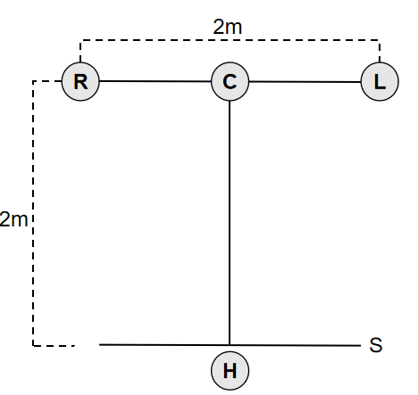
Figure S1. Test area set-up.

Food reward
We used dry dog kibble as the bait. This kind of food was a common reward used in daily training of these police dogs and all the dogs came to participant in the test in a food-deprived state during regular feeding schedule, which ensured enough motivation for each subject.

Experimenter and Handler
During the whole test procedure, all the handlers (H) were their owners in order to reduce stress level and promote better engagement. All the experimenter (the one who presented the food and the stimuli in front of the dog, E) were our stuff with professional training. The primary reason for using an unfamiliar person as the experimenter is to standardize the procedure and avoid unintentional cues (e.g., subtle changes in posture, gaze, or even breathing patterns), whereas a trained experimenter can execute the gesture in a highly consistent and neutral manner across all trials.

General Procedures
- Familiarization
Prior to the assessments, all dogs were given a 30-minute acclimation period to adapt to the environment or the unfamiliar experimenters, ensuring that they were comfortable and familiar with their surroundings before the tests began. This reduces the tendency to explore instead of paying attention to the test.

- Warm-up
At the beginning, all the dogs were required to pass a warm-up criterion. This step was conducted to assure the dogs were motivated to search for food and to prevent side biases. First, H positioned the dog at location H. E approached the dog to offer food in her hand while saying "look," enabling the dog to observe and smell. E then stepped backward while facing the dog and put the food bowl at location C without making a sound. The bowl used during the test was showed in Figure S2. After placing the bait, E knelt behind the bowl with her hands resting flat on her thighs, looking directly down at her lap. The dog was allowed to approach the bowl and obtain the reward. If the subject did not approach the bowl within 15 s, the trial was repeated. To pass the warm-up phase, the subject was required to successfully retrieve the food from the bowl on two consecutive trials within a maximum of six trials. This phase called One Bowl Centered.
Phase 2, which called One Bowl Alternating, was similar to phase 1, except that the bowl’s position was counterbalanced between the R or L positions. The same repeat criteria and pass criteria were used.

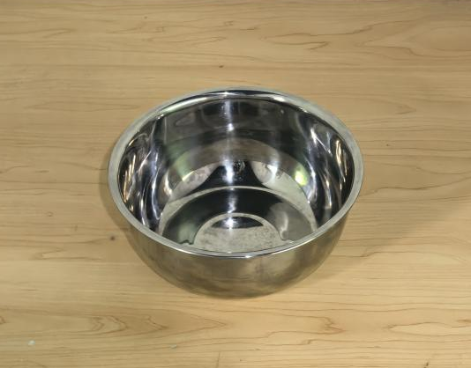
Figure S2. The bowl used in our test tasks.

- Working Memory
Two bowls were placed at both R and L. E was provided a list denoting which side to place for each trail. Side placement was counterbalanced with the constraint that the reward could not be on the same side in more than two consecutive trials. H positioned the dog at location H. E approached the dog to offer food in her hand while saying "look," enabling the dog to observe and smell. E then stepped backward while facing the dog and put the food bowl at the appropriate location (R or L) without making a sound. After placing the bait, E walked back to the center location C and knelt behind the bowl with her hands resting flat on her thighs, looking directly down at her lap. The dog was allowed to approach the bowl and obtain the reward.
If the subject chose the baited bowl, the subject was allowed to have the reward and the next trial was administered. If the subject chose the incorrect bowl, E said "wrong" in a monotone voice and the subject was not rewarded nor allowed to see where the food was located. If the subject did not choose any bowl within 15 s, the trial was repeated. A “choice” was defined as the dog’s nose passing over the edge of a bowl. The dog was required to choose the baited bowl first in four out of five consecutive trials, within a maximum of 20 trials, to advance to the Gesture Comprehension test.

- Gesture Comprehension
In Gesture Comprehension, the experimenter provided one of four cues – arm pointing, communicative marker, body versus gesture control, or odor control (details are described below) – before allowing the dog to begin searching.
Two bowls were placed at both R and L. E was provided a list denoting which side to place for each trail. Side placement was counterbalanced with the constraint that the reward could not be on the same side in more than two consecutive trials. H positioned the dog at location H. E approached the dog to offer food in her hand while saying "look," enabling the dog to observe and smell. E closed her fingers around the food and rotated her wrist so that the back of her hand faced the subject, occluding the food. E then stepped backward to the bowl at position R, bent down and either placed or pretended to place (as appropriate for the trial) the food in the bowl, then walked across to and did the same at the bowl at position L, making identical hand movements and sounds at each bowl. After placing the bait, E walked back to the center location C and performed the designated gesture for the task. She then said "okay!" signaling H to let go of the subject. Throughout the trial, H (who did not know the location of the hidden food) sat still in place.
A “choice” was defined as the dog touching the bowl or its nose passing over the edge of the bowl. If the subject chose the baited bowl, the subject was allowed to have the reward and E gave verbal praise. If the subject chose the incorrect bowl, E said "wrong" in a monotone voice and the subject was not rewarded nor allowed to see where the food was located. If the subject did not choose any bowl within 15 s, the trial was repeated.

2.1 Pointing Gesture
After placing the bait, E knelt at location E, bent forward to establish eye-level contact with the dog, and pointed with her proximal arm to the baited bowl, index finger extended, and head turned toward the baited bowl. E then turned her head to look at the subject, said “look!,” and turned her head back toward the baited bowl gaze alternating this way three times, all while maintaining the pointing arm’s position. E then said "Okay!" and maintained the pointing gesture and gazed toward the baited bowl until the trial ended. A total of six test trials were conducted.

2.2 Marker Gesture
After placing the bait, E knelt at location E, picked up a small blue wooden block (5 cm x 5 cm x 5 cm, see Figure S3) in her right hand. Prior to the test, all the subjects underwent a brief familiarization session with the marker object in the test setting to minimize the possibility that the result were due to the novel interest to the object itself. E then held it out in front of her to show the subject while saying “look!”. From the kneeling position, E reached over to set the block next to the bowl at position R, and either left it there if that bowl was the baited one in the trial, or picked it back up. She then reached over to either touch her empty hand to the spot next to position L if she had left the block at position R, or set the block next to the bowl at position L. This procedure ensured that both bowls had equal attention from the experimenter and proximity to her hand. E then returned her hands to rest on her thighs, said “Okay!”, and remained kneeling and looking straight down until the trial ended. A total of six test trials were conducted.

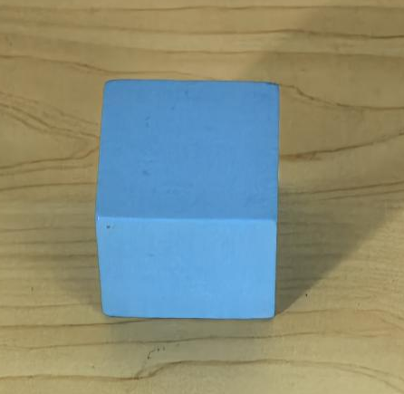
Figure S3. The marker we used in marker gesture task.

2.3 Body versus Pointing Control
This gesture was identical to pointing gesture, except that E knelt directly behind the unbaited bowl (location R or L) instead of in the center (location C). This created a choice between the bowl which E was closest to in proximity, and the bowl toward which E was pointing. This controlled for the possibility that the poor performance could be explained simply by avoidance of the human. A total of six test trials were conducted.

2.4 Odor Control
After placing the bait, no gesture was administered. E knelt down in the center (location C) resting her hands on her thighs, said “Okay!”, and remained kneeling and looking straight down until the trial ended. This created a situation in which subjects had no social information to use to find the food, testing for the possibility that they could use solely olfactory information to locate the food. A total of six test trials were conducted.

Abort Criteria
We employed strict abort criteria during the test. If the subject failed to make a choice within 15 seconds on two consecutive trials or exhibited significant signs of stress (such as excessive whining, barking, escape behavior, or defecation), a break was taken. In most cases where a break was necessary, another attempt was made later the same day. Following a break, the subject restarted the warm-up trials from the beginning. If the subject still exhibits similar symptoms, it would be removed from the test population.
In some cases, if a dog didn’t show such signs but was unable to was unable to finish a specific task due to some reasons (e.g., posed a bite risk to the experimenter if the pointing gesture was sustained, or became so fixated on the marker that all other things were ignored), we would not directly exclude this individual and would skip the current task and proceed to the next step.

Salomons, H., Smith, K. C. M., Callahan-Beckel, M., Callahan, M., Levy, K., Kennedy, B. S., . . . Hare, B. (2021). Cooperative Communication with Humans Evolved to Emerge Early in Domestic Dogs. Current Biology, 31(14), 3137-+. doi:10.1016/j.cub.2021.06.051

