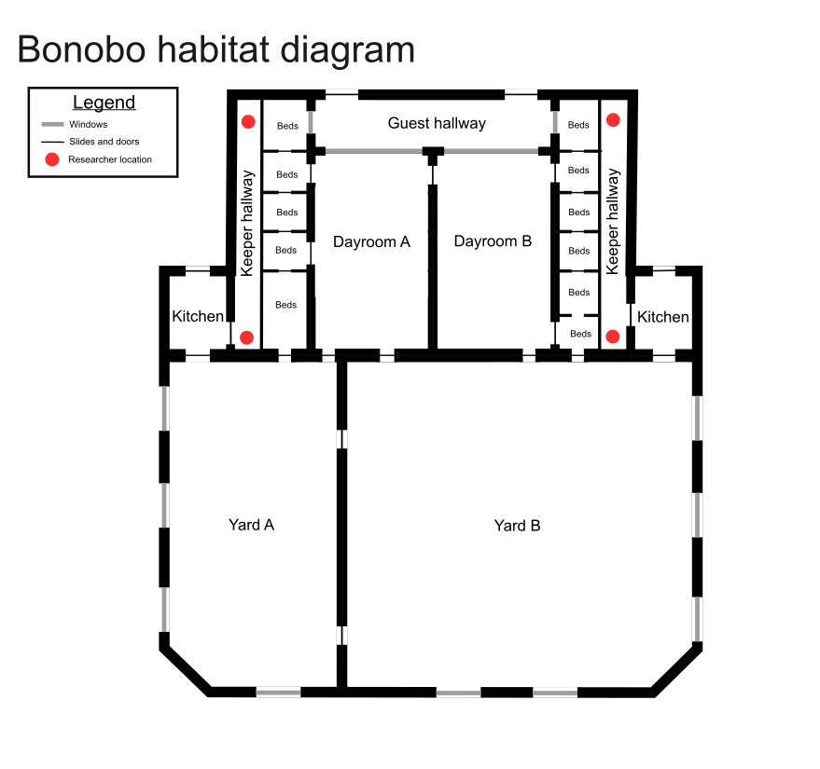Supplementary Figure 1: Diagram of the bonobo habitats at Twycross Zoo at the time of testing. Red dots indicate the position of the researcher during judgement bias training and testing sessions.

