Investigating Planning Behavior in California Sea Lions (Zalophus californianus) Using Computerized Maze Testing
Celeste L. Schonberg, Holli C. Eskelinen, Kelley A. Winship^{1*}, and Mark J. Xitco, Jr.
¹ National Marine Mammal Foundation, 2240 Shelter Island Drive #200, San Diego, CA 902106, USA
* Correspondence: kelley.winship@nmmf.org

Fig. S1 Chart used to track the completion order, date, and score of testing sessions for one subject. A single chart was created for each subject in which the "Test Block" (referred to in the text as "test set") order was unique. Trainers were only responsible for recording the session date and the subject's score
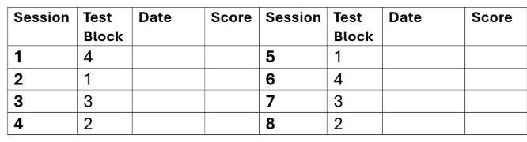

Table S1. The total number and overall proportion of times MAZE was the chosen option during the Selection game, the total number of Selection game sessions each subject played prior to beginning pre-testing, and the overall proportion of correct responses during MT in the Selection game. Values were used to illustrate correlations between experience and performance during training to that of MAZE Testing
 | Anakin | Marty | Rex | Slider | Yoda
Total # Times Presented | 495 | 63 | 1854 | 223 | 398
Total # Times Selected | 52 | 18 | 275 | 22 | 181
Overall Proportion of Times Chosen | 0.11 | 0.29 | 0.15 | 0.1 | 0.45
Total # of Sessions | 12 | 3 | 57 | 6 | 27
Overall Proportion of Correct Responses | 0.59 | 0.67 | 0.87 | 0.5 | 0.78

Fig. S2 Mean (±1SE) success rate for each subject across both exposures in which performance did not significantly increase upon second exposure to the same testing layouts.
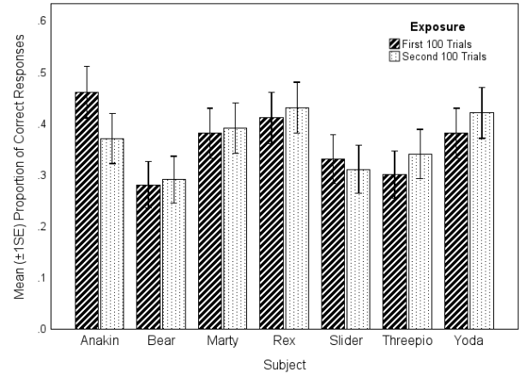

Table S2. The overall proportion of correct responses for each subject across the four trial types (Away + Reversal (A+R), Away, Direct, and Reversal). The highest overall success rate was Yoda's performance in Direct trials, and the lowest was Slider's performance in A+R trials.
 | A+R | Away | Direct | Reversal
Anakin | 0.12 | 0.3 | 0.59 | 0.45
Bear | 0.13 | 0.13 | 0.46 | 0.39
Marty | 0.18 | 0.19 | 0.66 | 0.48
Rex | 0.13 | 0.22 | 0.77 | 0.52
Slider | 0.05 | 0.22 | 0.73 | 0.28
Threepio | 0.08 | 0.32 | 0.68 | 0.22
Yoda | 0.13 | 0.26 | 0.89 | 0.34

Fig. S3 The mean (±1SE) success rate for the sample that was higher in trials without traps present (M = 0.6, SD = 0.49), than those where the sea lion could fall into a trap (M = 0.25, SD = 0.44).
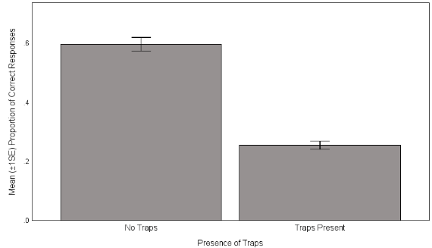

Fig. S4 The mean (±1SE) proportion of correct responses which decreased with each addition of a critical choice (CC). In those with only 1 CC, M = 0.73, SD = 0.45, N = 56. When there were 2 CCs, M = 0.46, SD = 0.5, N = 378. Those with 3 CCs had M = 0.35, SD = 0.48, N = 644. Finally, in layouts with 4 CCs M = 0.22, SD = 0.413. In those with only 1 CC, M = 0.73, SD = 0.45, N = 322.
