Supplementary Material 1. Scan parameters and settings
 | T₁-MPRAGE | Multi-echo gradient echo
TR | 2000 ms | 47 ms
TE | 2.3 ms | 7 to 42 in 5 ms (N_{echo} = 8)
Scan duration | 3 min | 8 min 23 sec
Field of view | 270(AP) × 189(LR) × 135(SI) | 270(AP) × 186(LR) × 135(SI)
Matrix size | 224 × 156 × 112 | 224 × 154 × 112
Voxel size | 1.2 × 1.2 × 1.2 mm³ | 1.2 × 1.2 × 1.2 mm³
Flip angle | 9° | 20°
Pixel bandwidth | 250 Hz | 240 Hz
Parallel imaging factor | 2 | 2
Acquisition dimension | 3D | 3D
Scan plane | Axial | Axial
Flow compensation | N/A | First echo, 3 directions
Abbreviations. MPRAGE, magnetization-prepared rapid acquisition with gradient echo; TR: repetition time; TE: echo time; AP: anterior-posterior; LR: left-right; SI: superior-inferior

Supplementary Material 2. Illustration of the process to reconstruct R2* maps
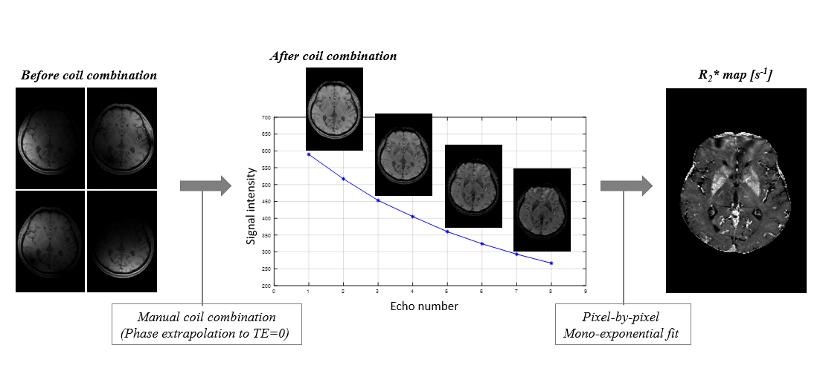
The image data from individual coil channels were processed using an in-house coil combination code. R2* was calculated by pixel-by-pixel mono-exponential fitting of the magnitude data from all echo-times.

Supplementary Material 3. Overall variability of R2* and QSM. QSM shows larger within-group standard deviations relative to the inter-group differences compared to R2* (boldface numbers in the last row).

 | R2* (s⁻¹) |  |  |  |  |  |  | QSM (ppb)
 | NC (n=12) |  | PD (n=14) |  |  |  |  | NC (n=12) |  | PD (n=14)
 | mean | stdev |  | mean | stdev |  | abs(diff) | mean | stdev |  | mean | stdev |  | abs(diff)
Nucleus accumbens | 20.7 | 1.9 |  | 22.5 | 2.5 |  | 1.8 | 5.6 | 9.2 |  | 11.8 | 7.5 |  | 6.2
Caudate | 23.5 | 2.3 |  | 25.9 | 3.2 |  | 2.4 | 27.8 | 4.5 |  | 29.8 | 4.1 |  | 2
Putamen | 27.8 | 2.9 |  | 31.2 | 4.9 |  | 3.4 | 25.9 | 7.3 |  | 30.3 | 8.6 |  | 4.4
Globus pallidus | 37.7 | 5.2 |  | 39.2 | 4.5 |  | 1.5 | 54.9 | 15.1 |  | 51.6 | 12.8 |  | 3.3
Thalamus | 19.8 | 0.9 |  | 20.3 | 1.2 |  | 0.5 | 0.1 | 2.7 |  | -0.5 | 2.6 |  | 0.6
Substantia nigra | 29.1 | 2.8 |  | 31.9 | 3.5 |  | 2.8 | 70.3 | 10.6 |  | 71.6 | 15.1 |  | 1.3
Red nucleus | 26.4 | 2.8 |  | 28.8 | 3.3 |  | 2.4 | 71.2 | 12.3 |  | 67.7 | 10.5 |  | 3.5
Dentate nucleus | 30 | 3.2 |  | 31.4 | 2.7 |  | 1.4 | 50.2 | 15.8 |  | 39.6 | 10.4 |  | 10.6
R. amygdala | 15.5 | 1.1 |  | 16.5 | 1.8 |  | 1 | 0.9 | 9.5 |  | 0.6 | 7.9 |  | 0.3
L. amygdala | 16.6 | 1.2 |  | 16.5 | 1.5 |  | 0.1 | -2 | 7.9 |  | 0.7 | 8.2 |  | 2.7
R. hippocampus | 17.7 | 1 |  | 17.7 | 1.6 |  | 0 | 1.7 | 4.5 |  | 1.9 | 3.2 |  | 0.2
L. hippocampus | 17.2 | 1 |  | 17.4 | 1 |  | 0.2 | 0.9 | 2 |  | 1.5 | 4.4 |  | 0.6
minimum | 15.5000 | 0.9000 |  | 16.5000 | 1.0000 |  | 0.0000 | -2.00 | 2.00 |  | -0.50 | 2.60 |  | 0.20
maximum | 37.7000 | 5.2000 |  | 39.2000 | 4.9000 |  | 3.4000 | 71.20 | 15.80 |  | 71.60 | 15.10 |  | 10.60
average | 23.5000 | 2.1917 |  | 24.9417 | 2.6417 |  | 1.4583 | 25.63 | 8.45 |  | 25.55 | 7.94 |  | 2.98

Abbreviations. NC, normal control; PD: Parkinson’s disease; stdev, standard deviation; abs(diff), absolute difference between the mean values of NC, PD groups

