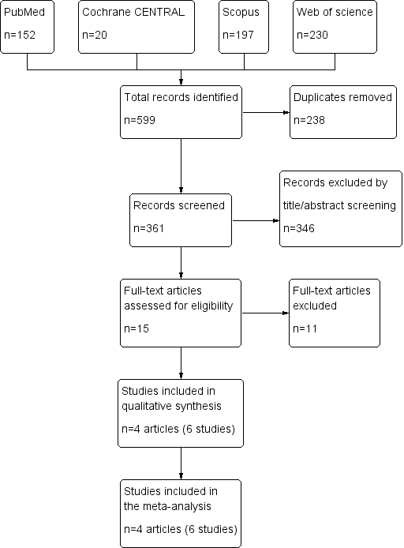
PRISMA flow diagram of the study selection process

