Supplementary Figure 1. Flowchart describing the selection from the original cohort of 72,283 people with MS to the cohort of 35,243 analyzed.

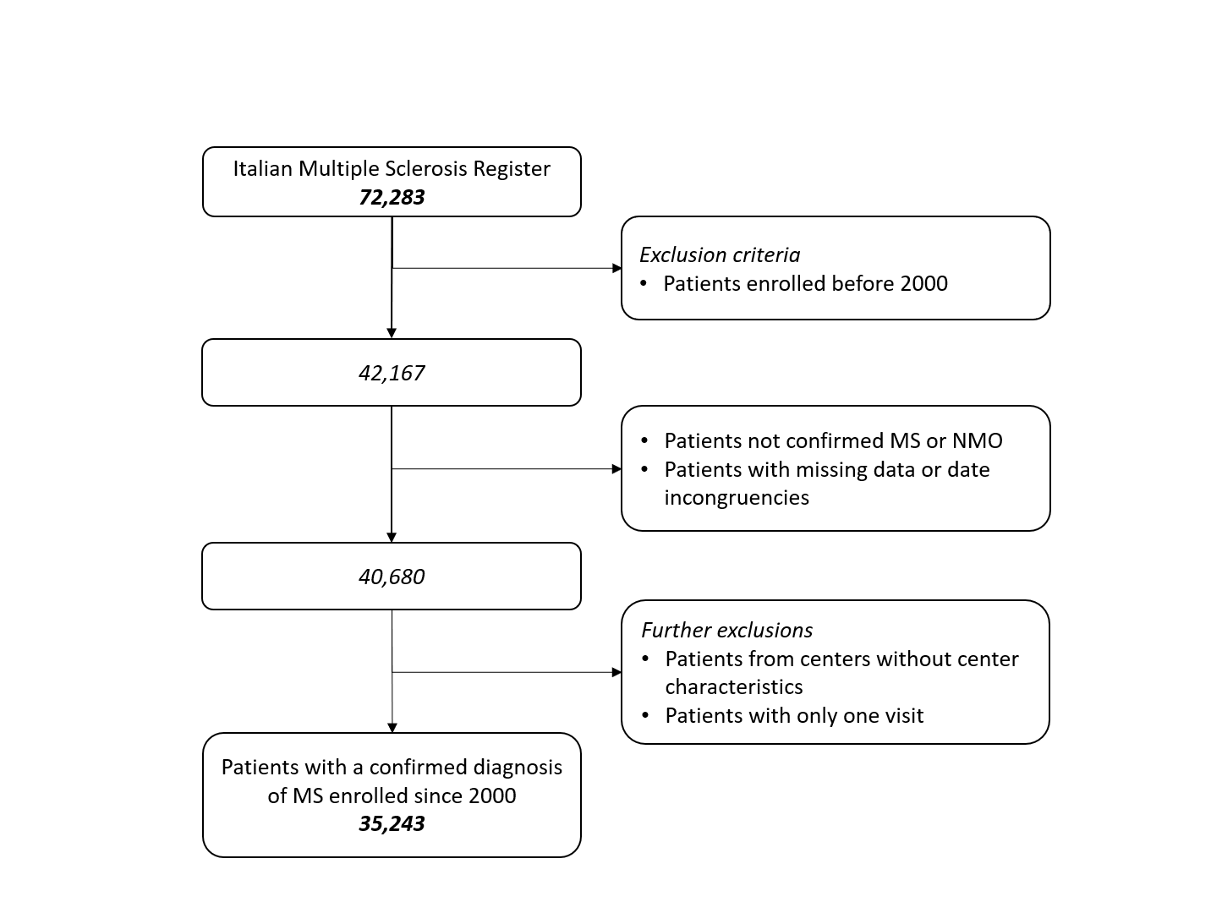

Supplementary Table 1. Baseline characteristics of 5,437 patients enrolled since 2000 and included in the minimum dataset from the Italian MS and Related Disorders Register, but not considered in the final study cohort.

Characteristics | Patients
Calendar year at first visit - No. (%)
2000-2009 | 1,215 (22.4)
2010-2014 | 1,192 (21.9)
2015-2021 | 3,030 (55.7)
Sex - No. (%)
Female | 3,725 (68.5)
Age at onset (years)
Mean (SD) | 34.5 (11.6)
Age at first visit (years)
Mean (SD) | 38.3 (12.3)
Time between disease onset and first visit (months)
Median (IQR) | 22.1 (5.5-70.7)
Number of. of symptoms at onset - No. (%)
1 | 4,542 (83.5)
≥2 | 777 (14.3)
Symptoms at onsetª - No. (%)
Brain system | 1,344 (24.7)
Optic | 1,346 (24.8)
Supratentorial | 1,472 (27.1)
Spinal | 1,607 (29.6)
Age at diagnosis (years)
Mean (SD) | 36.3 (18.8)
Time between disease onset and diagnosis (months)
Median (IQR) | 7.1 (2.0-24.4)
First disease phenotype - No. (%)
Clinically isolated syndrome | 5,160 (94.9)
Primary progressive | 277 (5.1)
Disease phenotype at first visit^{b} - No. (%)
Clinically isolated syndrome | 1,409 (25.9)
Relapsing-remitting | 3,642 (67.0)
Primary progressive | 236 (4.3)
Progressive-relapsing | 41 (0.8)
Secondary progressive | 109 (2.0)
Type of DMT at first visit - No. (%)
No treatment | 2482 (45.6)
First-line treatment | 2,141 (39.4)
Second-line treatment | 669 (12.3)
Off-Label treatment | 146 (2.7)
EDSS score at first visit
Median (IQR) | 1.5 (1.0-2.5)
Multiple sclerosis disease severity at first visit
Median (IQR) | 3.7 (1.6-6.3)
Area of first visit - No. (%)
North-West | 1,583 (29.1)
North-East | 307 (5.7)
Center | 1,210 (22.3)
South | 1,602 (29.5)
Islands | 735 (13.5)
Deprivation index (quintiles) - No. (%)
I-II | 2,291 (42.1)
III | 539 (9.9)
IV-V | 2,607 (48.0)
DMT: disease-modifying therapy; EDSS: Expanded disability status scale; IQR: interquartile range; SD: standard deviation. ª Not mutually exclusive. ^{b} Defined as the last of the three disease courses recorded before the first visit to a center on the Register.

Supplementary Table 2. Characteristics of 106 centers included in the Italian MS and Related Disorders Register, 2018.

Characteristics | Centers
Area of the center - No. (%)
North-West | 36 (34.0)
North-East | 14 (13.2)
Center | 22 (20.8)
South | 22 (20.8)
Islands | 12 (11.3)
Deprivation index (quintiles) - No. (%)
I-II | 39 (36.8)
III | 26 (24.5)
IV-V | 41 (38.7)
Type of center - No. (%)
Azienda Ospedaliera (Hospital)/Azienda Ospedaliera Universitaria (University Hospital) | 68 (64.2)
Presidio Ospedaliero ASL | 26 (24.5)
Other | 12 (11.3)
Organizational structure of the operating unit ª - No. (%)
Complex | 72 (67.9)
Simple | 28 (26.4)
Other | 5 (4.7)
Center provides days or time dedicated to multiple sclerosis patients - No. (%)
No | 2 (1.9)
Yes | 104 (98.1)
Center with difficulties in access to DMT ª - No. (%)
No | 58 (54.7)
Yes | 46 (43.4)
Hospital beds dedicated to multiple sclerosis patients - No. (%)
No | 66 (62.3)
Yes | 40 (37.7)
No. patients with multiple sclerosis followed at the center
Median (IQR) | 500 (250-1000)
Number of neurologists dedicated to multiple sclerosis
Median (IQR) | 3 (2-5.5)
Number of nurses dedicated to multiple sclerosis
Median (IQR) | 2 (2-4)
Presence of a PDTA ª - No. (%)
No | 28 (26.67)
Yes | 77 (73.33)
Presence of a formal PDTA ª - N. (%)
No | 63 (60.0)
Yes | 42 (40.0)
DMT: disease modifying therapy; IQR: interquartile range; PDTA: Diagnostic and Critical Pathways; SD: standard deviation. ª Discrepancies in the total are due to missing values.

Supplementary Table 3. Univariate odds ratios (OR) and corresponding confidence intervals (CI) for clinically isolated syndrome (CIS), primary progressive (PP)/progressive-relapsing (PR), and secondary progressive (SP) phenotypes at first visit compared to Relapsing-remitting (RR) phenotypes according to selected patients’ and center characteristics among 35,243 patients in the Italian MS and Related Disorders Register, 2000-2021.

 | CIS (9 310) | PP/PR (1 770) | SP (575)
 | OR (95% CI) ª | OR (95% CI) ª | OR (95% CI) ª
Patients’ characteristics
Calendar year at first visit
2000-2009 | 1^{b} | 1^{b} | 1^{b}
2010-2014 | 0.88 (0.83-0.95) | 1.00 (0.88-1.14) | 1.57 (1.26-1.97)
2015-2021 | 0.94 (0.88-1.00) | 1.21 (1.07-1.37) | 1.22 (0.97-1.53)
Sex
Male | 1^{b} | 1^{b} | 1^{b}
Female | 0.99 (0.94-1.04) | 0.50 (0.45-0.55) | 0.68 (0.57-0.80)
Age at first visit
<35 years | 1^{b} | 1^{b} | 1^{b}
≥35 years | 0.84 (0.80-0.88) | 9.72 (8.25-11.45) | 7.35 (5.69-9.50)
Time between disease onset and first visit
<13 months | 1^{b} | 1^{b} | 1^{b}
≥13 months | 0.11 (0.11-0.12) | 2.39 (2.12-2.69) | 15.27 (10.04-23.22)
Center characteristics
Area of first visit
North-West | 1^{b} | 1^{b} | 1^{b}
North-East | 1.77 (1.03-3.02) | 1.43 (0.87-2.34) | 1.39 (0.76-2.53)
Center | 1.62 (1.01-2.60) | 1.06 (0.68-1.65) | 1.36 (0.79-2.33)
South | 1.54 (0.97-2.46) | 1.27 (0.83-1.96) | 1.51 (0.90-2.54)
Islands | 0.73 (0.40-1.34) | 1.24 (0.71-2.16) | 0.83 (0.42-1.67)
Deprivation index
I-II | 1^{b} | 1^{b} | 1^{b}
III | 0.59 (0.37-0.93) | 0.81 (0.52-1.24) | 1.36 (0.80-2.31)
IV-V | 0.76 (0.51-1.13) | 0.93 (0.65-1.32) | 1.40 (0.90-2.18)
Number of patients with multiple sclerosis followed at the center
<500 | 1^{b} | 1^{b} | 1^{b}
≥500 | 0.87 (0.61-1.23) | 0.98 (0.70-1.36) | 0.71 (0.48-1.06)
Number of neurologists dedicated to multiple sclerosis
<3 | 1^{b} | 1^{b} | 1^{b}
≥3 | 1.12 (0.75-1.66) | 1.06 (0.73-1.54) | 0.84 (0.53-1.32)
Number of nurses dedicated to multiple sclerosis
<2 | 1^{b} | 1^{b} | 1^{b}
≥2 | 1.20 (0.71-2.02) | 1.42 (0.80-2.50) | 0.95 (0.48-1.92)
Center with difficulties in access to DMT
No | 1^{b} | 1^{b} | 1^{b}
Yes | 1.37 (0.96-1.94) | 1.30 (0.95-1.79) | 1.14 (0.768-1.68)
Hospital beds dedicated to multiple sclerosis patients
No | 1^{b} | 1^{b} | 1^{b}
Yes | 0.86 (0.59-1.23) | 0.88 (0.63-1.23) | 1.09 (0.73-1.64)
PDTA
No | 1^{b} | 1^{b} | 1^{b}
Yes | 1.15 (0.76-1.72) | 1.08 (0.74-1.57) | 0.66 (0.43-1.03)
DMT: disease-modifying therapy; PDTA: Diagnostic and Critical Pathways. ª Odds ratio from multinomial, multilevel logistic regression models with random effects for center compared to RR phenotype. ^{b} Reference category.

