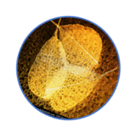

Parallel chart for clinicians of patients with Neuromyelitis Optica Spectrum Disorders

NARRARE LA NEUROMIELITE OTTICA

YESTERDAY
When I first met him/her[…] My first impression on her/him[…]His/her body was[…]Diagnosis communication[…] I was[…] At home his/her relatives[…]

TODAY
She/he today[…] His/her body is[…]His daily routine is[…] She/he wants[…] The clinical treatment[…] When I meet her/him[…] Relationship with parenthal caregivers[…] Being his/her doctor is[…]

TOMORROW
When I think about his/her tomorrow[…] I would like to[…]

NARRATIVE EXPERIENCE
Telling my story was[…]

THANKS FOR YOUR ENERGY, THOUGHTS AND TIME. EVERY STORY COUNTS!

