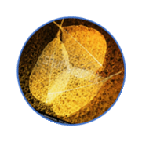
Illness plot for patients with Neuromyelitis Optica Spectrum Disorders

NARRATIVE MEDICINE TO INVESTIGATE THE QUALITY OF LIFE OF PATIENTS WITH NEUROMYELITIS OPTICA

YESTERDAY
Before Neuromielite Optica […] Suddenly […] People and medical centre I went to […] When I received the clinical diagnosis […] So I felt […] My body[…] (moving, looking around, talking, eating, drinking, was…) My daily routine was […] At home […] With others […] I would […]

TODAY
Today[…]I feel[…] My body… (moving my body, looking around, talking, eating, drinking is…) My daily routine is[…] At home[…] With others[…] Neuromyelitis Optica is[…] The treatment for Neuromyelitis Optica is[…] About medical doctors[…] I want[…]

TOMORROW
Tomorrow[…]I would like to[…]

NARRATIVE EXPERIENCE
Telling my story was…

THANK YOU FOR YOUR TIME, ENERGY AND THOUGHTS. EVERY STORY COUNTS.

