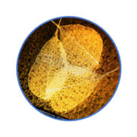
Narrative plot for caregivers of patients with Neuromyelitis Optica Spectrum Disorders

YESTERDAY
Before Neuromyelitis Optica[…] Suddenly[…] People and medical centre we went to[…] When we received the clinical diagnosis[…] She/he was[…] So I was/I felt[…] His/her body[…]Her/his daily routine was[…] My daily routine was[…] At home[…] With others[…] She/He wanted[…] I wanted[…]

TODAY
She/he today[…] She/he feel[…] I feeL[…] Her/his body is[…]Her/his daily routine is[…]My daily routine is[…] At home[…] With others[…]Neuromyelitis Optica is[…] The treatment[…] About medical doctors[…] She/he wants[…] I want[…]

TOMORROW
Tomorrow[…] I would like to[…]

NARRATIVE EXPERIENCE
Telling my story was…

THANK YOU FOR YOUR TIME, ENERGY AND THOUGHTS. EVERY STORY COUNTS!

