Supplementary Table 1 Individual AEs reported in the SASª
AEs by primary system organ class^{b} | n (%)
General disorders and administration site conditions  Injection site erythema  Injection site pruritus  Drug ineffective  Gastrointestinal disorders  Constipation  Nausea  Skin and subcutaneous tissue disorders  Infections and infestations  COVID-19  Nervous system disorders | 22 (6.2)  6 (1.7)  5 (1.4)  4 (1.1)  14 (4.0)  8 (2.3)  5 (1.4)  9 (2.5)  6 (1.7)  5 (1.4)  5 (1.4)
AE = adverse event, SAS = safety analysis set
ªTotal patients in SAS = 354; ^{b}Includes system organ class reported in ≥1% of the study population and specific disorders reported in ≥1% of the study population

Supplementary Fig. 1 PEARL study design. ªBaseline is defined as the 28-day period prior to initiating treatment with fremanezumab; eligible patients have ≥21 days of data from this 28-day period in their headache diary. ^{b}Fremanezumab is initiated within 3 months of the first visit (Month 0). CM = chronic migraine, EM = episodic migraine
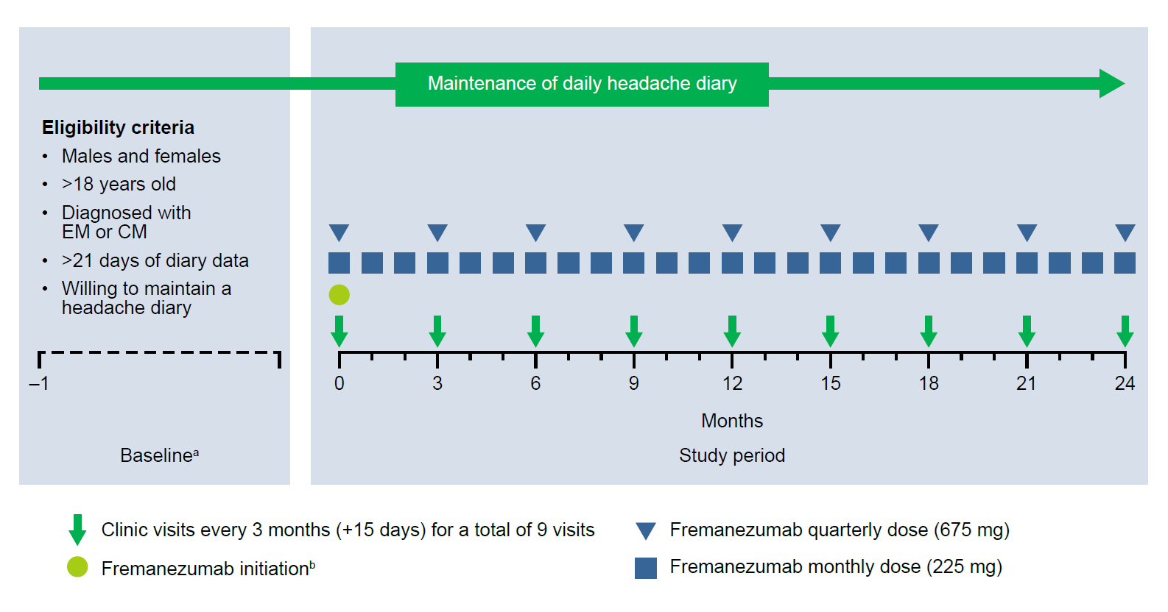

Supplementary Fig. 2 Proportion of patients achieving ≥50% reduction in MMD at Month 3 and Month 6 by migraine type. CM = chronic migraine, EM = episodic migraine, MMD = monthly migraine days
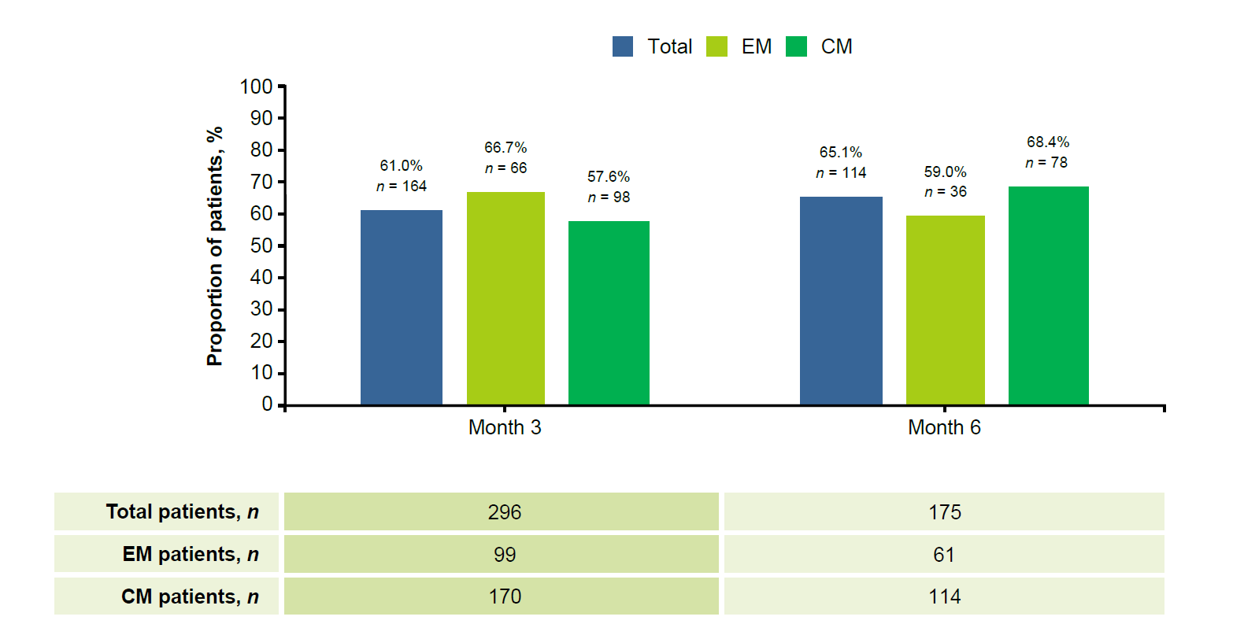

Supplementary Fig. 3 Proportion of patients achieving ≥50% reduction in MIDAS score at Month 3 and Month 6 by migraine type. CM = chronic migraine, EM = episodic migraine, MIDAS = Migraine Disability Assessment Scale

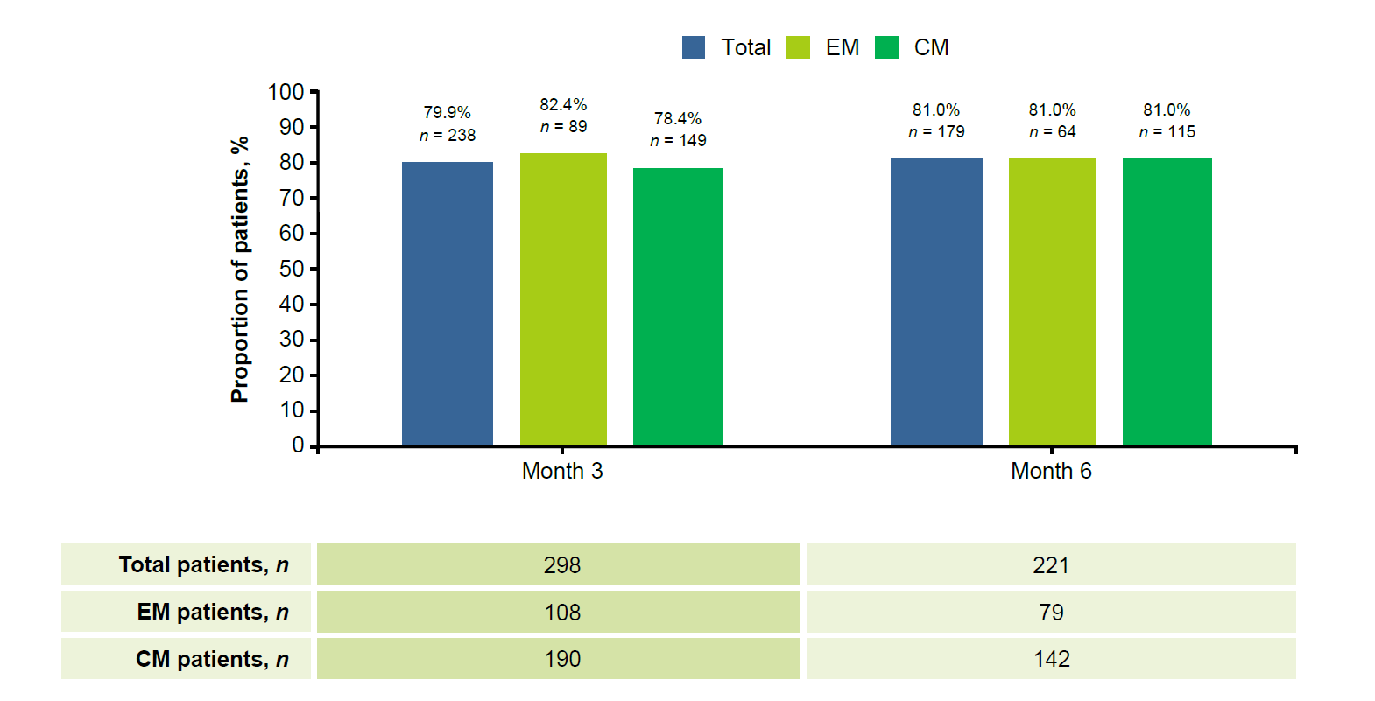

Supplementary Fig. 4 Change from baseline in the monthly average number of days with any acute migraine medication use at Month 3 and Month 6 by migraine type. CM = chronic migraine, EM = episodic migraine

