Supplementary Table 1. Correlation matrix showing Spearman’s r coefficients for the main diagnostic test variables.
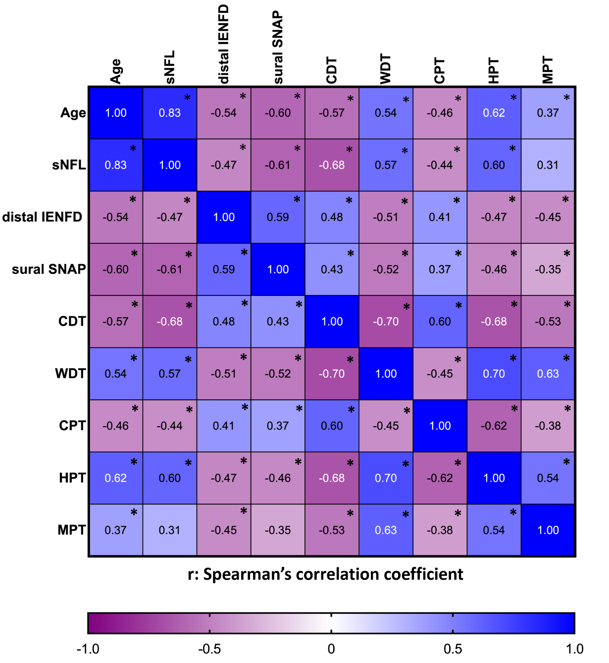

Supplementary Table 1. * indicate correlations with p<0.05. sNfL: serum neurofilament light chain levels; distal IENFD: intraepidermal nerve fibre density at the distal site; sural SNAP: sural sensory nerve action potential; CDT: cold detection threshold; WDT: warm detection threshold; CPT: cold pain threshold; HPT: heat pain threshold; MPT: mechanical pain threshold.

