Supplementary material
supplementary material .1: Forest plot of the subgroup analysis of Effect of Traditional CBT vs Tele-CBT on Depression
supplementary material .2: Sensitivity analysis of the effect of CBT on depression
supplementary material .3: Forest plot of the subgroup analysis of the Effect of Traditional CBT vs Tele-CBT on Anxiety.
supplementary material .4: Sensitivity analysis of the effect of CBT on Anxiety
supplementary material .5: Forest plot of the long-term effects of CBT on Depression versus control in PD patients based on follow-up values of different time points
supplementary material .6: Forest plot of the long-term effects of CBT on Anxiety versus control in PD patients based on follow-up values of different time points.

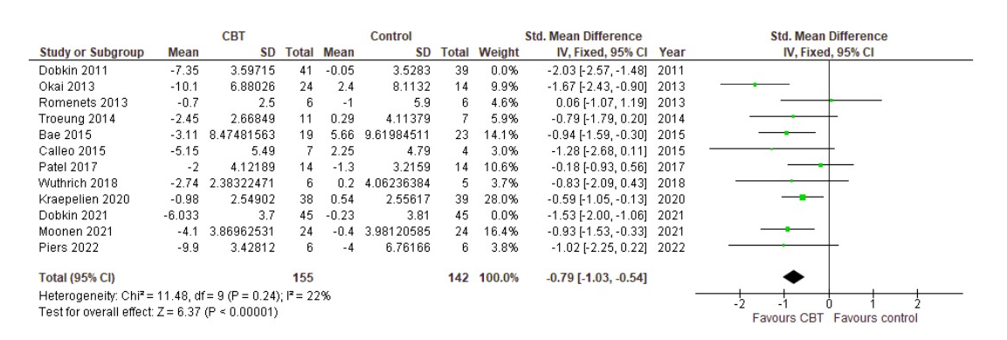
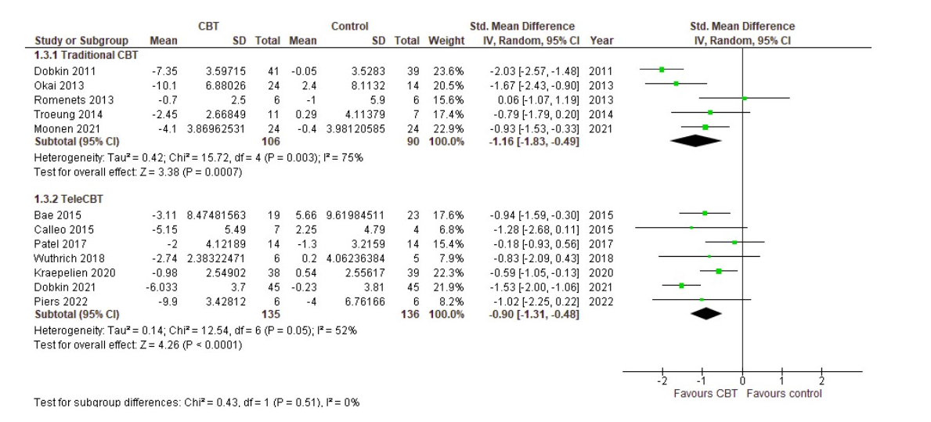
supplementary material .1: Forest plot of the subgroup analysis of Effect of Traditional CBT vs Tele-CBT on Depression.
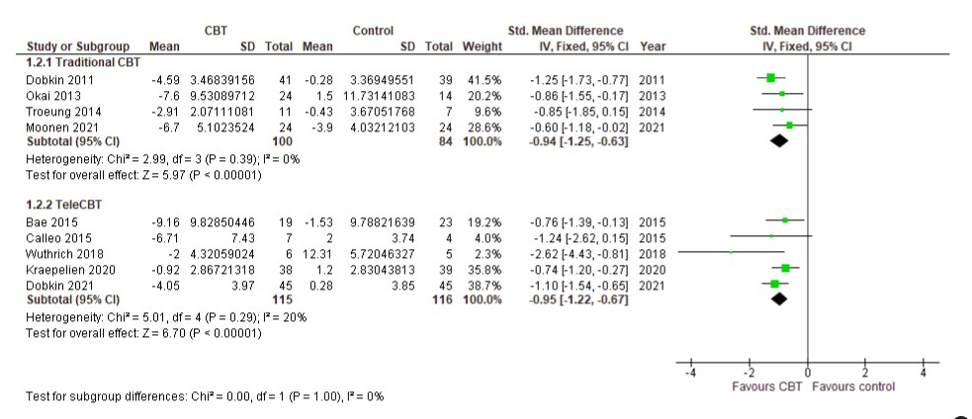
supplementary material .2: Sensitivity analysis of the effect of CBT on depression
supplementary material .3: Forest plot of the subgroup analysis of the Effect of Traditional CBT vs Tele-CBT on Anxiety.
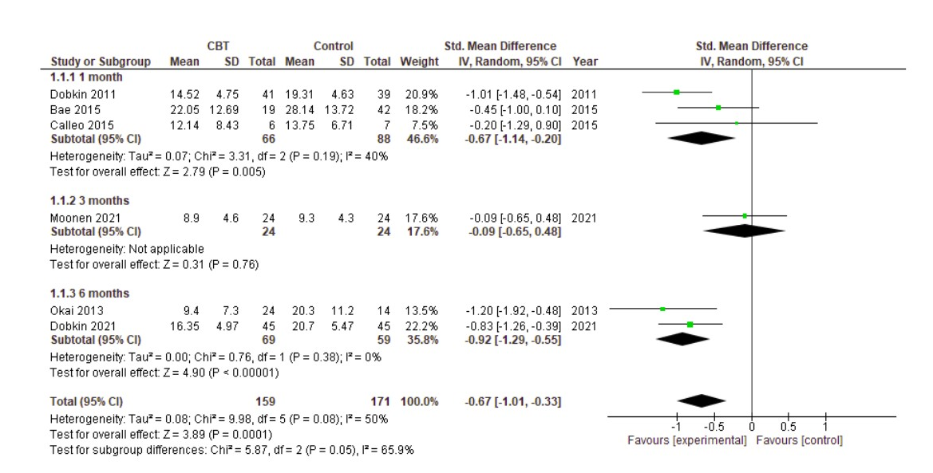
` supplementary material .4: Forest plot of the long-term effects of CBT on Depression versus control in PD patients based on follow-up values of different time points
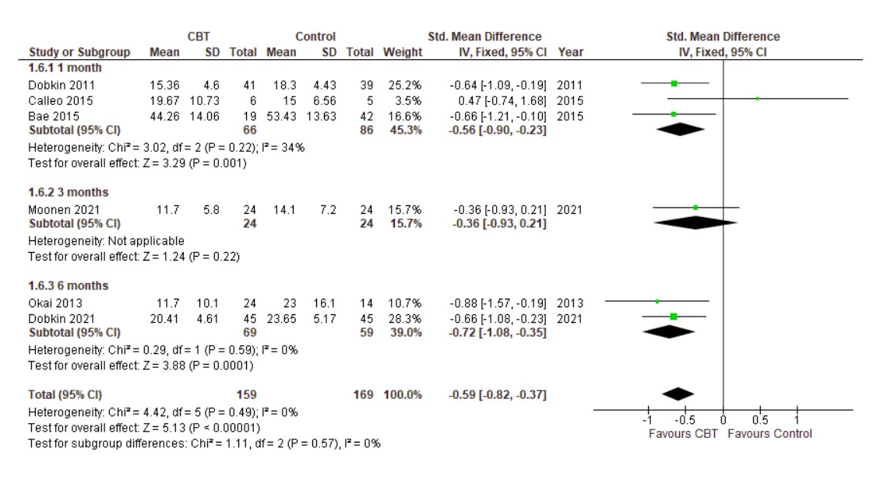
supplementary material .5: Forest plot of the long-term effects of CBT on Anxiety versus control in PD patients based on follow-up values of different time points.

