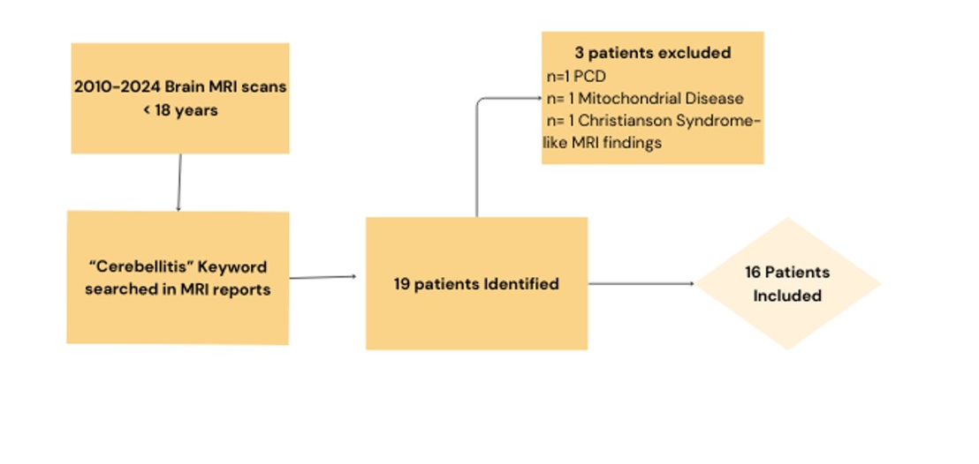
Supplementary material 1: Flow diagram for inclusion and exclusion of studies.

