Administrative Region | Mean Annual Cases | Mean Annual New Cases | Prevalence  (per 100.000 persons) [95% CI] | Incidence  (per 100.000 person-years) [95% CI] | Mortality  (per 100.000 person-  years) [95% CI]
Eastern Macedonia and Thrace | 2320 | 274 | 413 [396 - 430] | 49 [43 - 55] | 71 [64 - 78]
Central Macedonia | 6209 | 710 | 346 [337 – 354] | 40 [37 – 43] | 66 [62 – 70]
Western Macedonia | 908 | 100 | 356 [334 – 380] | 39 [32 – 48] | 57 [48 – 67]
Epirus | 1309 | 155 | 409 [387 – 432] | 48 [41 – 57] | 61 [53 - 70]
Thessaly | 3640 | 478 | 529 [512 – 546] | 69 [63 – 76] | 83 [76 – 90]
Western Greece | 3029 | 334 | 467 [451 – 484] | 51 [46 – 57] | 79 [72 – 86]
Ionian Islands | 976 | 122 | 477 [448 – 508] | 60 [50 – 71] | 83 [71 – 96]
Central Greece | 2006 | 220 | 395 [378 – 412] | 43 [38 – 49] | 74 [67 – 82]
Attica | 15396 | 1980 | 404 [397 – 410] | 52 [50 – 54] | 74 [71 – 76]
Peloponnese | 2440 | 254 | 452 [435 – 471] | 47 [42 – 53] | 80 [73 – 88]
Northern Aegean | 811 | 102 | 416 [388 – 446] | 52 [43 – 64] | 72 [61 – 85]
Southern Aegean | 925 | 130 | 282 [264 – 301] | 40 [33 – 47] | 41 [35 – 49]
Crete | 1943 | 216 | 311 [298 – 325] | 35 [30 – 39] | 55 [50 – 61]
Greece | 41912 | 5073 | 400 [396 – 404] | 48 [47 – 50] | 71 [69 – 72]
Supplemental Table 1. Mean annual cases, mean annual new cases, overall prevalence, incidence and mortality rates per region in Greece. Incidence reported for years 2020-2023 and prevalence and mortality for years 2020-2024
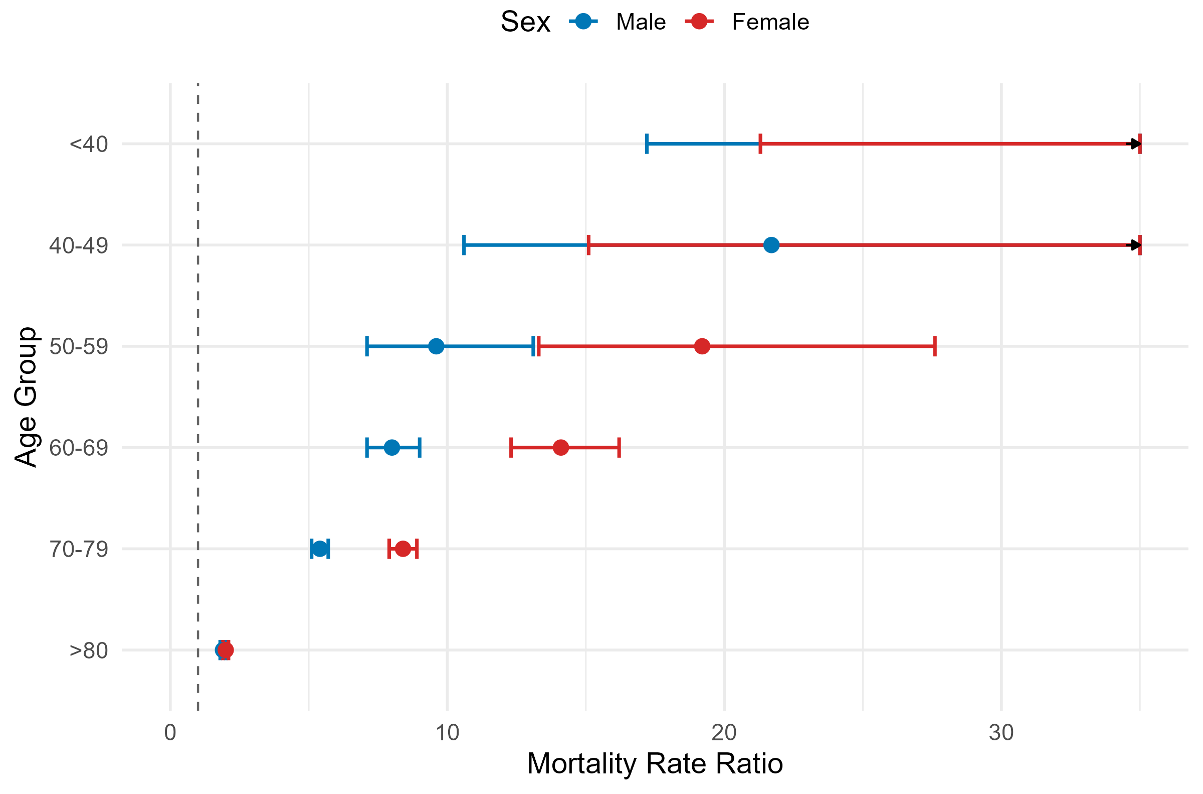
Supplemental Figure 1. Sex- and Age- stratified Mortality Rate Ratios of patients with Parkinson’s Disease compared to the general population (2020-2024)

