Supplementary data:

Supplementary Table S1: Pairwise Comparisons Between MG Subgroups and Controls
 | EOMG vs Control | LOMG vs Control | VLOMG vs Control | EOMG vs LOMG | EOMG vs VLOMG | LOMG vs VLOMG
 | p-value | p-value | p-value | p-value | p-value | p-value
Urinary Symptoms
Urinary incontinence (ICIQ UI-SF score≥6) | <0.001 | <0.001 | <0.001 | 0.387 | 0.686 | 0.252
Total ICIQ UI-SF SCORE
Slight (1-5) | 0.385 | 0.070 | 0.431 | 0.360 | 0.246 | 0.071
Moderate (6-12) | 0.703 | 0.055 | 0.815 | 0.154 | 0.921 | 0.191
Severe (13-18) | <0.001 | <0.001 | <0.001 | 0.839 | 0.764 | 0.950
Very severe (19-21) | 0.025 | 0.027 | 0.064 | 0.943 | 0.824 | 0.784
Stress urinary incontinence | <0.001 | <0.001 | 0.054 | 0.242 | 0.262 | 0.044
Daytime frequency ≥8 times | 0.574 | 0.261 | 0.983 | 0.552 | 0.668 | 0.365
Nighttime Frequency
1 time | 0.044 | 0.119 | 0.393 | 0.937 | 0.419 | 0.467
2 times | 0.089 | 0.471 | 0.138 | 0.631 | 0.993 | 0.651
≥3 times | 0.102 | <0.001 | 0.045 | 0.107 | 0.642 | 0.286
OABSS score† | 0.029 | <0.001 | 0.011 | 0.155 | 0.252 | 0.597
Any nighttime void (≥1 episode/night) | 0.559 | 0.111 | 0.062 | 0.262 | 0.194 | 0.970
Urgency
Once a week or more | 0.939 | 0.462 | 0.646 | 0.571 | 0.742 | 0.820
About once a day | 0.013 | 0.422 | 0.219 | 0.385 | 0.016 | 0.091
2–4 times a day | 0.005 | <0.001 | <0.001 | 0.371 | 0.061 | 0.467
5 times a day or more | <0.001 | <0.001 | 0.010 | 0.552 | 0.391 | 0.200
Duration of urinary symptoms | 0.011 | 0.194 | 0.015 | 0.004 | 0.070 | 0.370

*Significant at p<0.05; values in bold remain significant after Bonferroni correction (p<0.0167 for MG subgroup vs control comparisons, p<0.0167 for between MG subgroup comparisons). †Mann-Whitney U test used for continuous variables; all other comparisons used χ² test or Fisher's exact test as appropriate.
Abbreviations: EOMG, early-onset myasthenia gravis. LOMG, late-onset myasthenia gravis. VLOMG, very late-onset myasthenia gravis.; ICIQ-UI SF, International Consultation on Incontinence Questionnaire-Urinary Incontinence Short Form; OABSS, Overactive Bladder Symptom Score.

Supplementary table S2: Multivariate Analysis for Predicting Urinary Incontinence (ICIQ UI-SF≥6)
Variable | Adjusted Odds Ratio | 95% CI | P-value
MG-ADL Score | 2.38 | 1.04-5.46 | 0.041
Pyridostigmine Only | 0.29 | 0.05-1.58 | 0.153
LOMG | 1.61 | 0.54-4.82 | 0.395
Disease Duration | 1.07 | 0.95-1.21 | 0.274
Diuretics | 1.89 | 0.52-6.86 | 0.332
Note: Variables with p < 0.25 in univariate analysis were included in the multivariate model.
Abbreviations: MG-ADL, Myasthenia Gravis Activities of Daily Living; LOMG, late-onset myasthenia gravis.

Supplementary table S3: Frequency of Medication Use Among MG Patients Included in the Univariate Analysis:
Medication Category | Number of Patients Receiving Treatment (n, %)
Diuretics | 7 (0.08)
Alpha Blockers | 9 (0.10)
Anticholinergics | 0
Narcotics | 0
Sedatives | 0
Antihistamines | 1 (0.01)
ACE-Inhibitors/ARBs | 11(0.12)

Abbreviations: ACE-Inhibitors, angiotensin-converting enzyme inhibitors; ARBs, angiotensin II receptor blockers.

Supplementary table S4a: Urinary symptoms and scores in MG patients and controls, stratified by sex
Variable | MG males (n=48) | Control males (n=50) | MG females (n=38) | Control females (n=40) | P-value
Urinary incontinence  (ICIQ UI-SF score≥6) | 21 (43.8%) | 7 (14.0%) | 24 (63.2%) | 4 (10.0%) | <0.001
Total ICIQ UI-SF  SCORE | 5.7±6.7 | 1.3±3.3 | 9.5±7.6 | 1.3±3.7 | <0.001
Slight (1-5) | 1 (2.1%) | 0 (0.0%) | 3 (7.9%) | 2 (5.0%) | 0.199
Moderate (6-12) | 7 (14.6%) | 7 (14.0%) | 6 (15.8%) | 2 (5.0%) | 0.436
Severe (13-18) | 14 (29.2%) | 0 (0.0%) | 14 (36.8%) | 2 (5.0%) | <0.001
Very severe (19-21) | 0 (0.0%) | 0 (0.0%) | 4 (10.5%) | 0 (0.0%) | 0.002
Stress urinary  incontinence | 6 (12.5%) | 1 (2.0%) | 21 (55.3%) | 5 (12.5%) | <0.001
OABSS total score | 5.0±4.4 | 2.1±2.0 | 6.4±4.9 | 1.5±1.8 | <0.001
Nocturia (≥2/night) | 27 (56.2%) | 15 (30.0%) | 19 (50.0%) | 8 (20.0%) | 0.001
Daytime frequency  (≥8/day) | 3 (6.2%) | 0 (0.0%) | 3 (7.9%) | 1 (2.5%) | 0.214
Urgency (≥ once/day) | 20 (41.7%) | 6 (12.0%) | 23 (60.5%) | 1 (2.5%) | <0.001
Footnotes: Values are shown as n (%) for categorical variables and mean±SD for continuous variables. P-values are for overall comparison across the four groups.
Abbreviations: MG, myasthenia gravis; UI, urinary incontinence; ICIQ-UI SF, International Consultation on Incontinence Questionnaire-Urinary Incontinence Short Form; OABSS, Overactive Bladder Symptom Score.
Supplementary table S4b: Pairwise comparisons between groups (Bonferroni-adjusted p-values)
Variable | MG Male vs Control Male | MG Male vs MG Female | MG Male vs Control Female | Control Male vs MG Female | Control Male vs Control Female | MG Female vs Control Female
Urinary incontinence (ICIQ UI-SF≥6) | 0.009 | 0.514 | 0.004 | <0.001 | 1.000 | <0.001
Total ICIQ UI-SF SCORE | 0.001 | 0.056 | 0.006 | <0.001 | 1.000 | <0.001
Stress urinary incontinence | 0.341 | <0.001 | 1.000 | <0.001 | 0.507 | <0.001
OABSS total score | 0.012 | 1.000 | <0.001 | <0.001 | 0.590 | <0.001
Nocturia (≥2/night) | 0.083 | 1.000 | 0.005 | 0.464 | 1.000 | 0.050
Daytime frequency (≥8/day) | 0.682 | 1.000 | 1.000 | 0.461 | 1.000 | 1.000
Urgency (≥ once/day) | 0.007 | 0.768 | <0.001 | <0.001 | 0.760 | <0.001
P-values are adjusted for multiple testing using the Bonferroni method. Comparisons are between MG and control groups within and across sexes for each variable.
Abbreviations: MG, myasthenia gravis; UI, urinary incontinence; ICIQ-UI SF, International Consultation on Incontinence Questionnaire-Urinary Incontinence Short Form; OABSS, Overactive Bladder Symptom Score.

Supplementary Table S5. Association of multiparity and BPH in MG with urinary outcomes
Sex | Predictor | Outcome | Overall prevalence  n/N (%) | Odds ratio (95% CI) | P-value
Female | Multiparity | UI (ICIQ-UI SF ≥6) | 24/38 (63.2%) | 1.19 (0.77-1.84) | 0.443
Female | Multiparity | Stress UI | 21/38 (55.3%) | 1.11 (0.70-1.76) | 0.651
Male | BPH | UI (ICIQ-UI SF ≥6) | 21/48 (43.8%) | 0.95 (0.27-3.34) | 0.936
Male | BPH | Nocturia (≥2/night) | 27/48 (56.2%) | 1.05 (0.30-3.70) | 0.936
Supplementary table summarizing the association of multiparity (females) and benign prostatic hyperplasia (BPH, males) among MG with selected urinary outcomes. Values are shown as overall prevalence in the sex-specific subgroup and odds ratios (ORs) with 95% confidence intervals (CIs)
Abbreviations: BPH: benign prostatic hyperplasia; UI: urinary incontinence; ICIQ-UI SF: International Consultation on Incontinence Questionnaire-Urinary Incontinence Short Form.

Supplementary Table S6. UI by comorbidity count for older-onset MG (LOMG+VLOMG)
Variable | 0-1 comorbidities (UI n/N, %) | ≥2 comorbidities (UI n/N, %) | p-value
Urinary incontinence (ICIQ UI-SF score≥6) | 22/39 (56.41%) | 2/6 (33.33%) | 0.5384
Footnotes: Multimorbidity was defined as the presence of ≥2 documented comorbid conditions (vs 0-1), based on recorded diagnoses in the medical record. P-value is for comparison of urinary incontinence prevalence between patients with 0-1 comorbidities and those with ≥2 comorbidities.
Abbreviations: UI, urinary incontinence (ICIQ-UI SF ≥6); ICIQ-UI SF, International Consultation on Incontinence Questionnaire-Urinary Incontinence Short Form; MG, myasthenia gravis; LOMG, late-onset myasthenia gravis; VLOMG, very late-onset myasthenia gravis.
Supplementary Table S7. Pyridostigmine (Users vs non-users):

Variable | Pyridostigmine Users (UI n/N, %) | Non-users (UI n/N, %) | p-value
Urinary incontinence (ICIQ UI-SF score≥6) | 23/44 (52.27%) | 22/42 (52.38%) | 1.000
Footnotes: Comparison of urinary incontinence prevalence between pyridostigmine users and non-users in MG patients.
Abbreviations: UI (Urinary incontinence) = ICIQ-UI SF ≥6; MG, myasthenia gravis.

Supplementary figure 1a: Prevalence of Urinary Incontinence in MG Patients Compared to Controls
Supplementary figure 1a: MG patients showed a higher overall prevalence of UI compared to age- and sex-matched controls.
Abbreviations: MG, Myasthenia Gravis; UI, urinary incontinence.

Supplementary figure 1b: Severity of Overactive Bladder Symptoms in MG Patients Compared to Controls

Supplementary figure 1b: MG patients reported higher rates of OAB symptoms compared to controls, based on OABSS components.
Abbreviations: MG, Myasthenia Gravis; OABSS, Overactive Bladder Symptom Score.
Supplementary figure 2a: Median Time (T50) From Onset of MG to First Urinary Incontinence (UI) Symptoms by MG Subtype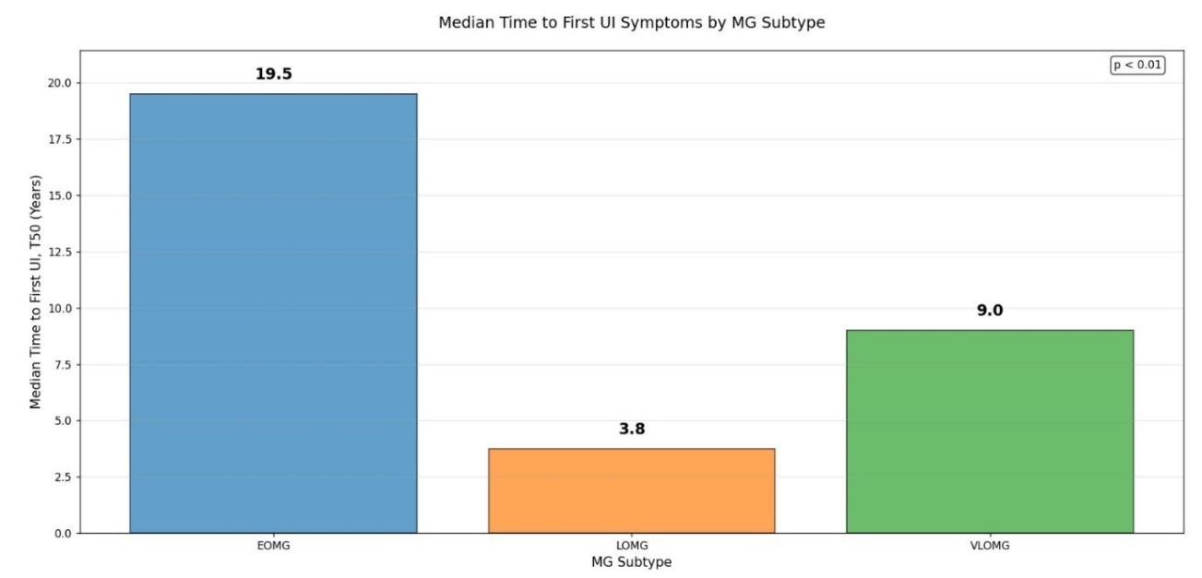
Supplementary figure 2a: LOMG patients reached UI earlier (3.8 years) than VLOMG (9.0) and EOMG (19.5) (p < 0.01).
Abbreviations: EOMG, early-onset MG; LOMG, late-onset MG; VLOMG, very late-onset MG; UI, urinary incontinence. Abbreviations: EOMG, early-onset MG; LOMG, late-onset MG; VLOMG, very late-onset MG; UI, urinary incontinence; T50, time at which 50% of patients developed UI.
Supplementary figure 2b: Median Time (T50) From Onset of MG to First Urinary Incontinence (UI) Symptoms Stratified by Disease Severity
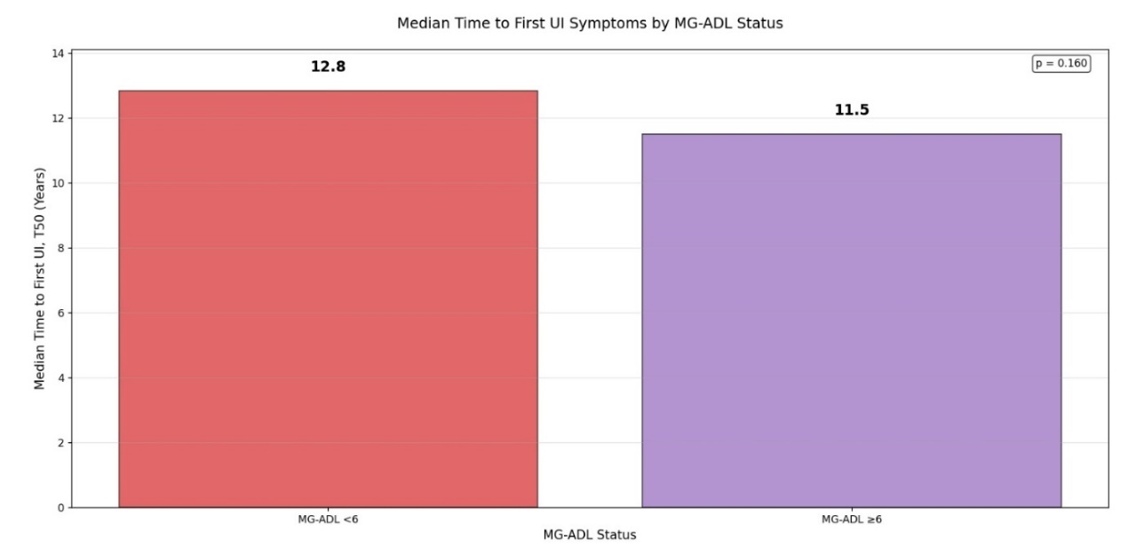
Supplementary figure 2b: patients with MG-ADL ≥6 developed UI earlier than those with MG-ADL <6 (11.5 vs. 12.8 years; p = 0.160).
Abbreviations: MG-ADL, Myasthenia Gravis Activities of Daily Living; UI, urinary incontinence; T50, time at which 50% of patients developed UI.

