Supplementary materials
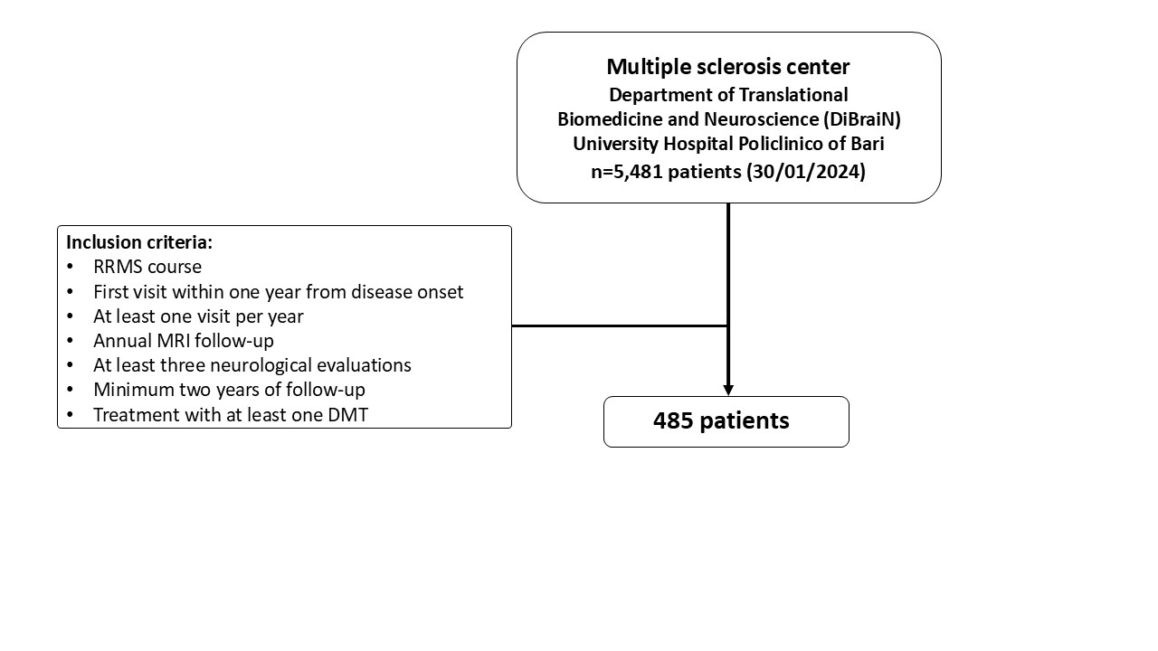
Supplementary Figure 1. Flowchart of patients’ selection procedure.

Supplementary Table 1. Baseline clinical characteristics stratified by initial treatment strategy.
 | Overall  (485) | Patients first treated with ME DMTs  (351) | Patients first treated with HE DMTs  (134) | SMD
Female sex, n (%) | 313 (64.5) | 223 (63.5) | 90 (67.2) | 0.08
Age at onset, mean ± SD, years | 30.65 ± 11.16 | 30.84 ± 10.87 | 30.16 ± 11.91 | -0.06
Time from onset to diagnosis, median (IQR), years | 0.41 (0.18-0.86) | 0.36 (0.16-0.68) | 0.78 (0.25-1.21) | 0.10
Time from diagnosis to first DMT start, median (IQR), years | 0.19 (0.08-0.40) | 0.18 (0.07-0.36) | 0.24 (0.11-0.50) | 0.11
Follow up (mean ± SD), years | 7.35 ± 3.94 | 9.34 ± 3.30 | 6.68 ± 2.85 | -0.84
Age at first DMT start (mean ± SD), years | 32.23 ± 11.42 | 31.73 ± 11.0 | 33.53 ± 12.41 | 0.15
EDSS at onset¸ median (IQR) | 2.0 (0-5.0) | 2.0 (0-5.0) | 2.5 (1.0-5.0)
Presence of oligoclonal bands in CSF, n (%) | 373 (77) | 256 (75.21) | 109 (81.34)
Disease duration (mean ± SD), years | 7.63 ± 3.57 | 8.65 ± 3.30 | 4.98 ± 2.85 | 1.15
Number of visits for each patient, median (IQR) | 9 (3-48) | 10 (7-16) | 6 (7-16) | 0.08
Type of MS onset, multifocal n (%) | 104 (23) | 69 (19.66) | 35 (26.12)

*Continuous variables were summarized as mean (SD) or median (IQR) according to their distribution. Standardized mean differences were calculated on continuous variables regardless of the summary statistic displayed.
Abbreviations: disease-modifying treatments, DMTs; high-efficacy, HE; moderate-efficacy, ME; cerebrospinal fluid, CSF; Italian MS and related disorders Register, RISM; standardized mean differences, SMD.

