Supplementary Fig. 1. PFGE patterns among human isolates of S. suis in Poland.
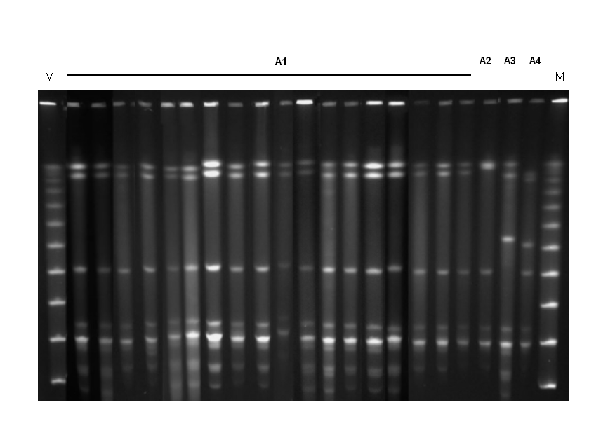
M, molecular weight marker (Lambda PFG Ladder, New England BioLabs, MA); A1-A4, PFGE patterns observed among 21 analysed isolates.

