Supplementary material: Systematic review of oral antibiotic treatment of pyelonephritis

Table 4: Summary of search strategy for identification of studies
MEDLINE | "pyelonephritis" ^{a,b} OR "kidney infection*" ^{b} OR "upper urinary tract infection*" ^{b}  AND  "Anti-Bacterial agents" ª OR "antibiotic*" ^{b}  AND  "treatment" ^{b} OR "management" ^{b}  AND NOT  "children.ti." ^{b}
Embase+  Embase classic | "acute pyelonephritis" ª OR "pyelonephritis" ^{b} OR "upper adj urinary adj tract adj infection*" ^{b} OR "kidney infection*" ^{b}  AND  "antibiotic agent or antiinfective agent" ª OR "antibiotic*" ^{b}  AND  "treatment" ^{b} OR "management" ^{b}  AND NOT  "children.ti." ^{b}
CENTRAL (Trials) | "pyelonephritis" ^{a,b} OR "kidney infection*" ^{b} OR "upper urinary tract infection*" ^{b}  AND  "Anti-Bacterial agents" ª OR "antibiotic*" ^{b}  AND  "treatment" ^{b} OR "management" ^{b}  AND NOT  "children.ti." ^{b}
CDSR (Reviews) | "pyelonephritis" ^{b}  AND  "antibiotics" ^{b}
Individual searches were adapted for each database. All literature up to October (MEDLINE and CENTRAL) or November (Embase+ Embase classic) 2016 was included in the search. RCT filters were used to filter results for MEDLINE, Embase and CENTRAL.¹⁶
CENTRAL The Cochrane Central Register of Controlled Trials, CDSR The Cochrane Database for Systematic Reviews.
ª : standard keyword searches. ^{b} : MeSH/EMTREE

Table 5: Percentage of infections from which Escherichia coli was isolated
Study | E.coli isolated
Cox 2002 | 76.1%
Richard 1998 | 69%*
Bach 1995 | 56.4%
Hyslop 1992 | 84.3%
Talan 2000 | 92.5%
The proportion of infections from which E.coli was isolated, out of the total number of infections for each study is displayed as a percentage. Total number of infections refers to all patients included in the efficacy analyses. *This excludes Richard et al. which refers to E.coli infection rates in all enrolled patients.

Screening of articles
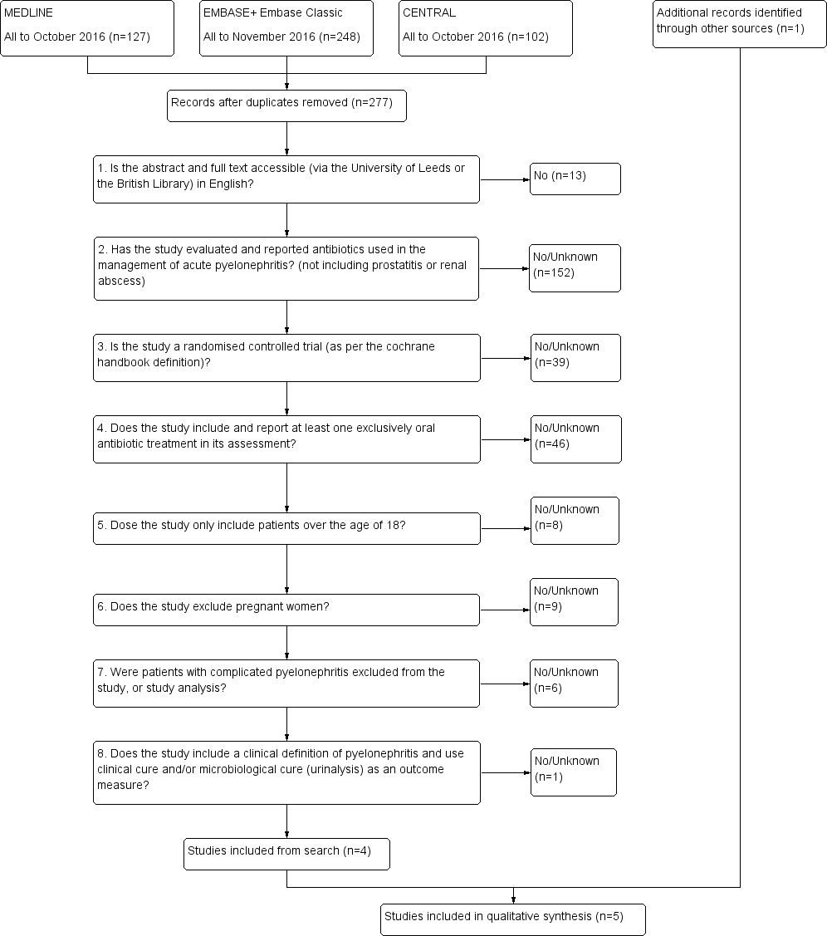

Screening & Eligibility

Included

Identification

Figure 1. Adapted PRISMA flowchart made using Review Manager 5.3.¹⁷ The number of articles rejected per each exclusion criteria is listed (right). Studies of patients with complicated pyelonephritis, defined as known diabetes/metabolic disease or known structural/functional urological abnormalities, were excluded from the analysis. We did not include the lower urinary tract features of being male and urinary catheterisation within our definition of complicated pyelonephritis. The search of CDSR (Cochrane Database for Systematic Reviews) generated 15 results for screening. Four reviews were identified as relevant, evaluating antibiotics used for pyelonephritis or duration of therapy for pyelonephritis. Manual reference searching of these papers using inclusion/exclusion criteria generated one additional study for inclusion, not already identified in the search. Manual reference searching of NICE and IDSA/ESCMID pyelonephritis treatment guidelines did not identify any additional studies satisfying inclusion criteria that were not already identified in the search.

Risk of bias in included studies
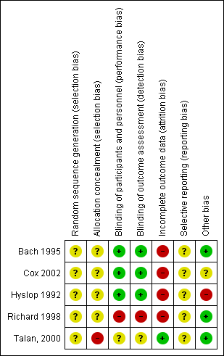
Figure 2: Risk of bias for each included study. Each study is broken down into various potential areas for bias. The figure was created using Revman¹⁷, utilising The Cochrane Collaboration Tool for Assessing Risk of Bias.⁶
+ Low risk of bias. – High risk of bias. ? Unclear risk of bias.

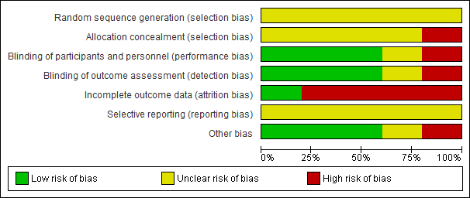
Figure 3: Risk of bias distribution for included studies. Data represented is for all five studies combined. Percentages represent the proportion of studies with high, low, or unclear levels of each type of bias. The figure was created using Revman¹⁷, utilising The Cochrane Collaboration Tool for Assessing Risk of Bias.⁶

Title: A systematic review of randomised clinical trials for oral antibiotic treatment of acute pyelonephritis.
Journal name: European Journal of Clinical Microbiology & Infectious Diseases
Article type: Original article
Authors: Jonathan W S Cattrall, Alyss V Robinson, Andrew Kirby^{1/2}*
1 University of Leeds, UK.
2 Leeds Teaching Hospitals NHS Trust, UK.
*Corresponding author E-mail: a.kirby@leeds.ac.uk

