Supplementary Information 1. Dutch Neonatal CLABSI Surveillance Criteria (8)
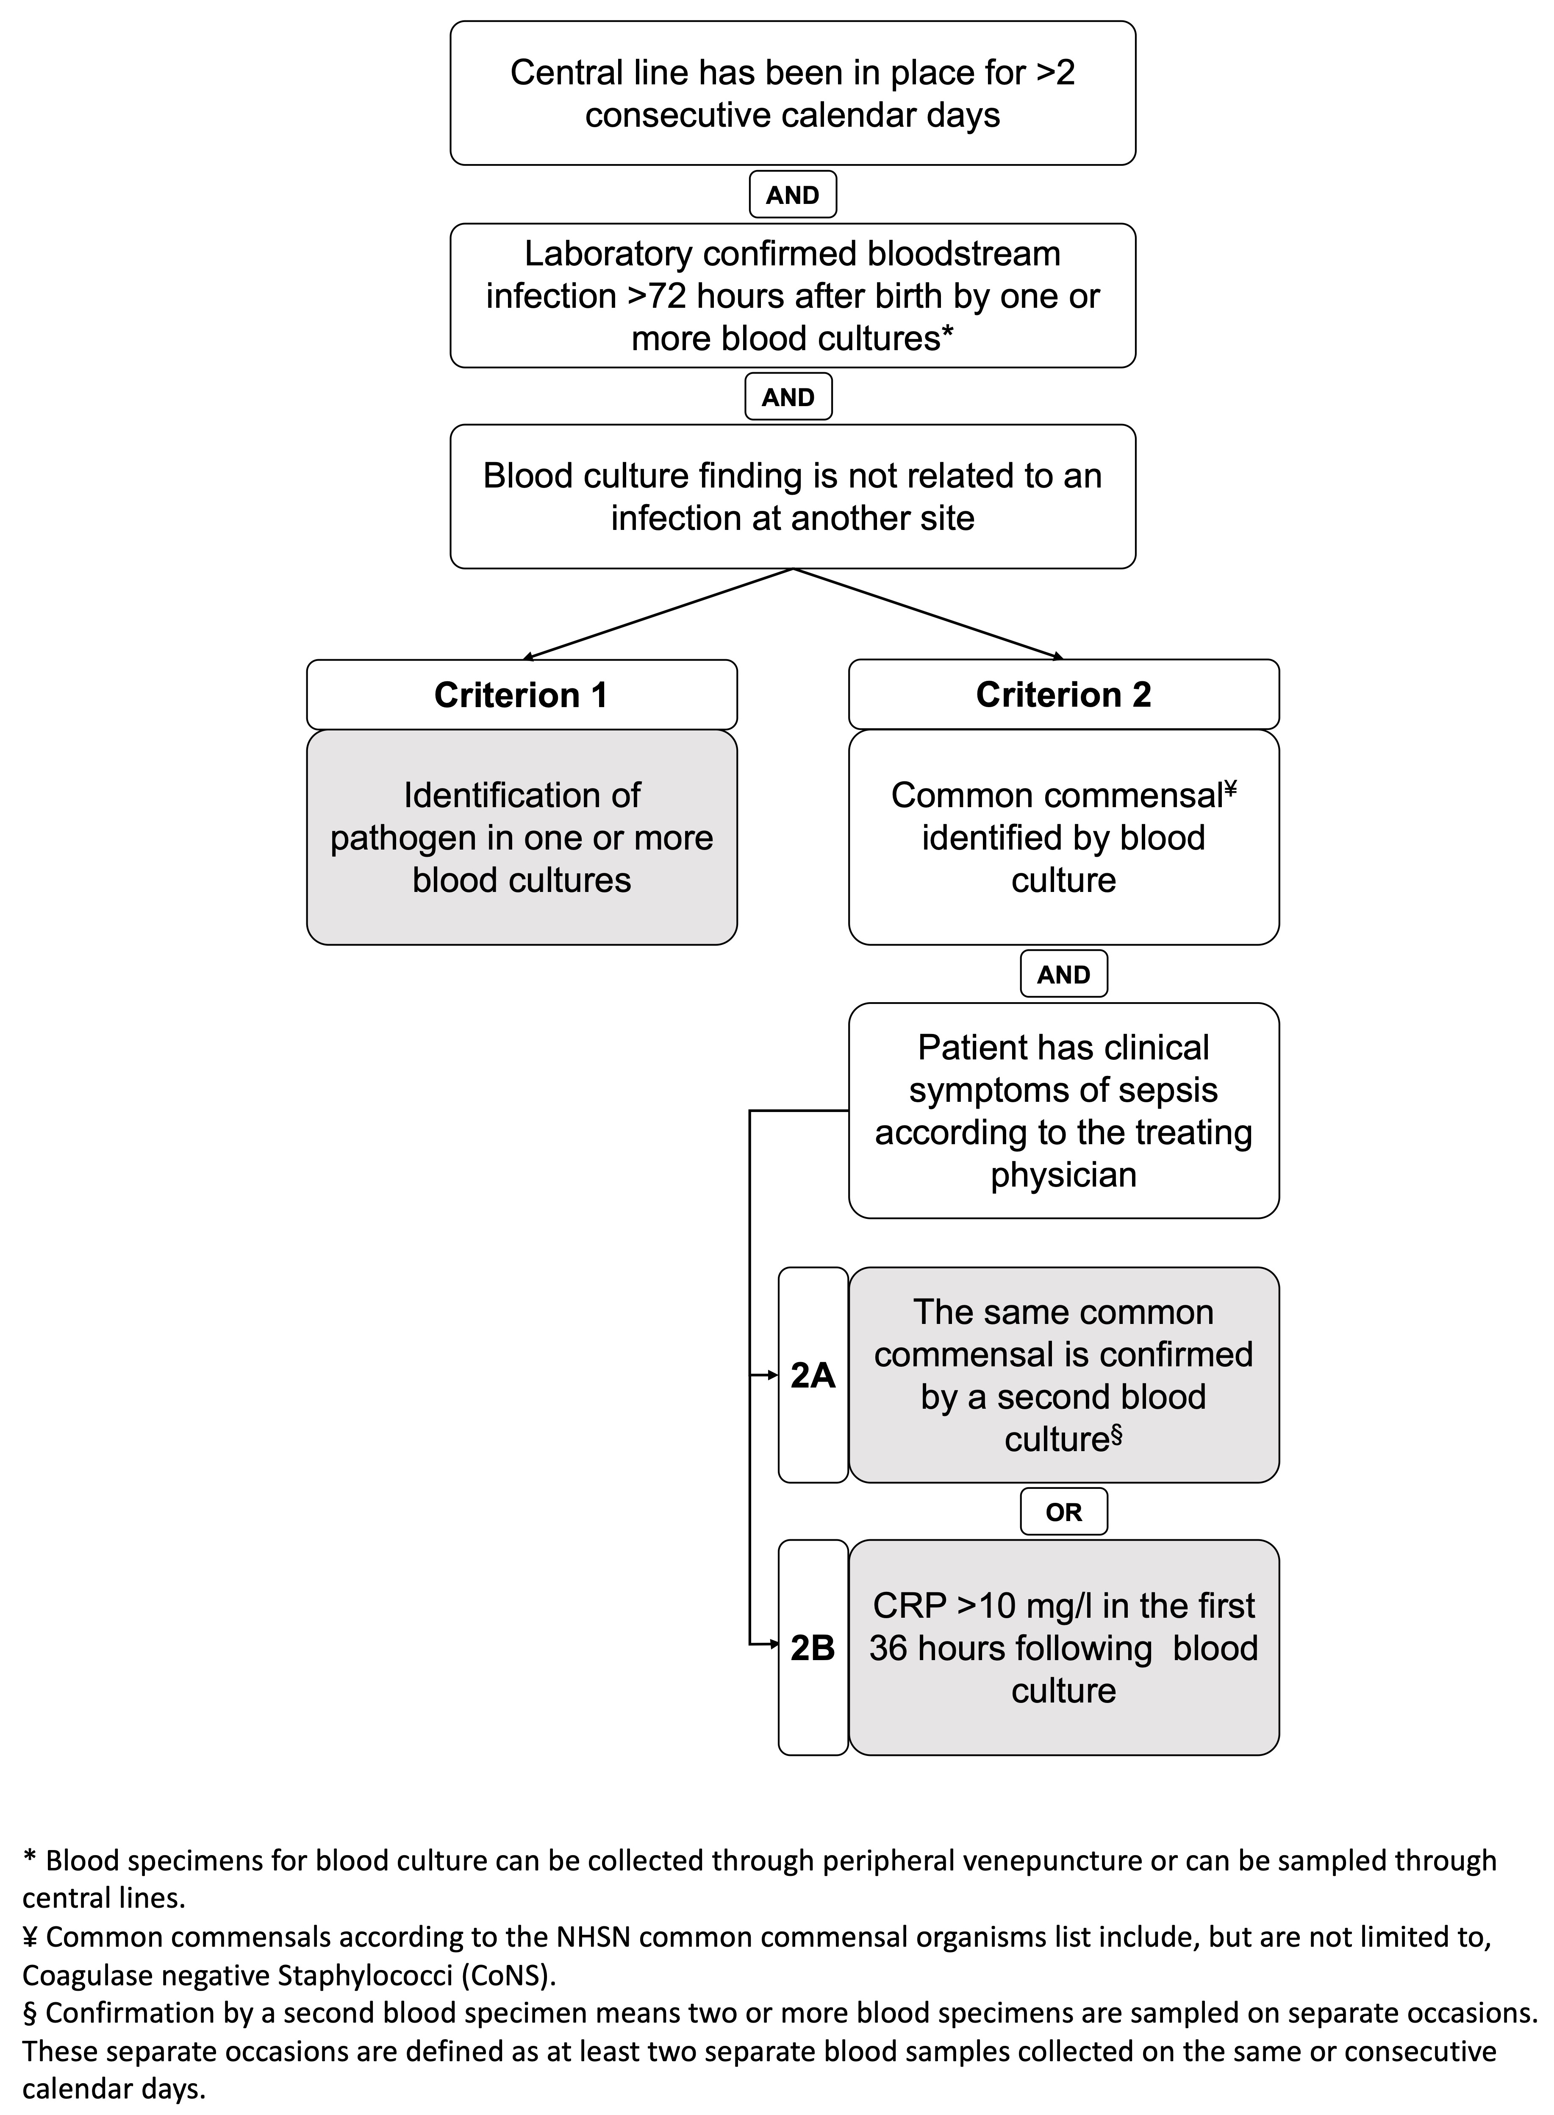

Supplementary Information 2. Annual Number of Neonates with NBSI

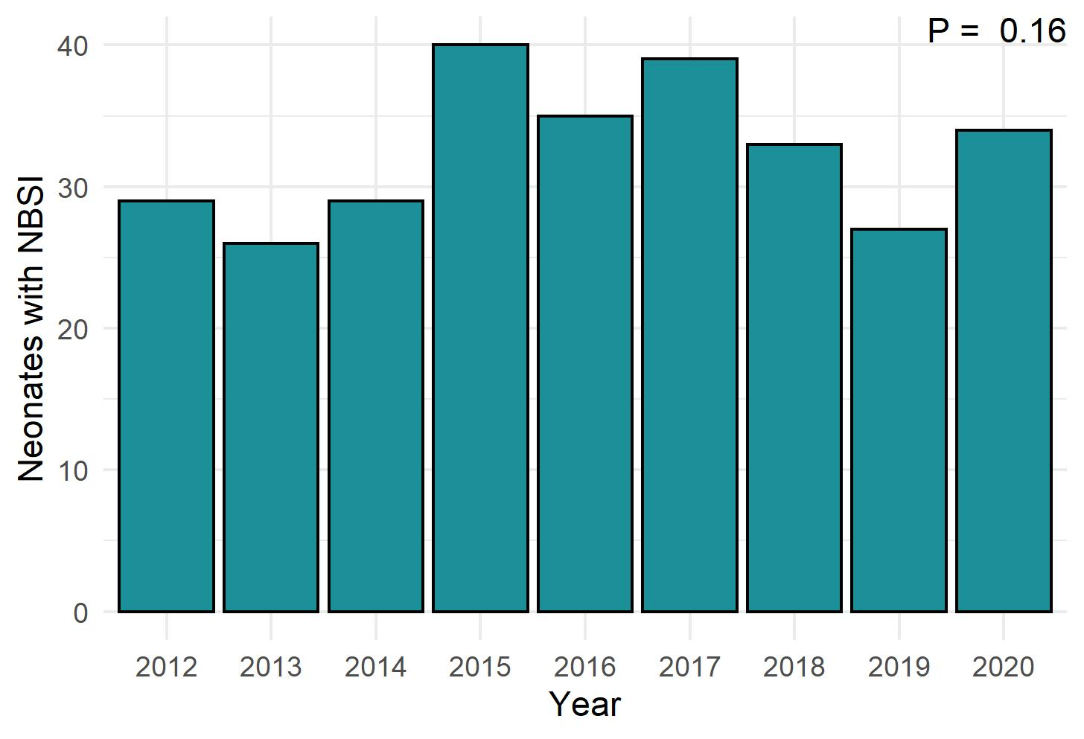

Supplementary Information 3. Demographics Neonates with a Central-line Stratified According to Gestational Age
Year | 2012 | 2013 | 2014 | 2015 | 2016 | 2017 | 2018 | 2019 | 2020
Number of neonates with a central-line | 119 (69%) | 120 (66%) | 110 (62%) | 96 (65%) | 116 (62%) | 75 (44%) | 81 (53%) | 86 (47%) | 88 (51%)
24^{0/7}- 25^{6/7} wks | 15 (11%) | 9 (6.8%) | 12 (9.0%) | 10 (7.5%) | 16 (12%) | 14 (11%) | 22 (17%) | 20 (15%) | 15 (11%)
26^{0/7}- 27^{6/7} wks | 28 (12%) | 23 (10%) | 25 (11%) | 30 (13%) | 26 (11%) | 27 (12%) | 24 (10%) | 18 (7.8%) | 29 (13%)
28^{0/7}- 29^{6/7} wks | 42 (12%) | 56 (17%) | 51 (15%) | 34 (10%) | 44 (13%) | 24 (7.1%) | 23 (6.8%) | 32 (9.5%) | 31 (9.2%)
30^{0/7}- 31^{6/7} wks | 34 (18%) | 32 (17%) | 22 (12%) | 22 (12%) | 30 (16%) | 10 (5.2%) | 12 (6.3%) | 16 (8.4%) | 13 (6.8%)
Line-days per neonate | 6.2 [3.8, 8.4] | 6.6 [4.5, 8.8] | 6.8 [4.5, 8.9] | 7.2 [5.0, 10.1] | 6.6 [4.5, 9.2] | 6.8 [4.9, 9.8] | 7.4 [4.9, 9.4] | 7.8 [5.8, 11.0] | 7.2 [5.7, 10.3]
24^{0/7}- 25^{6/7} wks | 7 (4,14) | 9 (6,11) | 12 (6.9) | 8 (7.16) | 9 (7,12) | 5 (3,9) | 9 (6,11) | 10 (7,16) | 10 (8,16)
26^{0/7}- 27^{6/7} wks | 6.6 (4.6,10.1) | 7.1 (5.1,9.9) | 7.4 (5.0,8.7) | 8.9 (6.9,11.3) | 7.0 (5.9,10.7) | 7.7 (6.4,10.8) | 7.9 (5.0.1,9) | 7.3 (5.9,8.8) | 7.1 (5.2,10.3)
28^{0/7}- 29^{6/7} wks | 6.7 (4.2,8.7) | 6.8 (4.9, 8.3) | 7.1 (5.0,9.0) | 6.3 (4.6,9.6) | 6.1 (4.0, 7.5) | 6.3 (5.3, 8.9) | 6.9 (4.0, 8.8) | 6.9 (5.5, 10.8) | 6.9 (5.3,10.2)
30^{0/7}- 31^{6/7} wks | 4.7 (2.4,6.4) | 5.3 (3.5,8.4) | 4.1 (2.1,6.8) | 4.9 (3.4,7.8) | 5.8 (3.9,7.6) | 5.0 (3.3,7.3) | 5.1 (4.8,7.6) | 7.6 (4.9,8.8) | 6.3 (5.1,7.4)
Total line-days | 862 | 835 | 793 | 792 | 852 | 594 | 660 | 787 | 764
24^{0/7}- 25^{6/7} wks | 156 | 80 | 158 | 110 | 152 | 95 | 229 | 244 | 189
26^{0/7}- 27^{6/7} wks | 214 | 185 | 163 | 291 | 240 | 236 | 186 | 142 | 239
28^{0/7}- 29^{6/7} wks | 280 | 386 | 370 | 266 | 275 | 205 | 174 | 262 | 254
30^{0/7}- 31^{6/7} wks | 211 | 184 | 103 | 124 | 184 | 57 | 71 | 137 | 82
Neonates with CLABSI | 10 | 8 | 7 | 19 | 13 | 10 | 8 | 10 | 12
24^{0/7}- 25^{6/7} wks | 0 (0%) | 0 (0%) | 2 (29%) | 5 (26%) | 6 (46%) | 2 (20%) | 1 (12%) | 6 (60%) | 4 (33%)
26^{0/7}- 27^{6/7} wks | 3 (30%) | 2 (25%) | 2 (29%) | 10 (53%) | 5 (38%) | 3 (30%) | 5 (62%) | 1 (10%) | 2 (17%)
28^{0/7}- 29^{6/7} wks | 4 (40%) | 6 (75%) | 2 (29%) | 2 (11%) | 2 (15%) | 4 (40%) | 1 (12%) | 2 (20%) | 5 (42%)
30^{0/7}- 31^{6/7} wks | 3 (30%) | 0 (0%) | 1 (14%) | 2 (11%) | 0 (0%) | 1 (10%) | 1 (12%) | 1 (10%) | 1 (8.3%)
CLABSI incidence per 1,000 line-days | 11.6 | 9.58 | 8.83 | 25.3 | 15.3 | 16.8 | 12.1 | 13.9 | 15.7
24^{0/7}- 25^{6/7} wks | 0.00 | 0.00 | 12.7 | 54.4 | 39.4 | 21.0 | 4.36 | 28.6 | 21.1
26^{0/7}- 27^{6/7} wks | 14.0 | 10.8 | 12.3 | 34.4 | 20.8 | 12.7 | 26.9 | 7.05 | 8.38
28^{0/7}- 29^{6/7} wks | 14.3 | 15.5 | 5.41 | 7.51 | 7.26 | 19.5 | 5.73 | 7.63 | 19.7
30^{0/7}- 31^{6/7} wks | 14.2 | 0.00 | 9.74 | 16.1 | 0.00 | 17.4 | 14.1 | 7.38 | 12.2
Results are presented as N, n (%), median [IQR] or N normalized per 1,000 line-days.
wks, weeks; CLABSI, central-line associated bloodstream infection

Supplementary Information 4. Sensitivity Analyses for Non-CoNS-related CLABSI
Year | 2012 | 2013 | 2014 | 2015 | 2016 | 2017 | 2018 | 2019 |  | 2020 | P valueª
Non-CoNS CLABSI episodes | 3 | 0 | 2 | 2 | 5 | 2 | 3 |  | 4 | 3 | –
Non-CoNS CLABSI incidence per 1,000 line-days | 3.42 | 0.00 | 2.46 | 2.23 | 5.51 | 3.29 | 4.49 |  | 4.85 | 3.79 | 0.42
Results are presented as N or N normalized per 1,000 line-days.
CoNS, coagulative negative staphylococci; CLABSI, central-line associated bloodstream infection.
ª P value corresponds to ANOVA test of the increase in model fit by adding year to Poisson regression.

Supplementary Information 5. Transition Probabilities According to Different States

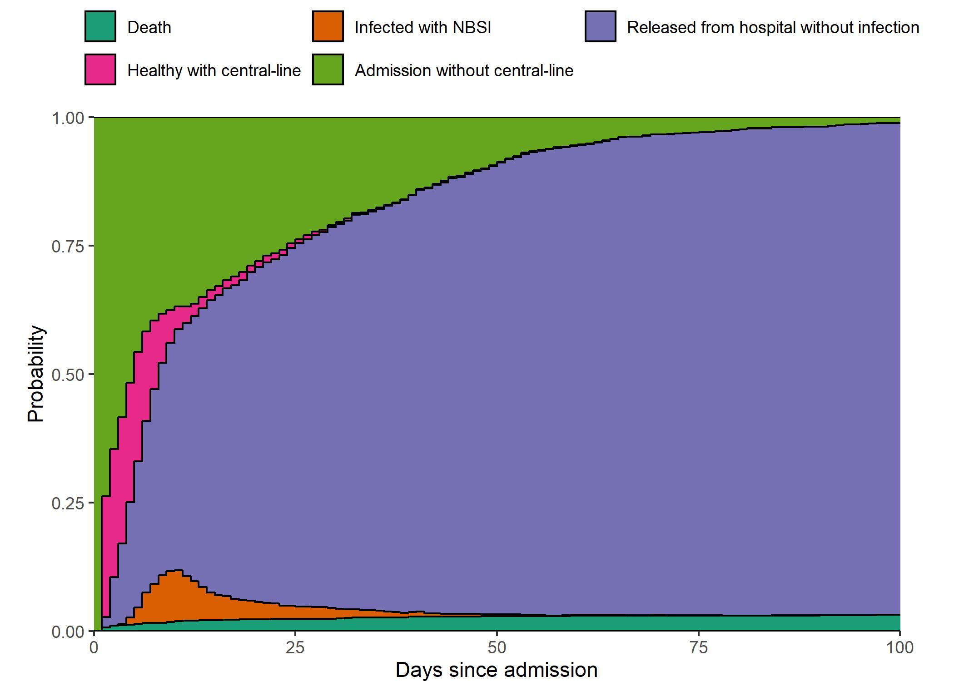

Supplementary Information 6. Overall NBSI Risk According to Admission Duration Given a Central-line

