30-day all-cause mortality
In-hospital mortality

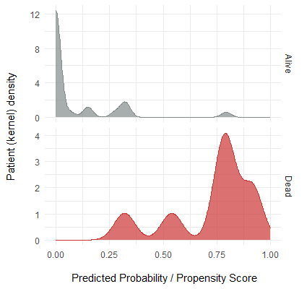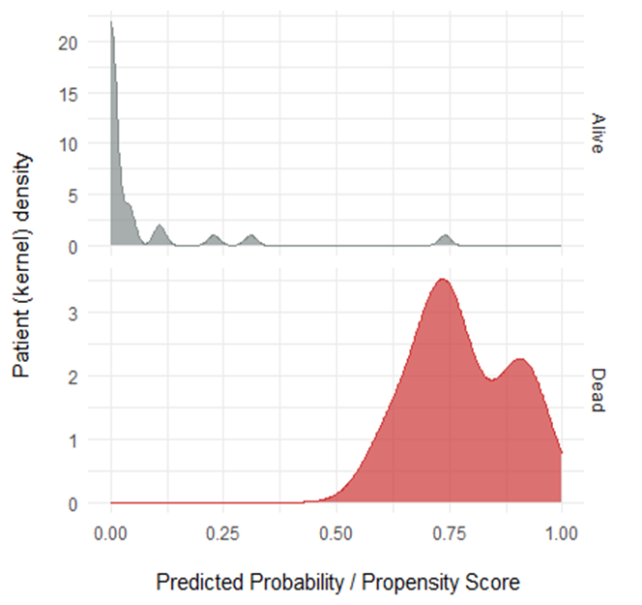
Supplementary Figure S1 - Estimated probability of dying / propensity scores for patients with ceftazidime/avibactam-resistant KPC-producing Klebsiella pneumoniae bloodstream infection when employing a random forest classifier consisting of chronic kidney disease, acute kidney injury following the ceftazidime/avibactam-resistant KPC-Kp bloodstream infection, recent renal replacement therapy history, the absolute Charlson Comorbidity Index score and whether cardiac surgery had been the reason for admission. This reduced-feature RF classifier provided an accuracy of 89% (75% F1 score, given the unbalanced nature of the dataset) in predicting in-hospital mortality, and an accuracy of 97% (93% F1 score, idem) in predicting 30-day all-cause mortality using a hold-out validation set.

