Supplementary Material
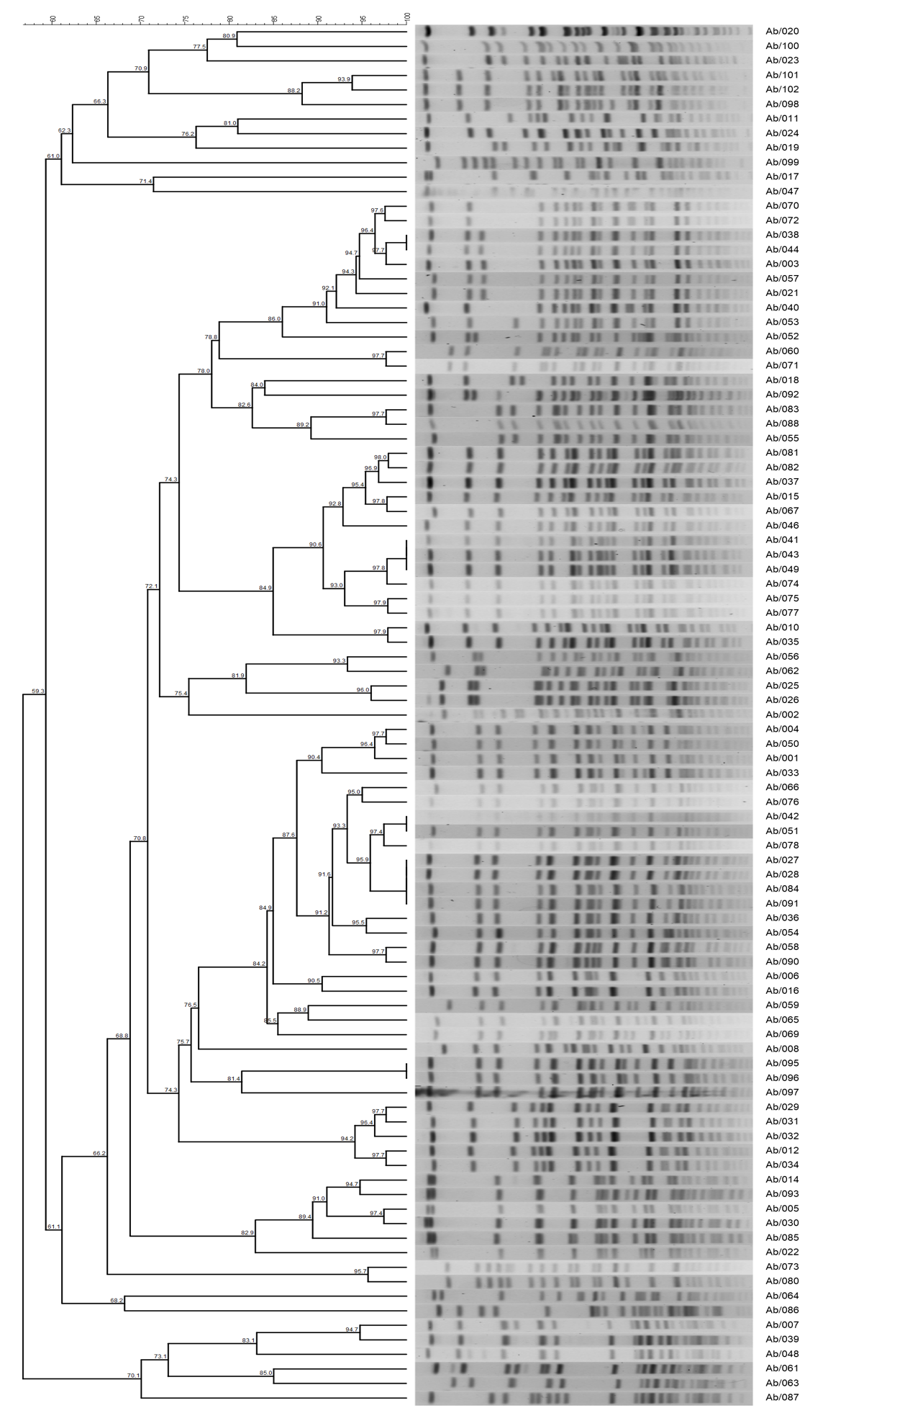
Supplementary Figure 1: PFGE dendrogram of CRAB isolates.

Supplementary Table 1: The primer sequences and amplicon sizes.
Genes | Primer sequence (5 →3) | Amplicon Size
bla_{OXA-51} | F-5’-TAATGCTTTGATCGGCCTTG-3’  R-5’-TGGATTGCACTTCATCTTGG-3’ | 353 bp
bla_{OXA-23} | F-5’-GATCGGATTGGAGAACCAGA-3’  R-5’-ATTTCTGACCGCATTTCCAT-3’ | 501 bp
bla_{OXA-58} | F-5’-AAGTATTGGGGCTTGTGCTG-3’  R-5’-CCCCTCTGCGCTCTACATAC-3’ | 599 bp
bla_{OXA-24} | F-5’-GGTTAGTTGGCCCCCTTAAA-3’  R-5’-AGTTGAGCGAAAAGGGGATT-3’ | 246 bp
bla_{NDM} | F-5’-GGTTTGGCGATCTGGTTTTC-3’  R-5’-CGGAATGGCTCATCACGATC-3’ | 621 bp
bla_{IMP} | F-5’-GGAATAGAGTGGCTTAAYTCTC-3’  R-5’-GGTTTAAYAAAACAACCACC-3’ | 232 bp
bla_{PER-1} | F-5’-AATTTGGGCTTAGGGCAGAA-3’  R-5-ATGAATGTCATTATAAAAGC-3’ | 925 bp
mcr-1 | F-5'-CGGTCAGTCCGTTTGTTC-3'  R-5'-CTTGGTCGGTCTGTAGGG-3' | 308 bp

