Supplementary Table 1. A detailed list of all the variables collected for each episode of SAB
Category | Variables collected
General | Patient’s age; Patient’s gender; Community-acquired SAB; Health care-associated SAB; Nosocomial SAB
Mortality | Deceased within 30 days?; Numbers of days until decease; In hospital-mortality
Charlson Comorbidity Score | Congestive heart failure; Dementia; Chronic pulmonary disease; Rheumatologic disease; Mild liver disease; Moderate/severe liver disease; Diabetes with complications; Moderate/severe renal disease; Hemiplegia or paraplegia; Any malignancy; Metastatic solid tumor; AIDS
Sepsis (SOFA score) | Respiration-score; Coagulation-score; Liver-score; Cardiovascular score; Central nervous system score; Renal score
SAB, including risk factors | TTP for BC demonstrating SAB; Follow-up BC collected within 48–96 hours?: Follow-up BC positive for SA?; Previous SAB within 2 years; Hemodialysis; Permanent iv catheter; Port-a-cath
SABU, including risk factors | UC positive for SA?; Amount of growth of SA; Earlier surgery in urinary tract; Urinary tract catheterization; Urinary tract obstruction disease
UTI | Suprapubic tenderness; Costovertebral pain; Increased urinary frequency; Urgency; Dysuria; Sign of UTI (pyuria, inflamed nephrostomy)
Focus of infection | Positive imaging indicating a focus; Focal signs or symptoms; SA found in focal culture
Complicated SAB | Endocarditis according to Duke-ISCVID criteria; Septic arthritis; Deep tissue abscess; Vertebral osteomyelitis; Epidural abscess; Septic thrombophlebitis; Meningitis; Other focus considered complicated; Attributable mortality; Recurrent infection; Embolic stroke
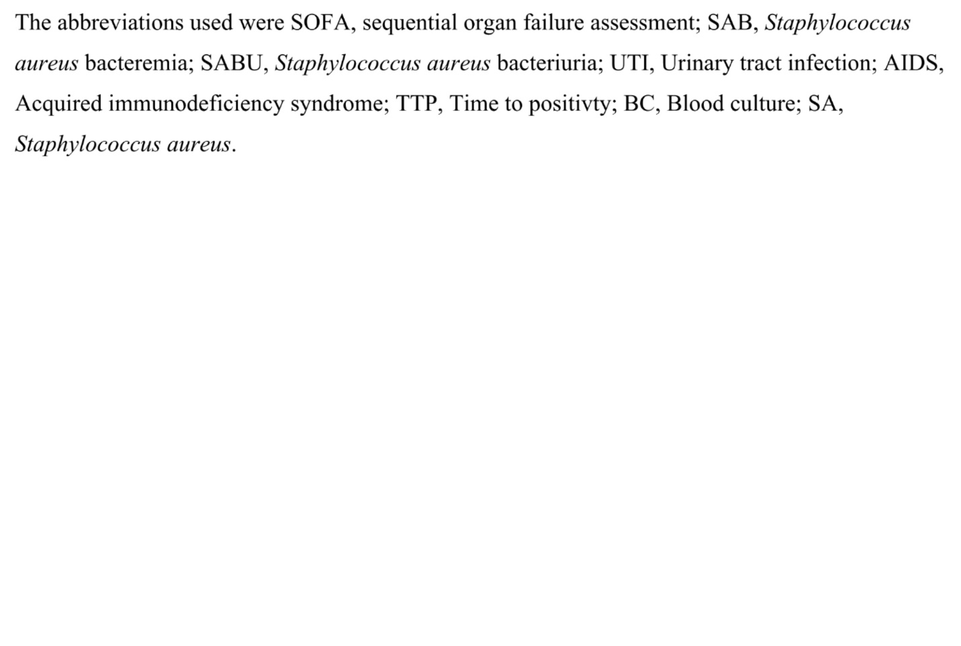
Supplementary Table 2. A description of the foci of infection
Focus | SABU  n = 37 | Non-SABU  n = 117
Complicated ones
IE | 4 (11%) | 7 (6.0%)
Septic arthritis | 1 (2.7%) | 5 (4.3%)
Vertebral osteomyelitis | 0 | 7 (6.0%)
Epidural abscess | 4 (11%) | 6 (5.1%)
Deep tissue abscess | 2 (5.4%) | 13 (11%)
Septic thrombophlebitis | 0 | 12 (10%)
Pneumonia | 0 | 12 (10%)
Empyema | 0 | 2 (1.7%)
Uncomplicated ones
Skin and wound infections | 3 (8.1%) | 10 (8.5%)
Osteitis | 0 | 3 (2.6%)
UTI | 20 (54%) | 0
Others* | 0 | 6 (5.1%)
Not known focus | 11 (30%) | 50 (43%)

In 2 episodes in the SABU group and in 1 episode in the non-SABU group there were more than 1 foci, hence the sum of the foci is greater than the number of episodes in the group.
* Others include colitis, cholecystitis, parotitis, and infection in the dose pocket of pacemaker and port-a-cath. The abbreviations used were SABU, Staphylococcus aureus bacteriuria; UTI, urinary tract infection.
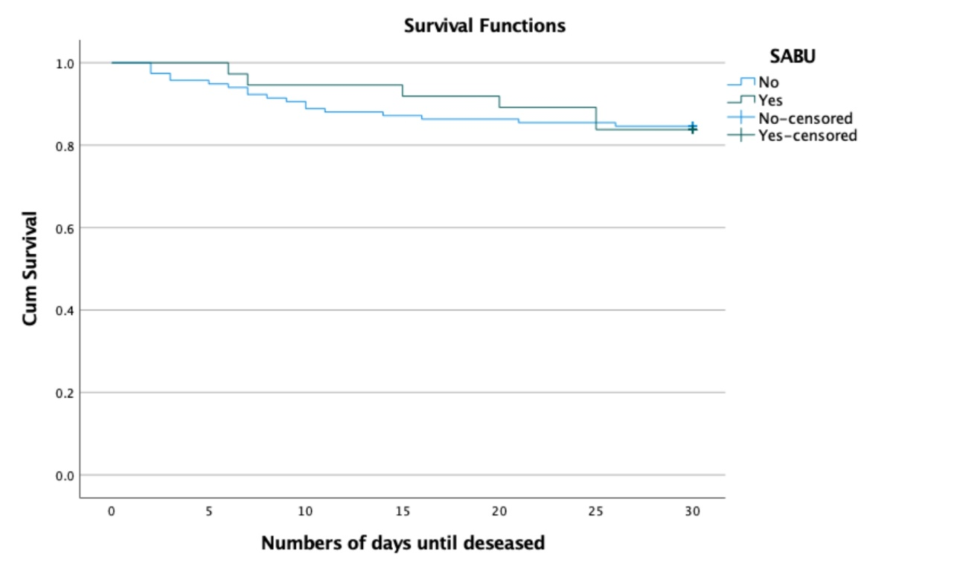
Supplementary Fig. 1. A graph showing a Kaplan-Meier survival analysis for the 30 days mortality rate, comparing patients with and without bacteriuria. The difference between the groups was non-significant, where a P-value of < 0.05 was considered statistically significant. SABU, Staphylococcus aureus bacteriuria.

