SUPPLEMENTARY DATA

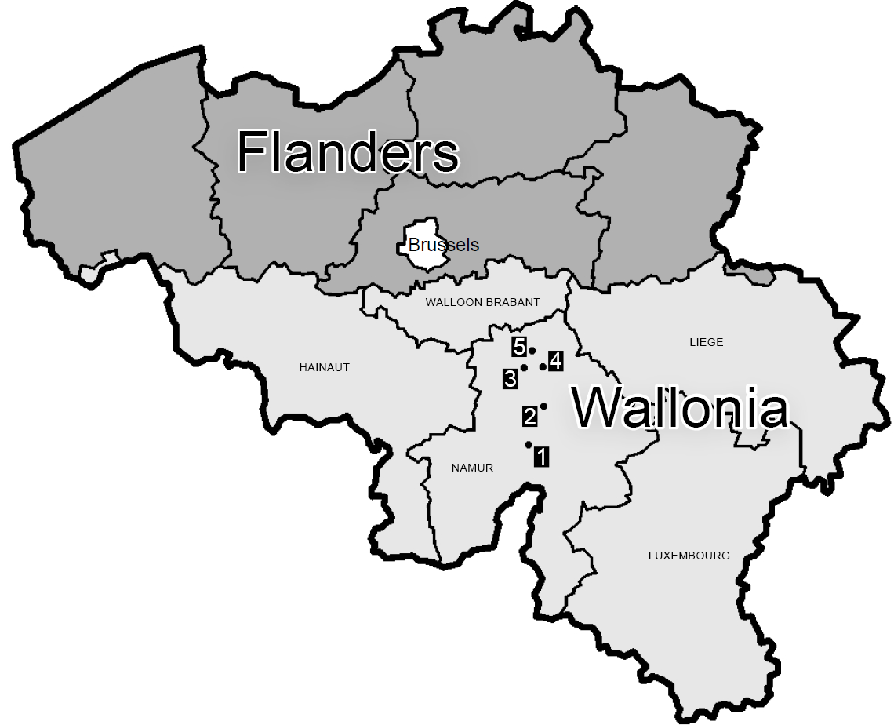
Figure 1 Map of Belgium showing the Namur Hospital Network sites.
1: CHU UCL Namur site Dinant
2: CHU UCL Namur site Godinne
3: CHU UCL Namur site Namur
4: Centre Hospitalier Régional de Namur site Namur
5: Clinique Saint-Luc Bouge

Practices of Belgian National Reference Laboratory for echinococcosis:
Currently, the Belgian National Reference Laboratory (BNRL) uses a two-step protocol for serological testing: screening by ELISA followed by confirmatory Western blot (WB).
The Em2plus ELISA test (Bordier) is used for screening with sensitivity and specificity greater than 90% [44,45].
WB is used for confirmation of a positive screening test, for differentiation between AE and cystic echinococcosis, and in case of high clinical suspicion, even if the screening test result is below the cut-off [46].
The BNRL uses a commercially available WB assay (which uses whole larval antigen extract from E. multilocularis) with a higher sensitivity (97%) than the screening ELISA tests [46].
The WB band pattern considered indicative of Echinococcus sp. infection includes 7 and/or 26-28 kDa bands. 16 and/or 18 kDa bands are considered specific for AE.

The BNRL currently uses two types of Echinococcus PCR: the first is a real-time multiplex PCR targeting the mitochondrial DNA gene (nad3) of EM together with the cox 2 gene specific for Echinococcus granulosus (EG); the second is a nested PCR adapted from Trachsel et al. that is slightly more sensitive, targets mitochondrial genes (nad1, rrnS), and allows differentiation between EM and EG [27].
Real-time PCR was introduced into the BNRL’s diagnostic algorithm in 2022: Since then, real-time PCR is performed first, followed by nested PCR if negative.
The BNRL currently also performs sequencing of EM.

