Supplementary file I.


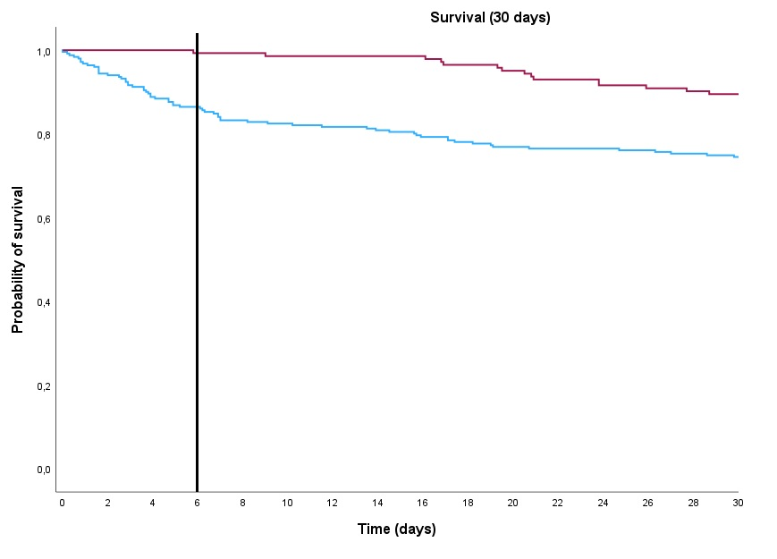
Supplementary figure 1. Survival in S. aureus bacteremia patients that did or did not receive a PET/CT.

Kaplan-Meier curve representing survival of patients with S. aureus bacteremia at 30 days. The black line represents day six, which was the median time to PET/CT (Q1 4.3 – Q3 8.3).

Supplementary figure 2. Survival in S. aureus bacteremia patients that did or did not receive a PET/CT (adjusted for immortal time bias).
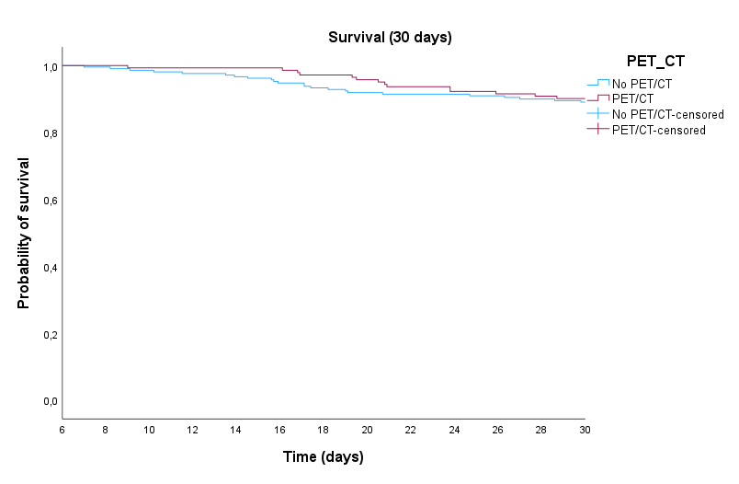

Kaplan-Meier curve representing survival of patients with S. aureus bacteremia at 30 days, without patients that passed away in the first six days, which was the median time to PET/CT (Q1 4.3 – Q3 8.3).

