Supplementary material for: QuickMIC rapid AST in clinical routine – evaluation of accuracy and speed in comparison to routinely used automated AST systems
Anna Olsson¹, Alexandra Rafeletou¹, Amanda Åman¹, Nicolette Athanasiou², Celia García-Rivera³, Derek Gerstbrein², Brian Mesich², Logan Patterson⁴, Julia Vahturova⁵, Nicole VanZeeland², Andrea Ricart Silvestre³, Kevin Alby⁶, Matthew L. Faron², Jessica Hoff², Marina Ivanova⁵, Juan Carlos Rodríguez Díaz³, Cecilia Johansson¹, Christer Malmberg^{#, 1,6}
¹Gradientech AB, Uppsala, Sweden.
²Department of Pathology, Medical College of Wisconsin, Milwaukee, WI, USA.
³Dr. Balmis University General Hospital, Alicante Institute for Health and Biomedical Research (ISABIAL), Alicante, Spain
⁴Department of Pathology and Laboratory Medicine, Medical University of South Carolina, Charleston, SC, USA.
⁵Clinical Microbiology Laboratory, East-Tallinn Central Hospital, Tallin, Estonia
⁶Department of Pathology and Laboratory Medicine, University of North Carolina School of Medicine, Chapel Hill, NC, USA.
⁷Department of Medical Sciences, Uppsala University, Uppsala, Sweden.

# Corresponding author
Christer Malmberg
Postal adress: Gradientech AB, Dag Hammarskjölds väg 36B, 752 37 Uppsala
Email address: christer.malmberg@gradientech.se
ORCID: https://orcid.org/0000-0003-3187-8732

Table S1. Details on turnaround time calculations for each data set
Site | TAT start | TAT end
VITEK® 2 | Blood culture positivity | Reportable MIC value available
MicroScan WalkAway plus | Blood culture positivity | 16 hours after start¹
BD Phoenix™ | Gram staining² | Reportable MIC value available
¹A template time of 16 hours was applied from PMID: 39194288, as the instrument did not store this information. ² Time of Gram-staining was used instead of blood culture positivity, as this information was not available in the laboratory LIS.

Table S2. Overview of the number of left-over blood cultures included in the study
 | East-Tallinn Central Hospital | General University Hospital Dr. Balmis | The Medical College of Wisconsin Inc. | UNC Medical Centre | Total
Enrolled left-over blood cultures | 37 | 90 | 59 | 52 | 238
Samples lacking legacy AST data | 4 | 17 | 7 | 18 | 46
Polymicrobial, anaerobic, fastidious or gram-positive samples | 2 | 1 | 0 | 0 | 3
Infection other than bloodstream | 0 | 0 | 0 | 4 | 4
Other (instrument or user error) | 2 | 20 | 6 | 2 | 30
Included in the final dataset | 29 | 52 | 46 | 28 | 155
Table S3. Number of species included in the study at each study site
 | East-Tallinn Central Hospital | General University Hospital Dr. Balmis | The Medical College of Wisconsin Inc. | UNC Medical Centre
E. coli | 22 | 30 | 21 | 19
K. pneumoniae | 1 | 8 | 11 | 8
K. oxytoca | 0 | 0 | 2 | 0
K. aerogenes | 0 | 1 | 1 | 0
C. braaki | 0 | 1 | 0 | 0
C. koseri | 0 | 0 | 1 | 0
C. freundii | 0 | 1 | 1 | 0
P. mirabilis | 4 | - | 2 | 1
Proteus spp. | - | 1 | - | -
P. aeruginosa | 0 | 2 | 1 | 0
S. marcescens | 0 | 1 | 1 | 0
S. rubidae | 0 | 1 | 0 | 0
S. maltophilia | 0 | 0 | 1 | 0
E. cloacae | 1 | 1 | 4 | 0
E. kobei | 0 | 1 | 0 | 0
E. hormaechei | 0 | 2 | 0 | 0
E. roggenkampii | 0 | 1 | 0 | 0
Salmonella spp. | 0 | 1 | 0 | 0
R. ornithinolytica | 1 | 0 | 0 | 0
Total | 29 | 52 | 46 | 28

Table S4 – QuickMIC TTR per antibiotic
Antibiotic | TTR | SD | Q1 | Q3
AMI | 02:27 | 00:14 | 02:20 | 02:30
CEP | 03:11 | 00:19 | 03:00 | 03:20
CIP | 03:13 | 00:28 | 02:50 | 03:48
COL | 02:52 | 00:25 | 02:40 | 03:00
CTA | 03:27 | 00:18 | 03:20 | 03:50
CTV | 02:55 | 00:18 | 02:50 | 03:00
CTZ | 03:18 | 00:20 | 03:00 | 03:30
GEN | 03:09 | 00:28 | 02:50 | 03:30
MER | 03:05 | 00:26 | 02:40 | 03:20
PIT | 03:13 | 00:17 | 03:00 | 03:20
TIG | 03:12 | 00:27 | 02:50 | 03:40
TOB | 02:54 | 00:23 | 02:40 | 03:10

Figure S5. Bias plots of QuickMIC GN vs. Phoenix, VITEK2 and MicroScan Walkaway
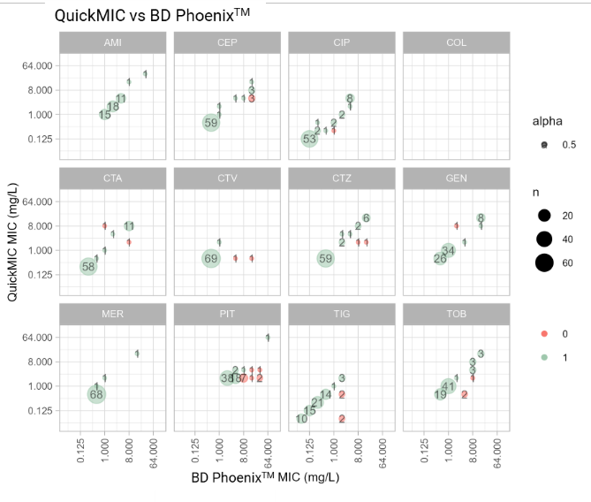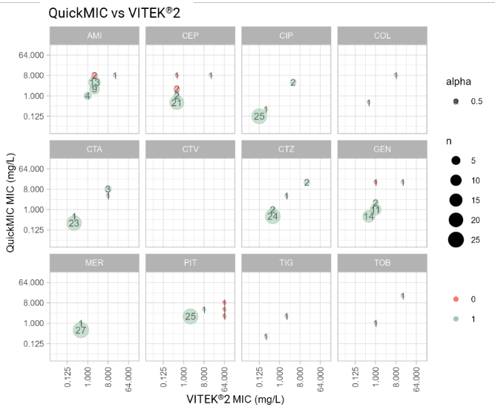
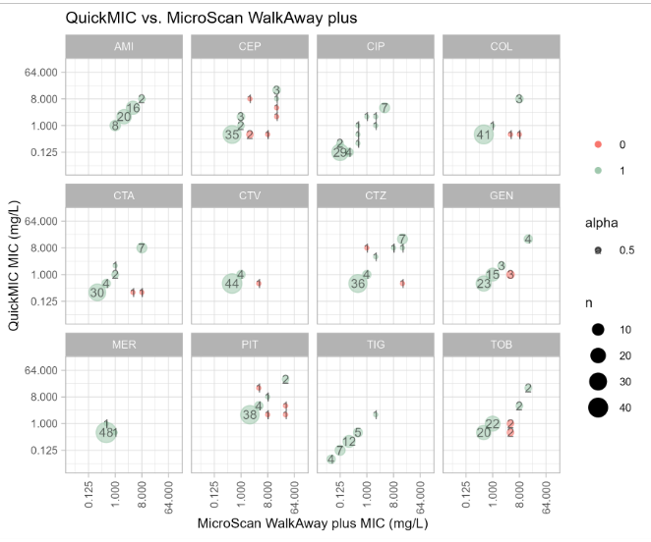
Figure S5. Comparison of QuickMIC MIC results with the MIC results from the three automated AST systems included in the study. On the y-axis are the QuickMIC results, and the x-axis shows the respective comparator result. The dot size and number indicates the number of strains with the same result, and green color indicates a result where QuickMIC was in Essential Agreement with the comparator method, while a red dot indicates a result not in agreement with the comparator method. It is worth noting that a result may in actuality be an error in either QuickMIC or the comparator method, as compared to what the reference method broth microdilution may have indicated.
Table S6 – Detailed data for agreement calculations between BD PhoenixTM and QuickMIC. AB: antibiotic, N: nr of runs with MIC results for both methods, Nc: nr of runs with categorical data for both methods, Ns: nr of strains run on both methods, CA: categorical agreement, EA: essential agreement, S,I,R: nr of susceptible/intermediate/resistant strains according to the comparator method, MiD: minor deviations, MD: major deviations, VMD: very major deviations, OS: nr of strains with on-scale results for both methods.
AB | N | N_{c} | N_{s} | CA | EA | S | I | R | MiD | MD | VMD | Bias | OS
AMI | 46 | 45 | 74 | 44 (97.8) | 46 (100) | 45 | 0 | 0 | 0 (0) | 1 (2.2) | 0 (0) | 2.22 | 0
CEP | 70 | 69 | 70 | 64 (92.8) | 67 (95.7) | 61 | 1 | 7 | 5 (7.2) | 0 (0) | 0 (0) | -8.41 | 5
CIP | 71 | 71 | 73 | 66 (93) | 70 (98.6) | 55 | 2 | 14 | 4 (5.6) | 0 (0) | 1 (1.4) | -8.25 | 7
COL | - | - | - | - | - | - | - | - | - | - | - | - | -
CTA* | - | 72 | 74 | 69 (95.8) | - | 61 | 1 | 10 | 2 (2.8) | 1 (1.4) | 0 (0) | - | -
CTV | 72 | 72 | 73 | 71 (98.6) | 70 (97.2) | 71 | 0 | 1 | 0 (0) | 0 (0) | 1 (1.4) | -65.26 | 16
CTZ | 73 | 11 | 73 | 9 (81.8) | 71 (97.3) | 0 | 2 | 9 | 2 (18.2) | 0 (0) | 0 (0) | -1.22 | 7
GEN | 71 | 69 | 71 | 68 (98.6) | 70 (98.6) | 60 | 0 | 9 | 0 (0) | 0 (0) | 1 (1.4) | -1.20 | 1
MER | 71 | 70 | 74 | 70 (100) | 71 (100) | 70 | 0 | 0 | 0 (0) | 0 (0) | 0 (0) | 2.86 | 1
PIT | 72 | 72 | 73 | 67 (93.1) | 60 (83.3) | 65 | 1 | 6 | 0 (0) | 0 (0) | 5 (6.9) | -88.57 | 33
TIG** | 68 | - | 70 | - | 64 (94.1) | - | - | - | - | - | - | -5.88 | 6
TOB | 73 | 72 | 73 | 69 (95.8) | 70 (95.9) | 61 | 0 | 11 | 0 (0) | 0 (0) | 3 (4.2) | -8.22 | 9
Overall | 687 | 623 | 74 | 597 (95.8) | 659 (95.9) | 549 | 7 | 67 | 13 (2.1) | 2 (0.3) | 11 (1.8) | -10.67 | 85
* CTA on the QuickMIC panel was compared with ceftriaxone on the Phoenix panel, for CA only. ** The TIG measurement ranges for QuickMIC and Phoenix did not overlap due to differences in breakpoints between CLSI and EUCAST, making categorical comparison impossible.
Table S7 – Detailed data for agreement calculations between VITEK®2 and QuickMIC.
AB | N | N_{c} | N_{s} | CA | EA | S | I | R | MiD | MD | VMD | Bias | OS
AMI | 29 | 29 | 29 | 28 (96.6) | 27 (93.1) | 28 | 0 | 1 | 0 (0) | 0 (0) | 1 (3.4) | 48.28 | 1
CEP | 27 | 27 | 27 | 24 (88.9) | 24 (88.9) | 26 | 0 | 1 | 2 (7.4) | 1 (3.7) | 0 (0) | -80.77 | 2
CIP | 28 | 28 | 28 | 28 (100) | 28 (100) | 26 | 0 | 2 | 0 (0) | 0 (0) | 0 (0) | 0.00 | 0
COL | 2 | 2 | 29 | 2 (100) | 2 (100) | 1 | 0 | 1 | 0 (0) | 0 (0) | 0 (0) | 0.00 | 0
CTA | 28 | 28 | 28 | 28 (100) | 28 (100) | 24 | 0 | 4 | 0 (0) | 0 (0) | 0 (0) | -20.83 | 2
CTV | - | - | - | - | - | - | - | - | - | - | - | - | -
CTZ | 29 | 29 | 29 | 29 (100) | 29 (100) | 26 | 1 | 2 | 0 (0) | 0 (0) | 0 (0) | 11.11 | 5
GEN | 29 | 29 | 29 | 28 (96.6) | 28 (96.6) | 28 | 0 | 1 | 0 (0) | 1 (3.4) | 0 (0) | 10.71 | 0
MER | 28 | 28 | 28 | 28 (100) | 28 (100) | 28 | 0 | 0 | 0 (0) | 0 (0) | 0 (0) |  | 0
PIT | 29 | 29 | 29 | 26 (89.7) | 26 (89.7) | 26 | 0 | 3 | 0 (0) | 0 (0) | 3 (10.3) | -13.79 | 1
TIG | 2 | 1 | 29 | 1 (100) | 2 (100) | 1 | 0 | 0 | 0 (0) | 0 (0) | 0 (0) | 0.00 | 1
TOB | 2 | 2 | 28 | 2 (100) | 2 (100) | 1 | 0 | 1 | 0 (0) | 0 (0) | 0 (0) | 0.00 | 0
Overall | 233 | 232 | 29 | 224 (96.6) | 224 (96.1) | 215 | 1 | 16 | 2 (0.9) | 2 (0.9) | 4 (1.7) | 7.43 | 12

Table S8 – Detailed data for agreement calculations between MicroScan Walkaway plus and QuickMIC
AB | N | N_{c} | N_{s} | CA | EA | S | I | R | MiD | MD | VMD | Bias | OS
AMI | 46 | 45 | 47 | 45 (100) | 46 (100) | 45 | 0 | 0 | 0 (0) | 0 (0) | 0 (0) | 0.00 | 0
CEP | 50 | 49 | 50 | 42 (85.7) | 44 (88) | 40 | 2 | 7 | 6 (12.2) | 0 (0) | 1 (2) | -2.91 | 4
CIP | 48 | 47 | 49 | 45 (95.7) | 48 (100) | 32 | 5 | 10 | 2 (4.3) | 0 (0) | 0 (0) | -26.96 | 8
COL | 47 | 46 | 49 | 44 (95.7) | 45 (95.7) | 41 | 0 | 5 | 0 (0) | 0 (0) | 2 (4.3) | -4.26 | 1
CTA | 46 | 45 | 49 | 42 (93.3) | 44 (95.7) | 37 | 0 | 8 | 1 (2.2) | 0 (0) | 2 (4.4) | -1.72 | 2
CTV | 49 | 48 | 50 | 48 (100) | 48 (98) | 48 | 0 | 0 | 0 (0) | 0 (0) | 0 (0) | -2.04 | 1
CTZ | 52 | 51 | 52 | 50 (98) | 50 (96.2) | 40 | 2 | 9 | 0 (0) | 0 (0) | 1 (2) | 0.81 | 4
GEN | 48 | 47 | 51 | 44 (93.6) | 45 (93.8) | 40 | 0 | 7 | 0 (0) | 0 (0) | 3 (6.4) | -6.25 | 3
MER | 50 | 49 | 50 | 49 (100) | 50 (100) | 49 | 0 | 0 | 0 (0) | 0 (0) | 0 (0) | -98.00 | 1
PIT | 49 | 48 | 49 | 46 (95.8) | 45 (91.8) | 45 | 0 | 3 | 0 (0) | 1 (2.1) | 1 (2.1) | -4.08 | 2
TIG | 29 | 27 | 48 | 27 (100) | 29 (100) | 27 | 0 | 0 | 0 (0) | 0 (0) | 0 (0) | 0.00 | 1
TOB | 50 | 50 | 51 | 46 (92) | 46 (92) | 42 | 0 | 8 | 0 (0) | 0 (0) | 4 (8) | -12.00 | 4
Overall | 564 | 552 | 52 | 528 (95.7) | 540 (95.7) | 486 | 9 | 57 | 9 (1.6) | 1 (0.2) | 14 (2.5) | -4.19 | 31

