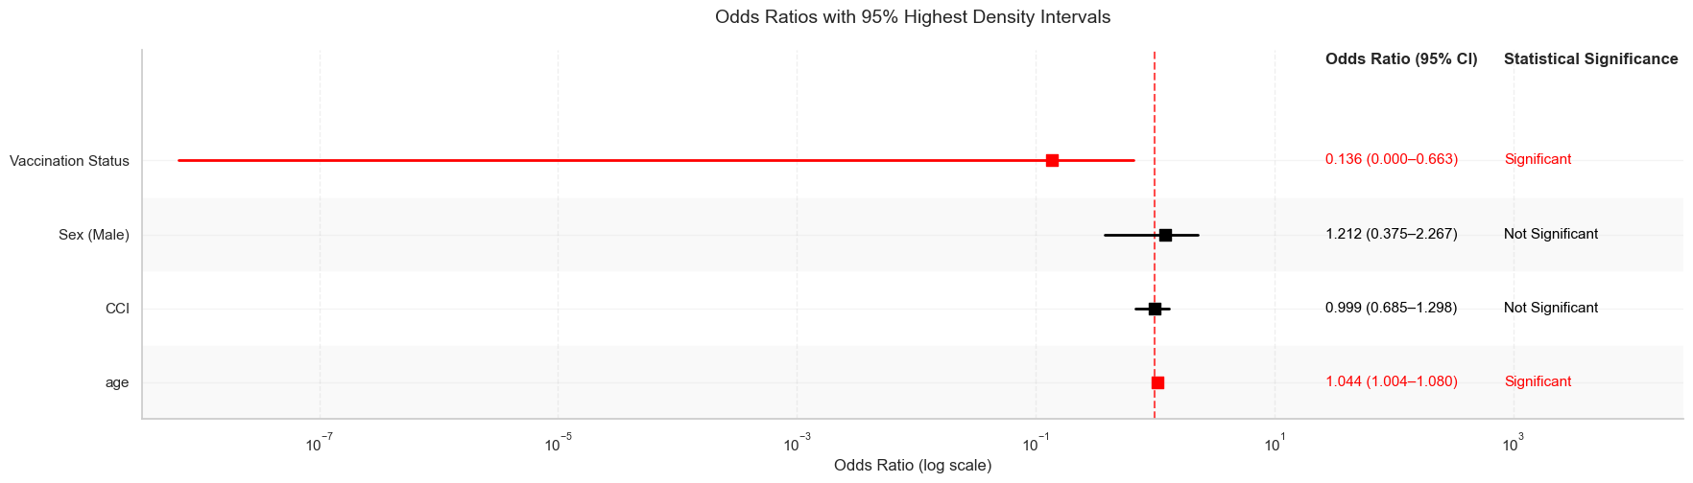
bayesian_odds_ratio_plot

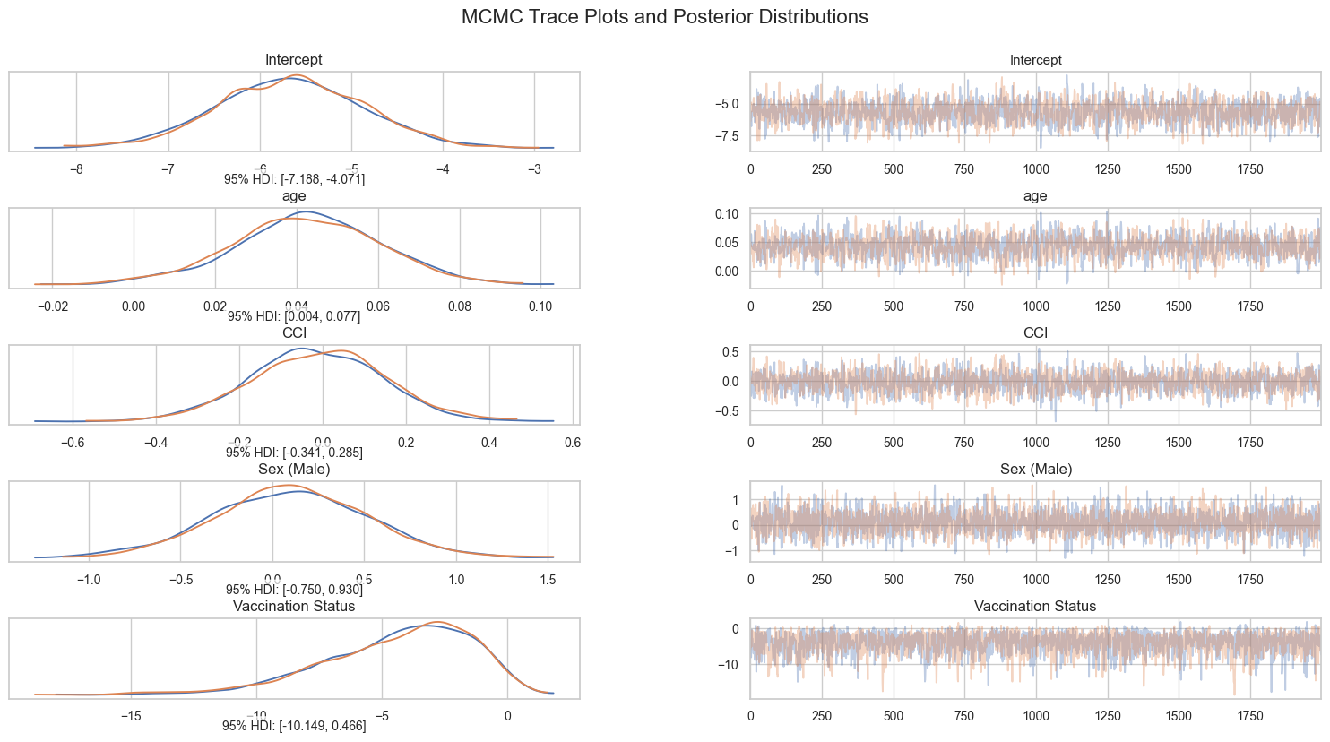
bayesian_trace_plots_enhanced

