Supplementary Figure 1. Covariate balance before and after implementation of inverse probability of treatment weighting.

Supplementary Figure 2. Partial effects plots regarding continuous variable in the Cox model.

Supplementary Figure 3. Forest plot of outcomes stratified by combination therapy or not in the desirability of outcome ranking (DOOR) analysis.
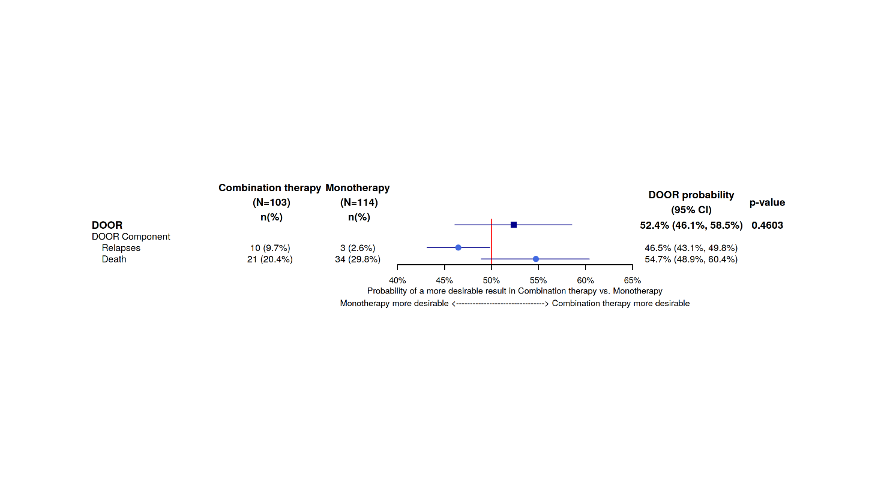

Supplementary Table 1. Generalized Variance Inflation Factor (GVIF) results.
Variable | GVIF | Df | GVIF1/(2⋅Df)
Combination therapy | 2.423821 | 1 | 1.556863
Sex | 1.814981 | 1 | 1.347212
ns(Age, df = 2) | 2.215917 | 2 | 1.220080
Body mass index at least 30 | 2.314086 | 1 | 1.521212
Chronic Obstructive Pulmonary Disease | 1.694491 | 1 | 1.301726
Oncohematological disease | 2.174767 | 1 | 1.474709
Diabetes mellitus | 1.772995 | 1 | 1.331539
Cardiovascular disease | 1.419469 | 1 | 1.191415
Cirrhosis | 1.868287 | 1 | 1.366853
ns(APACHE II score, df = 2) | 5.004528 | 2 | 1.495687
Hospital acquired infection | 3.783667 | 1 | 1.945165
Mechanical ventilation | 1.681376 | 1 | 1.296679
ExtraCorporeal Membrane Oxygenation | 1.396351 | 1 | 1.181673
Dialysis | 2.783004 | 1 | 1.668234
Septic shock | 1.650067 | 1 | 1.284549
KPC rectal colonization | 2.512398 | 1 | 1.585055
Type of infection | 4.201337 | 2 | 1.431683
Polymicrobial infection | 2.428216 | 1 | 1.558273

Note: in case of you have degrees of freedom (Df) greater than 1, the reference is the last column (GVIF^{1/(2 * Df)}). Thresholds: A common rule of thumb is that a value in the last column greater than 2 (which is equivalent to a standard VIF of 4) might indicate collinearity issues.

Supplemental Table 2. Survival probability ratios (SPR) when restricting the analysis to the combination between ceftazidime/avibactam (C/A) and fosfomycin versus monotherapy
Time (days) | Survival probability % — C/A + Fosfo | Survival probability % — Monotherapy | SPR | 95% CI
7 | 87.2% | 84.1% | 1.04 | 0.79–1.22
14 | 82.4% | 76.9% | 1.07 | 0.76–1.28
30 | 70.8% | 61.4% | 1.15 | 0.74–1.42

Supplemental Table 3. Survival probability ratios (SPR) after including time to active treatment in the model.

Time (days) | Survival probability % — Combination therapy | Survival probability % — Monotherapy | SPR | 95% CI
7 | 87.1% | 92.6% | 0.940 | 0.80–1.07
14 | 82.3% | 87.8% | 0.937 | 0.77–1.08
30 | 66.5% | 55.3% | 1.202 | 0.73–1.67

Supplemental Table 4. Desirability of outcome ranking (DOOR) partial credit scoring in scenarios A, B, and C.
Door Rank | Scenario A (full credit) | Scenario B (no credit) | Scenario C (partial credit)
Alive and no events | 100 | 100 | 100
Alive with relapse | 100 | 0 | 70
Dead | 0 | 0 | 0

