Supplementary text and boxplots:
Comparison between groups of patients with at least one 2-point score and patients with no 2-point score at different time points. Antibody reactivities with significant differences between the groups are listed.

Baseline
97 patients had at least one 2-point score, while eight patients had none. P-values and corresponding boxplots are listed below:
Serum:
- p18 B.afzelii IgM significant higher in the 2-point group (p=0.048)
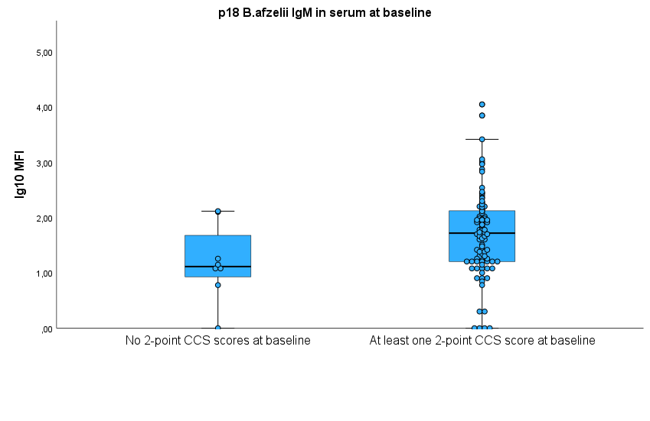

CSF: All reactivities were higher in the 2-point group
- OspC B.garinii IgM (p=0.036)
- p58 IgM (p=0.007)
- p39 IgM (p= 0.014)
- p18 B.ss IgM (p=0.014)

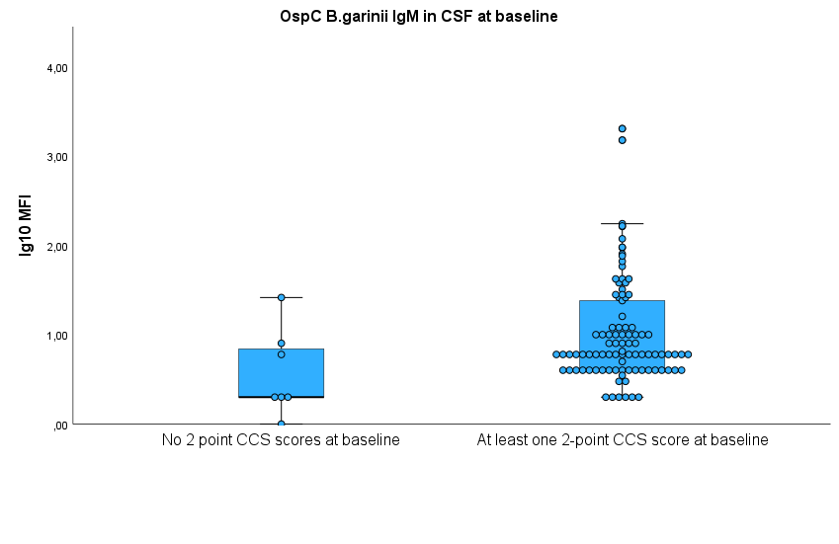

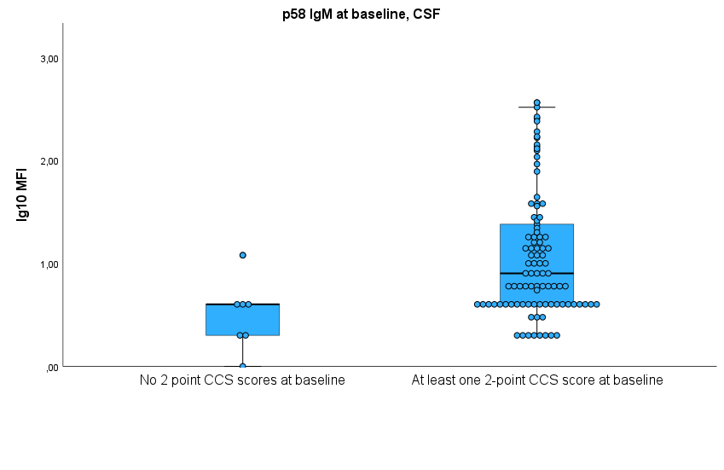

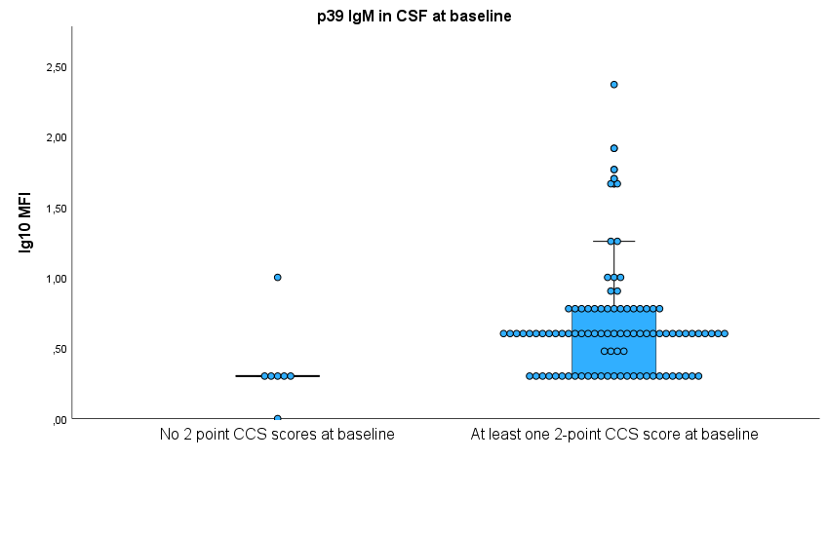
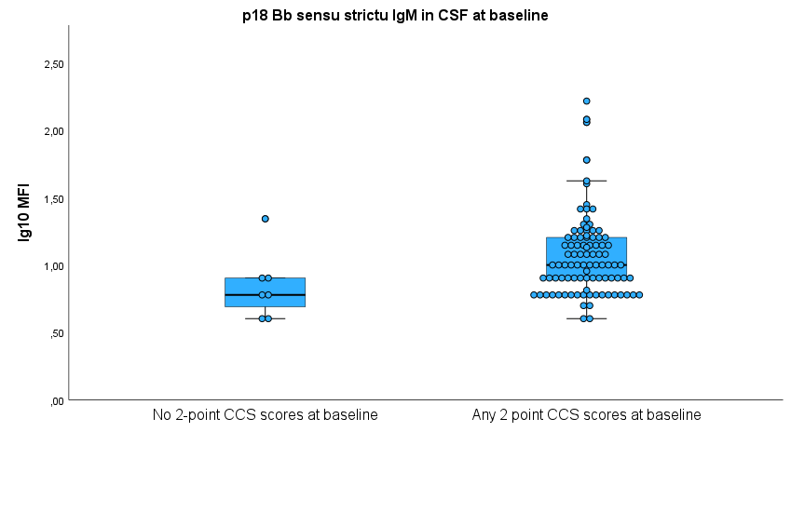

Six months
21 patients had at least one 2-point score, while 78 patients had no 2-point scores.
Serum: All reactivities were higher in the 2-point group
- OspC B.afzelii IgM (p= 0.012)
- OspC B.garinii IgM (p=0.010)
- OspC Bb.ss IgM (p=0.007)
- OspC Bb.ss IgG (p=0.038)
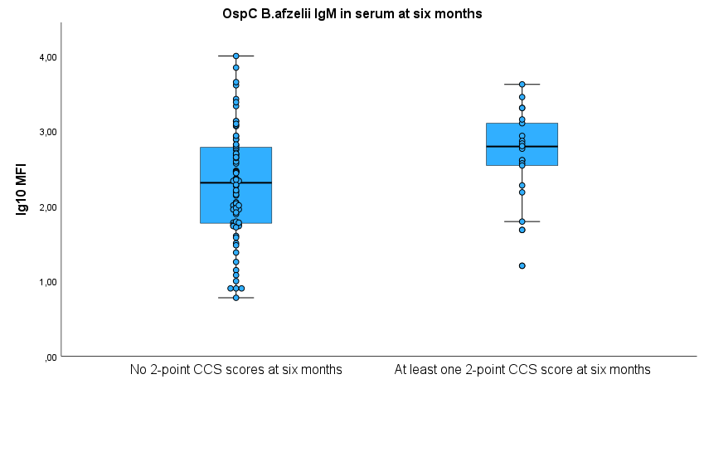
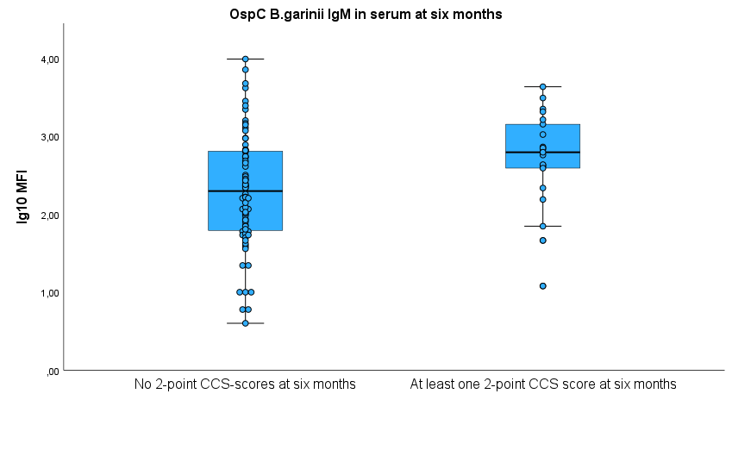

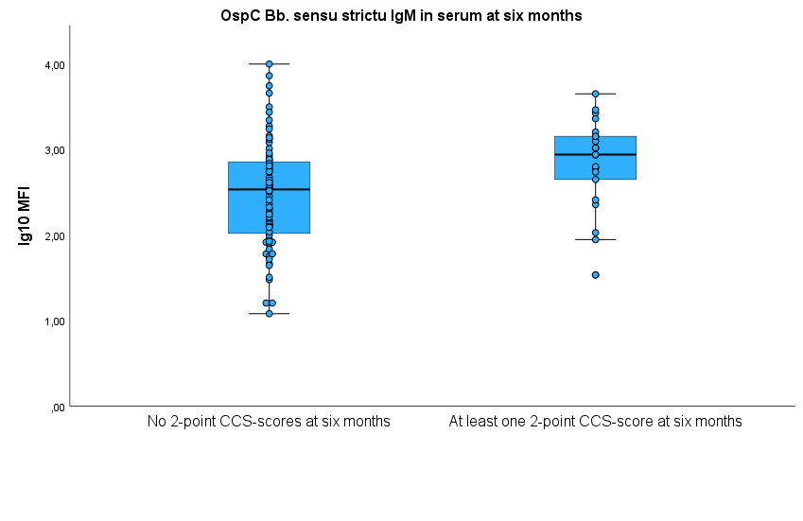
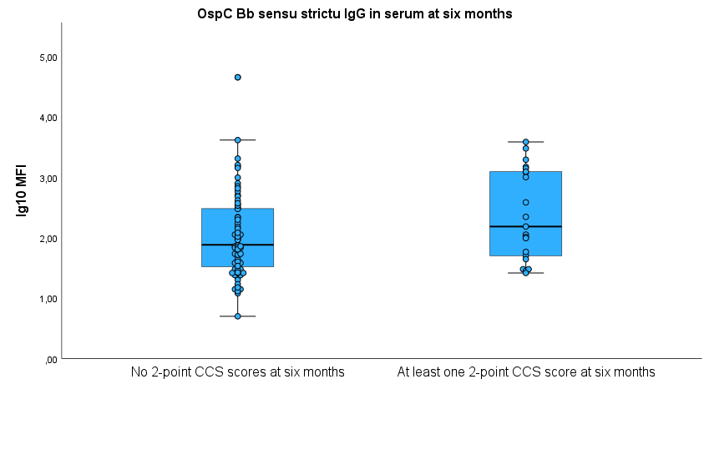

Twelve months
14 patients had at least one 2-point score and 74 patients had no 2-point scores.
Serum:
- VlsE IgM (p=0.024), significant higher in the patient group with no 2-point scores.
- p18 B.garinii IgG (p=0.030), significant higher in the group with at least one 2-point score.

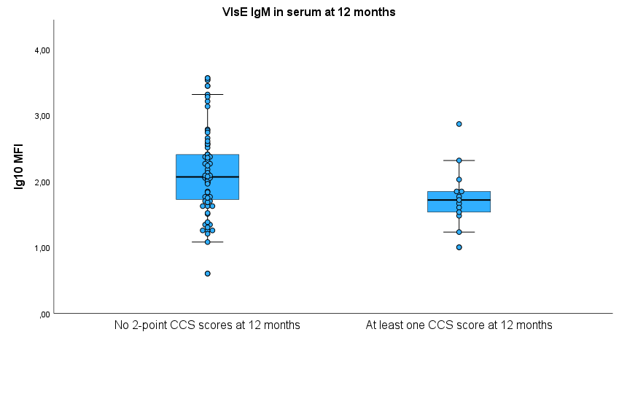

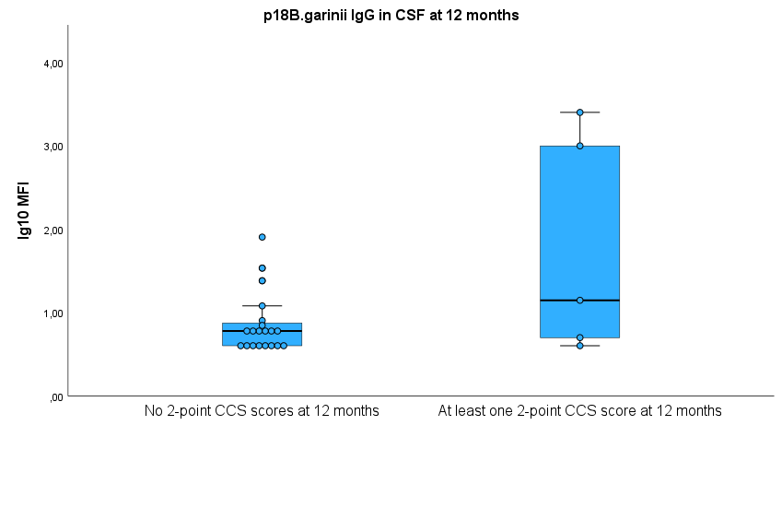

CCS over or under 10 points at baseline
CCS >10: N=39, CCS<=10: N=67
- p18 Bb sensu strictu IgM in CSF, p-value 0.038
- p18 Bb sensu strictu IgM in serum, p-value 0.044
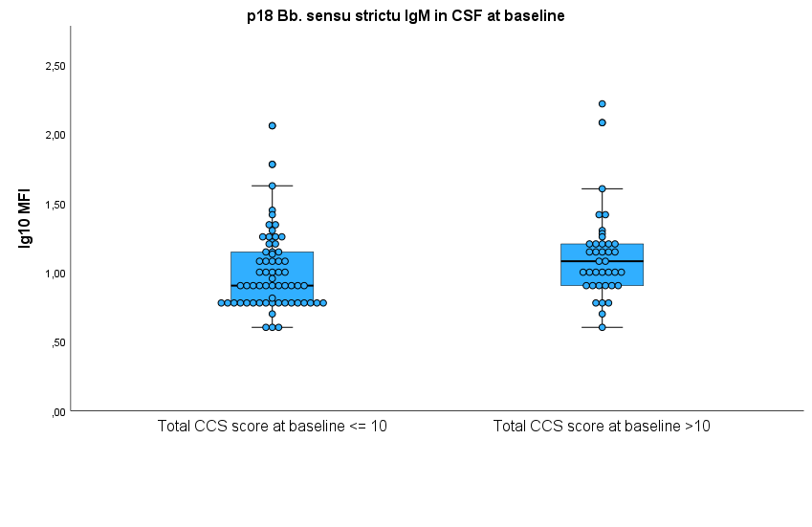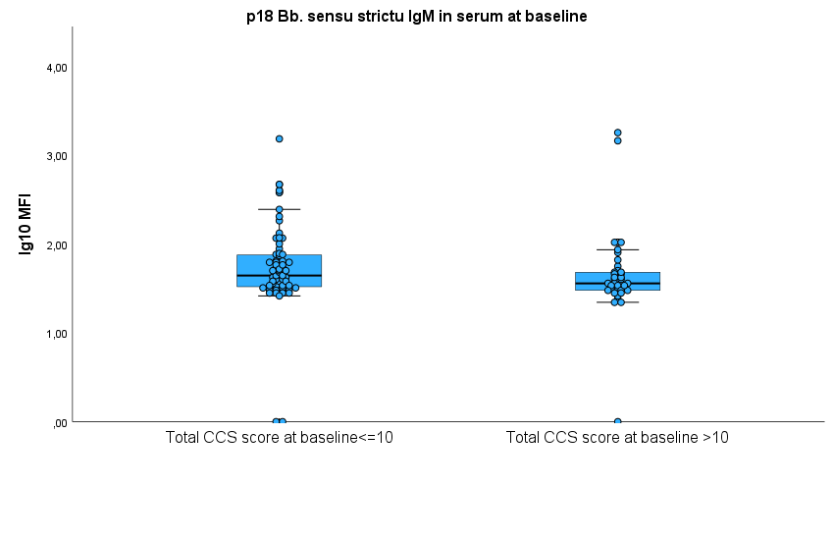

Duration of symptoms before diagnosis over and under 42 days
Symptom duration ≥ 42 days, n=16
Symptom duration > 42 days, n=89
- p58 IgM in serum at baseline, p-value 0.023
- OspC B.afzelii IgG in serum at baseline, p-value 0.016
- P18 Bb sensu strictu IgG in serum at baseline, p-value 0.048

