Impact of an antibiotic stewardship program on antimicrobial consumption and resistance in a setting with high volume prescribing and widespread resistance: an interrupted time series analysis.

Supplementary data
Table of Contents
A. Time-series analysis pre- and post-intervention 2
A.1. Statistical analysis 2
A.2. Data description 3
A.2.1 Tables 3
A.2.2 Graphs - Antibiotic consumption 7
A.2.3 Graphs - Resistant isolates (/1000 pt-days) 12
A.3. Interrupted time series analysis 28
A.3.1 Antibiotics consumption 28
A.3.2 Resistant isolates (/1000 pt-days) 37
B. Time-series (linear transfer functions) analysis 68
B.1. Statistical analysis 68
B.2. Data description 69
B.2.1 Tables 69
B.2.2 Graphs 70
B.3. Results 73

Time-series analysis pre- and post-intervention

A.1. Statistical analysis

Monthly consumptions of antibiotics along with the incidence of resistant isolates were summarized through their median and interquartile range for the pre- and post-intervention periods. Differences between the overall pre- and post-intervention levels were assessed using Mann-Whitney tests (non-parametric tests).

Trends over time were graphically explored through scatterplots including lowess¹ smoothers. Trends and intervention effects were assessed through interrupted time series models² where presence of autocorrelation was assessed through the Cumby-Huizinga general test³ and taken into account as necessary.

All analyses were performed using Stata version 14.2 (Stata Corp., TX USA). P-values less than 0.05 were considered as indicating statistical significance whereas those between 0.05 and 0.10 are referred to as indicative.

References

- Cleveland, W. S. 1979. Robust locally weighted regression and smoothing scatterplots. Journal of the American Statistical Association 74: 829-836.
- Ariel Linden, Ann Arbor. Conducting interrupted time‐series analysis for single‐and multiple‐group comparisons. The Stata Journal, 2015; 15(2),480–500.
- Cumby, R. E. and Huizinga, J. 1992. Testing the autocorrelation structure of disturbances in ordinary least squares and instrumental variables regressions. Econometrica, 60:1, 185-195.

A.2. Data description

A.2.1 Tables

Table SA.1. Antibiotics consumption (DDDs/100 p-days) by period.
 | Period
 | Pre-intervention | Post-intervention | Overall
 | Median (IQR) | Median (IQR) | Median (IQR) | p-value
Total antibiotic consumption | 79.90 (78.80, 81.20) | 79.65 (78.90, 81.10) | 79.70 (78.85, 81.15) | 0.808
Carbapenem consumption | 21.50 (20.60, 22.70) | 11.80 (10.70, 15.10) | 18.55 (11.55, 21.50) | <0.001
Colistin consumption | 7.10 (6.50, 7.80) | 4.90 (4.10, 6.10) | 6.25 (4.80, 7.35) | <0.001
Gentamicin consumption | 0.30 (0.20, 0.80) | 1.10 (0.90, 1.20) | 0.90 (0.35, 1.10) | <0.001
Amikacin consumption | 1.55 (1.30, 1.70) | 1.40 (1.30, 1.60) | 1.50 (1.30, 1.70) | 0.147
Aminoglycoside consumption | 1.95 (1.60, 2.30) | 2.50 (2.30, 2.80) | 2.30 (1.90, 2.65) | <0.001
Ciprofloxacin consumption | 12.70 (12.30, 13.60) | 10.10 (9.60, 11.30) | 11.70 (10.10, 12.70) | <0.001
Fluoroquinolones consumption | 17.00 (16.30, 17.50) | 13.90 (13.30, 14.60) | 15.75 (13.85, 17.00) | <0.001
Tigecycline consumption | 5.35 (4.80, 6.00) | 1.95 (1.70, 2.60) | 3.80 (1.90, 5.30) | <0.001

Table SA.2 Resistant isolates (/1000 p-days) by period.
A. Hospital
 | Period
 | Pre-intervention | Post-intervention | Overall
 | Median (IQR) | Median (IQR) | Median (IQR) | p-value
All Pathogens
Carbapenem resistant isolates/1000 pt-days | 0.387 (0.210, 0.565) | 0.411 (0.300, 0.639) | 0.390 (0.247, 0.588) | 0.398
Carbapenem + Aminoglycosides resistant isolates/1000 pt-days | 0.138 (0.066, 0.245) | 0.319 (0.213, 0.499) | 0.230 (0.132, 0.377) | <0.001
Carbapenem + Colistin resistant isolates/1000 pt-days | 0.062 (0.000, 0.122) | 0.074 (0.000, 0.234) | 0.071 (0.000, 0.140) | 0.012
Carbapenem + Tigecycline resistant isolates/1000 pt-days | 0.000 (0.000, 0.067) | 0.082 (0.000, 0.183) | 0.067 (0.000, 0.142) | <0.001
K. pneumoniae
Carbapenem resist./1000 pt-days | 0.187 (0.125, 0.262) | 0.154 (0.073, 0.228) | 0.167 (0.081, 0.245) | 0.743
Carbapenem + Aminoglycosides resist./1000 pt-days | 0.000 (0.000, 0.070) | 0.075 (0.000, 0.151) | 0.029 (0.000, 0.136) | 0.001
Carbapenem + Colistin resist./1000 pt-days | 0.059 (0.000, 0.071) | 0.000 (0.000, 0.075) | 0.000 (0.000, 0.073) | 0.836
Carbapenem + Tigecycline resist./1000 pt-days | 0.000 (0.000, 0.000) | 0.000 (0.000, 0.077) | 0.000 (0.000, 0.000) | 0.006
Ps Aeruginosa
Carbapenem resist./1000 pt-days | 0.000 (0.000, 0.069) | 0.070 (0.000, 0.142) | 0.000 (0.000, 0.085) | 0.105
Carbapenem + Aminoglycosides resist./1000 pt-days | 0.000 (0.000, 0.000) | 0.000 (0.000, 0.077) | 0.000 (0.000, 0.034) | <0.001
Carbapenem + Colistin resist./1000 pt-days | 0.000 (0.000, 0.000) | 0.000 (0.000, 0.000) | 0.000 (0.000, 0.000) | 0.132
Carbapenem + Tigecycline resist./1000 pt-days | 0.000 (0.000, 0.000) | 0.000 (0.000, 0.000) | 0.000 (0.000, 0.000) | 0.515
A. baumannii
Carbapenem resist./1000 pt-days | 0.155 (0.063, 0.216) | 0.154 (0.076, 0.357) | 0.154 (0.073, 0.303) | 0.273
Carbapenem + Aminoglycosides resist./1000 pt-days | 0.082 (0.000, 0.214) | 0.154 (0.076, 0.357) | 0.146 (0.067, 0.282) | 0.012
Carbapenem + Colistin resist./1000 pt-days | 0.000 (0.000, 0.000) | 0.070 (0.000, 0.152) | 0.000 (0.000, 0.072) | <0.001
Carbapenem + Tigecycline resist./1000 pt-days | 0.000 (0.000, 0.000) | 0.074 (0.000, 0.154) | 0.000 (0.000, 0.101) | 0.001

B. Community
 | Period
 | Pre-intervention | Post-intervention | Overall
 | Median (IQR) | Median (IQR) | Median (IQR) | p-value
All Pathogens
Carbapenem resistant isolates/1000 pt-days | 0.070 (0.000, 0.148) | 0.225 (0.084, 0.375) | 0.142 (0.031, 0.329) | 0.001
Carbapenem + Aminoglycosides resistant isolates/1000 pt-days | 0.000 (0.000, 0.125) | 0.146 (0.073, 0.301) | 0.076 (0.000, 0.217) | 0.001
Carbapenem + Colistin resistant isolates/1000 pt-days | 0.000 (0.000, 0.000) | 0.070 (0.000, 0.144) | 0.000 (0.000, 0.073) | 0.001
Carbapenem + Tigecycline resistant isolates/1000 pt-days | 0.000 (0.000, 0.000) | 0.071 (0.000, 0.136) | 0.000 (0.000, 0.079) | 0.003
K. pneumoniae
Carbapenem resist./1000 pt-days | 0.000 (0.000, 0.125) | 0.085 (0.068, 0.225) | 0.071 (0.000, 0.165) | 0.012
Carbapenem + Aminoglycosides resist./1000 pt-days | 0.000 (0.000, 0.060) | 0.000 (0.000, 0.144) | 0.000 (0.000, 0.075) | 0.065
Carbapenem + Colistin resist./1000 pt-days | 0.000 (0.000, 0.000) | 0.000 (0.000, 0.071) | 0.000 (0.000, 0.061) | 0.200
Carbapenem + Tigecycline resist./1000 pt-days | 0.000 (0.000, 0.000) | 0.000 (0.000, 0.069) | 0.000 (0.000, 0.000) | 0.014
Ps Aeruginosa
Carbapenem resist./1000 pt-days | 0.000 (0.000, 0.000) | 0.000 (0.000, 0.075) | 0.000 (0.000, 0.000) | 0.152
Carbapenem + Aminoglycosides resist./1000 pt-days | 0.000 (0.000, 0.000) | 0.000 (0.000, 0.075) | 0.000 (0.000, 0.000) | 0.025
Carbapenem + Colistin resist./1000 pt-days | 0.000 (0.000, 0.000) | 0.000 (0.000, 0.000) | 0.000 (0.000, 0.000) | -
Carbapenem + Tigecycline resist./1000 pt-days | 0.000 (0.000, 0.000) | 0.000 (0.000, 0.000) | 0.000 (0.000, 0.000) | -
A. baumannii
Carbapenem resist./1000 pt-days | 0.000 (0.000, 0.073) | 0.075 (0.000, 0.152) | 0.070 (0.000, 0.142) | 0.013
Carbapenem + Aminoglycosides resist./1000 pt-days | 0.000 (0.000, 0.071) | 0.075 (0.000, 0.152) | 0.069 (0.000, 0.142) | 0.008
Carbapenem + Colistin resist./1000 pt-days | 0.000 (0.000, 0.000) | 0.000 (0.000, 0.074) | 0.000 (0.000, 0.000) | <0.001
Carbapenem + Tigecycline resist./1000 pt-days | 0.000 (0.000, 0.000) | 0.069 (0.000, 0.078) | 0.000 (0.000, 0.073) | 0.008

C. All isolates
 | Period
 | Pre-intervention | Post-intervention | Overall
 | Median (IQR) | Median (IQR) | Median (IQR) | p-value
All Pathogens
Carbapenem resistant isolates/1000 pt-days | 0.488 (0.306, 0.805) | 0.724 (0.511, 0.906) | 0.634 (0.375, 0.891) | 0.071
Carbapenem + Aminoglycosides resistant isolates/1000 pt-days | 0.217 (0.078, 0.424) | 0.522 (0.366, 0.653) | 0.392 (0.209, 0.641) | <0.001
Carbapenem + Colistin resistant isolates/1000 pt-days | 0.069 (0.000, 0.136) | 0.145 (0.073, 0.312) | 0.124 (0.029, 0.212) | 0.001
Carbapenem + Tigecycline resistant isolates/1000 pt-days | 0.063 (0.000, 0.119) | 0.148 (0.073, 0.336) | 0.080 (0.000, 0.211) | <0.001
K. pneumoniae
Carbapenem resist./1000 pt-days | 0.231 (0.146, 0.388) | 0.309 (0.156, 0.430) | 0.256 (0.147, 0.422) | 0.223
Carbapenem + Aminoglycosides resist./1000 pt-days | 0.000 (0.000, 0.074) | 0.148 (0.075, 0.227) | 0.076 (0.000, 0.213) | <0.001
Carbapenem + Colistin resist./1000 pt-days | 0.067 (0.000, 0.119) | 0.072 (0.000, 0.144) | 0.070 (0.000, 0.124) | 0.368
Carbapenem + Tigecycline resist./1000 pt-days | 0.000 (0.000, 0.000) | 0.069 (0.000, 0.091) | 0.000 (0.000, 0.072) | <0.001
Ps Aeruginosa
Carbapenem resist./1000 pt-days | 0.031 (0.000, 0.072) | 0.078 (0.000, 0.146) | 0.069 (0.000, 0.143) | 0.035
Carbapenem + Aminoglycosides resist./1000 pt-days | 0.000 (0.000, 0.000) | 0.071 (0.000, 0.142) | 0.000 (0.000, 0.076) | <0.001
Carbapenem + Colistin resist./1000 pt-days | 0.000 (0.000, 0.000) | 0.000 (0.000, 0.000) | 0.000 (0.000, 0.000) | 0.132
Carbapenem + Tigecycline resist./1000 pt-days | 0.000 (0.000, 0.000) | 0.000 (0.000, 0.000) | 0.000 (0.000, 0.000) | 0.515
A. baumannii
Carbapenem resist./1000 pt-days | 0.208 (0.125, 0.375) | 0.250 (0.163, 0.488) | 0.225 (0.147, 0.454) | 0.101
Carbapenem + Aminoglycosides resist./1000 pt-days | 0.183 (0.066, 0.271) | 0.250 (0.163, 0.488) | 0.217 (0.133, 0.424) | 0.009
Carbapenem + Colistin resist./1000 pt-days | 0.000 (0.000, 0.000) | 0.073 (0.000, 0.234) | 0.000 (0.000, 0.076) | <0.001
Carbapenem + Tigecycline resist./1000 pt-days | 0.000 (0.000, 0.077) | 0.081 (0.071, 0.215) | 0.072 (0.000, 0.156) | <0.001

A.2.2 Graphs - Antibiotic consumption

Figure SA.1. Total antibiotic consumption pre- and post-intervention.
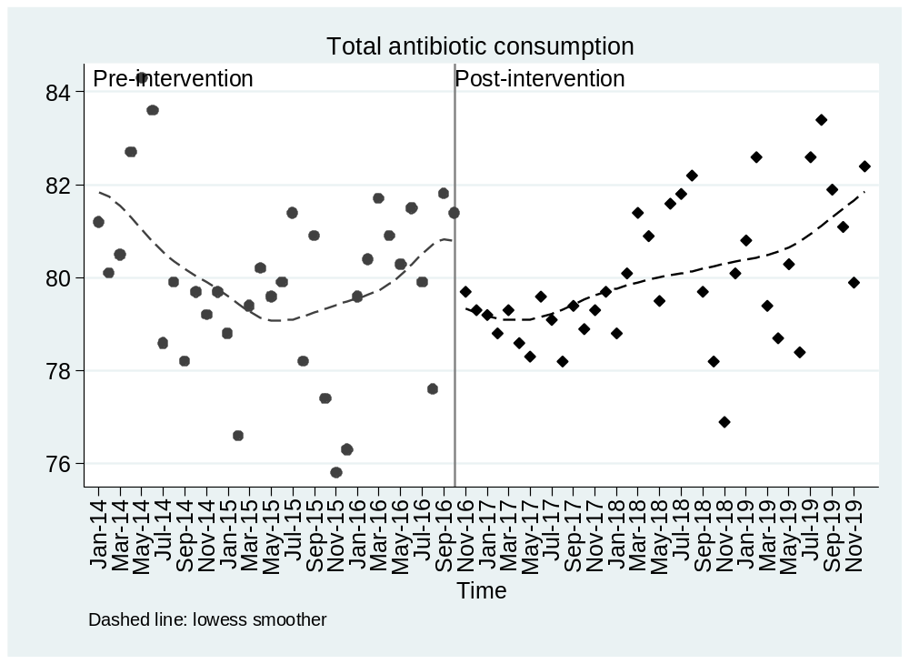

Figure SA.2. Carbapenem consumption pre- and post-intervention.
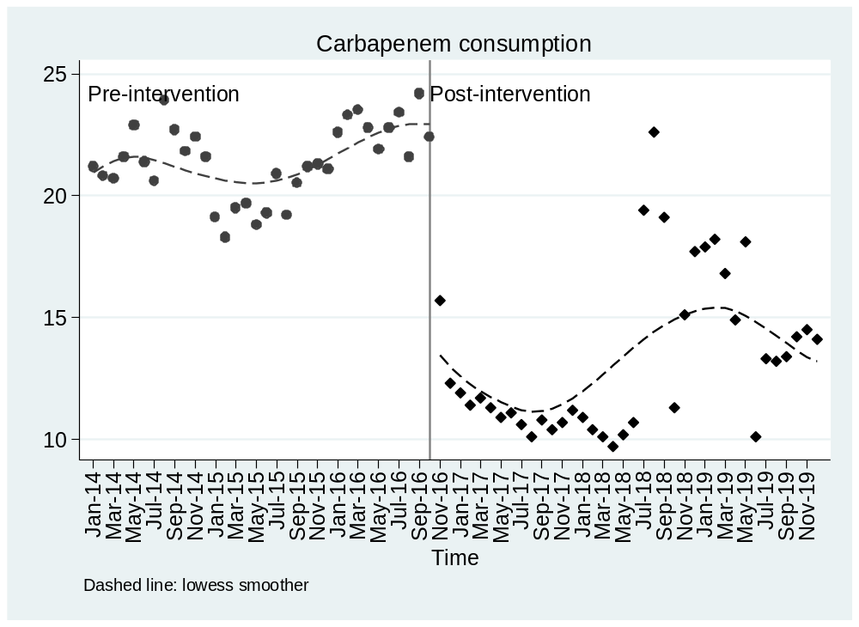

Figure SA.3. Colistin consumption pre- and post-intervention.
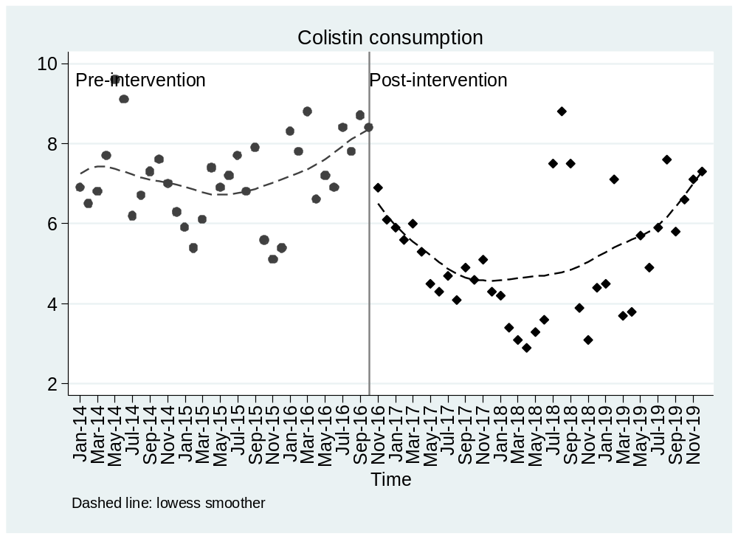

Figure SA.4. Gentamicin consumption pre- and post-intervention.
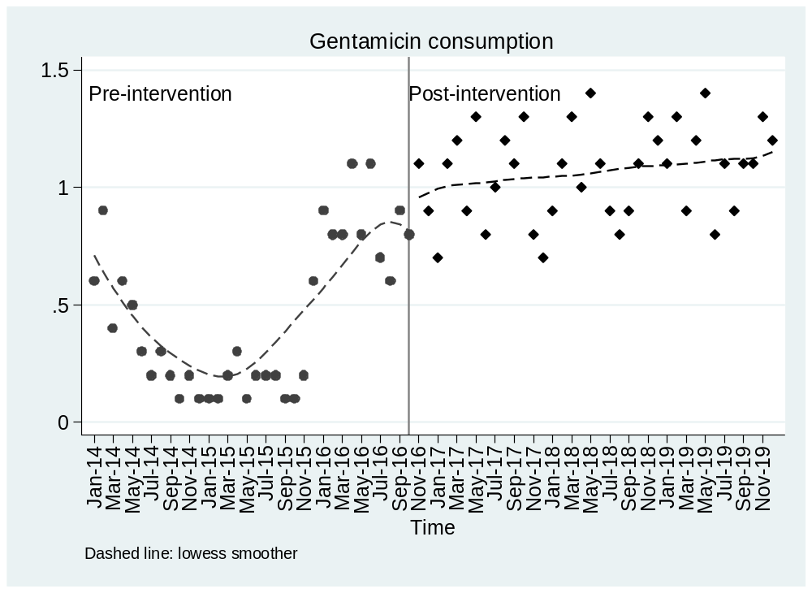

Figure SA.5. Amikacin consumption pre- and post-intervention.
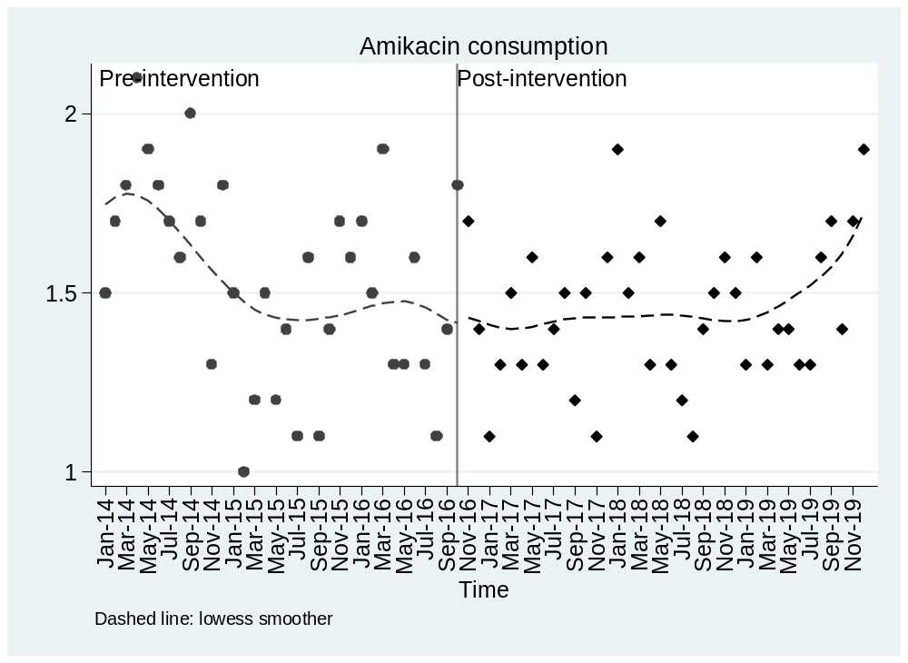

Figure SA.6. Aminoglycoside consumption pre- and post-intervention.
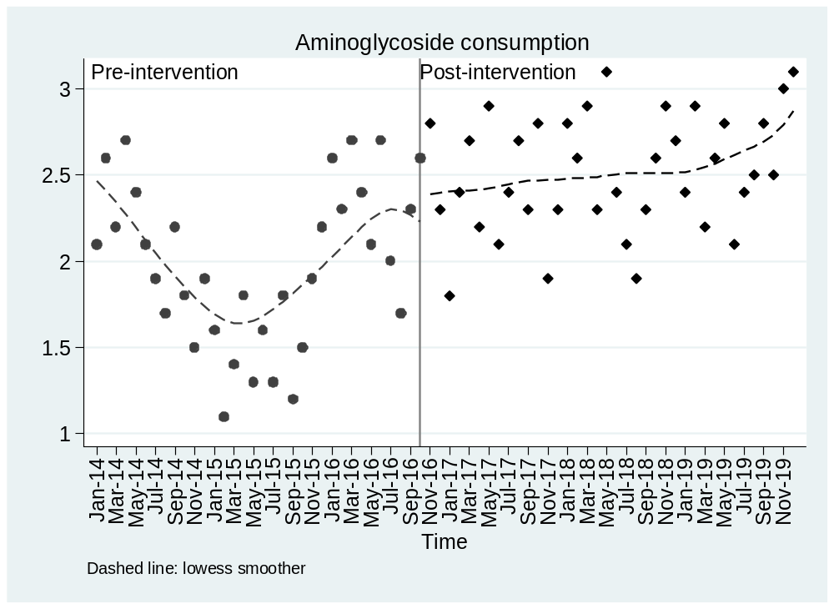

Figure SA.7. Ciprofloxacin consumption pre- and post-intervention.
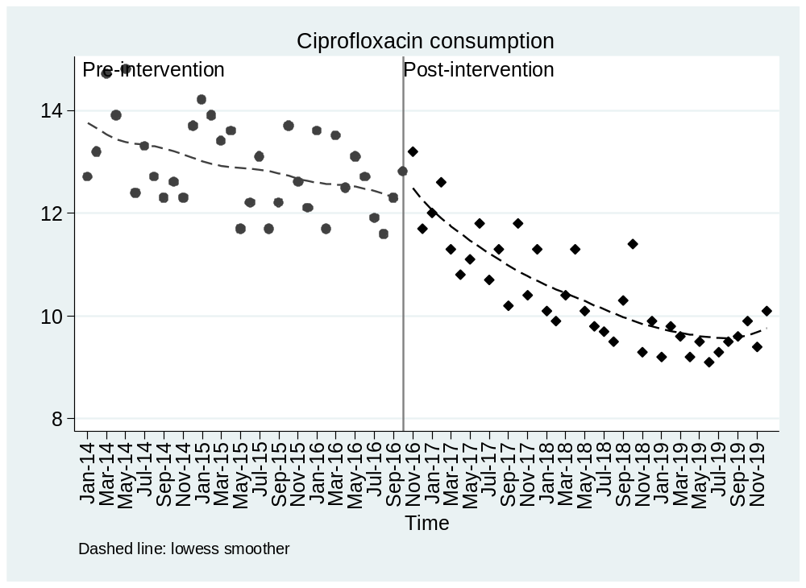

Figure SA.8. Fluoroquinolones consumption pre- and post-intervention.
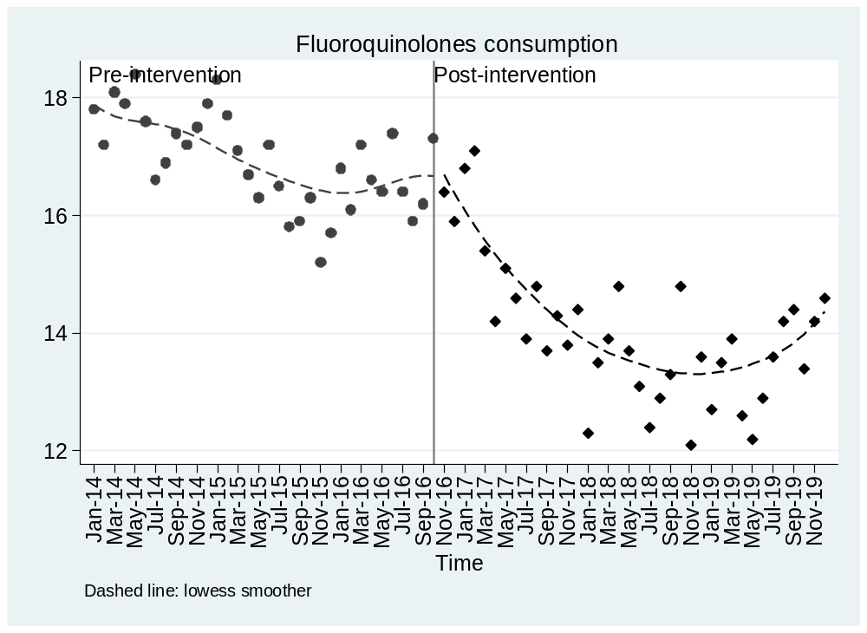

Figure SA.9. Tigecycline consumption pre- and post-intervention.
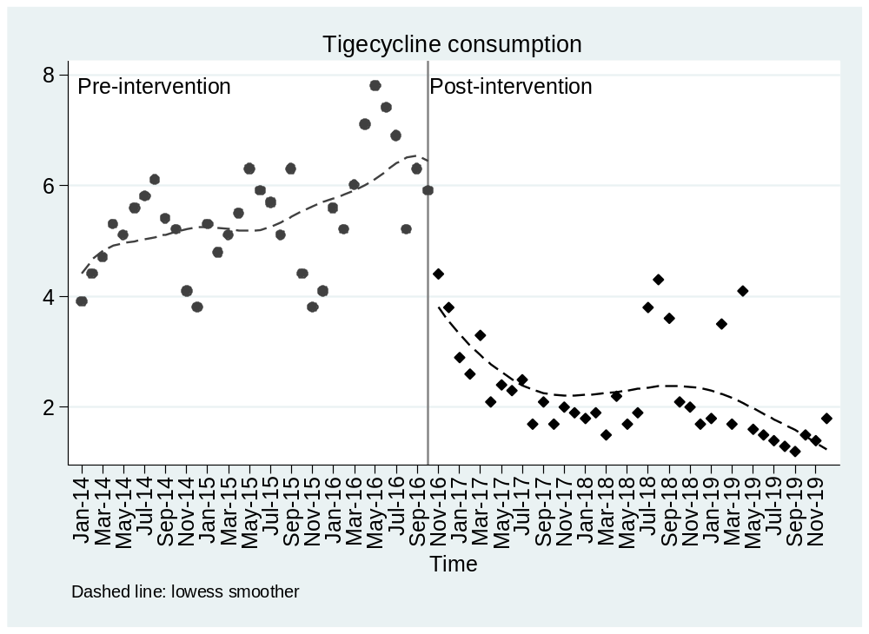

A.2.3 Graphs - Resistant isolates (/1000 pt-days)

Figure SA.10. Carbapenem resistant isolates/1000 pt-days pre- and post-intervention, All Pathogens
A. Hospital
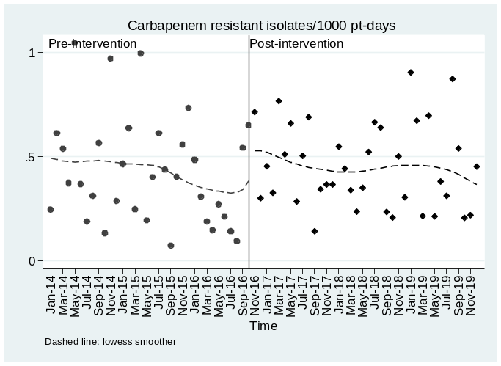
B. Community
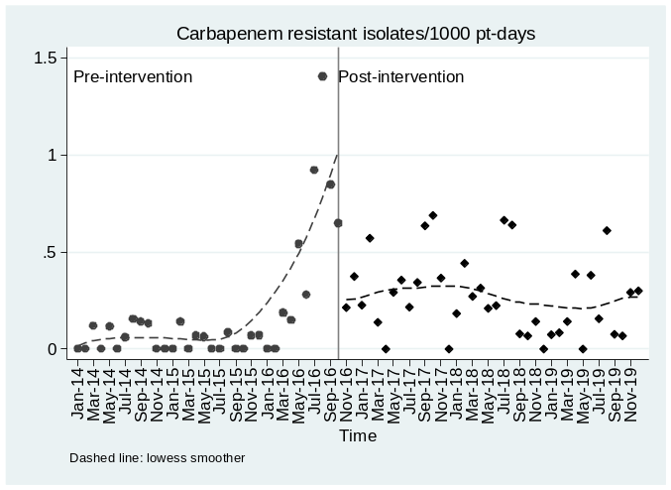
C. All

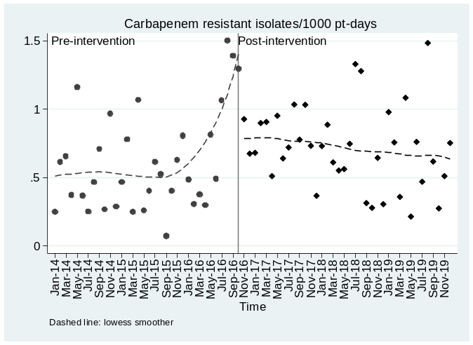
Figure SA.11. Carbapenem + Aminoglycosides resistant isolates/1000 pt-days pre- and post-intervention, All Pathogens
A. Hospital
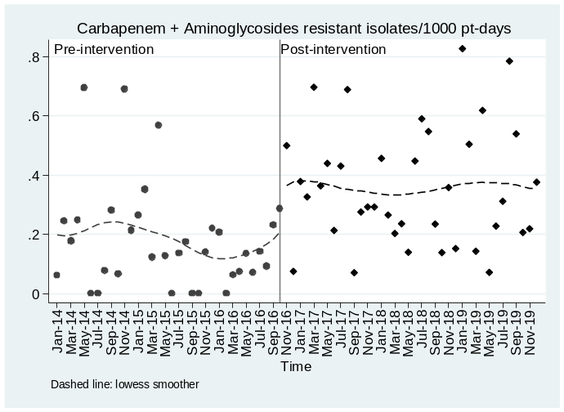
B. Community
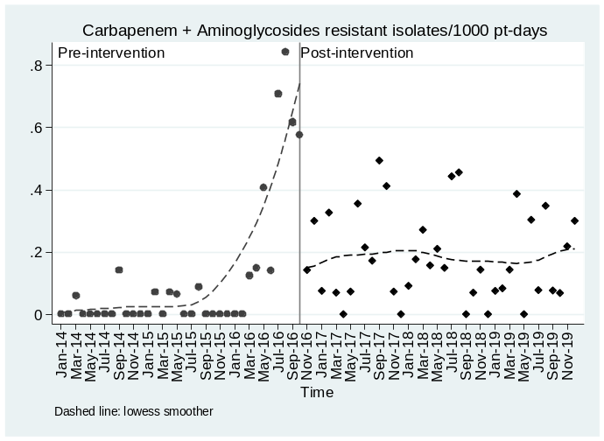
C. All
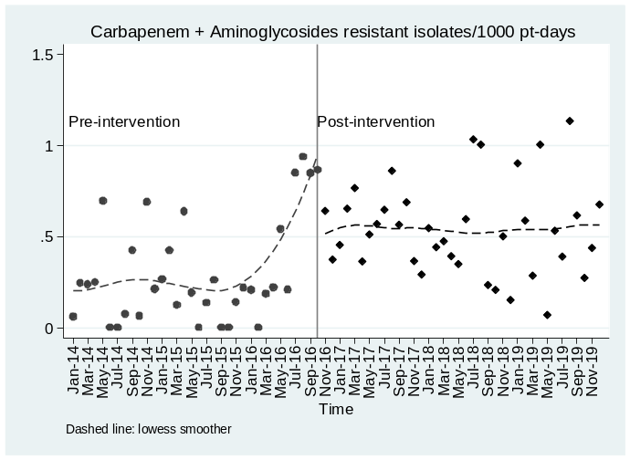

Figure SA.12. Carbapenem + Colistin resistant isolates/1000 pt-days pre- and post-intervention, All Pathogens
A. Hospital
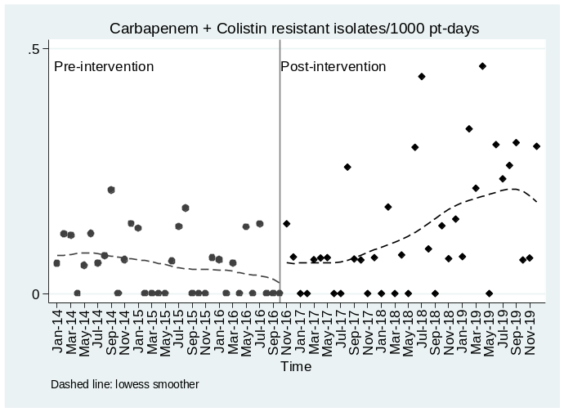
B. Community
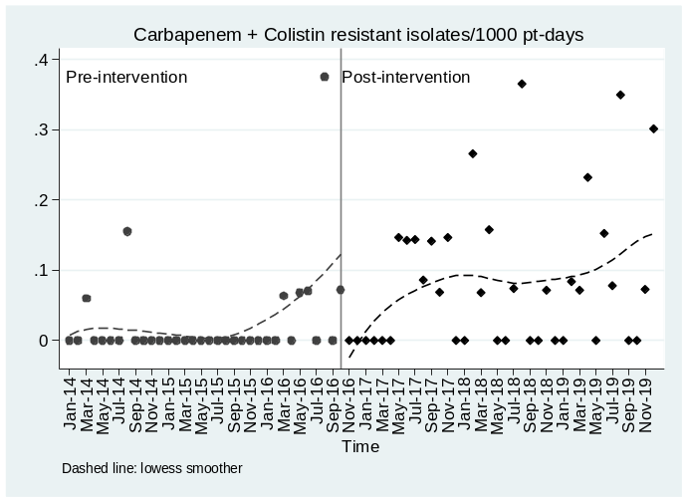
C. All
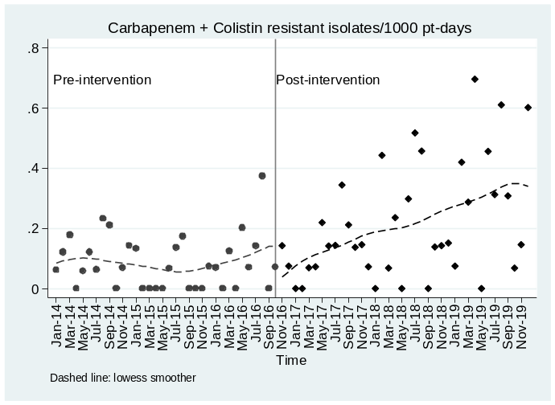

Figure SA.13. Carbapenem + Tigecycline resistant isolates/1000 pt-days pre- and post-intervention, All Pathogens
A. Hospital
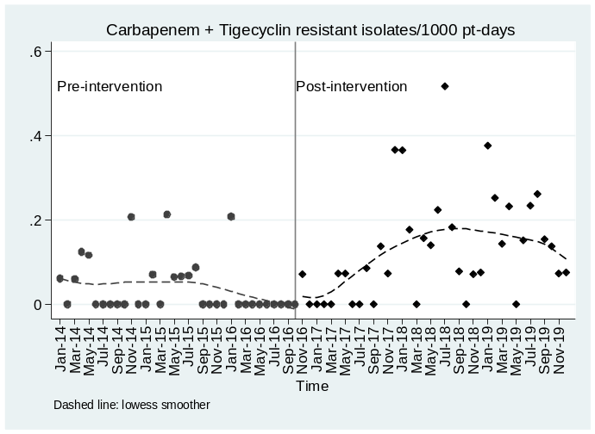
B. Community
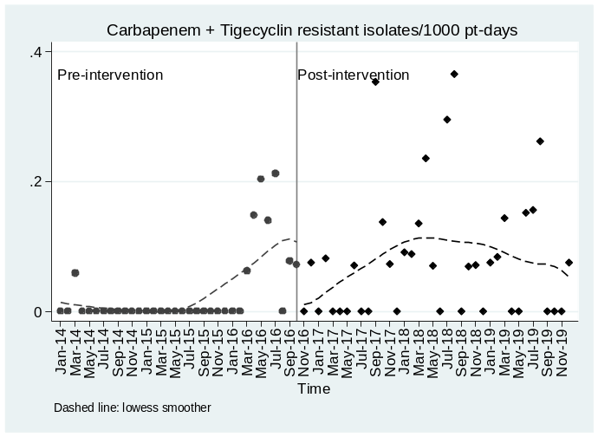
C. All
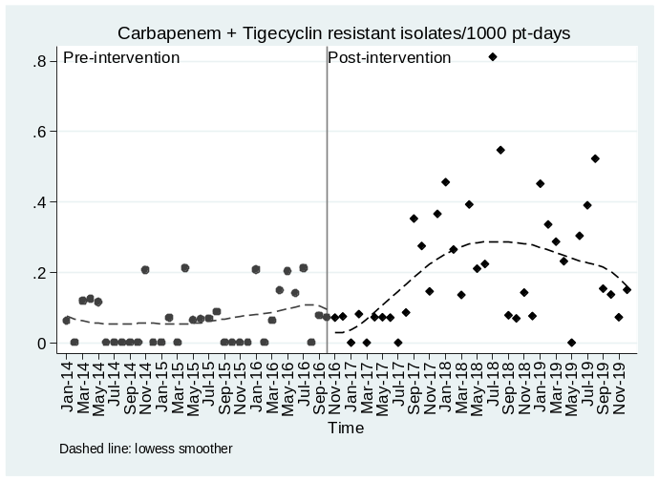

Figure SA.14. Carbapenem resistant isolates/1000 pt-days pre- and post-intervention, K. pneumoniae.
A. Hospital
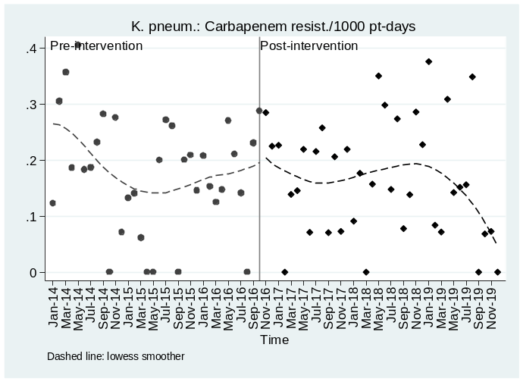
B. Community
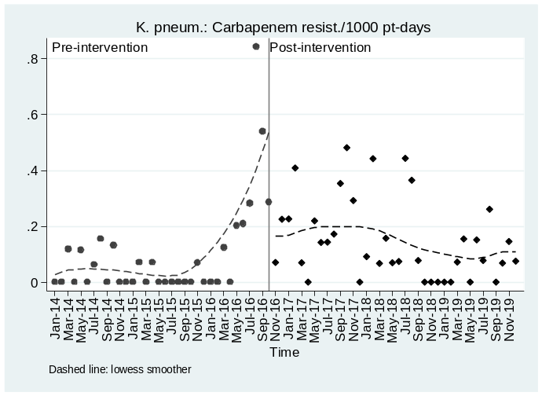
C. All
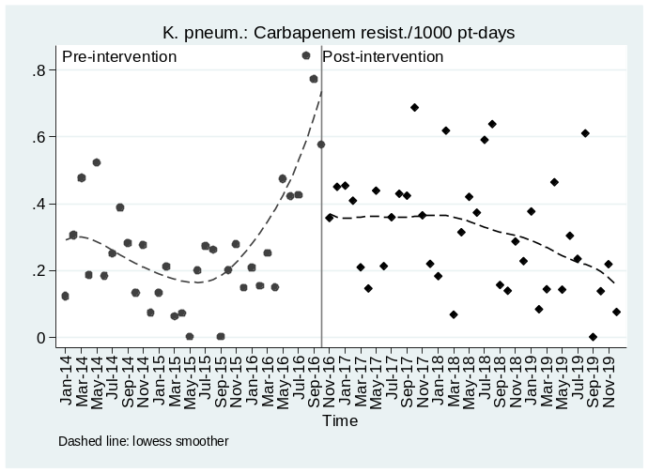

Figure SA.15. Carbapenem + Aminoglycosides resistant isolates/1000 pt-days pre- and post-intervention, K. pneumoniae.
A. Hospital
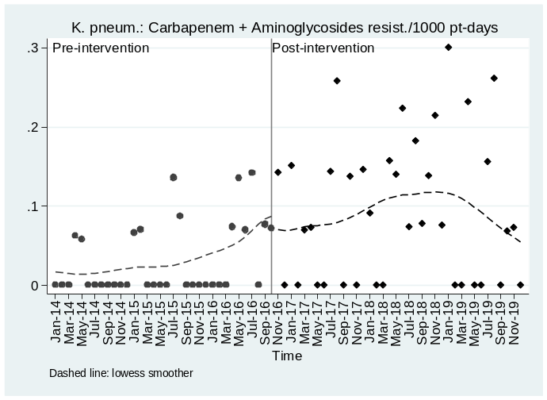
B. Community
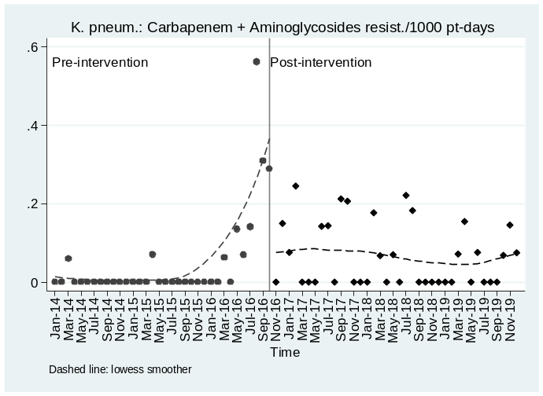
C. All
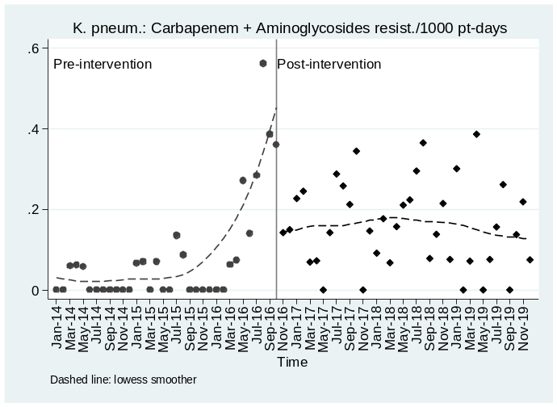

Figure SA.16. Carbapenem + Colistin resistant isolates/1000 pt-days pre- and post-intervention, K. pneumoniae.
A. Hospital
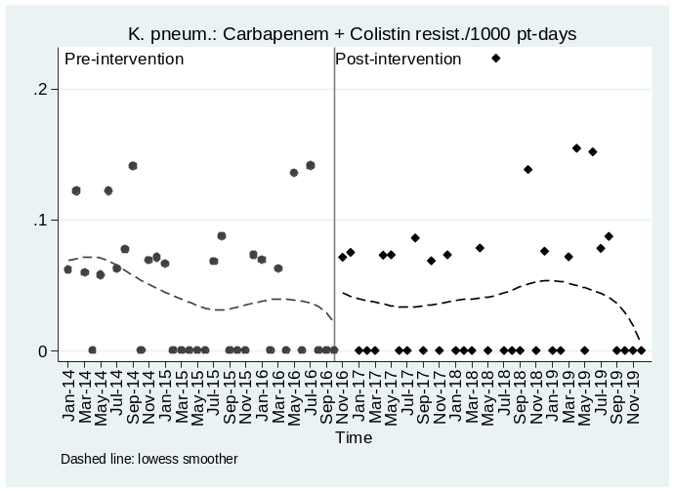
B. Community
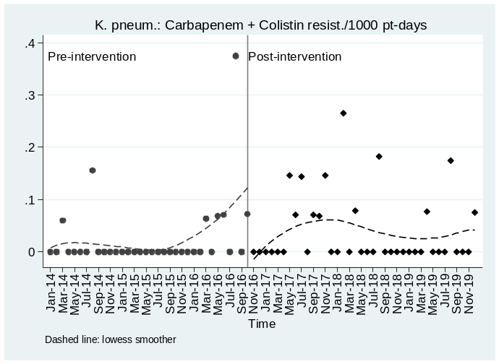
C. All
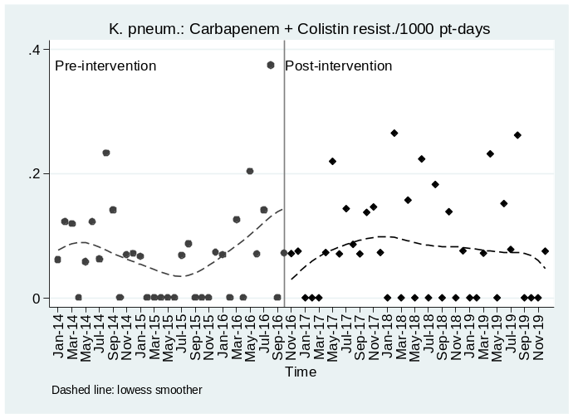

Figure SA.17. Carbapenem + Tigecycline resistant isolates/1000 pt-days pre- and post-intervention, K. pneumoniae.
A. Hospital
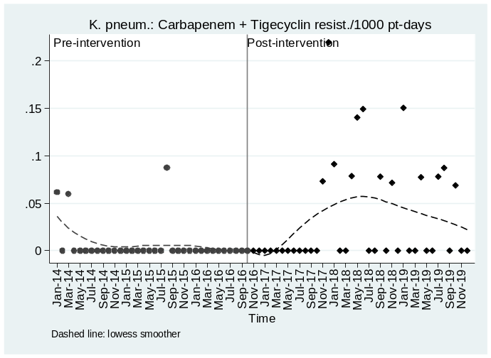
B. Community
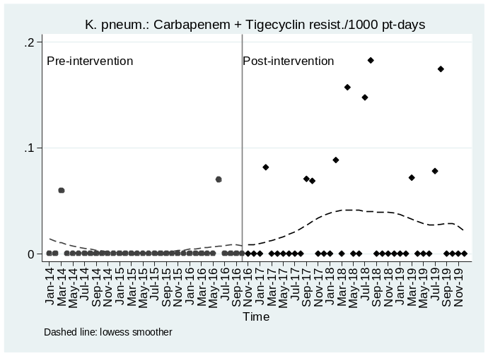
C. All
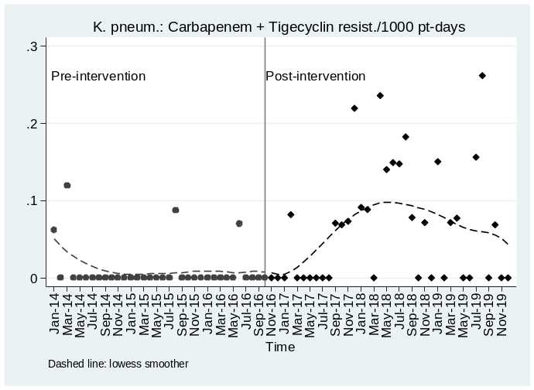

Figure SA.18. Carbapenem resistant isolates/1000 pt-days pre- and post-intervention, Ps Aeruginosa.
A. Hospital
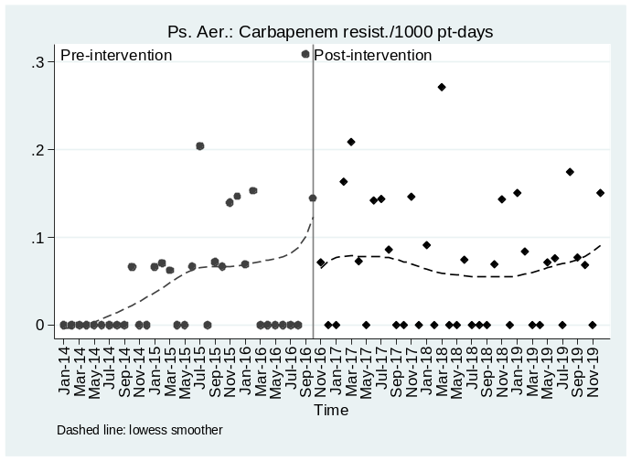
B. Community
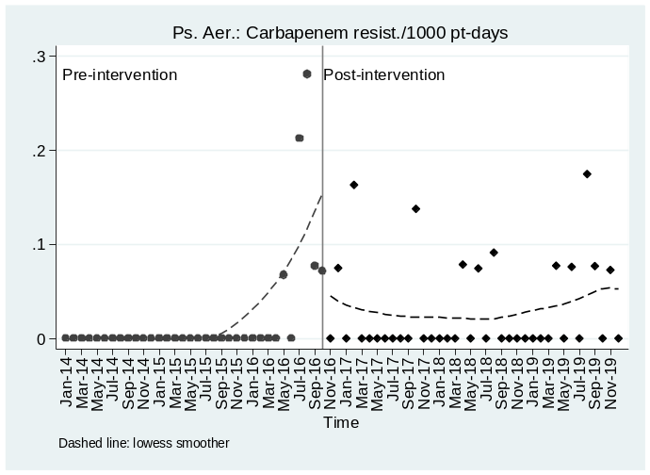
C. All
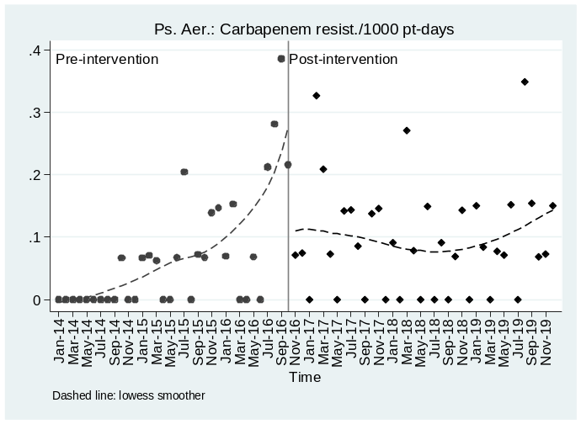

Figure SA.19 Carbapenem + Aminoglycosides resistant isolates/1000 pt-days pre- and post-intervention, Ps Aeruginosa.
A. Hospital
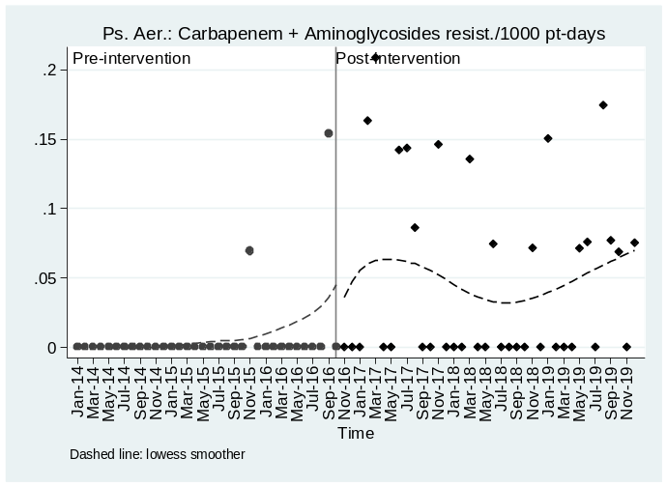
B. Community
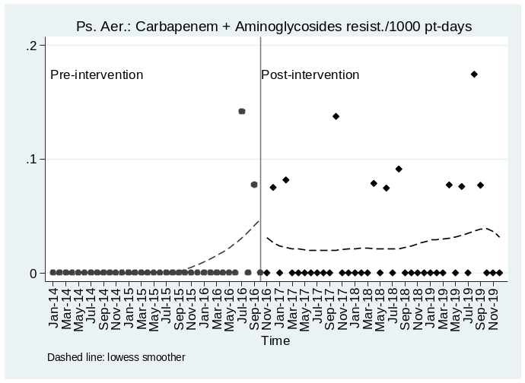
C. All
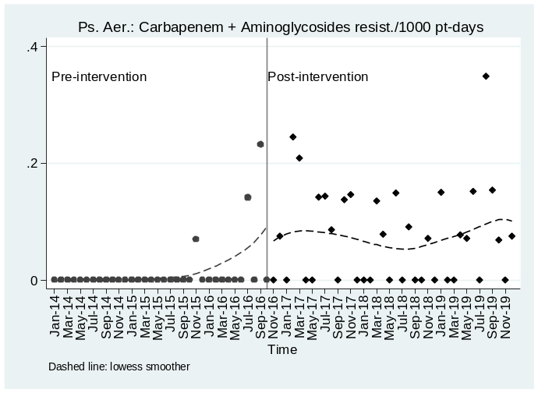

Figure SA.20. Carbapenem + Colistin resistant isolates/1000 pt-days pre- and post-intervention, Ps Aeruginosa.
A. Hospital
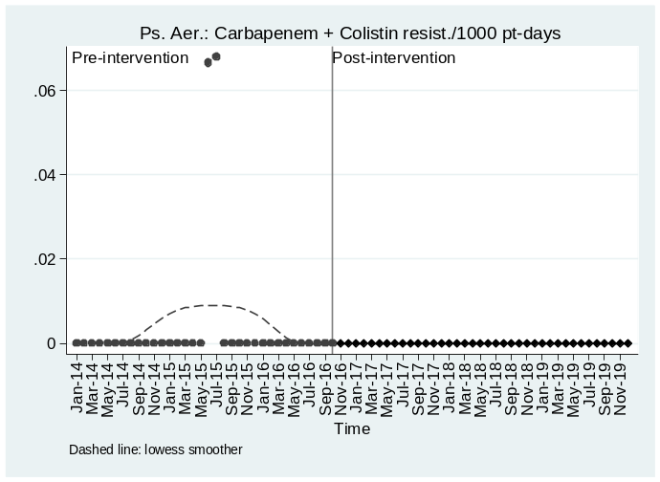
B. Community
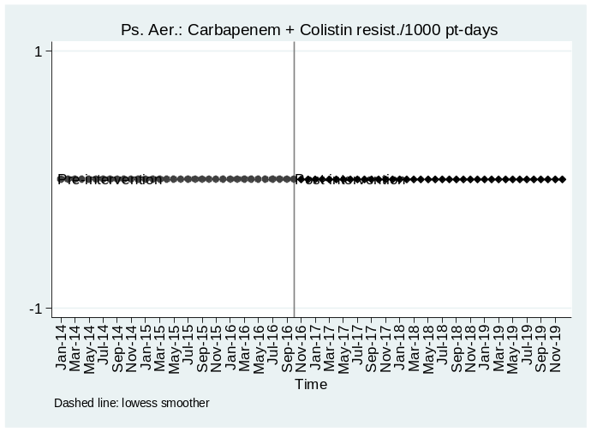
C. All

Figure SA.21. Carbapenem + Tigecycline resistant isolates/1000 pt-days pre- and post-intervention, Ps Aeruginosa.
A. Hospital
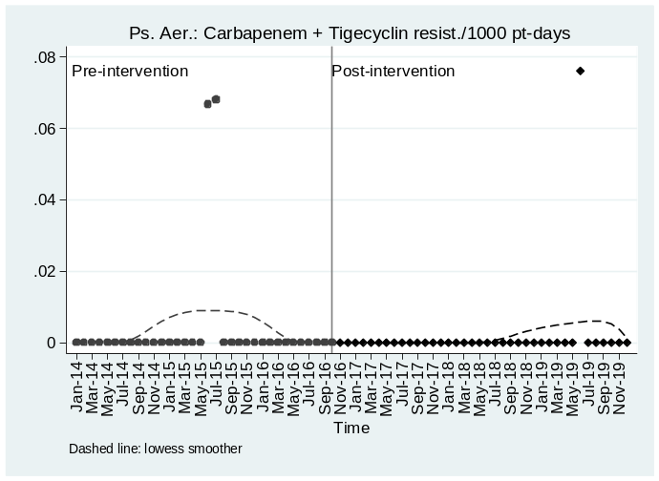
B. Community
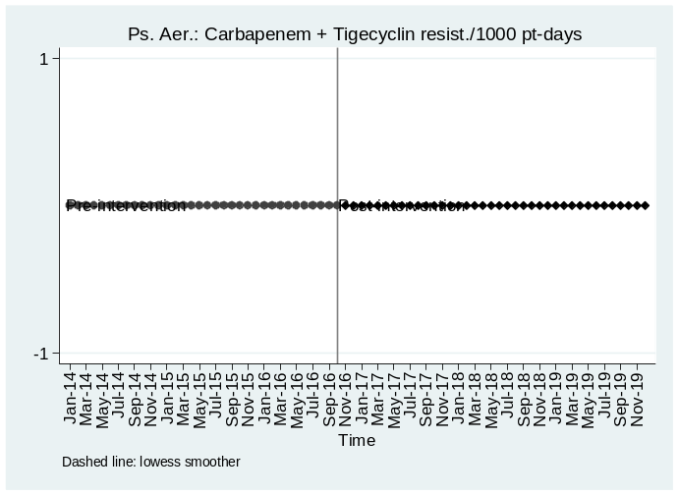
C. All

Figure SA.22. Carbapenem resistant isolates/1000 pt-days pre- and post-intervention, A. baumannii.
A. Hospital
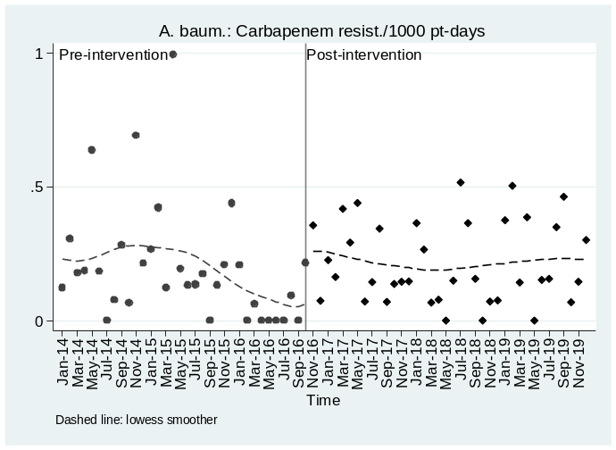
B. Community
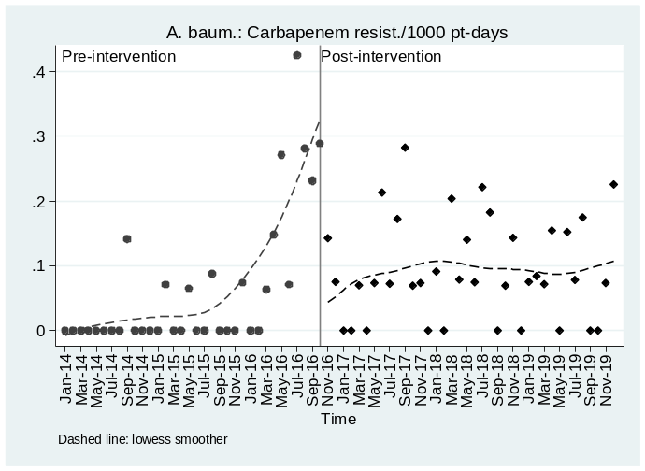
C. All
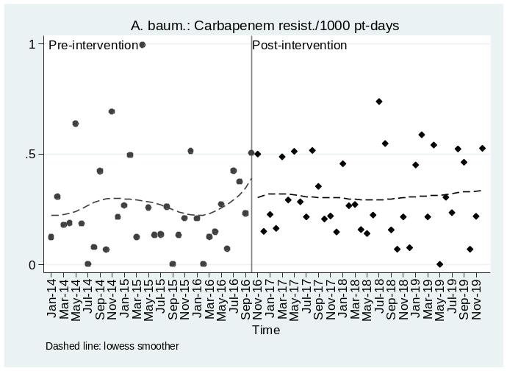

Figure SA.23. Carbapenem + Aminoglycosides resistant isolates/1000 pt-days pre- and post-intervention, A. baumannii.
A. Hospital
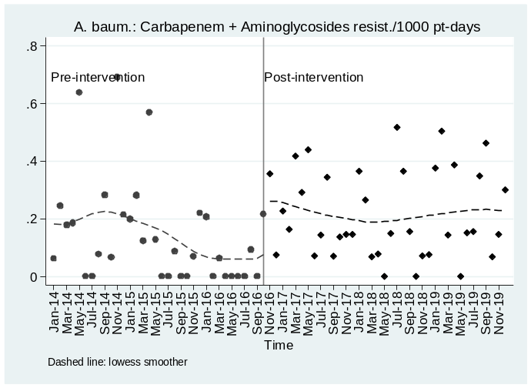
B. Community
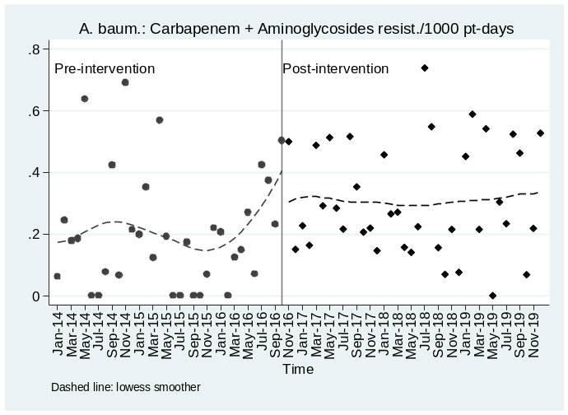
C. All

Figure SA.24. Carbapenem + Colistin resistant isolates/1000 pt-days pre- and post-intervention, A. baumannii.
A. Hospital
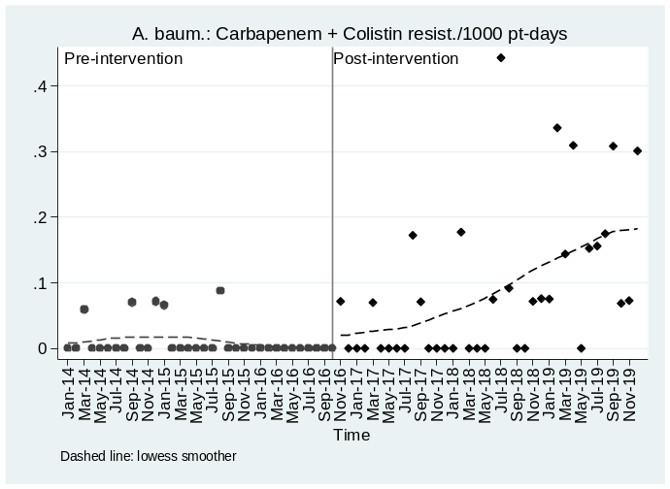
B. Community
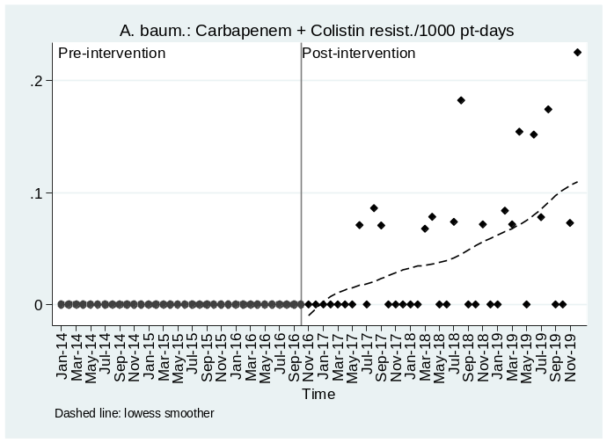
C. All
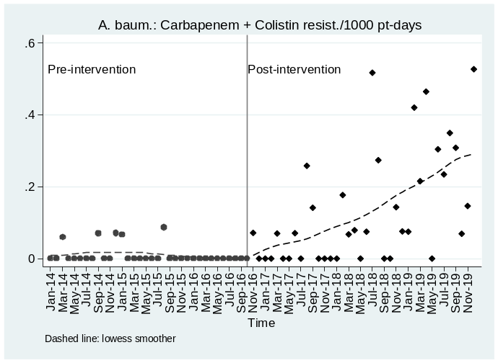

Figure SA.25. Carbapenem + Tigecycline resistant isolates/1000 pt-days pre- and post-intervention, A. baumannii.
A. Hospital
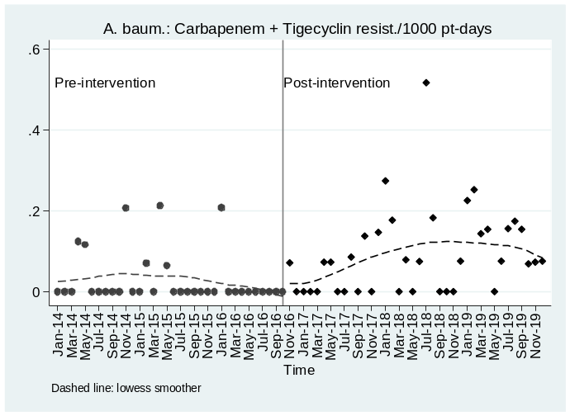
B. Community
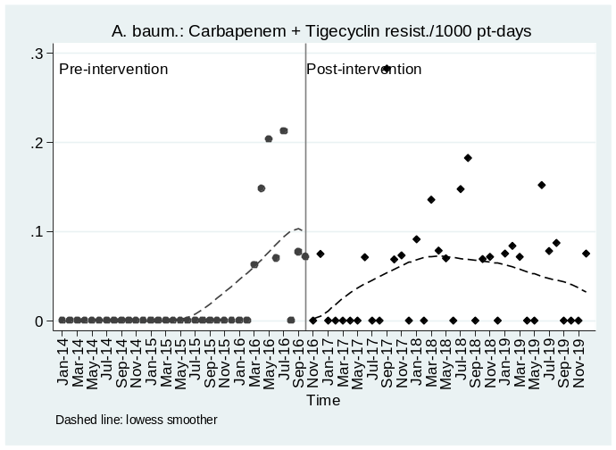
C. All
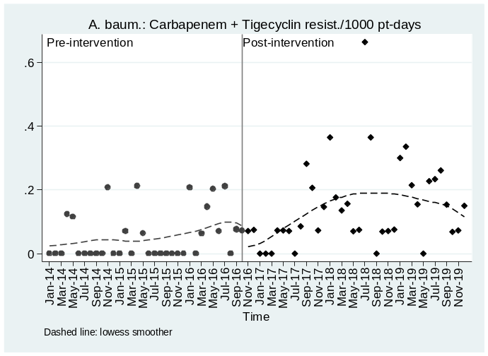

A.3. Interrupted time series analysis

A.3.1 Antibiotics consumption

Estimates on Total antibiotic consumption from an interrupted time-series model
Pre-intervention yearly slope: -0.488 (95% CI: -1.465, 0.489); p: 0.322
Change at intervention: -0.203 (95% CI: -1.835, 1.429); p: 0.805
Post-intervention yearly slope: 0.668 (95% CI: 0.162, 1.173); p: 0.010

Figure SA.26. Observed values and model predictions of Total antibiotic consumption pre- and post-intervention.

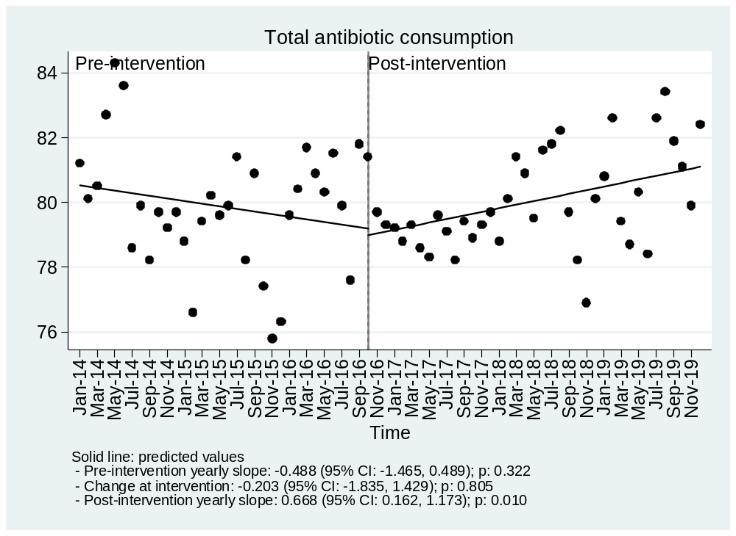

Estimates on Carbapenem consumption from an interrupted time-series model
Pre-intervention yearly slope: 0.549 (95% CI: -0.053, 1.150); p: 0.073
Change at intervention: -10.170 (95% CI: -13.058, -7.282); p: <0.001
Post-intervention yearly slope: 0.966 (95% CI: -0.433, 2.366); p: 0.173

Figure SA.27. Observed values and model predictions of Carbapenem consumption pre- and post-intervention.

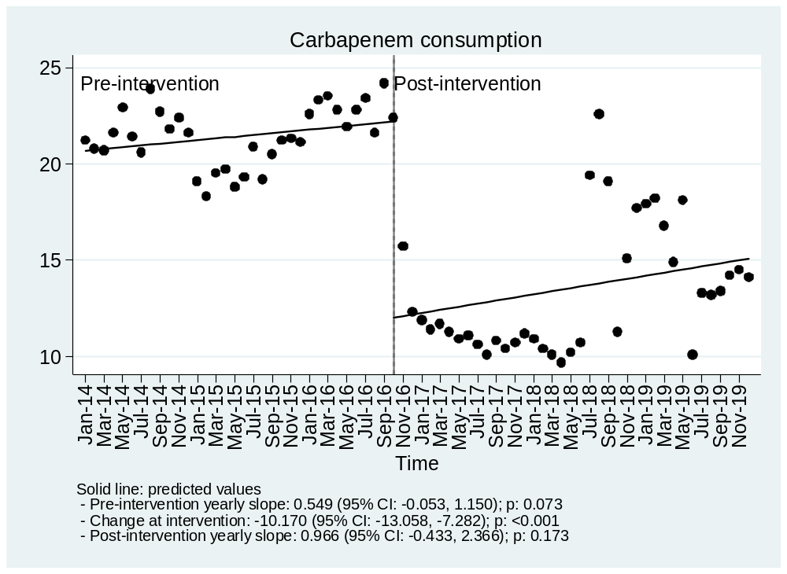

Estimates on Colistin consumption from an interrupted time-series model
Pre-intervention yearly slope: 0.132 (95% CI: -0.429, 0.692); p: 0.641
Change at intervention: -2.261 (95% CI: -3.667, -0.856); p: 0.002
Post-intervention yearly slope: 0.144 (95% CI: -0.495, 0.783); p: 0.655

Figure SA.28. Observed values and model predictions of Colistin consumption pre- and post-intervention.

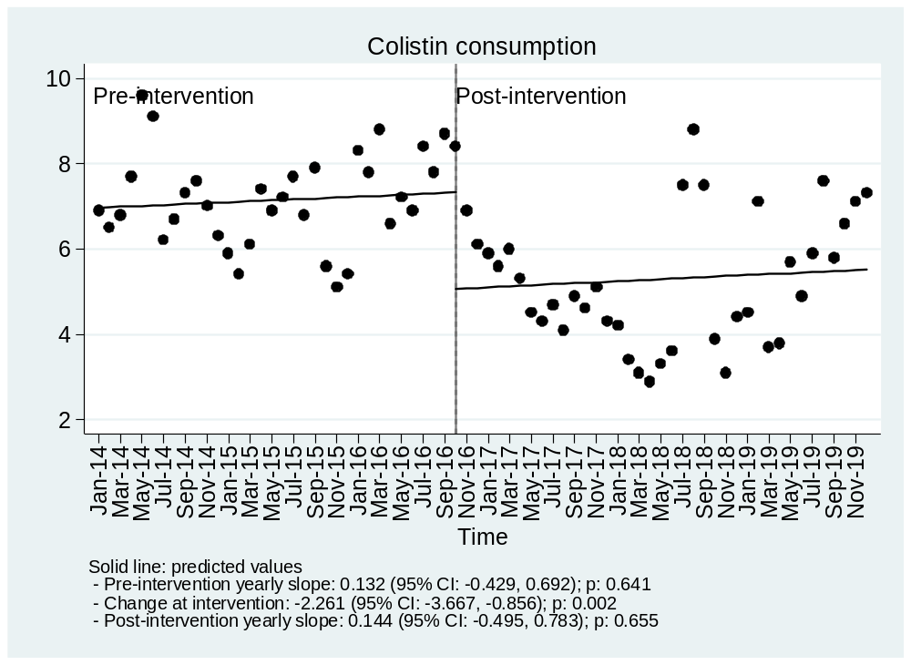

Estimates on Gentamicin consumption from an interrupted time-series model
Pre-intervention yearly slope: 0.173 (95% CI: -0.007, 0.354); p: 0.059
Change at intervention: 0.284 (95% CI: -0.017, 0.585); p: 0.064
Post-intervention yearly slope: 0.057 (95% CI: 0.004, 0.110); p: 0.036

Figure SA.29. Observed values and model predictions of Gentamicin consumption pre- and post-intervention.

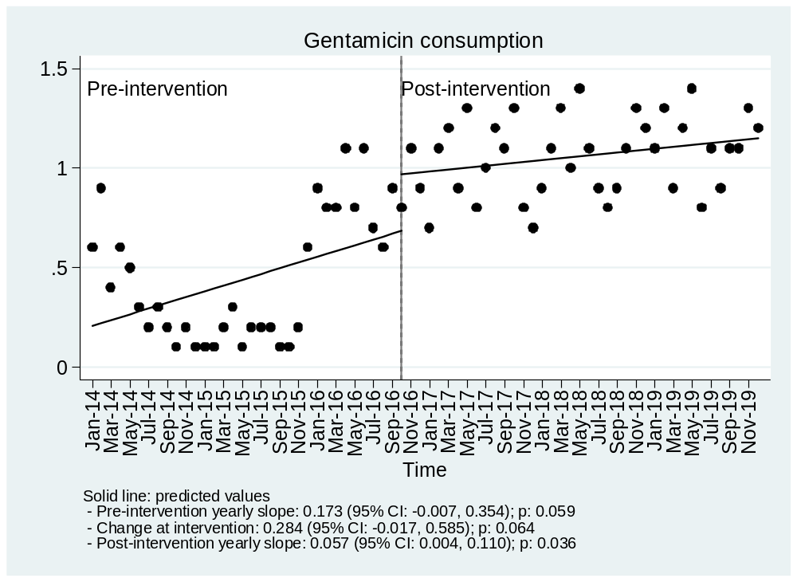

Estimates on Amikacin consumption from an interrupted time-series model
Pre-intervention yearly slope: -0.154 (95% CI: -0.250, -0.059); p: 0.002
Change at intervention: 0.108 (95% CI: -0.107, 0.324); p: 0.320
Post-intervention yearly slope: 0.027 (95% CI: -0.051, 0.105); p: 0.492

Figure SA.30. Observed values and model predictions of Amikacin consumption pre- and post-intervention.

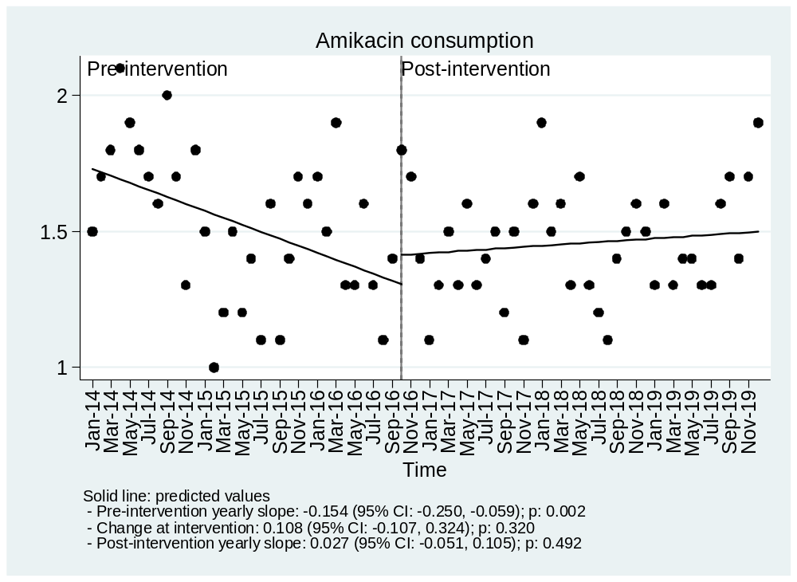

Estimates on Aminoglycoside consumption from an interrupted time-series model
Pre-intervention yearly slope: 0.026 (95% CI: -0.239, 0.291); p: 0.845
Change at intervention: 0.388 (95% CI: -0.073, 0.849); p: 0.098
Post-intervention yearly slope: 0.084 (95% CI: -0.019, 0.188); p: 0.110

Figure SA.31. Observed values and model predictions of Aminoglycoside consumption pre- and post-intervention.

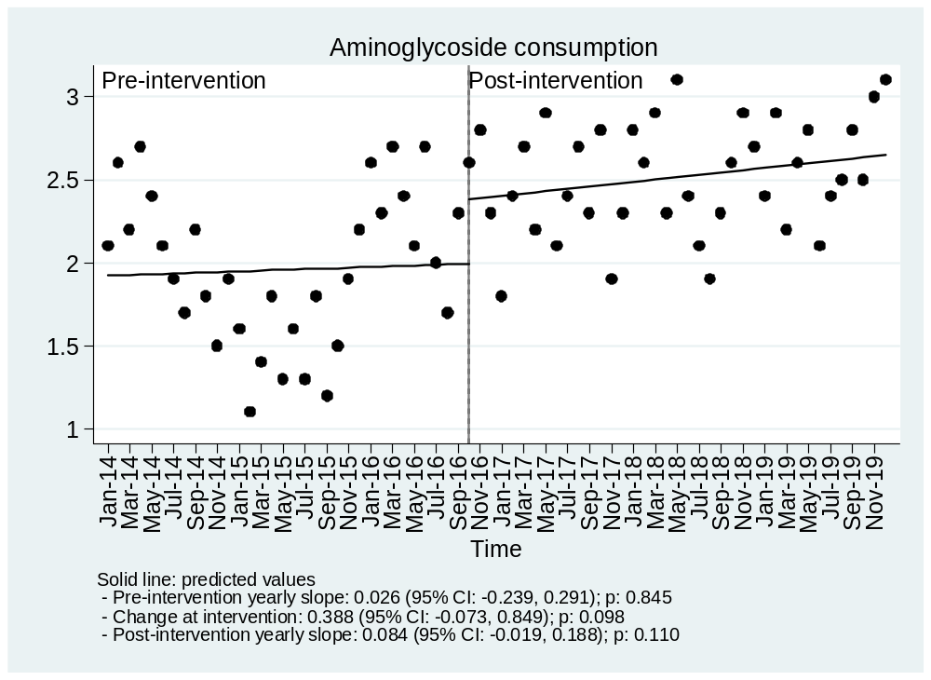

Estimates on Ciprofloxacin consumption from an interrupted time-series model
Pre-intervention yearly slope: -0.479 (95% CI: -0.811, -0.146); p: 0.005
Change at intervention: -0.250 (95% CI: -0.898, 0.399); p: 0.445
Post-intervention yearly slope: -0.943 (95% CI: -1.201, -0.685); p: <0.001

Figure SA.32. Observed values and model predictions of Ciprofloxacin consumption pre- and post-intervention.

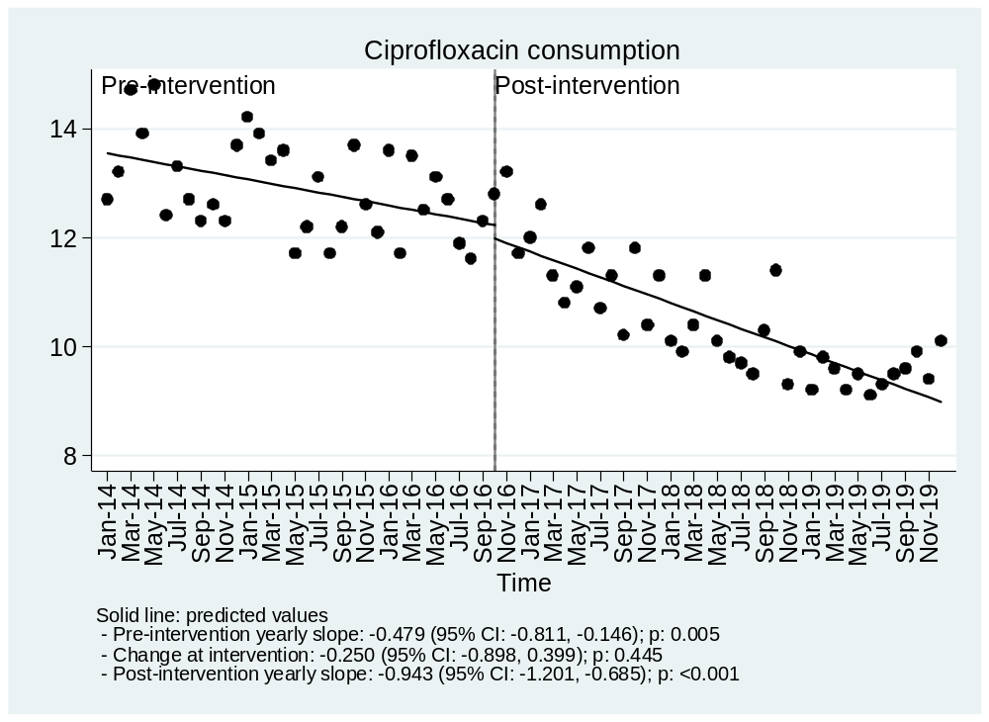

Estimates on Fluoroquinolones consumption from an interrupted time-series model
Pre-intervention yearly slope: -0.661 (95% CI: -0.927, -0.394); p: <0.001
Change at intervention: -0.525 (95% CI: -1.557, 0.507); p: 0.314
Post-intervention yearly slope: -0.849 (95% CI: -1.359, -0.339); p: 0.001

Figure SA.33. Observed values and model predictions of Fluoroquinolones consumption pre- and post-intervention.
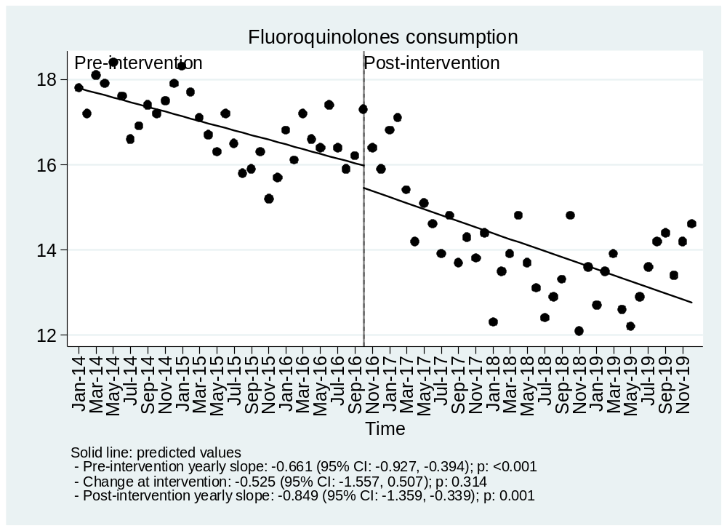

Estimates on Tigecycline consumption from an interrupted time-series model
Pre-intervention yearly slope: 0.613 (95% CI: 0.139, 1.087); p: 0.012
Change at intervention: -3.085 (95% CI: -4.315, -1.854); p: <0.001
Post-intervention yearly slope: -0.526 (95% CI: -0.923, -0.128); p: 0.010

Figure SA.34. Observed values and model predictions of Tigecycline consumption pre- and post-intervention.

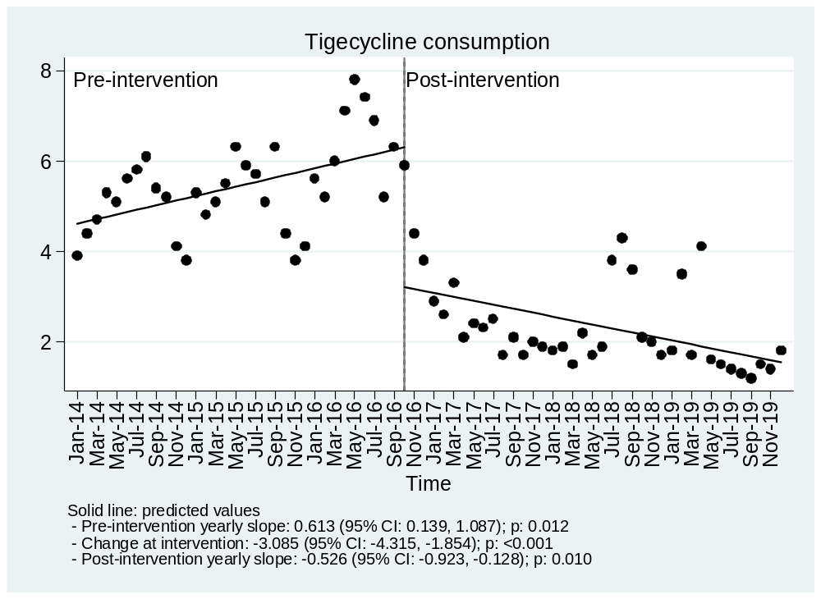

A.3.2 Resistant isolates (/1000 pt-days)

Estimates on Carbapenem resistant isolates/1000 pt-days from an interrupted time-series model
A. Hospital
Pre-intervention yearly slope: -0.091 (95% CI: -0.185, 0.002); p: 0.055
Change at intervention: 0.208 (95% CI: 0.027, 0.388); p: 0.025
Post-intervention yearly slope: -0.025 (95% CI: -0.092, 0.042); p: 0.451
B. Community
Pre-intervention yearly slope: 0.220 (95% CI: 0.023, 0.416); p: 0.029
Change at intervention: -0.114 (95% CI: -0.505, 0.277); p: 0.564
Post-intervention yearly slope: -0.055 (95% CI: -0.116, 0.005); p: 0.074
C. All
Pre-intervention yearly slope: 0.128 (95% CI: -0.070, 0.326); p: 0.200
Change at intervention: 0.094 (95% CI: -0.284, 0.472); p: 0.621
Post-intervention yearly slope: -0.081 (95% CI: -0.173, 0.012); p: 0.086

Figure SA.35. Observed values and model predictions of Carbapenem resistant isolates/1000 pt-days pre- and post-intervention.
A. Hospital
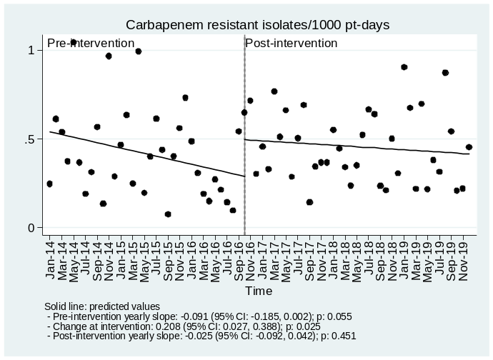
B. Community
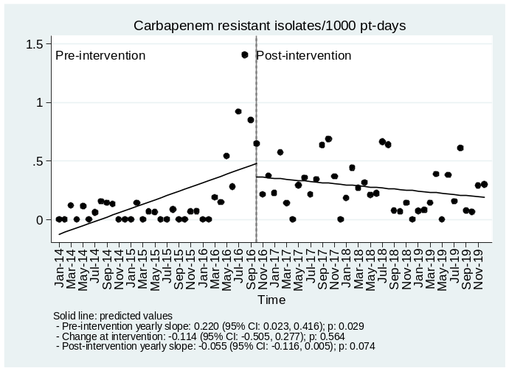
C. All
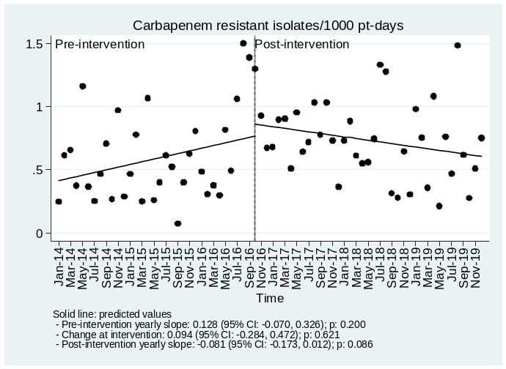

Estimates on Carbapenem + Aminoglycosides resistant isolates/1000 pt-days from an interrupted time-series model
A. Hospital
Pre-intervention yearly slope: -0.058 (95% CI: -0.124, 0.009); p: 0.087
Change at intervention: 0.251 (95% CI: 0.125, 0.378); p: <0.001
Post-intervention yearly slope: 0.006 (95% CI: -0.057, 0.069); p: 0.853
B. Community
Pre-intervention yearly slope: 0.161 (95% CI: 0.018, 0.304); p: 0.028
Change at intervention: -0.101 (95% CI: -0.376, 0.174); p: 0.466
Post-intervention yearly slope: -0.024 (95% CI: -0.074, 0.025); p: 0.330
C. All
Pre-intervention yearly slope: 0.103 (95% CI: -0.049, 0.255); p: 0.181
Change at intervention: 0.150 (95% CI: -0.148, 0.449); p: 0.318
Post-intervention yearly slope: -0.019 (95% CI: -0.094, 0.057); p: 0.626

Figure SA.36. Observed values and model predictions of Carbapenem+ aminglycoside resistant isolates/1000 pt-days pre- and post-intervention.
A. Hospital
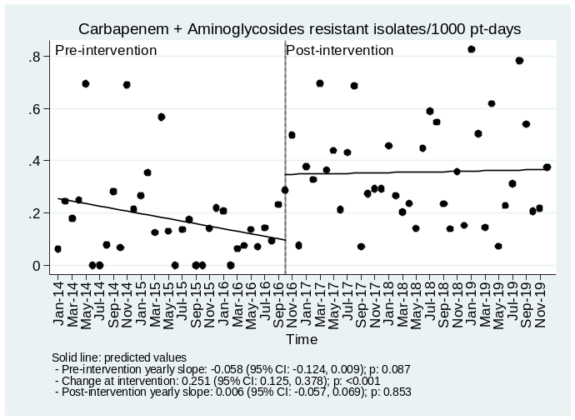
B. Community
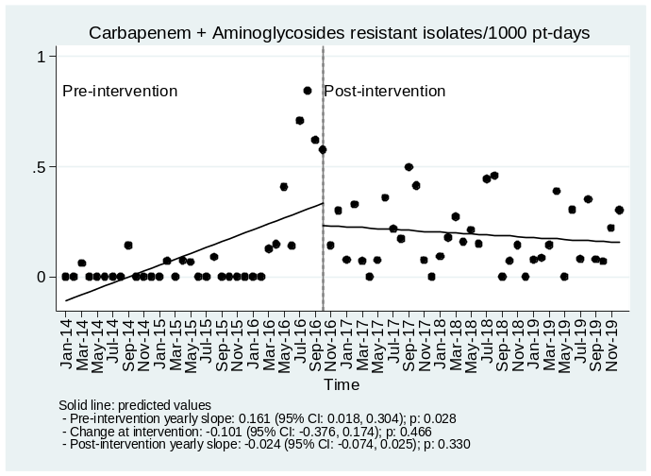
C. All
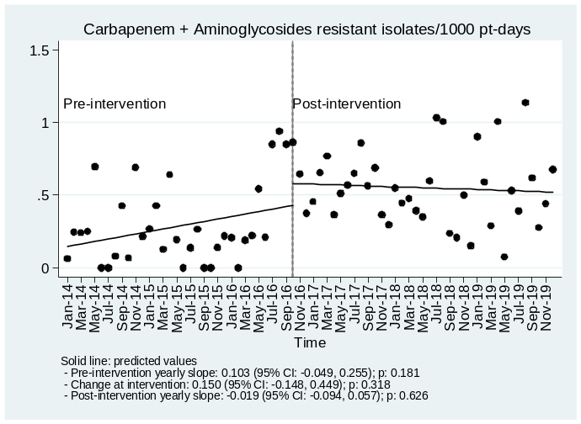

Estimates on Carbapenem + Colistin resistant isolates/1000 pt-days from an interrupted time-series model
A. Hospital
Pre-intervention yearly slope: -0.020 (95% CI: -0.040, -0.001); p: 0.043
Change at intervention: -0.012 (95% CI: -0.071, 0.047); p: 0.684
Post-intervention yearly slope: 0.068 (95% CI: 0.035, 0.100); p: <0.001
B. Community
Pre-intervention yearly slope: 0.023 (95% CI: -0.021, 0.067); p: 0.295
Change at intervention: -0.013 (95% CI: -0.107, 0.081); p: 0.785
Post-intervention yearly slope: 0.026 (95% CI: -0.008, 0.060); p: 0.136
C. All
Pre-intervention yearly slope: 0.003 (95% CI: -0.040, 0.046); p: 0.897
Change at intervention: -0.025 (95% CI: -0.129, 0.079); p: 0.634
Post-intervention yearly slope: 0.093 (95% CI: 0.041, 0.146); p: 0.001

Figure SA.37. Observed values and model predictions of Carbapenem + Colistin resistant isolates/1000 pt-days pre- and post-intervention.
A. Hospital
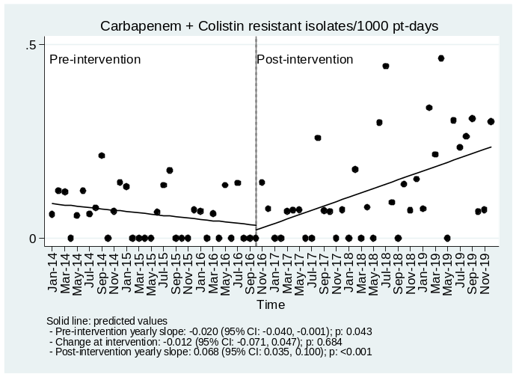
B. Community
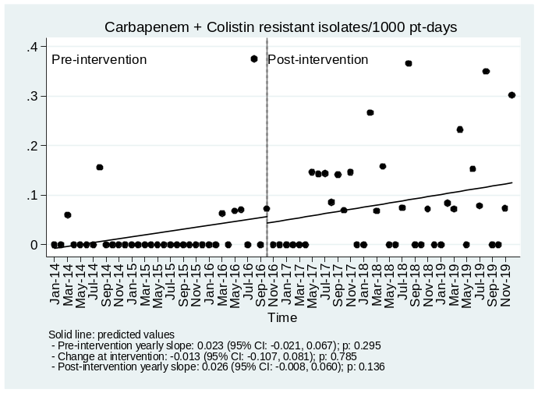
C. All
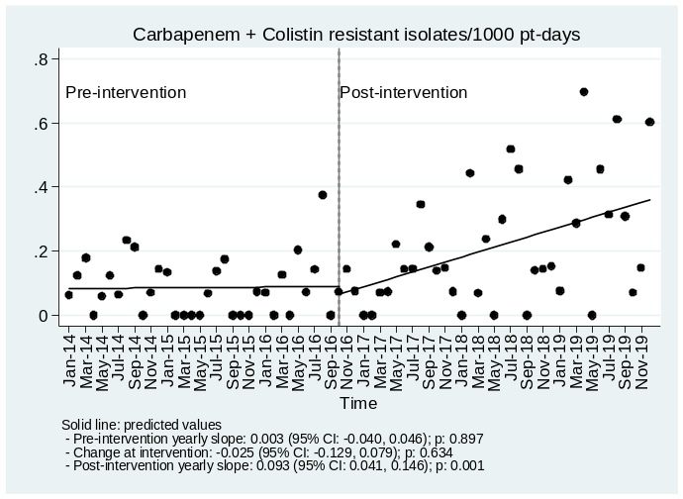

Estimates on Carbapenem + Tigecycline resistant isolates/1000 pt-days from an interrupted time-series model
A. Hospital
Pre-intervention yearly slope: -0.018 (95% CI: -0.040, 0.005); p: 0.131
Change at intervention: 0.035 (95% CI: -0.037, 0.107); p: 0.335
Post-intervention yearly slope: 0.048 (95% CI: 0.014, 0.083); p: 0.007
B. Community
Pre-intervention yearly slope: 0.040 (95% CI: 0.011, 0.068); p: 0.007
Change at intervention: -0.019 (95% CI: -0.094, 0.056); p: 0.614
Post-intervention yearly slope: 0.012 (95% CI: -0.017, 0.040); p: 0.414
C. All
Pre-intervention yearly slope: 0.022 (95% CI: -0.011, 0.056); p: 0.192
Change at intervention: 0.016 (95% CI: -0.094, 0.126); p: 0.772
Post-intervention yearly slope: 0.060 (95% CI: 0.002, 0.118); p: 0.044

Figure SA.38. Observed values and model predictions of Carbapenem + Tigecycline resistant isolates/1000 pt-days pre- and post-intervention.
A. Hospital
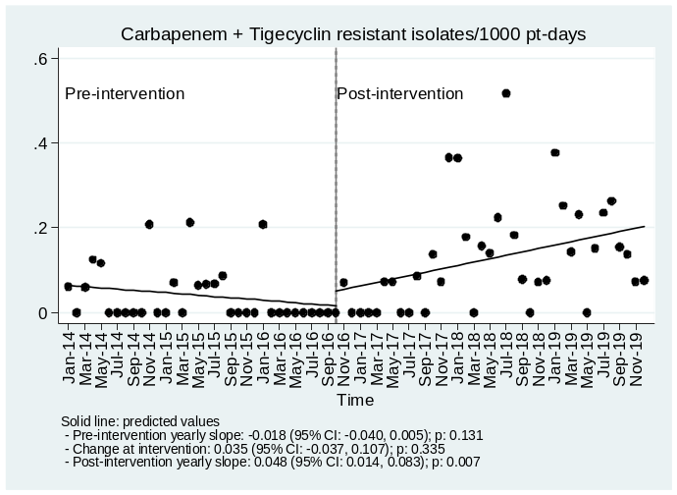
B. Community
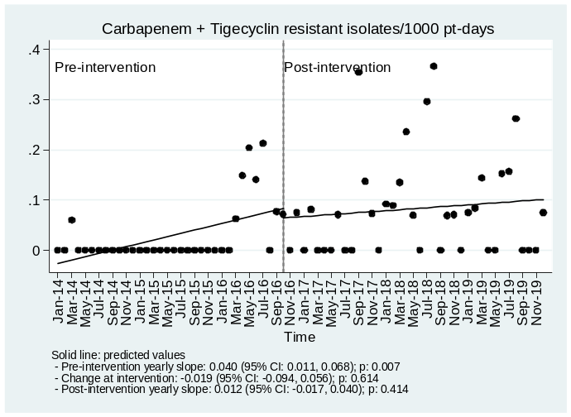
C. All
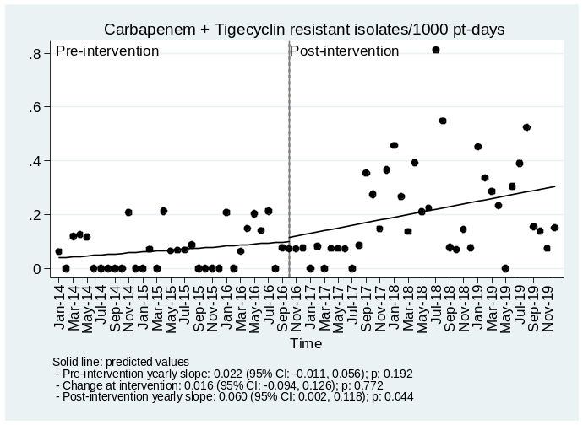

Estimates on K. pneumoniae Carbapenem resistant isolates/1000 pt-days from an interrupted time-series model
A. Hospital
Pre-intervention yearly slope: -0.031 (95% CI: -0.071, 0.009); p: 0.125
Change at intervention: 0.069 (95% CI: -0.015, 0.153); p: 0.105
Post-intervention yearly slope: -0.017 (95% CI: -0.055, 0.020); p: 0.351
B. Community
Pre-intervention yearly slope: 0.104 (95% CI: -0.013, 0.220); p: 0.080
Change at intervention: -0.004 (95% CI: -0.239, 0.231); p: 0.972
Post-intervention yearly slope: -0.052 (95% CI: -0.088, -0.016); p: 0.006
C. All
Estimates on K. pneum.: Carbapenem resist./1000 pt-days from an interrupted time-series model
Pre-intervention yearly slope: 0.072 (95% CI: -0.051, 0.195); p: 0.244
Change at intervention: 0.065 (95% CI: -0.166, 0.296); p: 0.577
Post-intervention yearly slope: -0.070 (95% CI: -0.117, -0.022); p: 0.004

Figure SA.39. Observed values and model predictions of K. pneumoniae Carbapenem resistant isolates/1000 pt-days pre- and post-intervention.
A. Hospital
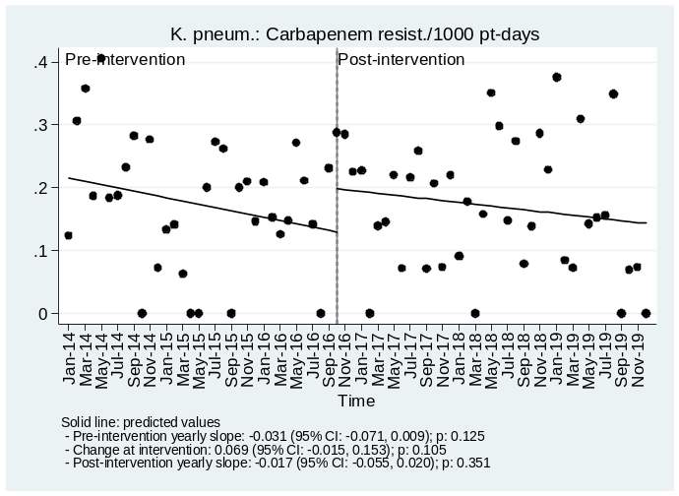
B. Community
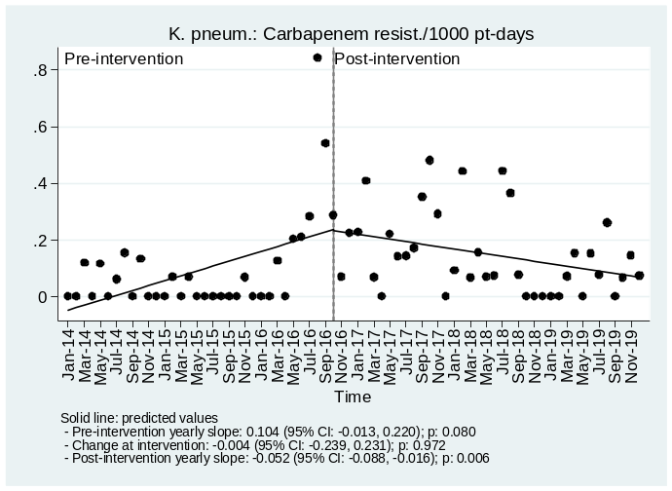
C. All
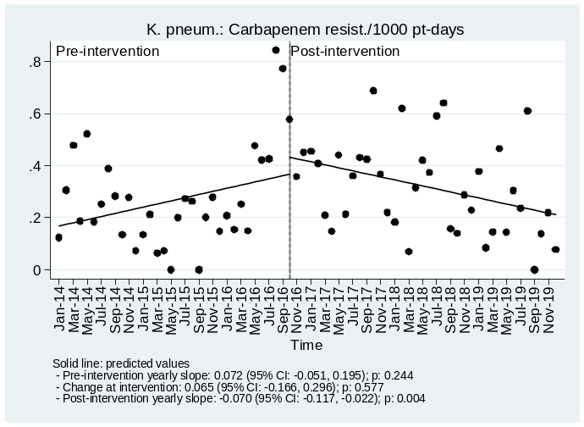

Estimates on K. pneumoniae Carbapenem + Aminoglycoside resistant isolates/1000 pt-days from an interrupted time-series model.
A. Hospital
Pre-intervention yearly slope: 0.021 (95% CI: 0.001, 0.040); p: 0.040
Change at intervention: 0.023 (95% CI: -0.033, 0.080); p: 0.411
Post-intervention yearly slope: 0.007 (95% CI: -0.019, 0.034); p: 0.581
B. Community
Pre-intervention yearly slope: 0.071 (95% CI: -0.003, 0.145); p: 0.061
Change at intervention: -0.033 (95% CI: -0.179, 0.113); p: 0.654
Post-intervention yearly slope: -0.025 (95% CI: -0.052, 0.003); p: 0.082
C. All
Pre-intervention yearly slope: 0.091 (95% CI: 0.014, 0.169); p: 0.022
Change at intervention: -0.009 (95% CI: -0.168, 0.149); p: 0.906
Post-intervention yearly slope: -0.017 (95% CI: -0.051, 0.016); p: 0.309

Figure A.40. Observed values and model predictions of K. pneumoniae Carbapenem + Aminoglycoside resistant isolates/1000 pt-days pre- and post-intervention.
A. Hospital
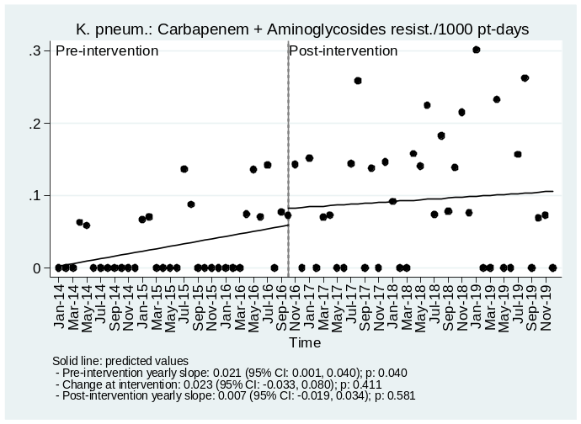
B. Community
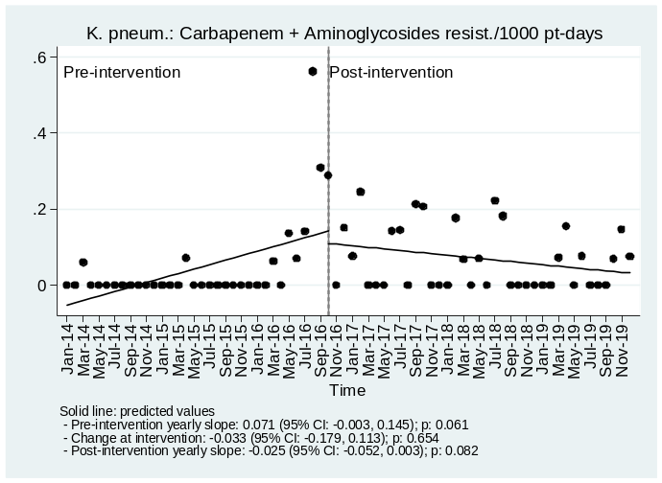
C. All
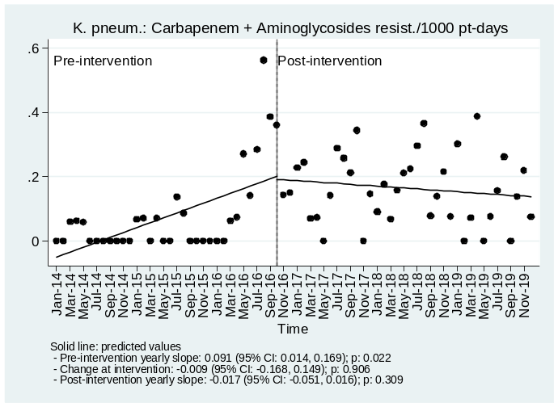

Estimates on K. pneumoniae Carbapenem + Colistin resistant isolates/1000 pt-days from an interrupted time-series model.
A. Hospital
Pre-intervention yearly slope: -0.014 (95% CI: -0.032, 0.004); p: 0.130
Change at intervention: 0.005 (95% CI: -0.034, 0.044); p: 0.798
Post-intervention yearly slope: 0.005 (95% CI: -0.013, 0.023); p: 0.559
B. Community
Pre-intervention yearly slope: 0.023 (95% CI: -0.021, 0.067); p: 0.295
Change at intervention: -0.006 (95% CI: -0.096, 0.084); p: 0.897
Post-intervention yearly slope: -0.007 (95% CI: -0.026, 0.013); p: 0.499
C. All
Pre-intervention yearly slope: 0.009 (95% CI: -0.034, 0.052); p: 0.674
Change at intervention: -0.001 (95% CI: -0.092, 0.090); p: 0.986
Post-intervention yearly slope: -0.001 (95% CI: -0.029, 0.026); p: 0.924

Figure SA.41. Observed values and model predictions of K. pneumoniae Carbapenem + Colistin resistant isolates/1000 pt-days pre- and post-intervention.
A. Hospital
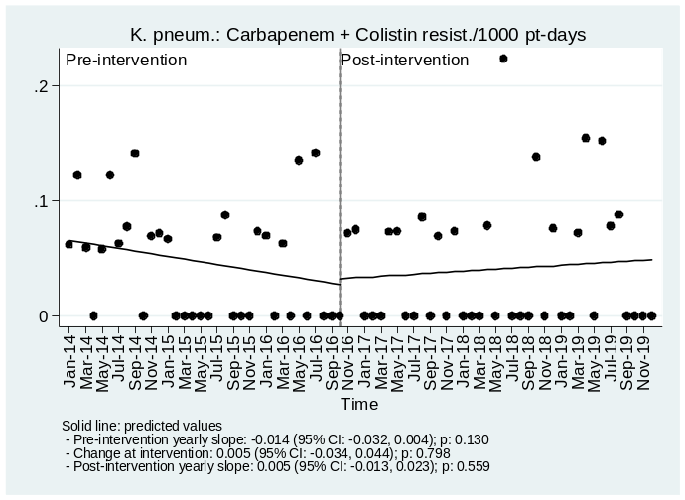
B. Community
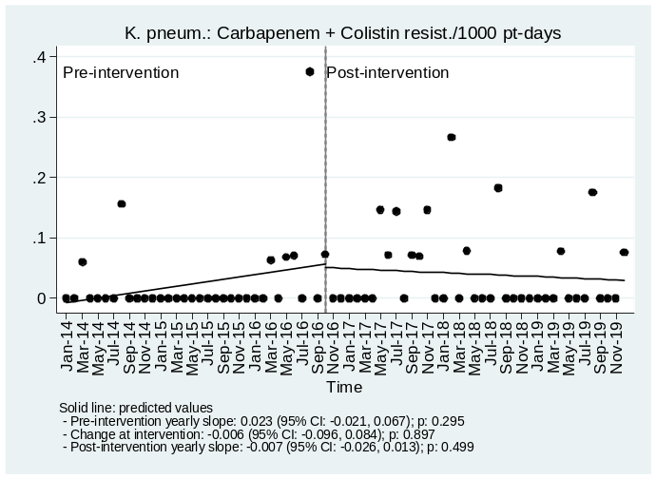
C. All
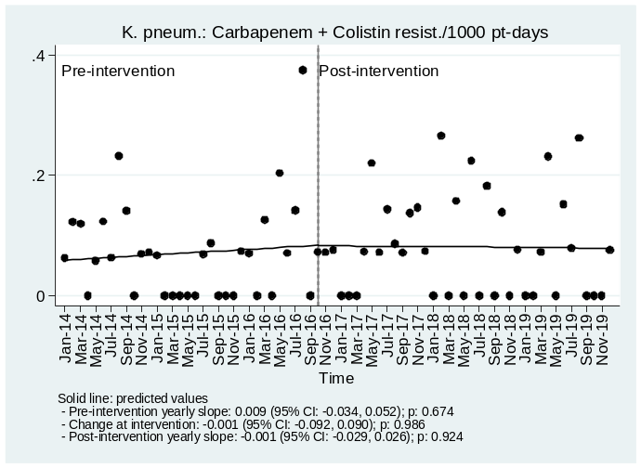

Estimates on K. pneumoniae Carbapenem + Tigecycline resistant isolates/1000 pt-days from an interrupted time-series model.
A. Hospital
Pre-intervention yearly slope: -0.006 (95% CI: -0.014, 0.002); p: 0.113
Change at intervention: 0.020 (95% CI: -0.013, 0.053); p: 0.232
Post-intervention yearly slope: 0.011 (95% CI: -0.003, 0.025); p: 0.126
B. Community
Pre-intervention yearly slope: 0.000 (95% CI: -0.009, 0.010); p: 0.949
Change at intervention: 0.014 (95% CI: -0.014, 0.043); p: 0.312
Post-intervention yearly slope: 0.006 (95% CI: -0.009, 0.022); p: 0.424
C. All
Pre-intervention yearly slope: -0.006 (95% CI: -0.020, 0.008); p: 0.396
Change at intervention: 0.035 (95% CI: -0.012, 0.081); p: 0.140
Post-intervention yearly slope: 0.017 (95% CI: -0.009, 0.044); p: 0.198

Figure SA.42. Observed values and model predictions of K. pneumoniae Carbapenem + Tigecycline resistant isolates/1000 pt-days pre- and post-intervention.
A. Hospital
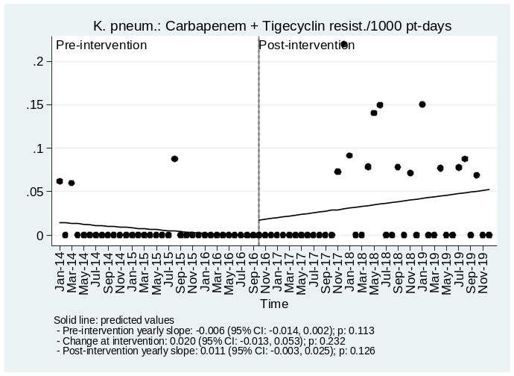
B. Community
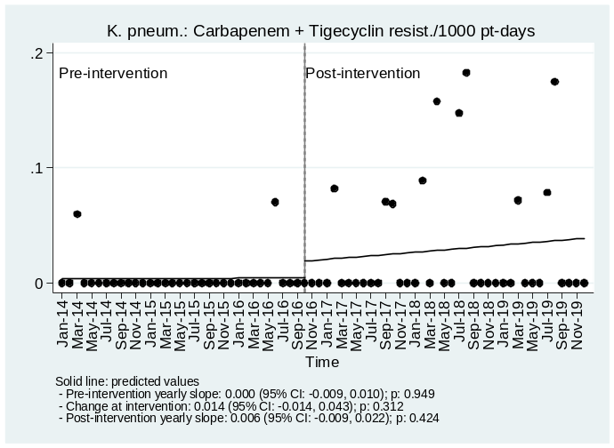
C. All
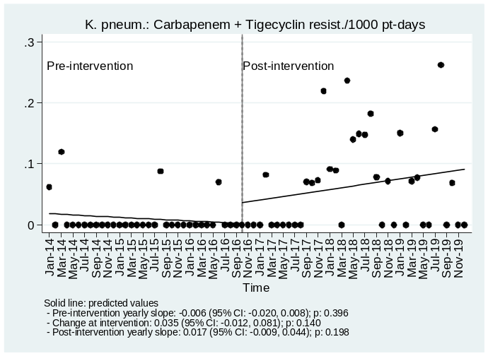

Estimates on P. aeruginosa Carbapenem resistant isolates/1000 pt-days from an interrupted time-series model
A. Hospital
Pre-intervention yearly slope: 0.035 (95% CI: -0.002, 0.073); p: 0.065
Change at intervention: -0.015 (95% CI: -0.100, 0.070); p: 0.727
Post-intervention yearly slope: -0.007 (95% CI: -0.030, 0.016); p: 0.542
B. Community
Pre-intervention yearly slope: 0.037 (95% CI: -0.005, 0.079); p: 0.083
Change at intervention: -0.047 (95% CI: -0.131, 0.038); p: 0.278
Post-intervention yearly slope: 0.003 (95% CI: -0.014, 0.020); p: 0.736
C. All
Pre-intervention yearly slope: 0.072 (95% CI: 0.022, 0.123); p: 0.006
Change at intervention: -0.061 (95% CI: -0.171, 0.048); p: 0.266
Post-intervention yearly slope: -0.004 (95% CI: -0.036, 0.028); p: 0.794

Figure SA.43. Observed values and model predictions of P. aeruginosa Carbapenem resistant isolates/1000 pt-days pre- and post-intervention.
A. Hospital
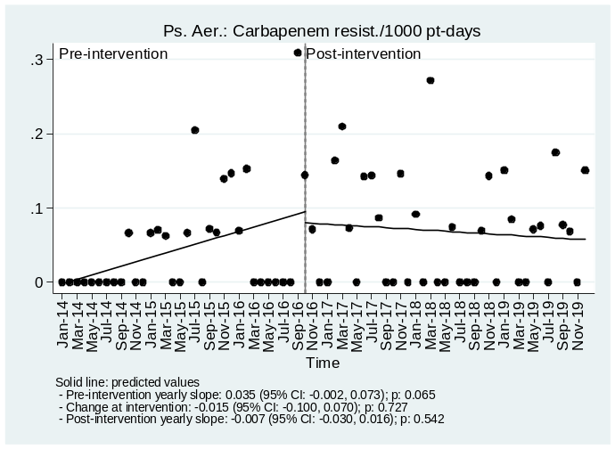
B. Community
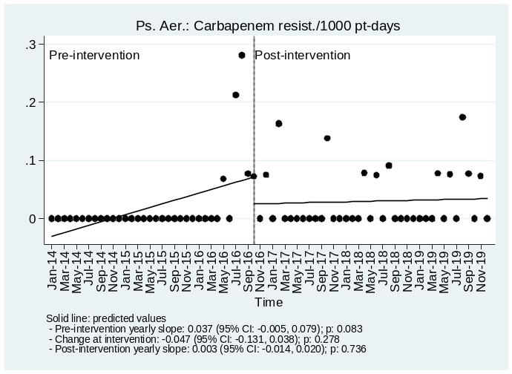
C. All
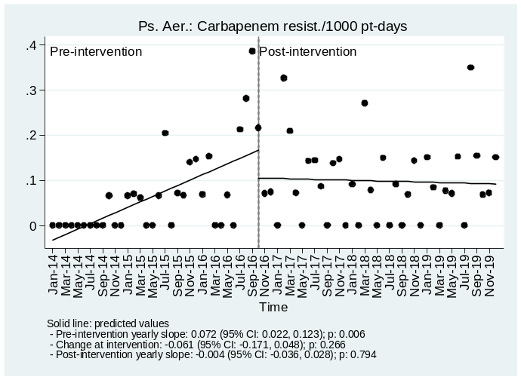

Estimates on P. aeruginosa Carbapenem + Aminoglycoside resistant isolates/1000 pt-days from an interrupted time-series model.
A. Hospital
Pre-intervention yearly slope: 0.012 (95% CI: -0.006, 0.029); p: 0.200
Change at intervention: 0.026 (95% CI: -0.039, 0.091); p: 0.432
Post-intervention yearly slope: -0.001 (95% CI: -0.025, 0.024); p: 0.953
B. Community
Pre-intervention yearly slope: 0.013 (95% CI: -0.004, 0.029); p: 0.123
Change at intervention: -0.010 (95% CI: -0.051, 0.031); p: 0.617
Post-intervention yearly slope: 0.006 (95% CI: -0.010, 0.022); p: 0.460
C. All
Pre-intervention yearly slope: 0.024 (95% CI: -0.001, 0.050); p: 0.062
Change at intervention: 0.015 (95% CI: -0.065, 0.096); p: 0.702
Post-intervention yearly slope: 0.005 (95% CI: -0.028, 0.039); p: 0.751

Figure SA.44. Observed values and model predictions of P. aeruginosa Carbapenem + Aminoglycoside resistant isolates/1000 pt-days pre- and post-intervention.
A. Hospital
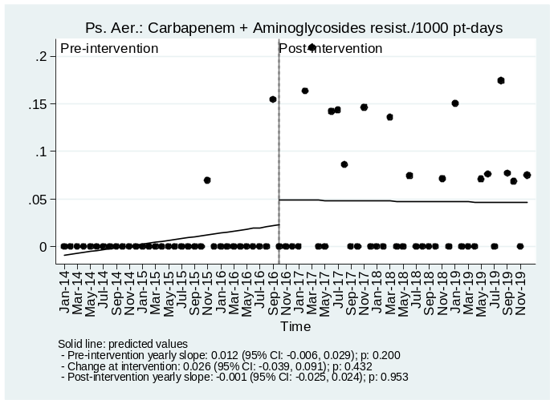
B. Community
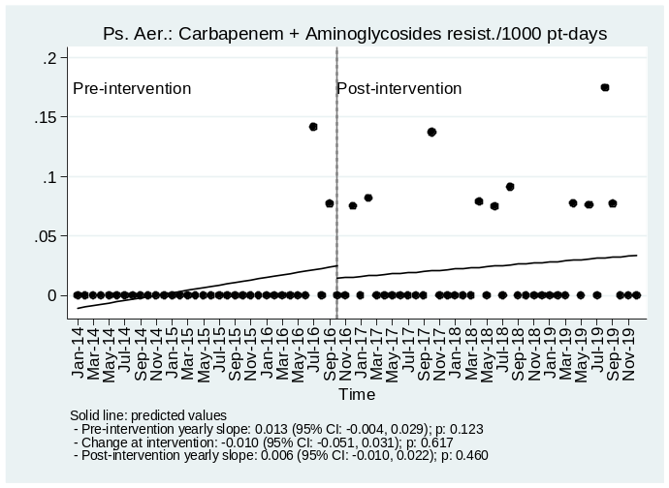
C. All
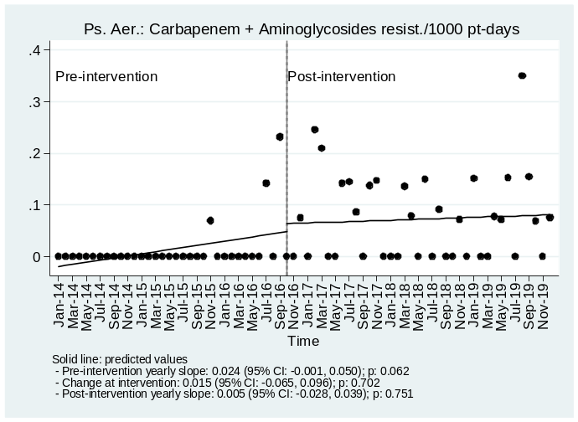

Estimates on P. aeruginosa Carbapenem + Tigecycline resistant isolates/1000 pt-days from an interrupted time-series model.
A. Hospital
Pre-intervention yearly slope: 0.001 (95% CI: -0.002, 0.004); p: 0.580
Change at intervention: -0.007 (95% CI: -0.018, 0.003); p: 0.181
Post-intervention yearly slope: 0.002 (95% CI: -0.002, 0.007); p: 0.305
B. Community
No A. baumannii Carbapenem + Tigecycline resistant isolates were detected from the community.
C. All
Pre-intervention yearly slope: 0.001 (95% CI: -0.002, 0.004); p: 0.580
Change at intervention: -0.007 (95% CI: -0.018, 0.003); p: 0.181
Post-intervention yearly slope: 0.002 (95% CI: -0.002, 0.007); p: 0.305

Figure SA.45. Observed values and model predictions of P. aeruginosa Carbapenem + Tigecycline resistant isolates/1000 pt-days pre- and post-intervention.
A. Hospital
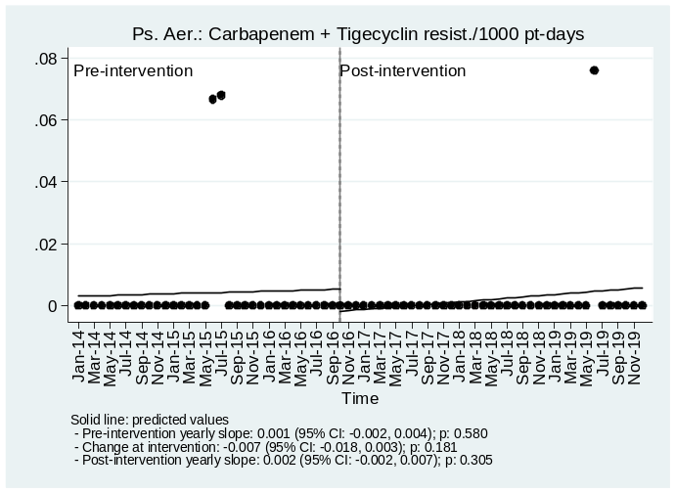
B. Community
No A. baumannii Carbapenem + Tigecycline resistant isolates were detected from the community.

C. All

Estimates on A. baumannii Carbapenem resistant isolates/1000 pt-days from an interrupted time-series model.
A. Hospital
Pre-intervention yearly slope: -0.095 (95% CI: -0.165, -0.025); p: 0.008
Change at intervention: 0.154 (95% CI: 0.027, 0.280); p: 0.018
Post-intervention yearly slope: -0.001 (95% CI: -0.045, 0.043); p: 0.972
B. Community
Pre-intervention yearly slope: 0.079 (95% CI: 0.035, 0.123); p: 0.001
Change at intervention: -0.063 (95% CI: -0.168, 0.043); p: 0.239
Post-intervention yearly slope: -0.006 (95% CI: -0.038, 0.026); p: 0.706
C. All
Pre-intervention yearly slope: -0.016 (95% CI: -0.086, 0.053); p: 0.645
Change at intervention: 0.091 (95% CI: -0.059, 0.241); p: 0.232
Post-intervention yearly slope: -0.007 (95% CI: -0.064, 0.050); p: 0.812

Figure SA.46. Observed values and model predictions of A. baumannii Carbapenem resistant isolates/1000 pt-days pre- and post-intervention.
A. Hospital
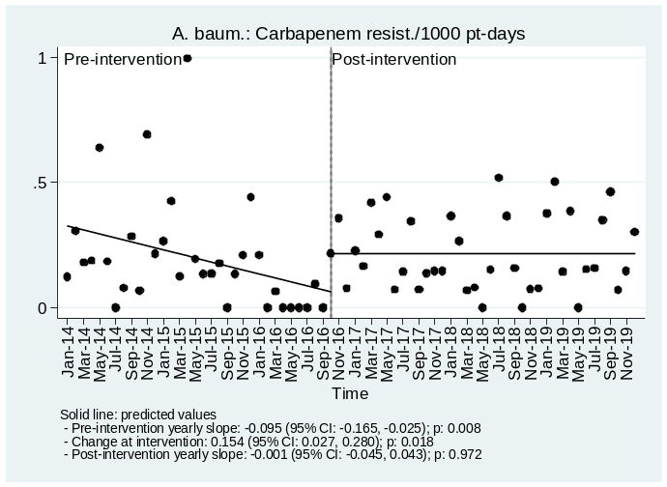
B. Community
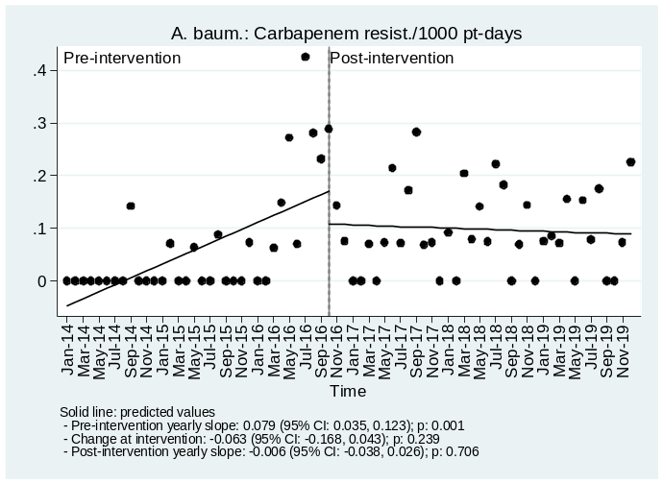
C. All
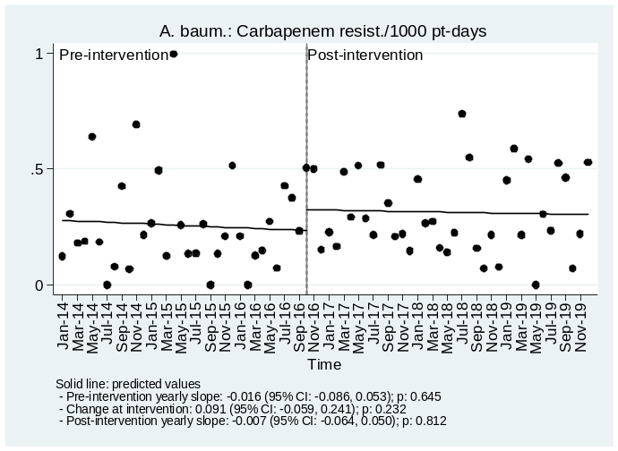

Estimates on A. baumannii Carbapenem + Aminoglycoside resistant isolates/1000 pt-days from an interrupted time-series model.
A. Hospital
Pre-intervention yearly slope: -0.090 (95% CI: -0.151, -0.029); p: 0.004
Change at intervention: 0.202 (95% CI: 0.100, 0.304); p: <0.001
Post-intervention yearly slope: -0.001 (95% CI: -0.045, 0.043); p: 0.972
B. Community
Pre-intervention yearly slope: 0.077 (95% CI: 0.019, 0.135); p: 0.009
Change at intervention: -0.058 (95% CI: -0.185, 0.069); p: 0.367
Post-intervention yearly slope: -0.006 (95% CI: -0.039, 0.027); p: 0.719
C. All
Pre-intervention yearly slope: -0.013 (95% CI: -0.087, 0.061); p: 0.728
Change at intervention: 0.144 (95% CI: -0.005, 0.294); p: 0.059
Post-intervention yearly slope: -0.007 (95% CI: -0.064, 0.050); p: 0.812

Figure SA.47. Observed values and model predictions of A. baumannii Carbapenem + Aminoglycoside resistant isolates/1000 pt-days pre- and post-intervention.
A. Hospital
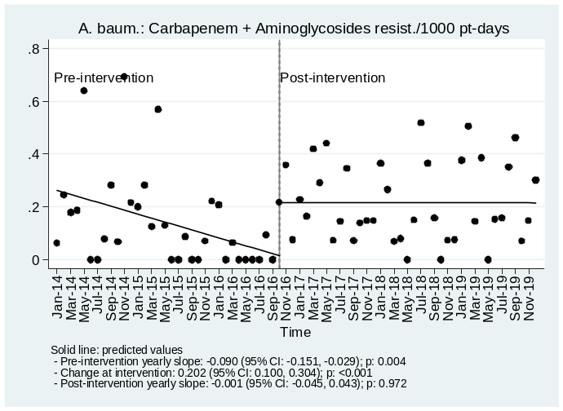
B. Community
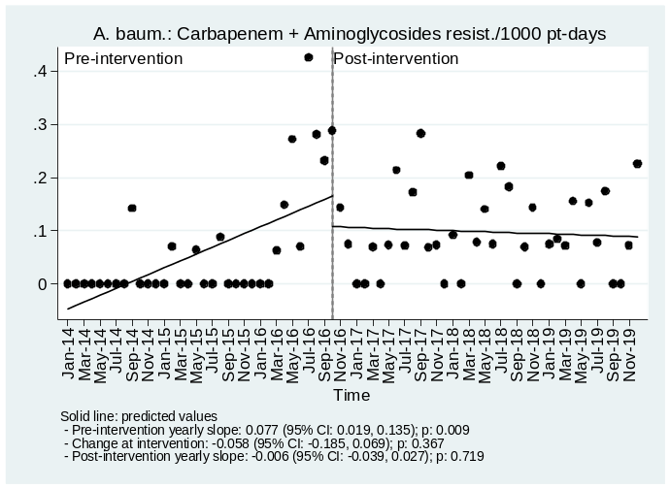
C. All
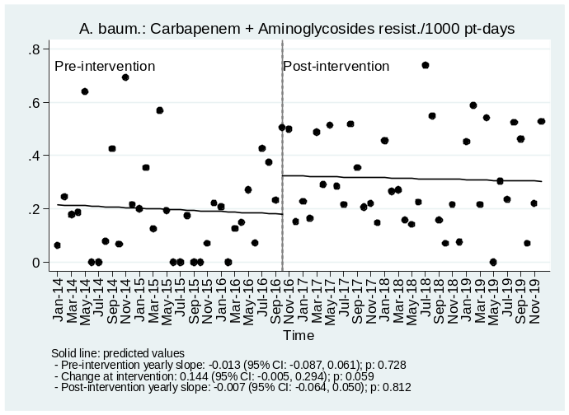

Estimates on A. baumannii Carbapenem + Colistin resistant isolates/1000 pt-days from an interrupted time-series model.
A. Hospital
Pre-intervention yearly slope: -0.007 (95% CI: -0.015, 0.001); p: 0.092
Change at intervention: -0.012 (95% CI: -0.052, 0.028); p: 0.551
Post-intervention yearly slope: 0.062 (95% CI: 0.037, 0.088); p: <0.001
B. Community
No A. baumannii Carbapenem + Colistin resistant isolates were detected from the community.
C. All
Pre-intervention yearly slope: -0.007 (95% CI: -0.015, 0.001); p: 0.092
Change at intervention: -0.019 (95% CI: -0.073, 0.035); p: 0.489
Post-intervention yearly slope: 0.095 (95% CI: 0.057, 0.132); p: <0.001

Figure SA.48. Observed values and model predictions of A. baumannii Carbapenem + Colistin resistant isolates/1000 pt-days pre- and post-intervention.
A. Hospital
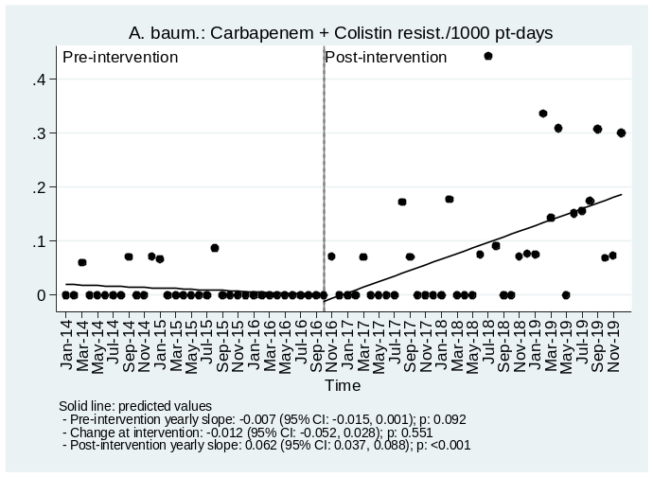
B. Community
No A. baumannii Carbapenem + Colistin resistant isolates were detected from the community.
C. All
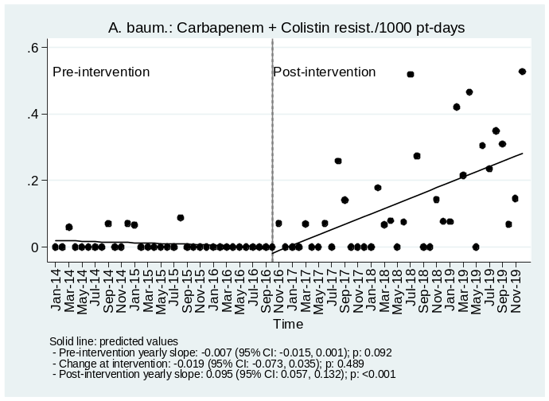

Estimates on A. baumannii Carbapenem + Tigecycline resistant isolates/1000 pt-days from an interrupted time-series model.
A. Hospital
Pre-intervention yearly slope: -0.012 (95% CI: -0.035, 0.011); p: 0.290
Change at intervention: 0.022 (95% CI: -0.032, 0.076); p: 0.418
Post-intervention yearly slope: 0.035 (95% CI: 0.010, 0.060); p: 0.007
B. Community
Pre-intervention yearly slope: 0.039 (95% CI: 0.013, 0.066); p: 0.004
Change at intervention: -0.033 (95% CI: -0.099, 0.032); p: 0.309
Post-intervention yearly slope: 0.005 (95% CI: -0.013, 0.024); p: 0.574
C. All
Pre-intervention yearly slope: 0.027 (95% CI: -0.002, 0.057); p: 0.068
Change at intervention: -0.011 (95% CI: -0.097, 0.074); p: 0.791
Post-intervention yearly slope: 0.040 (95% CI: 0.001, 0.079); p: 0.043

Figure SA.49. Observed values and model predictions of A. baumannii Carbapenem + Tigecycline resistant isolates/1000 pt-days pre- and post-intervention.
A. Hospital
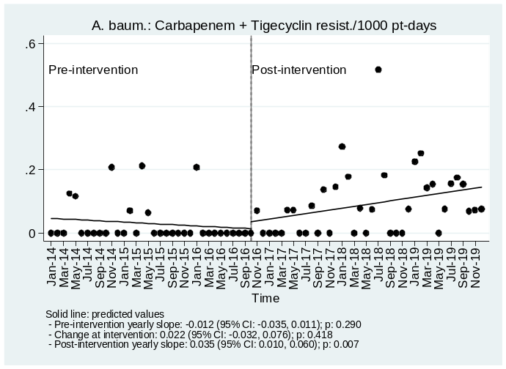
B. Community
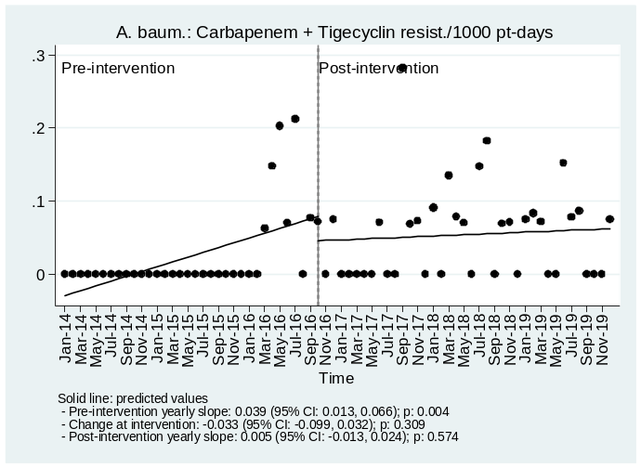
C. All
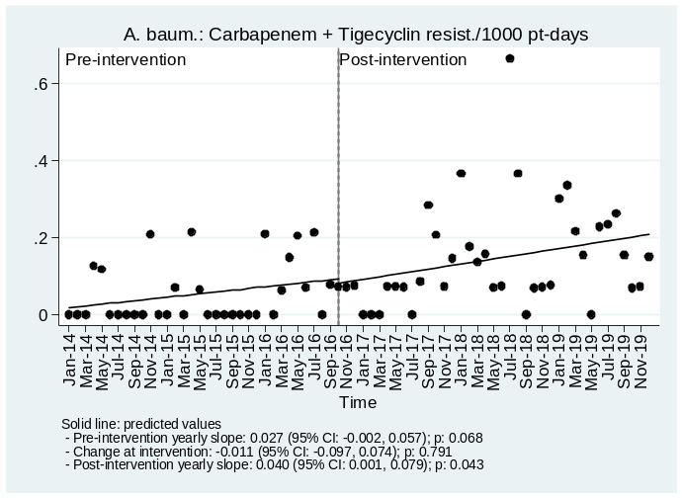

B. Time-series (linear transfer functions) analysis

B.1. Statistical analysis

Association between monthly consumptions of antibiotics (Carbapenem, Colistin, Tigecycline) with the incidence of resistant isolates was investigated using linear transfer function models and especially the method proposed by Box and Jenkins^{1,2} and the method proposed by Pankratz³.

Analyses were performed using Stata version 14.2 (Stata Corp., TX USA) and R version 4.0.2 [R Core Team (2020). R: A language and environment for statistical computing. R Foundation for Statistical Computing, Vienna, Austria. URL https://www.R-project.org/]. P-values less than 0.05 were considered as indicating statistical significance.

References

- Box, G. E., G. M. Jenkins, and G. C. Reinsel. 1994.Time Series Analysis – Forecasting and Control. 3d ed. Upper Saddle River, NJ: Prentice–Hall.
- McDowell, A. From the Help Desk: Transfer Functions. The Stata Journal, 2002; 2(1), 71-85.
- Pankratz, A. 1991. Forecasting with dynamic regression models:, John Wiley and Sons, New York

B.2. Data description

B.2.1 Tables

Table SB.1 Antibiotics consumption (DDDs/100 p-days) by period.
 | Period
 | Pre-intervention | Post-intervention | Overall
 | Median (IQR) | Median (IQR) | Median (IQR) | p-value
Carbapenem consumption | 21.50 (20.60, 22.70) | 11.80 (10.70, 15.10) | 18.55 (11.55, 21.50) | <0.001
Colistin consumption | 7.10 (6.50, 7.80) | 4.90 (4.10, 6.10) | 6.25 (4.80, 7.35) | <0.001
Tigecycline consumption | 5.35 (4.80, 6.00) | 1.95 (1.70, 2.60) | 3.80 (1.90, 5.30) | <0.001

Table SB.2. Resistant isolates (/1000 p-days) by period.
A. Hospital
 | Period
 | Pre-intervention | Post-intervention | Overall
 | Median (IQR) | Median (IQR) | Median (IQR) | p-value
All Pathogens
Carbapenem resistant isolates/1000 pt-days | 0.387 (0.210, 0.565) | 0.411 (0.300, 0.639) | 0.390 (0.247, 0.588) | 0.398
Carbapenem + Colistin resistant isolates/1000 pt-days | 0.062 (0.000, 0.122) | 0.074 (0.000, 0.234) | 0.071 (0.000, 0.140) | 0.012
Carbapenem + Tigecycline resistant isolates/1000 pt-days | 0.000 (0.000, 0.067) | 0.082 (0.000, 0.183) | 0.067 (0.000, 0.142) | <0.001

B.2.2 Graphs

Figure SB.1. Carbapenem consumption and Carbapenem resistant isolates/1000 pt-days, All Pathogens, Hospital.
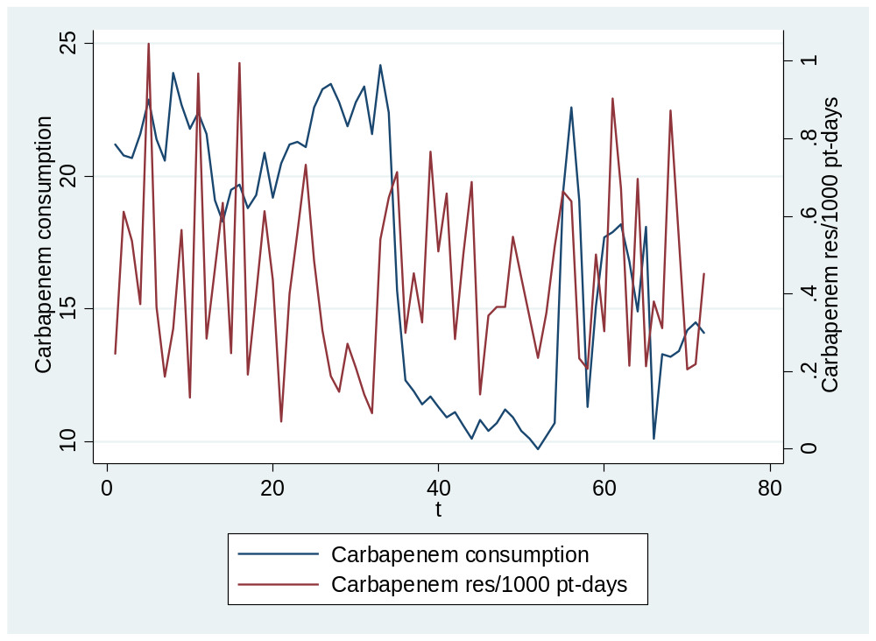

Figure SB.2. Filtered Carbapenem consumption and resistant cross-correlation.
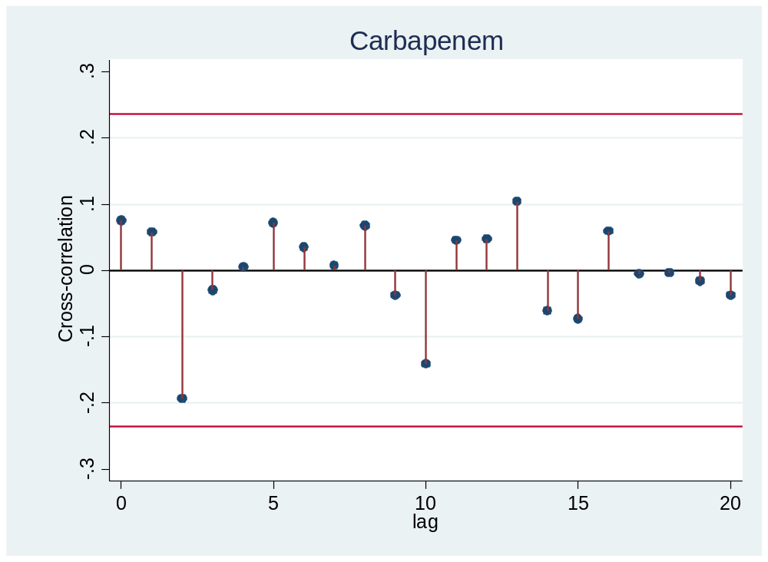

Figure SB.3. Colistin consumption and Carbapenem + Colistin resistant isolates/1000 pt-days, All Pathogens, Hospital.
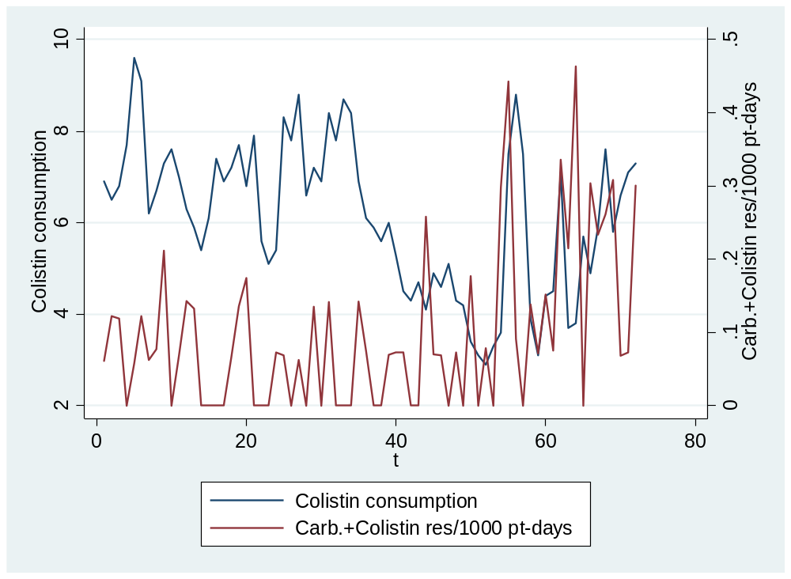

Figure SB.4. Filtered Colistin consumption and Carbapenem + Colistin resistant cross-correlation.
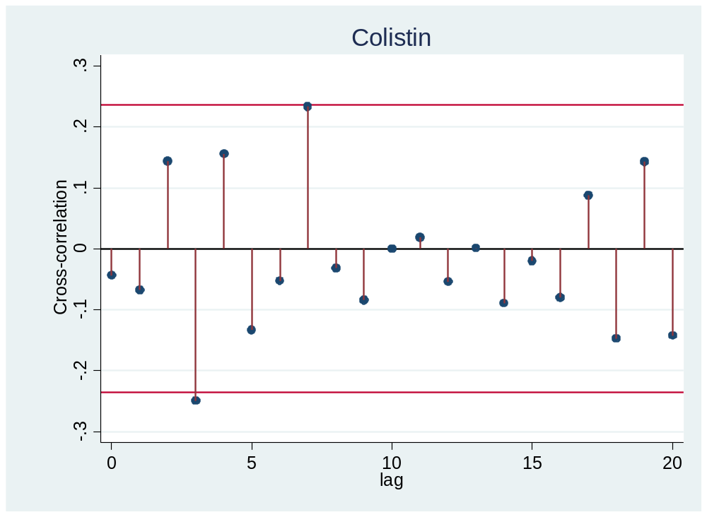

Figure SB.5. Tigecycline consumption and Carbapenem + Tigecycline resistant isolates/1000 pt-days, All Pathogens, Hospital
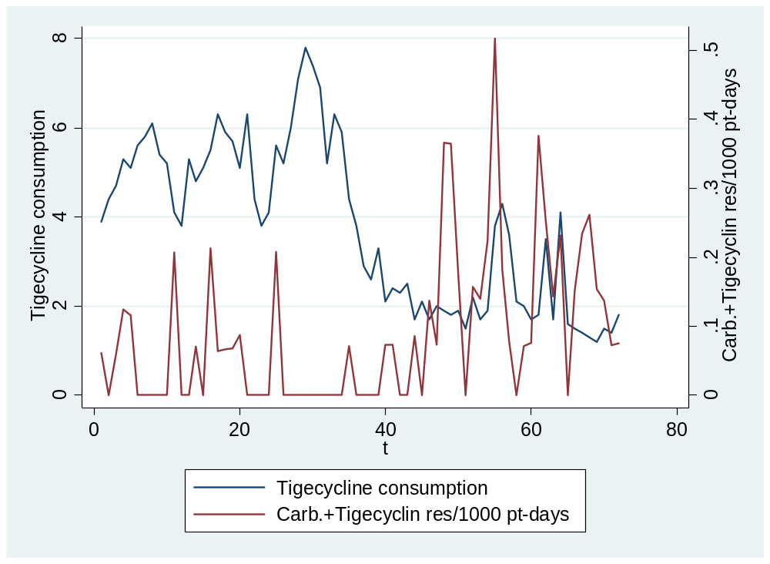

Figure SB.6. Filtered Tigecycline consumption and Carbapenem + Tigecycline resistant cross-correlation.
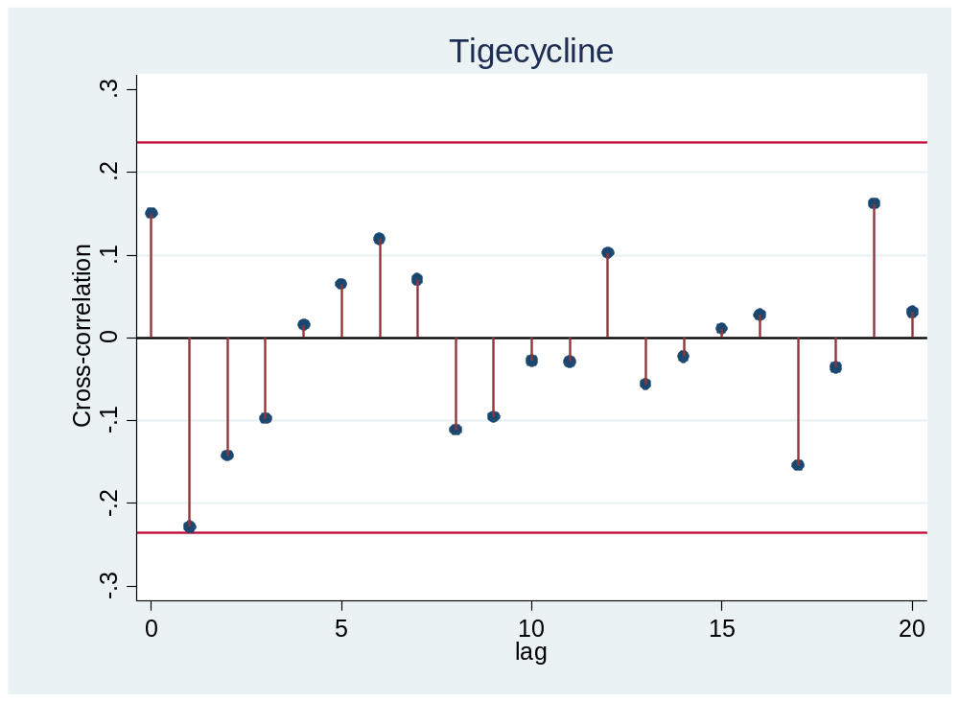

B.3. Results
As shown in Figure 2.2 cross-correlations between filtered series of Carbapenem consumption and resistance (Box and Jenkins method^{1,2}) were not significantly different from zero thus no association between lagged values of consumption and current values of resistance was identified. Initial exploratory steps of the method proposed by Pankratz³ did not reveal any significant or meaningful patterns of association either.
As shown in Figure 2.6 cross-correlations between filtered series of Tigecycline consumption and resistance (Box and Jenkins method^{1,2}) were not significantly different from zero thus no association between lagged values of consumption and current values of resistance was identified. Initial exploratory steps of the method proposed by Pankratz³ did not reveal any significant or meaningful patterns of association either.
As shown in Figure 2.4 cross-correlations between filtered series of Colistin consumption and resistance (Box and Jenkins method^{1,2}) there was a marginal indication of association between lag 3 of Colistin consumption with resistance which was not verified in ARIMA model (non-significant negative estimate: b= -0.013, p-value= 0.273). Initial exploratory steps of the method proposed by Pankratz³ did not reveal any significant or meaningful patterns of association either.

