Supplementary table 1: Serology and cerebrospinal fluid results of 3073 patients with a serum Borrelia IgG LIAISON® test from the capital region of Denmark, January 2016-January 2024
 | NB | Non-NB | p-value | OR (95% CI)
Total cases, N (%) | 392 (100%) | 2681 (100%)
Bbsl serology
Positive S-Bbsl IgG LIAISON® test, N (%) | 346 (88%) | 336 (12%) | <0.001 | 52.50 (37.81-72.88)
Positive IgG and/or IgM intrathecal Bbsl test, N (%) | 260 (66%) | 17 (<1%) | <0.001 | 308.66 (183.35-519.62)
CSF results

WBC /μL (cut-off >5 /μL), median (IQR)¹ | 92 (31-189) | 2 (1-5) | <0.001
Protein g/L (cut-off >0.50 mg/L), median (IQR)² | 0.85 (0.50-1.51) | 0.43 (0.31-0.60) | <0.001
Glucose mmol/L L (ref: 2.2-3.9 mmol/L), mean±SD | 3.28±0.85 | 3.65±0.87 | <0.001
Q-albumin (cut-off > 6.8), median (IQR) | 13.7 (6.60-26.70) | 5.80 (4.00-8.90) | <0.001
IgG-index (cut-off > 0.63), median (IQR) | 0.65 (0.48-0.94) | 0.48 (0.43-0.54) | <0.001
Abbreviations: NB, neuroborreliosis: OR, odds ratio: N, number: CI, confidence interval: Bbsl, Borrelia Burgdorferi sensu lato: IQR, interquartile range: S-Bbsl IgG, Serum Borrelia Burgdorferi sensu lato: immunoglobulin G: CSF, cerebrospinal fluid: WBC, white blood cell: SD, standard deviation
¹data available on 392/392 NB patients and 1970/2681 non-NB patients
²data available on 392/392 NB patients and 1962/2681 non-NB patients
³data available on 391/392 NB patients and 1942/2681 non-NB patients
⁴data available on 72/392 NB patients and 518/2681 non-NB patients
⁵data available on 67/392 NB patients and 490/2681 non-NB patients.

Supplementary Table 2: Sensitivity, specificity, and positive and negative predictive values of the serum Borrelia IgG LIAISON® test in different clinical scenarios.
 | TP (N) | FN (N) | TN (N) | FP (N) | Sensitivity % (95% CI) | Specificity % (95% CI) | PPV % (95% CI) | NPV % (95% CI) | LR+ (95% CI) | LR- (95% CI)
Clinical manifestations
Children with cranial neuropathy | 82 | 20 | 156 | 11 | 80 (71–87) | 93 (88–97) | 88 (80–94) | 89 (83–93) | 12.18 (7.65–19.40) | 0.21 (0.14–0.30)
Adults with cranial neuropathy | 54 | 15 | 314 | 36 | 78 (67–87) | 90 (86–93) | 60 (50–70) | 95 (92–97) | 7.60 (5.60–10.30) | 0.24 (0.16–0.35)
Adults with Bannwarth syndrome (with or without cranial neuropathy) / radiculitis / mononeuritis multiplex / PNP and mimics | 147 | 5 | 829 | 167 | 97 (93–99) | 83 (81–85) | 47 (41–53) | 99 (99–100) | 5.79 (5.20–6.45) | 0.04 (0.02–0.07)
Meningitis and mimics (without cranial neuropathy) | 31 | 5 | 519 | 58 | 86 (71–95) | 90 (87–92) | 35 (25–46) | 99 (98–100) | 8.52 (6.80–10.70) | 0.16 (0.09–0.27)
Children with meningitis (without cranial neuropathy) | 19 | 2 | 173 | 15 | 90 (71–98) | 92 (87–95) | 56 (40–71) | 99 (96–100) | 11.31 (7.10–18.00) | 0.10 (0.03–0.30)
Vasculitis / encephalitis and mimics | 16 | 0 | 210 | 33 | 100 (80–100) | 86 (81–90) | 33 (21–47) | 100 (98–100) | 7.35 (6.20–8.70) | 0.00 (0.00–0.10)
Symptom duration
Adults, ≥2 weeks | 174 | 3 | 980 | 199 | 98 (94–99) | 83 (81–85) | 47 (44–50) | 99 (98–100) | 5.76 (5.29–6.33) | 0.02 (0.01–0.03)
Children, ≥2 weeks | 47 | 1 | 254 | 29 | 98 (92–100) | 90 (87–93) | 62 (57–67) | 99 (98–100) | 9.80 (7.53–13.07) | 0.02 (0.01–0.03)
Adults, >4 weeks | 96 | 0 | 705 | 158 | 100 (96–100) | 82 (80–84) | 38 (35–41) | 100 (99-100) | 5.56 (5.00–6.25) | 0.00 (0.00-0.05)
Children, >4 weeks | 14 | 0 | 175 | 21 | 100 (80-100) | 89 (85-93) | 40 (33-47) | 100 (96-100) | 9.09 (7.14-20.00) | 0.00 (0.00-0.22)
>10 weeks | 47 | 0 | 598 | 127 | 100 (92-100) | 82 (79-85) | 27 (24-30) | 100 (99-100) | 5.56 (4.92-6.33) | 0.00 (0.00-0.10)
S-Bbsl IgG cutoff
Adults, >25 AU | 212 | 39 | 1883 | 214 | 84 (80–87) | 90 (89-91) | 50 (47–53) | 98 (97-99) | 8.40 (7.64-9.44) | 0.18 (0.16-0.19)
Children, >25 AU | 105 | 36 | 545 | 38 | 74 (67–81) | 93 (91-95) | 73 (66–80) | 94 (92-96) | 11.45 (7.89–15.40) | 0.27 (0.24–0.32)
Adults, >65 AU | 172 | 79 | 1978 | 119 | 68 (66-70) | 94 (94–96) | 59 (53-65) | 96 (94-96) | 12.04 (11.00–17.50) | 0.33 (0.31–0.36)
Children, >65 AU | 80 | 61 | 559 | 24 | 57 (52–60) | 96 (95-97) | 77 (68-85) | 90 (83-89) | 13.86 (11.00–20.00) | 0.45 (0.41–0.50)
Adults, >100 AU | 148 | 103 | 2011 | 86 | 59 (57-61) | 96 (94–96) | 63 (61-65) | 95 (92–96) | 14.37 (11.88–20.33) | 0.43 (0.30–0.36)
Adults with BW and mimics, >100 AU | 103 | 49 | 947 | 50 | 68 (65-71) | 95 (94-96) | 67 (64-70) | 95 (94-96) | 13.29 (10.83–17.75) | 0.34 (0.30-0.37)
Children, >100 AU | 59 | 82 | 568 | 15 | 42 (39-45) | 97 (96-98) | 80 (77-83) | 87 (85-89) | 16.08 (11.00–22.50) | 0.60 (0.55-0.63)
≥2 weeks,>100 AU | 151 | 74 | 1390 | 73 | 67 (65-69) | 95 (94-96) | 67 (62–68) | 95 (94-96) | 13.42 (11.00–17.25) | 0.35 (0.31-0.37)
Adults, ≥2 weeks,>100 AU | 121 | 56 | 1112 | 67 | 68 (66-70) | 94 (94–96) | 64 (62-66) | 95 (94-96) | 12.03 (9.43–14.00) | 0.34 (0.31-0.36)
Children, ≥2 weeks,>100 AU | 30 | 18 | 278 | 6 | 62 (57-67) | 98 (97-99) | 83 (79-87) | 94 (92-96) | 29.76 (19.00–67.00) | 0.38 (0.30–0.44)
Abbreviations: N, number: CI, confidence interval: TP, true positive: FN, false negative: TN, true negative: FP, false negative: PPV, positive predictive value: NPV, negative predictive value: LR, likelihood ratio: PNP, polyneuropathy: S-Bbsl IgG, Serum Borrelia burgdorferi sensu lato immunoglobulin G

Supplementary Table 3: AUC, accuracy, Youden Index and optimal cut-off of the serum Borrelia IgG LIAISON® test
 | AUC (95% CI) | Accuracy (95% CI) | Youden Index | Optimal cut-off (AU/mL)
Adults with Bannwarth syndrome (with or without cranial neuropathy) / radiculitis / mononeuritis multiplex / PNP and mimics | 0.94 (0.91-0.95) | 0.85 (0.84-0.86) | 0.80 | 15.09
Children with cranial neuropathy | 0.87 (0.82-0.91) | 0.88 (0.84-0.92) | 0.73 | 15.00*
Meningitis | 0.89 (0.82-0.94) | 0.90 (0.87-0.92) | 0.76 | 15.29
Vasculitis and encephalitis | 0.97 (0.94-0.98) | 0.87 (0.83-0.91) | 0.87 | 15.75
Adults, ≥2 weeks | 0.89 (0.87-0.92) | 0.85 (0.83-0.87) | 0.81 | 15.00*
Adults, >4 weeks | 0.92 (0.89-0.94) | 0.83 (0.81-0.85) | 0.84 | 36.46
*Because we assigned all values <15 AU/mL as 0 AU/mL, any ROC-derived optimal cut-off below 15 AU/mL was set to 15.00 AU/mL.
Abbreviations: AUC, area under the curve: CI, confidence interval

Supplementary Table 4: positive and negative rate of the serum Borrelia IgG LIAISON® test stratified on the diagnostic criteria
 | Total observations (N) | Pos S-IgG (N) | Neg S-IgG (N) | Positive rate (fraction) | Negative rate (fraction)
Entire cohort
Definite NB | 258 | 241 | 17 | 0.93 | 0.07
Possible NB | 134 | 105 | 29 | 0.78 | 0.22
Non-NB | 2681 | 336 | 2345 | 0.12 | 0.88
≥2 weeks
Definite NB | 182 | 178 | 4 | 0.98 | 0.02
Possible NB | 43 | 43 | 0 | 1.00 | 0.00
Non-NB | 1462 | 228 | 1234 | 0.15 | 0.85
>4 weeks
Definite NB | 86 | 86 | 0 | 1.00 | 0.00
Possible NB | 24 | 24 | 0 | 1.00 | 0.00
Non-NB | 1060 | 179 | 881 | 0.17 | 0.83

Abbreviations: N, number: S-IgG, serum immunoglobulin G: NB, neuroborreliosis: PNP, polyneuropathy

Supplementary Figure 1: Scatterplot of serum Borrelia IgG LIAISON® titer AU/mL as a function of symptom duration and Sensitivity–Specificity Trade-off Plot of the serum Borrelia IgG LIAISON® test titer cut-off points.
a)
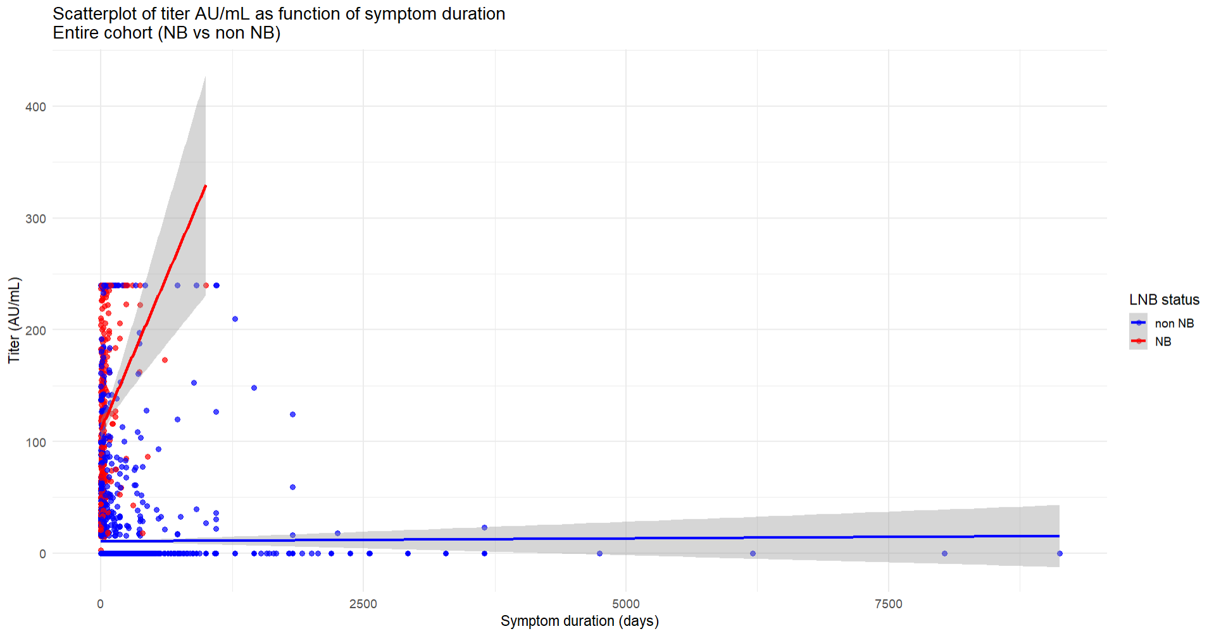

b)
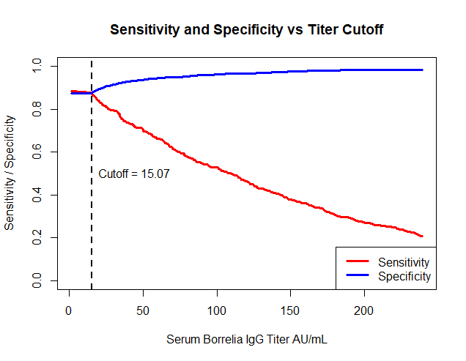
Abbreviations: NB, neuroborreliosis
- Titer values (AU/mL) as a function of symptom duration (days), shown with restricted cubic spline regression curves and their 95% confidence intervals (red and blue lines with grey confidence bands).
Titers increased with longer symptom duration in NB patients but showed no meaningful pattern in non-NB patients. After 4 weeks of symptoms, 8% of NB patients still had titers <40 AU/mL.

- Sensitivity and specificity of the LIAISON® test on the Y-axis as a function of the titer cut-off points at the x-axis. The vertical dotted line shows the cut-off point (15.07 AU/mL) where sensitivity = specificity at 0.87.

