Original article

Computational modeling and histologic analysis of 6.78- and 2-MHz monopolar radiofrequency-induced thermal reactions

*These authors contributed equally to this work.

Conflicts of interest: The authors declare no conflicts of interest.

Running head: DUAL-FREQUENCY MONOPOLAR RF
Keywords: Radiofrequency, monopolar, dual frequency, porcine model, computational modeling, collagen, elastic fiber, adipocyte, thermal diffusion
Figure Legends
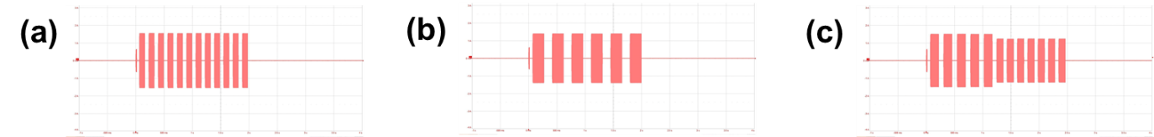
Fig S1 Schematic representation of radiofrequency (RF) pulse waveforms generated by the NMRF system for each depth parameter. (a) Type-S RF pulse, (b) type-M RF pulse, and (c) type-D RF pulse demonstrate distinctive pulse architectures reflecting their depth-specific modulation strategies

