Supplementary Fig 1. Serial clinical photographs of a representative patient at baseline, 2 months, and 6 months after monopolar RF treatment. At baseline, the mid-pupillary brow elevation (MPBE) measured 22.04 mm, the lateral canthal brow elevation (LCBE) 22.267 mm, the superior palpebral crease elevation (SPCE) 0.909 mm, and eyebrow angle (EA) 162.482°. At 2 months, MPBE increased to 22.906 mm, LCBE to 23.787 mm, SPCE to 1.321 mm, and EA decreased to 157.133°, indicating lateral brow elevation. At 6 months, MPBE measured at 22.547 mm, LCBE to 23.641 mm, SPCE to 1.095 mm, and EA further decreased to 142.33°, reflecting sustained improvement in brow and eyelid position compared to baseline.
a)
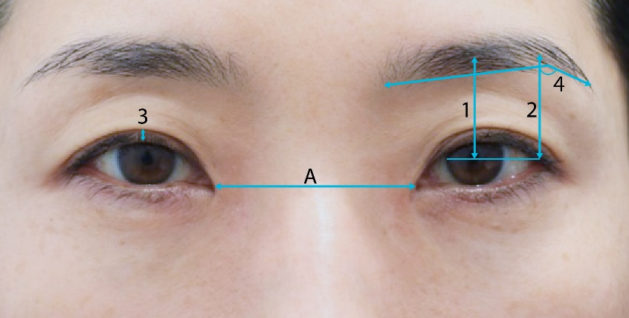
b)
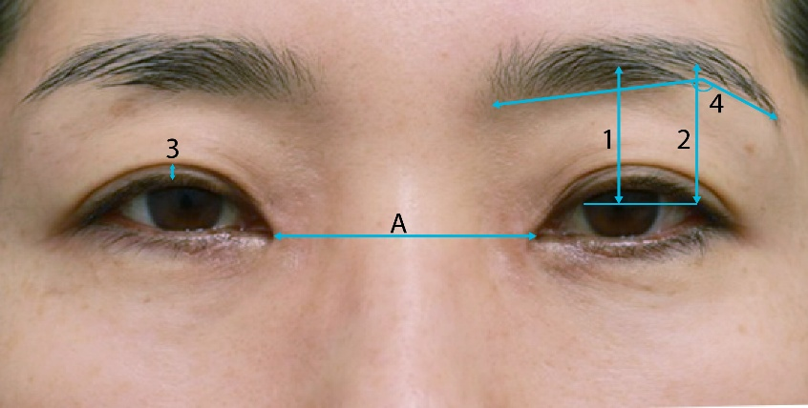
c)
