(("Plantar Fasciitis" OR "heel pain" OR "plantar pain" OR "plantar fascia") AND ("Shock Wave Therapy" OR "Extracorporeal Shockwave Therapy" OR "ESWT" OR "shockwave therapy") AND ("Laser Therapy" OR "low-level laser therapy" OR "LLLT" OR "laser treatment" OR "High-intensity Laser Therapy" OR "Lower-intensity Laser Therapy" OR "HILT" OR "LILT")) | PubMed (23)
 | Scopus (36)
 | Embase (27)
 | Cochrane (5)
 | Google Scholar (200)
 | WOS (17)
 | Total (108)

Table S1: Search strategy used to identify related studies using different databases.

Study | Inclusion criteria | Exclusion criteria
Riaz et al., 2023 | Patients suffering from chronic plantar fasciitis, minimum age 18 and maximum up to 70 years were included. Patients having a Visual analogue scale of more than 5 on the first step in the morning were included, having a duration of symptoms of more than6 months. Both genders were included. | Patients with previous surgery of plantar fasciitis, pregnancy, pacemaker fitted, Bleeding disorder, Any tumor of the treatment site, calcaneus stress fracture checked bysqueeze test were excluded.
Bidoki et al., 2024 | Inclusion criteria were age from 18 to 55 years old, diagnosis of PF confirmed by physical medicine and rehabilitation specialist and orthopedic surgeon, no response to conservative treatments such as ice, soft tissue massage, stretching, usage of insoles, and non-steroidal anti-inflammatory (NSAID) drugs after  6 weeks. | Exclusion criteria included having history of foot surgery in the last 6 months, history of corticosteroid injection in the last 6 months, history of surgery for lumbar disc herniation, diagnosis of rheumatologic disease (rheumatoid  arthritis, diffuse idiopathic skeletal hyperostosis (DISH), systemic lupus erythematosus (SLE), gout, Sjogren disease, enthesopathy, and so on), history of heel pain due to trauma in the last 3 months, wounds, infections, and tumors in the treatment area, HILT or ESWT contraindications, no desire to participate in the study, use of any medications that interfere with the healing process or affect the pain, such as glucocorticoids and NSAID drugs.
Thammajaree et al., 2023 | The inclusion criteria were pain at medial calcaneal tuberosity, unilateral (VAS ≥ 2/10), pain at the first step in the morning (VAS ≥ 2/10), and age ≥ 18. | The exclusion criteria were musculoskeletal disorders such as Tendo Achilles (TA) rupture, ankle osteoarthritis, prior surgery or metal implant in the lower back and lower limb, acute plantar fasciitis or having severe pain (P10/10), or unable to bear weight or positive result of Ottawa’s rule, pain medication within one week before participation, red flags, precautions/contra-indications, and systemic diseases such as cancer, autoimmune disease, vascular disease or observable skin change, infected area, coagulation disorders, diabetes-related, steroid (injection and oral), tattoo at plantar area, nerve or neurologic impairments, pregnancy, BMI ≥ 30, physical or mental disorders.
Timurtas et al., 2024 | Individuals who experienced pain on the medial tuberosity or medial process of the plantar fascia in the past month, felt pain in the morning at the first step, and agreed to participate in the study were included. | Participants were excluded if they had arthritis in the foot or ankle, cardiac arrhythmia or a pacemaker, previous foot or ankle surgery, cancer or tumor, acute trauma, body mass index (calculated as the weight in kilograms divided by the square of the height in meters) greater than 40, or participated in any other  therapy or had a corticosteroid injection in the past 6 months.
Koz et al., 2023 | Patients aged 18–70 years, having ongoing heel pain for at least 3 months, and not using oral and/or parenteral corticosteroids in the last 6 months met the inclusion criteria. | /
Elsehrawy et al., 2018 | Adults of both genders  over 18 years were included | <18 years
Ulusoy et al., 2017 | The inclusion criteria were the presence of symptoms of a chronic recalcitrant  plantar painful heel of 6 months duration that was unresponsive to 6 weeks of first tier conservative treatment (nonsteroidal anti-inflammatory drug, home exercise program, and standard insoles). The diagnosis was confirmed clinically by the physical examination finding of tenderness to palpation with local pressure at the origin of the plantar fascia on the medial tubercle of the calcaneus and an indication of significant pain bya score of �5 for �1 of 3 visual analog scales (VASs; intensity of pain measured by the VAS for the first few steps in the morning, during daily activities, and during  exercise) before treatment. | The exclusion criteria were previous local trauma, foot surgery, local steroid  injection within the previous 3 months, local infection, abnormalities in the knees or ankles, vascular disease, diabetes mellitus, malignancy, peripheral neuropathy, pacemaker, metal implants, rheumatic inflammatory disease, and plantar fascial  rupture.
Sanmak et al., 2019 | Being between 18 and 65 years, presence of heel pain, tenderness at the  insertion site of the plantar fascia on the anteromedial aspect of the calcaneal tubercle elicited by palpation, and unresponsiveness to medical treatment. | Being younger than 18 years of age, a history of inflammatory rheumatic disease, trauma of the foot or foot surgery, local dermatological lesion or infection, impaired peripheral circulation, a neurological disorder such as radiculopathy and neuropathy, patients with sequelae of lower extremity fracture, a congenital or acquired deformity, malignancy, cardiac pacemaker, metal implant at the application site, pregnancy, anticoagulant use for coagulopathy, and inflammation within or around plantar fascia identified by USG.
Ordahan et al., 2018 | Pain was (1) reproduced with palpation of the plantar fascia, (2) localized and sharp but not radiating, (3) worse in the initial step after and an extended  period of rest, and (4) decreased initially after the first steps but exacerbated with increased activityat least 6 weeks, (5) unresponsive conservative form of plantar fasciitis care (ie,rest, stretching, full-length silicone insole, prescription  NSAIDs when taken for a period of 2 weeks) | (1) history of previous steroid injections, (2) previous surgery of the foot, lumbar spine disc herniation or back injury, and (3) patients with rheumatic diseases (e.g., rheumatoid arthritis, spondyloarthropathy, gout disease, enthesopathy, Sjogren’s syndrome, and systemic lupus erythematosus). Also, patients with peripheral joint stiffness, redness, warmth, swelling, deformities, and skin changes including erythema were excluded from the study.
Naruseviciute et al., 2020 | 1) Unilateral plantar heel pain lasting for at least one month, mainly during the first few steps upon rising in the morning, which worsens with increased weight-bearing activity through the day. 2) Tenderness at the insertion site of the plantar fascia on the calcaneus. 3)Patients aged from 18 to 85 years. | Exclusion criteria include bilateral heel pain; a history of laser therapy already applied for the current heel pain episode; diagnosis of other heel pathologies such as calcaneal stress fracture, osteomyelitis, plantar fascia neoplasm, or plantar fascia rupture; a history of recent trauma or foot surgery; wounds or infections in the treatment area; impaired sensation in the treatment area; pigmentation changes on the skin in the treatment area, such as tattoos or birthmarks; implanted metal constructions in the treatment area; recent use of oral or injected corticosteroids within the last six weeks; a diagnosis of neurological heel pain (e.g., radiculopathy); a diagnosis of systemic inflammatory arthritis (e.g., gout, rheumatoid arthritis); other acute pathologies such as febrile fever or cold requiring treatment; other painful conditions necessitating painkillers (e.g., tooth pain, back pain); pregnancy; or a diagnosis of oncology.

Table S2: Inclusion and exclusion criteria of each included study.

ESWT | -0.35 (-2.38 to 1.68) | 0.63 (-1.15 to 2.42)
0.59 (-1.08 to 2.27) | HILT | -1.97 (-4.33 to 0.39)
-0.10 (-1.65 to 1.45) | -0.69 (-2.47 to 1.09) | LILT
Table S3: Pairwise and network meta-analysis of VAS score.

A
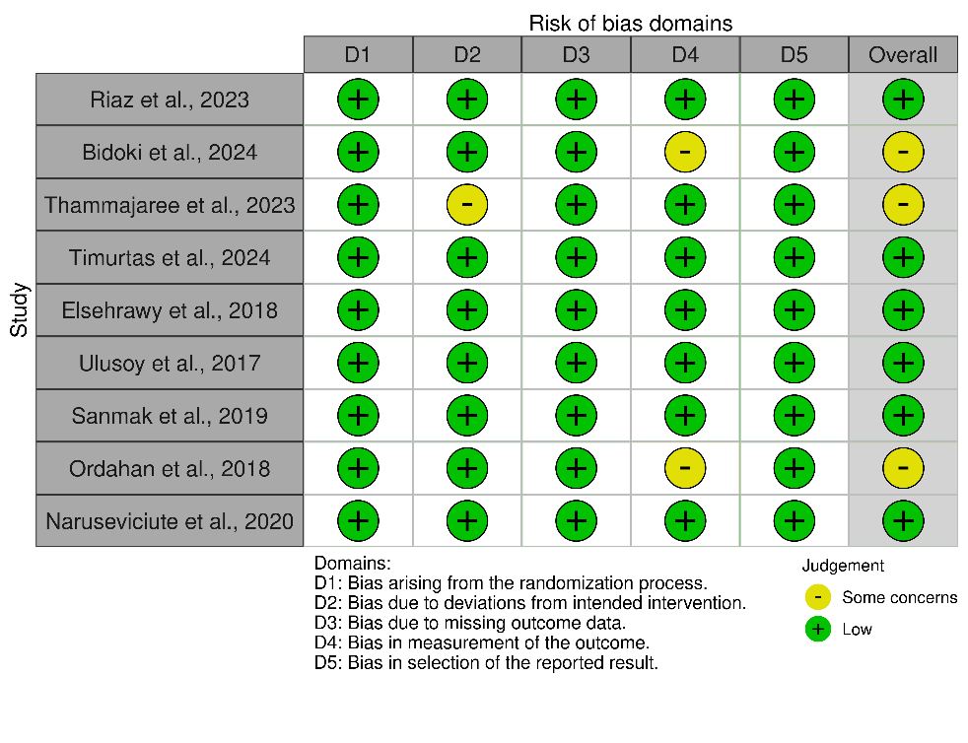

B
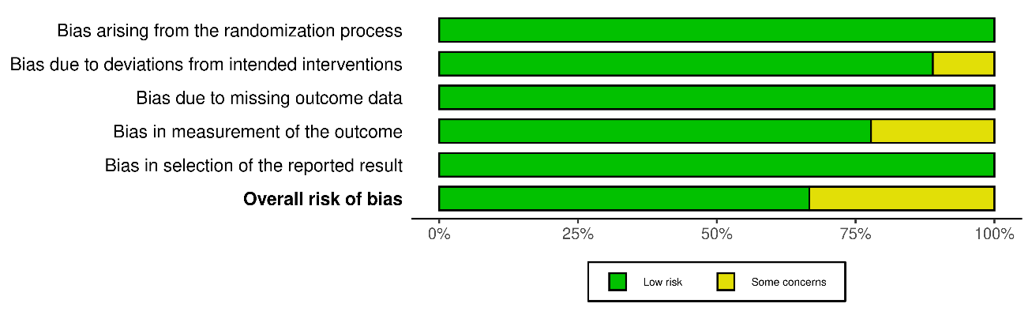
Figure S1: Quality assessment of the randomized controlled studies using ROB-2 tool.

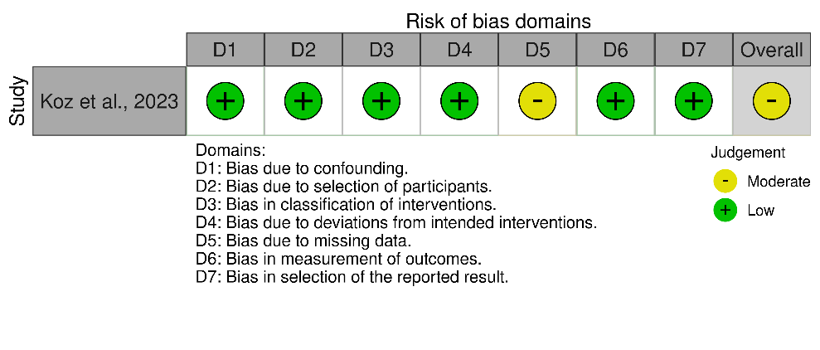
Figure S2: Quality assessment of the non-randomized studies using ROBINS tool.

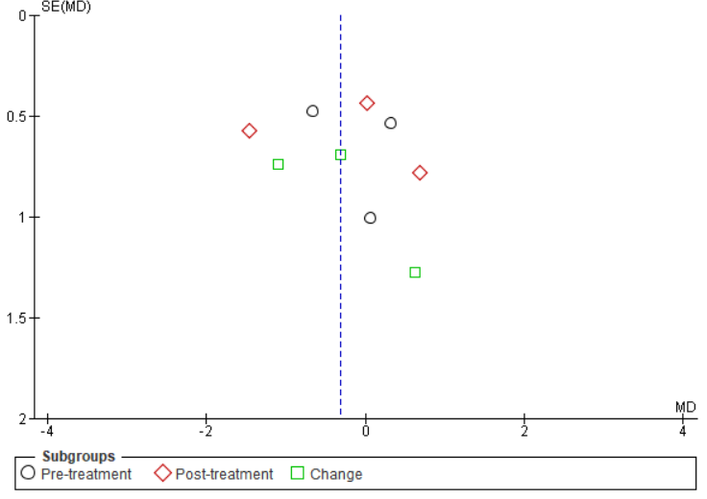
Figure S3: Funnel plot for VAS score of ESWT and HILT.
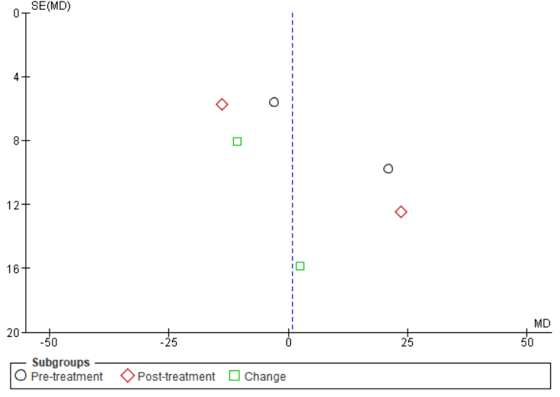
Figure S4: Funnel plot for FFI score of ESWT and HILT.
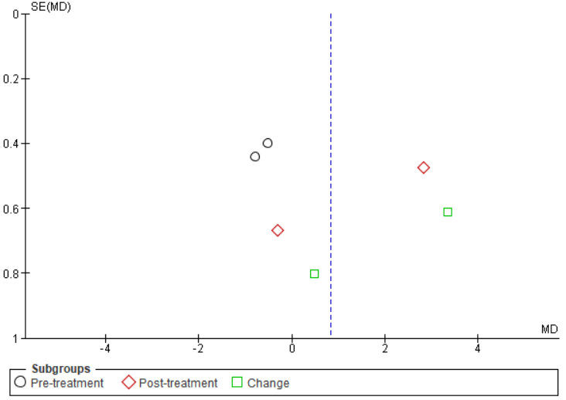

Figure S5: Funnel plot for VAS score of LILT and HILT.

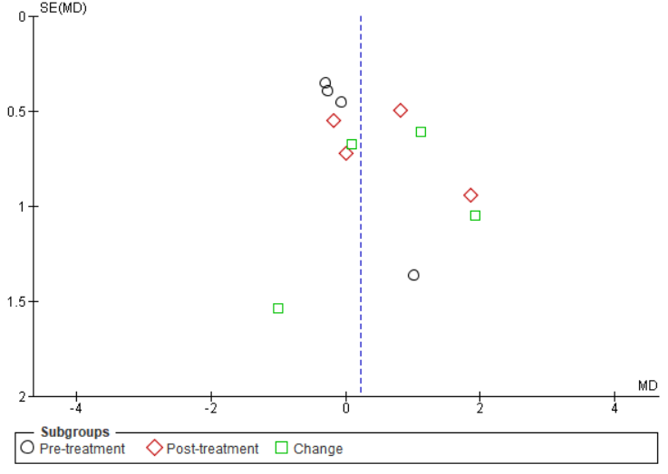

Figure S6: Funnel plot for VAS score of LILT and ESWT.

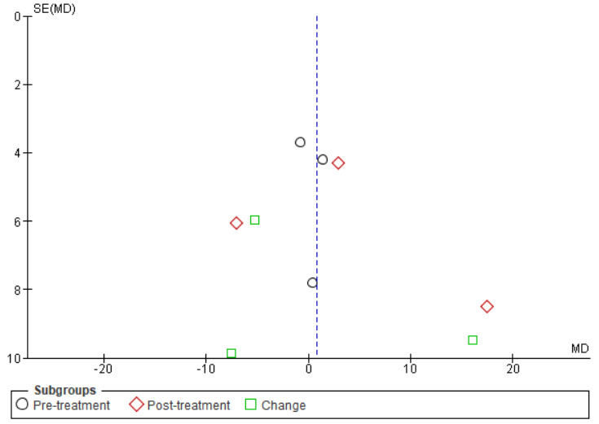
Figure S7: Funnel plot for FFI score of LILT and ESWT.

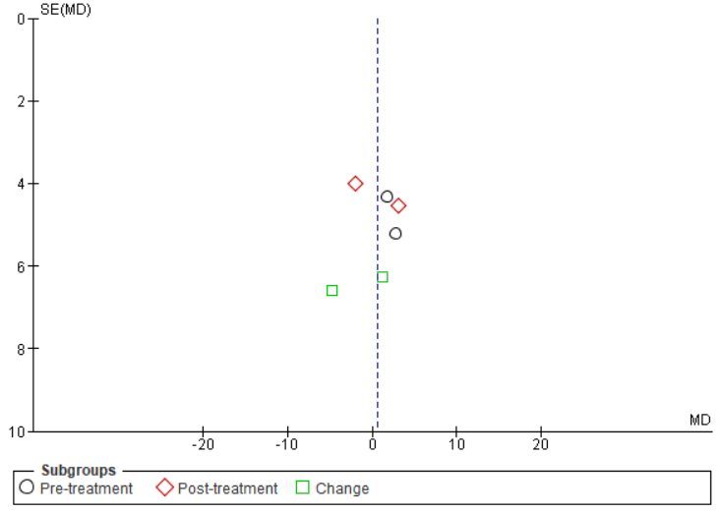

Figure S8: Funnel plot for AFOS score of LILT and ESWT.

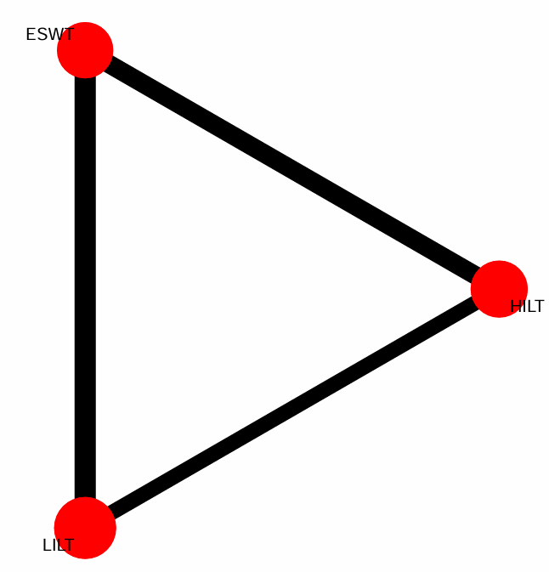
Figure S9: Visual presentation of network meta-analysis.

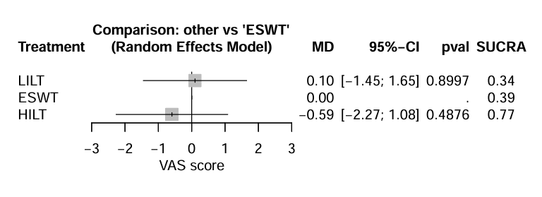
Figure S10: Network meta analysis for VAS score.

