Supplementary materials
Table S1: Altitudinal ranges of main production used for calibration of the climate model and approximate annual production volume of six Indonesian Arabica coffee origins
Region | Altitudinal range of main production (m) | Approximate annual production volume (t)¹
Aceh | 1200-1500 | 20,000-35,000
North Sumatra | 1200-1400 | 15,000-25,000
Sulawesi | 1400-1600 | 4,000-7,000
Flores | 1100-1400 | 2,000-4,000
Bali | 1000-1300 | 2,000-3,000
East Java | 1200-1400 | 10,000-15,000
¹based on Neilson (2008), modified and updated with reference to Badan Pusat Statistik (Indonesian Statistic Agency), 2013, Data Ekspor Coffee 2000-2012, Jakarta

Table S2: Bioclimatic variables from the Worldclim database that were used in the modeling of coffee (Coffea arabica) climates in Indonesia
Bio1 = Annual mean temperature
Bio2 = Mean diurnal range (Mean of monthly (max temp – min temp))
Bio3 = Isothermality (Bio2/Bio7) (*100)
Bio4 = Temperature seasonality (standard deviation *100)
Bio5 = Maximum temperature of warmest month
Bio6 = Minimum temperature of coldest month
Bio7 = Temperature annual range (Bio5 – Bio6)
Bio8 = Mean temperature of wettest quarter
Bio9 = Mean temperature of driest quarter
Bio10 = Mean temperature of warmest quarter
Bio11 = Mean temperature of coldest quarter
Bio12 = Annual precipitation
Bio13 = Precipitation of wettest month
Bio14 = Precipitation of driest month
Bio15 = Precipitation seasonality (coefficient of variation)
Bio16 = Precipitation of wettest quarter
Bio17 = Precipitation of driest quarter
Bio18 = Precipitation of warmest quarter
Bio19 = Precipitation of coldest quarter

Table S3: Global Circulation Models (GCMs) included in the modeling of future climatic suitability of coffee (Coffea arabica) in Indonesia and their countries of origin. Data were obtained from http://www.ccafs-climate.org/downloads/docs/Disaggregation-WP-02.pdf
Model Country
bccr_bcm2_0 Norway
cccma_cgcm3_1_t47 Canada
cnrm_cm3 France
csiro_mk3_0 Australia
csiro_mk3_5 Australia
gfdl_cm2_0 USA
gfdl_cm2_1 USA
giss_model_er USA
ingv_echam4 Italy
inm_cm3_0 Russia
ipsl_cm4 France
miroc3_2_medres Japan
miub_echo_g Germany/Korea
mpi_echam5 Germany
mri_cgcm2_3_2a Japan
ncar_ccsm3_0 USA
ncar_pcm1 USA
ukmo_hadcm3 UK
ukmo_hadgem1 UK

Figure S1: Adjustment of the Maxent model of climatic suitability for Arabica coffee (Coffea arabica) to coffee growing areas in Aceh, North Sumatra, Sulawesi, Flores, Bali and East Java for present climatic conditions
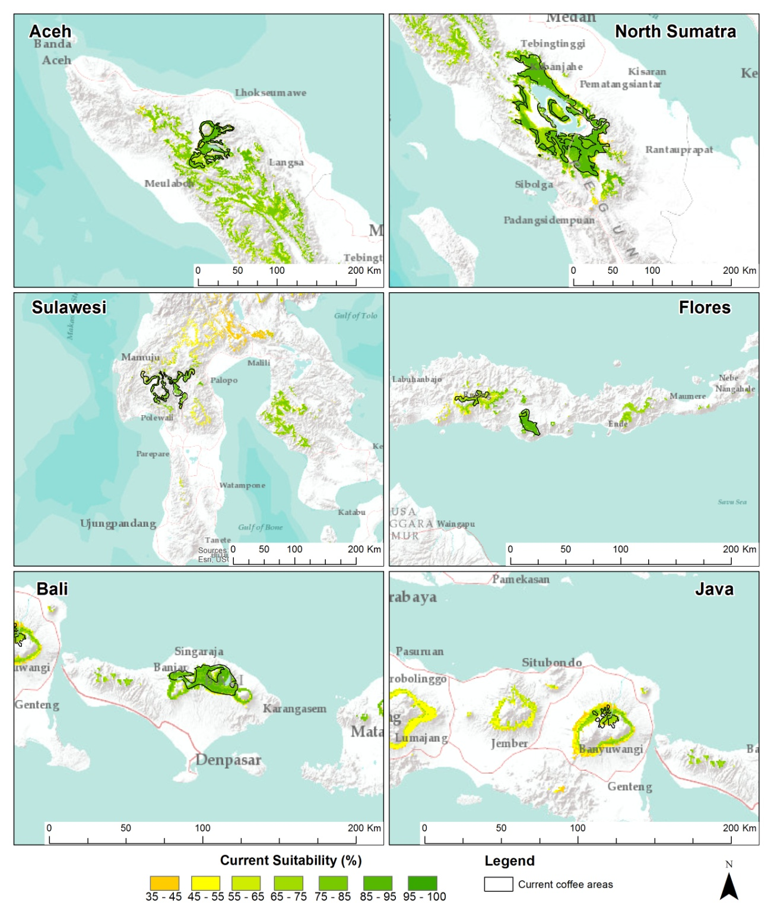

Figure S2: Variability in the projection of future climatic suitability for Arabica coffee production of various growing areas in Indonesia
